The Best of Days of the Year and Why They Matter

As Salaam Alaikum
The month of Dhul Hijjah, the twelfth month on our Islamic calendar has begun. It is indeed a time of significance. In fact ‘Dhu al- Hijjah’ literally means ‘possessor of the pilgrimage’. This is the month that believers from every corner of the earth come together in Makkah to perform the Hajj. The first ten days of this month are a blessed time to increase our ibadah, dhikr and reverence for Allah, SWT.
Our hearts are indeed with the pilgrims, many of whom are able to return to the Haram this year to perform the rites of Hajj. For those of us who are not making pilgrimage, there is much opportunity for blessing and reward.
Prophet Muhammad, peace be upon him, taught the believers that: "There are no days on which righteous deeds are more beloved to Allah than these ten days." (Bukhari)
This week we encourage you, your family and the community to believers to take advantage of this time. Allah is The Originator- Al Baari and The Giver of Gifts – Al-Wahhab. Allah alone created time and has given time to us as a mercy and a gift. Take this time to do more, to strive harder and seek forgiveness.
Allah reveals to us in the Holy Quran that there are times – some days, nights, or months mentioned in ayah that offer more reward. Dhul Hijjah is one of those times.
Also within this week, we will come upon the day of Arafah on July 8th. We offer reminders of how to spend these first days of Dhul Hijjah and the reward therein.
May the peace and blessings of Allah be upon us all
Sound Vision Team

The Best of Days and Day
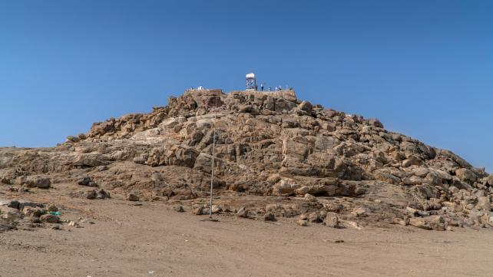
Mahasin D. Shamsid-Deen
Time is a benefit given to mankind and creation by Allah, The Most High. We are instructed to take advantage of and use time wisely. In the Holy Quran, Allah affirms and vows to humanity in Suratul Asr
“By the ‘passage’ of time, surely mankind is at loss, except those who have faith, do good, and urge each other to the truth, and urge each other to perseverance”
As Islam is a religion of justice and balance, we are given time to live, time to grow, time to reflect and time to be one who seeks the favor and receives the blessings. We have times in Islam that offer more reward and Mercy from Allah. Think of the equity in Islam. During Ramadan we have the last 10 nights and then the blessed night of power Laitaul Qadr. Correspondingly, during the month of Dhul Hijjah, we have the first 10 days and then the day of the recurring happiness, Eid Ul Adha
The first ten days of the month of Dhul Hijjah are of such significance that we have the confirmation, declaration and guarantee from Allah in the Holy Quran in Suratul-Fajr:
“By the dawn and the ten nights”
Suratul Fajr: 1-2
In the hadith tradition of Muhammad, the prophet (PBUH) and the consensus of scholars in Islam, there is agreement that these two verses from Suratul Fajr refer to the beginning of the month of Dhul Hijjah.
Dhul Hijjah is special because it is the time of Hajj and Yawm Al Arafah – The Day of Arafah.
During the height of the Coronavirus pandemic, Muslims were not able to make pilgrimage to Makkah. Although during that time hujjaj were at the Kaaba nor physically begging for the Mercy of Allah while at Mount Arafat, these days still passed. The isolated state of the ummah did not keep us from the benefits of this month. Even though we were not able to be there physically, we extracted the true beauty and spiritual significance because we were forced to focus on the meaning rather than the ritual of hajj. Thus, we gained a greater insight and appreciation..
Our task during the days of Dhul Hijjah are always to place a greater focus on Allah whether at Al-Haram or at home. Allah as Maker and Fashioner of time gives us more than just one special time of year for heightened ibadah. Prophet Muhammad (SAW) teaches us:
There are no days during which righteous deeds are more beloved to Allah than these days," meaning the (first) ten days of Dhul- Hijjah. They said: "O Messenger of Allah! Not even Jihad in the cause of Allah?" He said: "Not even Jihad in the cause of Allah, unless a man goes out with himself and his wealth and does not bring anything back.
Sahih
Hadith No: 1727 From: Sunan Ibn Majah. Chapter 9
Dhul Hijjah is a time for action and time we gain more blessing for our deeds. If we are not on hajj, we pray, we dhikr, we help the poor, we visit the sick, we offer sadaqah, we slaughter and share the meat,
The tradition of Prophet Muhammad (SAW) was to fast, especially on the Day of Arafah. If a believer is not able to fast any other time during these days, they should strive to at least fast on the 9th of Dhul Hijjah, the Day of Arafah.
The Day of Arafah is the most important day on the Islamic calendar, just as the night of power is the most important night. Muhammad, the prophet (pbuh) said “Hajj is Arafah” (Sahih Muslim) meaning that Arafah is the highest achievement of our worship during Hajj. When the pilgrims gather at Mount Arafat, they spend the day in prayer and submission to Allah. There is no better or significant form of ibadah.
Arafah was the day on which Allah (SWT) completed His revelation to the Prophet Muhammad (SAW), fulfilled favor upon His beloved Prophet Muhammad (SAW), and approved Islam as a way of life for all of mankind.
"This day I have perfected for you your religion and completed My favor upon you and have approved for you Islam as religion." (Surah al Maa'idah 5:3)
Fasting on the Day of Arafah connects non-hajjis to the hajj experience as pilgrims themselves do not fast on this day.
Muhammad, the prophet (PBUH) teaches the believers that fasting on Arafah is a forgiveness of sins for the year past and the year coming and said. "There is no day on which Allah frees people from the Fire more so than on the day of 'Arafah. He comes close to those (people standing on 'Arafah), and then He revels before His Angels saying, ‘What are these people seeking." (Muslim)
The opportunities for worship and the pleasure of Allah during this time is also enhanced by the tradition of Muhammad, the prophet (pbuh) who advised Muslims to recite the Tahleel, Takbeer, and Tahmeed as many times as possible on the day of Arafah, and also on the days of Tashreeq (11th, 12th, and 13th of Dhul Hijjah).
- Tahleel is to say "Laa ilaaha il-lal-laah"
- Takbeer is to say "Allahu Akbar"
- Tahmeed is to say "Alhamdulillaah"
- Tasbeeh is to say "Subhanallaah".
The first ten days of Dhul Hijjah are the best of days and Yawm Arafah is a blessed day. Prophet Muhammad (SAW) tell us:
On this day, Allah, the most Exalted, descends to the nearest heaven, and He is proud of His servants on the earth and says to those in heavens, look at My servants, they have come from far and near, with hair disheveled and faces covered with dust, to seek My Mercy. Even if their sins are as much the sand or the froth of the sea, I shall forgive them.

The First 10 Days of Dhul-Hijjah: Why They Matter
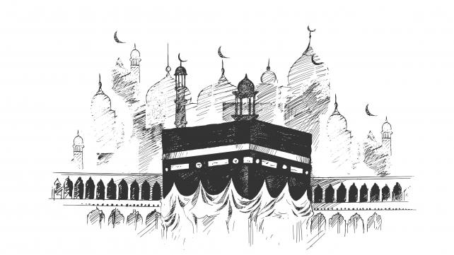
Samana Siddiqui
Even for those not performing the Hajj pilgrimage, the first ten days of the Islamic month of Dhul-Hijjah are considered very sacred. They are a time for increased reflection, seeking Allah's forgiveness, doing good, and various other forms of worship.
Prophet Muhammad, peace and blessings be upon him, has said about these days:
“There are no days in which righteous deeds are more beloved to Allah than these ten days." The people asked, "Not even Jihad for the sake of Allah?" He said, "Not even Jihad for the sake of Allah, except in the case of a man who went out to fight, giving himself and his wealth up for the cause, and came back with nothing.”
-(Bukhari).
So sacred are the first ten days of Dhul Hijjah that Allah swears an oath by them when He says in the Quran: "By the dawn; by the ten nights" (89:1-2). Swearing an oath by something indicates its importance and great benefit.

What kinds of worship should be performed?
Any good deed done for the sake of Allah according to the way He approves will be rewarded immensely during the first ten days, God willing. But some of the more specific actions mentioned in the traditions of the Prophet are fasting and verbal Dhikr (remembrance) of Allah.

Fasting
The Prophet said, "One fast during these days is equal to the fasting of one complete year, and the worship of one night during this period is equal to the worship in Lailatul-Qadr" (Tirmidhi).
It is particularly encouraged to fast on the ninth day of Dhul-Hijjah, known in Arabic as Yawm al-Arafa. The Prophet used to fast on this day (source: Hadith in al-Nisai and Abu Dawud). Fasting on this day will expiate a Muslim's sins for two years.

Dhikr
Dhikr, or the verbal remembrance of Allah, is another meritorious act during these first ten days of Dhul Hijjah. The Prophet encouraged Muslims to recite a lot of Tasbeeh (saying "Subhan Allah", which means Glory be to God), Tahmeed (saying “Alhamdu lillah” which means Praise be to God) and Takbeer (saying "Allahu akbar" which means God is Greater or God is the Greatest) during this time.
The Takbeer may include the words "Allahu akbar, Allahu akbar, la ilaha ill-Allah; waAllahu akbar wa Lillahi’l-hamd (translation: Allah is Most Great, Allah is Most Great, there is no god but Allah; Allah is Most Great and to Allah be praise)," as well as other phrases.
Ibn Umar and Abu Hurayrah, two of the Prophet's Companions, used to go out in the marketplace during the first ten days of Dhul-Hijjah, reciting Takbeer, and the people would recite Takbeer individually when they heard them.

Other good deeds
Generally, all good deeds are rewarded highly at this blessed time. These actions include praying, reading the Quran, making Dua (supplication), giving in charity, and being good to our families.
In addition, seeking Allah's forgiveness at this time is also encouraged. This means more than just a verbal expression of sorrow for past misdeeds. It also requires a firm resolution to avoid making the same mistakes in the future by giving up bad habits and behavior while sincerely turning to Allah.

24 ideas for simple pre-Eid-ul-Adha planning

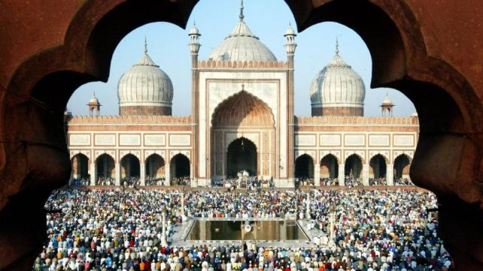
Abdul Malik Mujahid
While time is running out as the month of zil hajj is almost upon us, you can still come up with a plan for Eid-ul-Adha and prepare for it beforehand. Here are some ideas.

1. Talk it out with everyone
Make a specific Eid plan TODAY. Sit with the family and discuss what you will do on Eid day. Plan things step by step. Where will you go to do Eid prayers, where will you go afterwards or will you first go to the local farm to sacrifice an animal (see point number 3)? Get everyone involved and listen to all suggestions.

2. Dress for success
In most Muslim countries Eid is a time for buying new clothing. Spring is almost here, it's time to get rid of the heavy winter clothing and exchange it for lighter apparel. Make it a point to shop for Eid clothes and some new items as well.

3. Talk about Zabiha and arrange to do it
Eid-ul-Adha is a time to go on farm to sacrifice an animal for the sake of Allah, distribute its meat and to talk about Prophet Ibrahim (peace be upon him)'s sacrifice. Remember to stress that it was Ismail (Ishmael) who was the son meant to be sacrificed, not Ishaq (Isaac) as Bible says.
Arrange to go to a farm and sacrifice an animal.

4. Remember Hajj
Talk about Hajj during a family story night. Recount the memories of your experience or that of other family members. Also, discuss as a family when you want to go for Hajj or Umra. Be concrete. Don't say someday. Make a formal target.

5. Tell the story of Hajira and Hajj
On Hajj day talk about why millions of Muslims run between Safa and Marwa.

6. Have a Hajj competition
Have an open book competition in your home about Hajj and Prophet Ibrahim with prizes for all participants.

7. Make arrangements to meet someone really important
Take your children to see receive a person who has completed their Hajj (often called a "Hajji") when s/he comes back. Call relatives or friends of the Hajji-to-be now to find out when they are coming back, at which airport, time, etc.

8. "Allahu Akbar, Allahu Akbar...."
Involve the kids, especially the younger ones, in loud Takbirat while going and returning from the Eid Prayer.

9. Watch Adam learn out about Hajj
For children ages 2 to 8 "Take Me to the Kaba" is an excellent video choice on or before Eid. Many public schools show this fourth episode of Adam's World in their schools.

10. Check out the Hajj experience in multimedia format
For ages 8 and up, software like the Hajj & Umra CD-Rom might provide some new information. It also includes a game.
As well, for a personal experience of Hajj on video, check out Muslim American Michael Wolfe's Hajj experience.

11. Cool gift ideas
Give out a gift of any of the above items if you don't already own them.

12. For the family's study circle
For the collective family study circle verses from the Quran about Hajj and Prophet Ibrahim.

13. Talk about Prophet Ibrahim during story time
For your children's bedtime story, tell them about Prophet Ibrahim. Also please check out our set of story books for kids on the Prophets, which includes the story of Prophet Ibrahim.

14. Share Eid with the family and neighbors
Have two Eid dinners: one for the family on Eid day and one with neighbors. Or maybe you just want to share some dishes on Eid with your neighbors.

15. Take the car out for a...
Family trip to some place of enjoyment. Sing Eid songs in the car on the way, eat and stop in between for prayers. Make this the family's first long drive after winter.

16. Make your Eid one with real entertainment
Please avoid TV or movies on Eid break. Eid is family and fun time, and you don't necessarily need films or television to have a good time. Check out our unTV guide for some interesting information on television, in specific.

17. Decorate the home for Eid
There's nothing wrong with decorating the home for Eid. It'll help liven up the atmosphere. Use balloons, banners, streamers, lights, and more.

18. Get everyone involved in a school presentation on aspects of Hajj
The whole family can get involved in preparing a school presentation about the Hajj, Prophet Ibrahim, the Kaba, or Eid.
You would be surprised at how many Muslims don't know how central Prophet Ibrahim is to Islam.

19. Give gifts generously-give an Eidee
In some parts of the Muslim world a small amount of money is given to children as Eidee. You can do that or give a small present. Please avoid the commercialism (and please check out one perspective on why Eid gifts are better than Eidees)

20. Encourage the kids to make handmade gifts
Why not help children make gifts for one another? Not only is this inexpensive, handmade gifts tend to come from the heart, more than the wallet.

21. Start a family project
Why not mark Eid-ul-Adha with a new family project? For example, start of a family library. Discuss the issue practically: how many books, which kinds, budget, where will the library be set up in the home, etc.

22. Share with needy kids
During Eid-ul-Adha, children in need must be remembered by sharing something with them. Encourage a family donation from each member for needy children in a specific part of the world.

23. Discuss the Eid day menu
If you are the family member responsible for preparing the food on Eid day, consult other members of the family. Consultation may help you involve them in preparation and cleanup as well.

24. Hug your brother, hug your sister
At the place where Eid prayer is held, a lot of hugging goes. You will find some Muslims standing alone. They are either new Muslims or new immigrants without relatives and friends. Do hug them and greet them. If possible invite them to your home for a meal. Also inform them of any planned Eid celebrations at any community center.
Have a great Eid everyone. May Allah bless you with more and the best of this world and the real best in the everlasting life.

What to Do on the Arafah Day for non-Hajjis
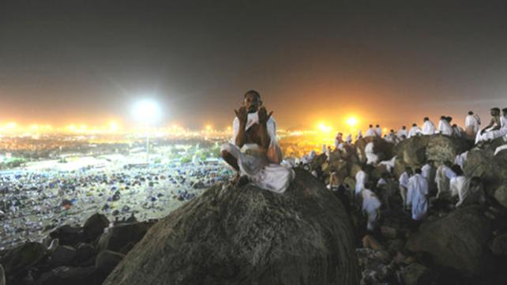
Ammarah Usmani
For a practicing Muslim, nothing seems more spiritually fulfilling in this month than traversing the streets of Madina, following the footsteps of the Prophet, peace and blessings of Allah be upon him, reliving the story of Prophet Ibrahim, and holding on to the cloth of the Kaba and weeping for Allah to forgive all sins, all while joined by millions of other Muslims.
The Arafah day, the 9th day of Zil Hajj, is crucial to the completion of Hajj. So much so that the Prophet said, “Hajj is Arafah” (Tirmidhi). Without completing this step, Hajj is not valid. It is on this vast plain that all of mankind will be gathered on the Day of Judgement.
The Prophet also explained the significance of the first ten days of Dhul-Hijjah.
“There are no days in which righteous deeds are more beloved to Allah than these ten days.” The people asked, “Not even Jihad for the sake of Allah?” He said, “Not even Jihad for the sake of Allah, except in the case of a man who went out, giving himself and his wealth up for the cause (of Allah), and came back with nothing” (Bukhari).
But for those of us for whom Allah hasn’t planned Hajj this year, how can we reap the benefits of this blessed month, these blessed ten days, and most importantly, the Arafah day?

1. Fast
Growing up, most of us probably witnessed our elders fasting during the first nine days of Dhul-Hijjah, and especially on the Arafah day. According to a Hadith, one who fasts sincerely on the day of Arafah will receive forgiveness of his/her sins for the previous and following year.
Avoiding food, drink, useless activities, and focusing on your relationship with your Rabb, for at least one day, seems like an extremely good bargain in return for two years of forgiveness.
But one crucial aspect to keep in mind is to not ritualize any act of worship, as is common in many cultures. This applies to any sincere act we do in this life, but especially for fasting on this day, make sure that you keep your full intention to please Allah, and educate yourself of the significance of this action, and not just to continue any ongoing tradition.

2. Make Dhikr (remembrance of Allah)
On this blessed day, any act of worship you do will result in more good deeds, so step up your remembrance of Allah, which you can do at any time of the day, during virtually any activity.
Repeat the specific Dhikr prescribed in the Sunnah. An especially blessed phrase is, “SubhanAllahi wa bihamdihi, SubhanAllahil Adheem” (Glory be to Allah and all praise is due to Him).
Prophet Muhammad, peace and blessings be upon him, said: “Two words (subhanAllah wa bihamdihi) are light on the tongue, weigh heavily in the balance, and are loved by the Most Merciful One.”

3. Recite/study/listen to the Quran
Not one day should go by that we forget about the Quran, and especially on this day, we should at least make an effort to open the book and drink up some wisdom.
If every good deed is multiplied, then just imagine how many good deeds you’re getting by just making an intention to listen to the words of your Rabb?
You can even listen to lectures of Tafseer. There are countless videos on YouTube, even small, two-minute videos, that you can benefit from.

4. Be a people person
You don’t need to embark on a humanitarian mission. Just visit your neighbor and ask how they’re doing. Bake a pie for them. Or better yet, invite them over for Iftar. Just don’t overdo the dishes, or else you’ll lose the spirit of the day. Just serve what you would eat on an average day.
If you have the energy while fasting, check out local volunteer opportunities that aren’t physically draining.
Don’t forget those at home. Spend time with your family. Have productive discussions, share something new that you learned, teach the youngsters, and just listen to what they have to say.
If you haven’t called a specific relative in many days, make a short, five-minute call. Don’t make it long and end up wasting your time and theirs. Keep it sweet and simple, ask how they’re doing, and share something beneficial.
The possibilities are quite endless. Be creative and just keep the intention of pleasing Allah in your mind.

5. Get in touch with nature
What better time to enjoy the creations of Allah than this season of colors? Step outside and witness the fall foliage. Worship is not limited to sitting inside and praying all day. Soak in the beauty all around you and glorify Allah.
And please, keep that phone in your pocket. Pictures accumulate in our devices, and we rarely even look at them again. Immerse yourself in the experience directly with your eyes, not through the camera lens.
These are all suggestions, and you may think of countless more ways to make this day more productive. Just don’t allow yourself to regret that you wasted time and missed out on two years of forgiveness, thousands of good deeds, and not to mention a rejuvenation of the body and soul.
And as with everything else, make this day meaningful.

Hajj Dua: that every Hajji should strive to make
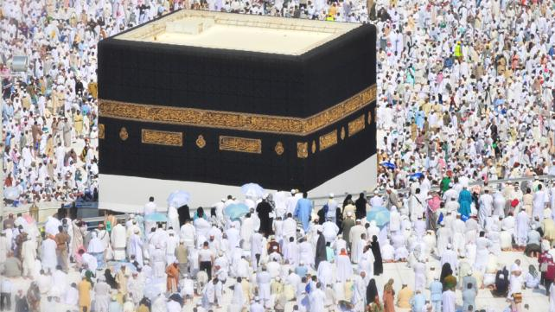
Samana Siddiqui
Hajj Dua is essentials for those making the Hajj pilgrimage, these are the last weeks of preparation before heading Zil hajj starts and hajjis are off to the journey of a lifetime. Amid the scramble to confirm travel and visa requirements, pack necessities, and tie up business at home to ensure full focus during Hajj, will be requests from family and friends for Dua.
Many pilgrims keep a written list handy throughout Hajj, dutifully offering their own supplications and those of loved ones. Others may save them on their cellphones.
Regardless of the method chosen, Hajj is an excellent opportunity for Hajj Dua , a time when we are visitors to God’s house, when we are not distracted by our day to day lives, and are more focused on worship, the very purpose of our pilgrimage.
Below are a few suggested Duas we can make during the journey of a lifetime.
- (Upon seeing the Kaba) Oh Allah, please accept all the Duas I make during Hajj and for the rest of my life.
- Ya Allah, I have committed countless sins, both big and small, many of which I may not even realize. Please forgive me for all of them and make me sensitive to my sins.
- Oh God, make me a just person who does not violate the rights of others. I know that You can forgive me for the wrong I have committed, but others may not. Please help me be just and seek forgiveness from others.
- Oh Allah, help me overcome my bad habits that keep me far from You, and help me develop habits that will bring me closer to You.
- My Lord, cure me of insincerity in my words and actions. Make every good deed I do be purely for Your sake and no one else’s.
- Oh God, thank You for every blessing I have - my faith, my health, my family, my job, my friends, my home, my nieghbors. Please continue to bless me in this life and please bless me with closeness to You in Paradise in the Hereafter.
- Ya Allah, open my heart towards my neighbor and open the hearts of neighbors towards us.
- Oh God, help me become better neighbor, better citizen and better Muslim.
- Dear Lord, help the people who are struggling for freedom, liberty and justice.
- Ya Allah, this life keeps me so busy and I sometimes feel distant from You. Make it easy for me to seek ways of nearness to You when I come back from Hajj in my daily life, and make me a Hereafter-oriented person.
- My Creator, make me a source of good in this world, a person who benefits others and is of service to them so that You will be pleased with me when I face You on the Day of Judgment.
- Oh God, strengthen my faith and make me a strong believer in all circumstances.
- Ya Allah, let me come back from Hajj changed for the better for the rest of my life.
The above 13 points sum up the Hajj Dua.

FAQs about Hajj: Basic Fiqh
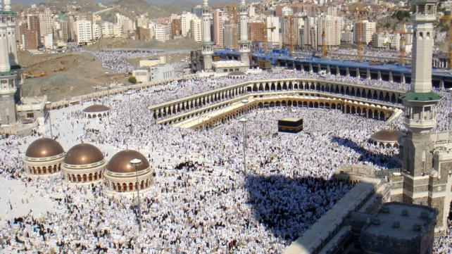
Hajj is the fifth pillar of Islam, and is required of every Muslim who is both physically and financially able to complete it. But there are many questions regarding the pilgrimage, some of which we hope to answer here:

Q: What is Hajj? What is its significance?
A: Hajj is a religious duty for Muslims, one that must be performed at least once in the life of every Muslim who is able to complete it. A reflection of the solidarity and unity of the Muslim Ummah, Hajj is the largest, most impressive spiritual pilgrimage in history.
When one performs Hajj—assuming they do so correctly—the Prophet said they will return from Hajj without sin and purified.
It has been narrated from Aba Abdillah (peace be upon him) that, "Hajj is of two types: Hajj for the sake of Allah and Hajj for the sake of people. A person who performs Hajj for Allah, surely his reward will be with Allah - Paradise; and a person who performs Hajj for people, surely his reward will be with people (to give him) on the Day of Resurrection."

Q: Do all Muslims have to perform Hajj?
A: Yes. However, there are certain factors to take into consideration.
First, only Muslim adults (whether male or female) are required to perform Hajj. This means that, while children may go to Hajj, it is not required of them. Maturity and an ability to understand the magnitude of the pilgrimage are needed to fully take advantage of the experience. A sound mind and full control of one’s mental capacities are required to perform Hajj.
Second, the Muslim has to be physically able to undergo the amount of travel and have the strength to perform the pilgrimage. Very weak, sick, elderly, or otherwise physically incapable Muslims are exempt from having to perform the pilgrimage.
Third, the Muslim must be financially able to perform Hajj. The expenses for the pilgrimage are not little, so every Muslim that goes must be free of debt and able to bear the costs.

Q: What is the significance of the first 10 Days of the month Hajj (called Dhul Hijjah)?
A: The Messenger of Allah said that the first 10 days of Zil Hajj are a special time of devotion and worship. This is when most of the Hajj pilgrimage rituals are performed. The first 10 days are also when the significant Day of Arafat (on the 9th day) occurs. The 10th day of Hajj marks the Eid Al-Adha holiday, the more significant of the two Islamic holidays.

Q: How much preparation is needed before I go on my Hajj trip?
A: As much as possible! Most people spend at least a month before any normal trip just preparing, shopping, planning, etc. But this isn’t your average trip to Disneyworld; Hajj is the most important trip you will ever go on throughout your life. Extensive planning is highly recommended. We suggest two to three months before your flight date, at least.
There is both religious and practical preparation required. For Hajj, there is obviously more to it than just grabbing a Hajj handbook (https://www.soundvision.com/book/a-handbook-of-umra-hajj), booking a flight, and going.
Hajj is the journey of a lifetime, so make sure you’re going with the right intention: to please Allah and nobody else. Study the Fiqh of Hajj before going (there are often classes or workshops offered at the local Masjid). Get books, DVDs, audio CDs, whatever it takes.
You should also take care to follow all of the policies and procedures implemented by the government of Saudi Arabia, like how to get a Hajj visa, joining a Hajj group, transportation, housing, etc.
Don’t forget to discuss with your boss about vacation time. Hajj will require about three to four weeks off. Talk to your employer(s) or anyone else who needs to know you’ll be out of town for a month.
Read our “8 Tips On Preparing For Hajj Now” page for more details.

Q: What do Muslims at Hajj wear?
A: Men wear the Ihram, two unstitched white cloths. Women can wear whatever they usually wear in prayer, so long as it is Islamically appropriate. Many choose to wear a simple jilbab.
Read about the obligations and prohibitions of Ihram.

Q: What are the Hajj rituals?
A: There are too many to get into detail here. Read the rituals of Hajj and Umrah here:

Q: Is Hajj very physically taxing? How much physical preparation is needed?
A: Hajj requires a lot of walking. Expect three million people and easily more to also be there. As such, you should make sure you’re strong enough to handle yourself in that type of crowd. (Many people build up their stamina by establishing an exercise routine in the weeks and even months leading up to Hajj.) To be at optimum health, you may also want to consult your doctor about any shots or broad-spectrum antibiotics he or she recommends you take before your trip.

Women & Hajj

Q: Can a woman in Ihram wear socks or jewelry during Hajj?
A: It is permissible.

Q: Can a woman cover her face in Hajj?
A: It is agreed by scholars that a woman should not cover her face (or wear gloves for that matter) during Hajj. The Prophet said, “The Muhrimah (a woman in Ihram) should not cover her face, nor should she wear gloves.” If a woman is in need of covering her face (i.e. if she fears the gaze of non-Mahram men on her) then it is permissible for her to cover her face.

Q: Does a woman need a Mahram to travel to Hajj?
A: There are different rulings from the four Madhhabs (schools of Islamic thought) regarding women traveling to Hajj with or without a Mahram.
- Shafi Maddhab: Hajj is not obligatory upon a woman until she finds a male Mahram relative or husband, or group of trusted women with whom she can perform the journey securely. If she finds any of the three, Hajj is obligatory on her. However, it is permissible for her to travel alone to Hajj if she shall be safe and fears nothing on the road (referencing a Hadith from the Prophet).
- Maliki Madhhab: Similar to the Shafii Maddhab. The Madhhab’s opinion is that a woman who cannot find a Mahram or husband to travel with can make the journey with a secure group, whether the group is a group of men, women, or a mix of both men and women.
- Hanbali Madhhab: If a woman cannot find a husband or male relative to travel with, she cannot go to Hajj and it is not obligatory on her.
- Hanafi Madhhab: Similar to the Hanbali Madhhab.

Q: Anything else I should know about Hajj?
A: We recommend you be familiar with all of the Hajj terminology and places. See our complete list here: (http://www.soundvision.com/hajj)

