CAIR to Release Full Results of Post-Debate Muslim Voter Survey | CAIR Condemns Racist Threat to NC Mexican-American Family | CAIR-DFW Welcomes Firing of Officer for Racist Posts

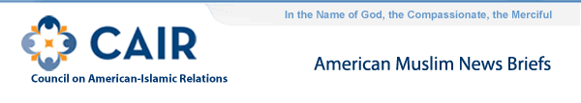
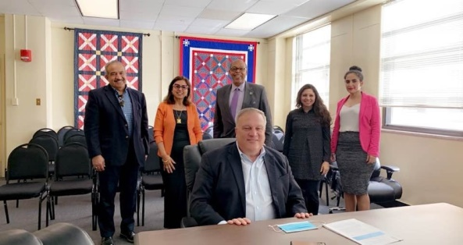
- When one of his wives was ill, the Prophet Muhammad (pbuh) would say, "O God, the Lord of the people! Remove the trouble and heal the patient, for You are the Healer. No healing is of any avail but Yours; healing that will leave behind no ailment." Sahih Al-Bukhari
- PHOTO: CAIR-KY was recently invited to meet with Kentucky Senate President Robert Stivers. Representing CAIR-KY were CAIR-KY Board members: Dr. Salah Shakir, Dr. Nadia Rasheed, Dr. Dina Rasheed and Noora Shalash (CAIR-KY Dir. Gov. Affairs). Senator Reginald Thomas also attended the meeting.
This meeting was an opportunity for President Stivers to get to know CAIR-KY members and to hear their issues of concern. Some topics discussed included CAIR-KY's support for Beonna's Law and for police reforms in Kentucky.
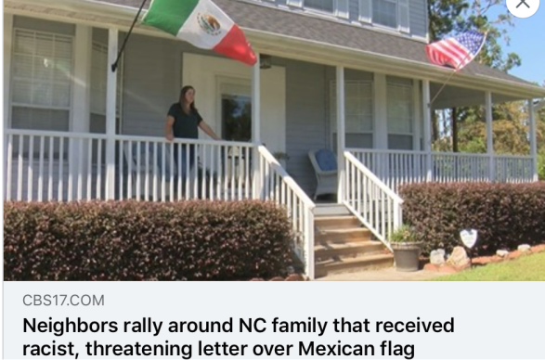
- CAIR Condemns Racist Threat Sent to Mexican-American Family in North Carolina
In a statement, CAIR National Communications Coordinator Ayan Ajeen said:
"As Americans with multiple identities, we should not have to choose between our different backgrounds to be accepted in our society. We are happy to see the neighborhood standing in solidarity with the family and against racism, xenophobia white supremacy."
- CAIR-DFW Welcomes Termination of Police Officer for Racist Facebook Posts
  - CAIR-SFBA Today Welcomed a Court Decision to Halt USCIS Fee Increases
  - CAIR: Faith Groups Decry Trump's Plans for Record Low Refugee Cap (AP)
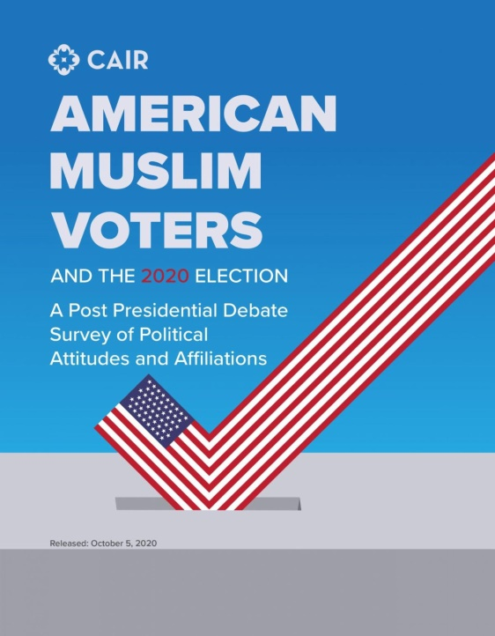
- LIVESTREAM: CAIR to Release Full Results of Post-Debate Muslim Voter Election Survey
On Monday, October 5 at 10 a.m. (ET), the Council on American Islamic Relations (CAIR), the nation's largest Muslim civil rights and advocacy organization, will hold an online news conference to release the full results of its post-presidential debate election survey of Muslim voters.
CAIR'S Poll asked 846 Muslim voters about their preferences for presidential candidates, political parties, and positions on a wide range of social and policy issues.
CAIR's September 30 survey of registered Muslim voters found that 59 percent of Muslim voters believe that Joe Biden won the first presidential debate, while 14 percent think that Donald Trump won. Due to the first presidential debate being so chaotic, 21 percent of Muslim voters were left unsure who won the debate.
Join CAIR on its Facebook and YouTube pages to hear from CAIR staff interpret the full results of CAIR's pre-election survey of Muslim voters.
Watch the Livestream on Facebook: https://www.facebook.com/CAIRNational/live/
YouTube: https://www.youtube.com/CAIRtv
[NOTE: Media may request an advance embargoed copy of the survey or submit questions to be answered live on Monday to: aajeen@cair.com, rmccaw@cair.com]
SURVEY RESULTS WILL ANSWER:
* Likelihood of registered Muslim voter turnout on November 3
* Which national political party do Muslim voters primarily vote for
* Which presidential candidate Muslim voters support
* Where Muslim voters lean on social and fiscal issues
* Muslim voter perception of Democratic and Republican party commitment to ensuring religious freedom, addressing racial inequality, providing accessible healthcare, treating immigrants fairly
* How many Muslim voters think the Democratic and Republican parties are friendly toward Muslims
* Whether Muslim voters think Islamophobia has risen in the past four years under President Trump

