Justice For All Statement On Police Killings Of George Floyd
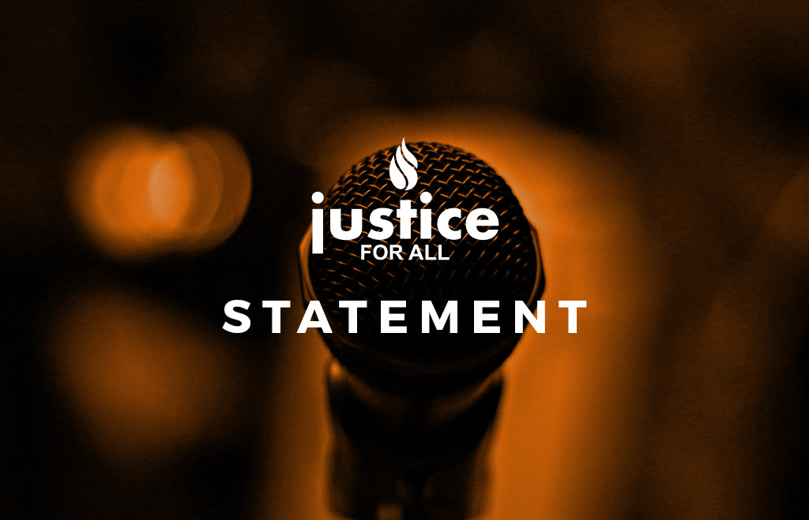
- May 27, 2020

- Staff Writer

- Black Lives Matter, Statements
Justice For All stands with the Black community in rage against the cruel and unjust killing of George Floyd by police officers in Minnesota. As we struggle to bring light to injustice around the globe, we must stand against the dark use of state power in our country, the United States of America.
The ongoing cases of police brutality and killings, where every case should matter and not just those that get media coverage, need policy and systematic changes. The recent killings of Breonna Taylor, while she slept in her home, is another egregious example of policing gone atrociously wrong.
Police killed 1,099 people in 2019. Black people were 24% of those killed despite being only 13% of the population. According to Mapping Police Violence, 99 percent of killings from 2013-2019 have not resulted in officers being charged with a crime.
There are solutions that work in countries across the world. Police use of force policies currently lack basic projections against police violence. Until alternative such as community policing options can be viably implemented we urge police departments to use the model use of force policy developed by Campaign Zero and Use of Force Project. The policy includes evidence-informed restrictions on police use of force that are designed to significantly reduce police violence in communities. It should be adopted by police chiefs and local elected officials without delay.
Black residents of the United States should not have to fear for their lives while running, driving, or sleeping in their homes

Content:
- Speak up for Black Lives, against racism
- Ask President Trump to sign Uyghur Human Rights Policy Act
- Thank your Congressperson for their vote
Asalamu alaykum
Once again a black man is murdered in broad daylight by police and once again the killers, recorded on video, are not arrested. Can you please speak up today?
Justice For All Condemns the Murder of George Floyd And Asks for A Full Investigation and Charges Against The Arresting Officers and Calls For Police Use of Force Reform
Police in the USA killed 1,099 people in 2019. Black people were 24% of those killed despite being only 13% of the population. According to Mapping Police Violence, 99 percent of killings from 2013-2019 have not resulted in officers being charged with a crime.
There are solutions that work in countries across the world. Police use of force policies currently lack basic projections against police violence. Until alternatives such as community policing options can be viably implemented, we urge police departments to use the model use of force policy developed by Campaign Zero and Use of Force Project. The policy includes evidence-informed restrictions on police use of force that are designed to significantly reduce police violence in communities. It should be adopted by police chiefs and local elected officials without delay.
Black residents of the United States should not have to fear for their lives while running, driving, or sleeping in their homes.
ACTION ALERT: We ask our supporters to call the Hennepin County Attorney Mike Freeman and demand that the police responsible be arrested and charged with murder.
Hennepin County Government Center
Phone: 612-348-5550, (612) 348-5561
or call the main line at 612-348-3000, 8 a.m. to 8 p.m., 7 day
House Following Senate Passed the Uyghur Bill
Congratulations!
The Save Uighur campaign welcomes the passage in the House of the Uyghur Human Rights Policy Act of 2020 by unanimous consent. The Senate passed the bill with unanimous consensus on May 14. The bill will now go to the desk of President Donald Trump to sign into law. The Uyghur Human Rights Policy Act of 2020 includes legislation that aims to sanction Chinese government officials for their crimes against humanity and creates a mandate for reports on human rights abuses in East Turkestan.
This is a result of the advocacy by people who brought their concerns to the table Kudos to every Uyghur who advocated for their cause despite real threats to their families.
We thank everyone who made calls to their representatives and senators. This is a win for the entire Uyghur, Muslim and the peace and justice community.
Here is the full text of Justice For All Statement.
ACTION ALERT:
Call or Write to President Trump to sign the bill into law-
Comments Line: 202-456-1111
https://www.whitehouse.gov/contact/
***

CAIR Joins 400+ Groups Urging Congressional Action on Police Violence | CAIR-Kentucky Calls for Firing of Police Officers | CAIR Joins 70+ Groups in Opposing CVE
Inbox | x
 | CAIR via cairdc.ccsend.com | 3:17 PM (4 hours ago)
 | to me
Having trouble viewing this email? Click here

- "Verily, God will not change the condition of a people until they change that which is within themselves." The Holy Quran, 13:11
The Prophet Muhammad (PBUH) said: "Whoever sees an evil, let him change it with his hand; and if he is not able to do so, then [let him change it] with his tongue; and if he is not able to do so, then with his heart - and that is the weakest of faith." Sahih Muslim
- CAIR-Houston to Join Black Lives Matter 'Justice 4 George Floyd' March
  - CAIR Action Alert: Join the Call for Comprehensive Police Reforms in Baltimore
  - CAIR Joins 70+ Civil Rights Groups in Letter to DHS Opposing 'Countering Violent Extremism' (CVE) Program Based on Junk Science, Targeting Vulnerable Communities
"TVTP replicates the agency's Countering Violent Extremism (CVE) program—a failed, anti-Muslim counterterrorism initiative based on the debunked assumption that certain communities are predisposed toward violence based on their race or faith and allows privacy and civil liberty violations," said CAIR Director of Government Affairs Robert S. McCaw. "There is no credible evidence that these programs prevent terrorism or violence."
- Watch: CAIR's 'Daily Dose' Conversation Discusses 'Could LMPD Get Away with It Because No Body Cam Footage?'
Today's program discussed Monday's shooting death of African-American business owner David McAtee in Louisville, Ky., police body cameras, and what can be done about it.
- CAIR-Kentucky Calls for Firing of Police Officers Involved in the Shooting Death of David McAtee
In a statement, Waheedah Muhammad, chair of CAIR-Kentucky said:
"We are horrified that while Kentucky citizens, along with the entire nation and world, are reeling from the horrific video of the police killing of George Floyd in Minnesota, and while the Black community of Louisville is also hurting and protesting the shooting death of Breonna Taylor - who also died at the hands of Louisville police - that we have yet another unarmed member of the African-American community die at the hands of police. The firing of Chief Conrad cannot be a cover. All officers involved in this incident should be fired."
- CAIR Joins Leadership Conference, 400+ Groups in Letter to Congress Urging Congressional Action on Police Violence
The letter states in part:
"Now is the time for Congress to pass meaningful police reform legislation. While we appreciate hearings and resolutions, we need comprehensive measures to happen. We need Congress to truly step up to the plate and protect Black communities from the systemic perils of over policing, police brutality, misconduct, and harassment, and end the impunity in which officers operate in taking the lives of Black people. It is your moral and ethical duty to ensure Black people and communities are free from the harm and threats from law enforcement and to curtail state sanctioned police violence and mili
- tarized police responses."

A protestor's guide
Friend –
This week, protests are continuing across the country in response to the tragic death of George Floyd at the hands of Minneapolis police – and as further killings by law enforcement occur, including the murders of David McAtee this very morning and Tony McDade last week.
Activists like you are taking to the streets to express their pain, their outrage, and their demands for racial justice and an end to police violence against Black people. As this happens, we want you to have what you'll need to know your risks and know your rights.
Emerson Sykes, staff attorney for the ACLU's Speech, Privacy, & Technology Project, shared these essentials in a video direct from the New York City protests over the weekend.
Please, share this video on Twitter, Instagram, or Facebook for anyone in your circle who may need it in the coming days – and educate yourself on its crucial message below.
SHARE ON TWITTER

SHARE ON INSTAGRAM

SHARE ON FACEBOOK

As you come out to protest, here's what our video notes to keep in mind:
- The right to protest is a fundamental human right guaranteed by the U.S. Constitution and the First Amendment.
- If you get stopped, ask if you are free to go. If the police say yes, calmly walk away.
- You have the right to record. The right to protest includes the right to record, including recording police doing their jobs.
- The police can order people to stop interfering with legitimate police operations, but video recording from a safe distance is not interfering.
- If you get stopped, police cannot take or confiscate any videos or photos without a warrant.
- If you are videotaping, keep in mind in some states, the audio is treated differently than the images. But images and video images are always fully protected by the First Amendment.
- The police's main job in a protest is to protect your right to protest and to de-escalate any threat of violence.
- If you get arrested, don't say anything. Ask for a lawyer immediately. Do not sign anything and do not agree to anything without an attorney present.
- If you get arrested, demand your right to a local phone call. If you call a lawyer for legal advice, law enforcement is not allowed to listen.
- Police cannot delete data from your device under any circumstances.
Friend, we understand that even with the legal protections laid out above, protesting has real risks – especially for Black and Brown people. We're also still in the midst of a global pandemic and know that your health and the health of others may take priority.
Whether you choose to physically protest this week or not, you can still ensure others are as informed and prepared as possible by sharing our video on Twitter, Instagram, or Facebook.
And no matter what – remember your rights and stay safe.
Thank you,The ACLU Team
P.S. Over this past weekend alone, we've seen a number of potentially unlawful actions on the part of law enforcement and other government entities during these protests – targeting journalists and endangering all of our free speech rights. Make no mistake: The ACLU will not allow these attacks on reporters to go unanswered. We'll be keeping you updated in our efforts moving forward – and in the meantime, thank you for staying informed.

