بسم الله والحمد لله والصلاة والسلام على رسول الله
Assalamu alaikum WaRahmatuLlaah WaBarakatuh,

Ramadan is a days away, and now is the perfect time to start training for it. This ensures that we will be able to see maximum results.

Worldwide, over 90 percent of Muslims say they fast in Ramadan. This is based on a 2013 Pew Research Center survey of over 38,000 Muslims in 39 countries.

The Companions of Prophet Muhammad used to start preparing for Ramadan six months in advance, God’s peace and blessings be upon the Prophet. They wanted to have a high level of Iman, a cleaner heart, and a determined mindset during the entire month.

We can do a lot in one month if we plan for it. The articles below can help you attain your best Ramadan ever insha Allah.

Another way to train for Ramadan is to start implementing the Prophetic Sunnahs. The Prophet used to fast Mondays and Thursdays. We can implement this Sunnah now, as it will enable us to get ready for Ramadan.

With all the anticipation and hype around the arrival of Ramadan, this year in particular, comes the responsibility to think and plan for this month wisely.
Given the plummeting public opinion about Islam and Muslims both in the US and Canada, and record number of Muslims reporting Islamophobia and discrimination, it’s high time for North American Muslims to strengthen their relationship with Allah, with their families and with their neighbors of other faiths.
Let us share the beauty of Ramadan with our friends, colleagues and neighbors. What’s there to hide?
Let’s impact public opinion about Muslims one person at a time!

ThinkingPoints
- Fasting helps us focus and reflect. How can you plan strategically for your life, your spirituality, your family, your career, and your relationship with the communnity?
- With rough and turbulent environment comes the urgency to turn to and reconnect with Allah. How will your communication with Allah be different this Ramadan? How often will you make a heart-felt Dua?
- If you are feeling confused or overwhelmed at times, why not turn to the Manual of Life, the Quran? How will you bring Quran recitation and reflection in your daily life?
- Ramadan is truly a family time. How can you take advantage of Ramadan’s schedule and culture to bring your family members together at Suhoor, Iftar and Taraweeh every day? How can you strengthen your relationship with your parents, siblings, spouse, or children?
- Ramadan is a prime time for giving and generosity! Can we ensure to divide our Sadaqat and Zakat equally into the following five causes: relief, local Masjid / Islamic centre, social services, youth development, and civic engaement?
- Islamophobia will continue to rise, unfortunately. One sure way to counter negative public opinion about Islam is through friendship and positive engagement. How will you connect with your neighbors, co-workers, and policy makers at a human level this Ramadan?
- Despite anti-Muslim bias found in media, many journalists are looking for genuine Muslim stories, How can you showcase the beauty of diversity, unity, cuisine, and culture to the wider public? How can you humanize Islam and Muslims in a world that thrives on dehumanizing and demonizing minorities?
- As you fast and feast this month, how can you remember those who struggle to find a decent meal every day? How can you enhance your love for the poor and needy?
- This is a federal election year. How can Ramadan be used strategically to galvanize the Muslim community to vote and volunteer for campaigns? How can you promote civic engagement in your community in this action-packed month?

ActionPoints
- Plan for Ramadan early with your family!
  - Ramadan 2016: 10 things Muslim families can plan
  - 5 things to do Shura about for Ramadan
  - 10 great goals to set for this Ramadan
- Busy mothers, make sure to organize yourself better for a more fun and productive Ramadan with children.
  - 23 tips to help moms organize for Ramadan
  - Seven strategies to train kids this Ramadan
  - 15 ways to make Ramadan special for your kids this year
  - 8 ways to handle a summer Ramadan with kids
- Make it a priotity to connect with neighbors of other faiths this Ramadan.
  - A Ramadan Priority: Connecting with Neighbors
  - 8 tips on sharing Ramadan with your neighbors
- Don’t forget to remind and engage young Muslims this year.
  - 7 ways to connect young Muslims to spirituality and community this Ramadan
  - Ways to remind young Muslims about Ramadan
  - 5 Ramadan party ideas for youth
- Identify 2 bad habits to give up throiugh this spiritual bootcamp.
  - Breaking the habit this Ramadan
  - 10 tips to help you keep those Ramadan habits
- Make conscious effort to eat simply and healthy!
  - Your body and your neighbor in Ramadan
  - Eating dollar a day meals this Ramadan
  - 7 tips for a healthier Ramadan
  - A simpler, healthier and greener Ramadan
- Find creative ways to share Ramadan with your fellow students and colleagues at work.
  - 10 ways to show your Ramadan this year
  - 10 ideas for Ramadan at your workplace
  - 8 Ramadan ideas for your campus
- Organize Iftars to mobilize your community to vote and to be engaged in the civic process.
- Make this Ramadan “Newsworthy”! Engage media to share the human and cultural side of Islam and Ramadan.
  - Ramadan & Media Relations: How To Create Positive “Newsworthy” Stories
Dear brothers and sisters, this Ramadan is a very critical and precious time. Please take out a couple of hours this week to sit with your family to think, plan, and strategize for the sake of your spirituality, your family, and your country, and the Ummah.
Peace
Sound Vision Team

Ramadan Ready? Thinking Points &amp; Action Points

Sound Vision Staff Writer

For your Prosper Preparation and Knowledge, these are set of Articles hope to help you prepare for the Blessed Month of Ramadan

No time like Ramadan time
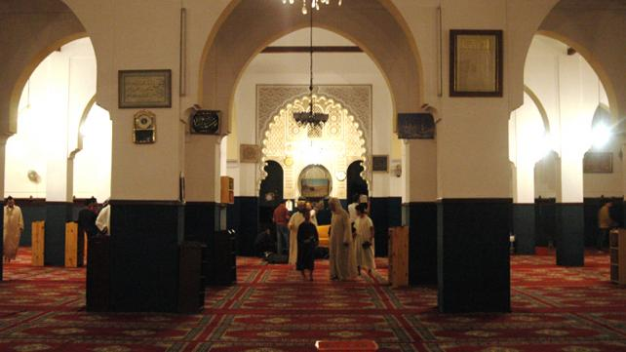
Khurram Murad

Golden hours on angel wings
Soon, once again, the blessed month of Ramadan will be with us; once again, like "golden hours on angel wings", will descend upon us its blessed moments. Like every other year since Hijrah, it will summon Muslims, as individuals and as a corporate body, to an intense and sustained life of Fasting and Prayer, of worship and obedience, of devotion and discipline — all centered on the Quran which, too, was sent down in these very moments in the custody of "noble and trustworthy" angels. Call will go forth to every believer to take to prolonged companionship with the Book of God. To a life of redoubled endeavor to become what God desires Muslims to be. Ramadan bids our hearts and minds, our society and polity, to come to.
Joyfully and dutifully the Muslims will respond. Every day will be spent in Fasting: from dawn to sunset, for one whole month, not a morsel of food, nor a drop of water, indeed nothing shall pass down the throat; nor will sex be indulged in. Each night. hours will be devoted to standing in Prayers before Allah, reciting and reading His words as sent down in the Quran. During the day, too, reading the holy text will be a cherished business.
Fasting, in one form or another, has always been an important and often necessary part of religious life, discipline and experience in every faith. As a means par excellence to come nearer to God, to discipline the self, to develop the strength to overcome the temptations of flesh, it needs no emphasis. Yet Islam turns Fasting, as it does every other act of worship and devotion, into something different and unique, the life-giving centre of life.
How does it impart new meaning and force to Fasting?
Put simply: by prescribing for it the time of Ramadan. This may sound like making things too simplistic, or trivializing the important. But Ramadan is no trivial event. For it is the month "in which was sent down the Quran: the Guidance for mankind, with manifest truths of guidance and the Criterion [by which to judge the true and the false" (Al-Baqarah 2:185). It was on a night in Ramadan that the last Divine message began to come down: "Read in the name of your Lord..." (Al-Alaq 96:1). That is why you must fast in Ramadan, says the Quran.
Ramadan therefore centers the entire discipline of Fasting on the Quran. The sole purpose is to prepare us for receiving the Divine guidance, for living the Quran, for witnessing the Truth and Justice that it perfects, for striving to make the word of God supreme.
How is this purpose achieved?
The fruit of Fasting ought to be that rich inner and moral quality which the Quran calls taqwa. "Ordained for you is Fasting . . . so that you might develop taqwa" (2:183). The most basic condition for being guided by the God, too, is taqwa. The significance is plain to see. Fasting, linked to Ramadan in which Allah's guidance came down, generates a taqwa which becomes directed on the supreme goal of entering the world of the Quran and of living therein, instead of being a spiritual ecstasy to be frittered away in the delights of soul. It becomes the key with which can be unlocked all the doors leading to the blessings which the Quran has to offer; honour, prosperity and freedom from fear and anxiety in this-world; success, Paradise and God's good pleasure in the life-to-come. No time for Fasting other than Ramadan could have made taqwa such a potent force.
More importantly, the fulfillment of being guided by the Quran comes about when we strive to discharge the mission it entrusts to us. For, having the Book of God — a weighty word — places on our shoulders a heavy responsibility: to hear is to make it heard, to know is to act, to have is to share, to say shahadah is to do shahadah. This means an unflinching pursuit to create a new self within us, and to create a new world of Quranic ideals outside us.
This is the sole purpose for which a new Ummah was created and charged with the mission of bringing man to God by witnessing to His guidance, "so that you be witnesses unto mankind, and the Messenger be witness unto you" (Al-Baqarah 2: 143). Otherwise, when the Quran came, the world was not devoid of godly men who fasted, and stood in prayers before God, and wept.
Discharging that mission requires immense inner and moral resources like knowledge of and devotion to the Quran, strong faith (Iman), resolve and steadfastness (sabr). For it is no light task. Few have a full and clear understanding of what it means. Let us pause here and reflect why, otherwise we shall never grasp what the Ramadan Fasting is for and what it achieves.
When in Ramadan the first ray of Divine revelation reached the Prophet, blessings and peace be on him, in Hira, its message of Iqra was impregnated with world-shaking forces; he, therefore. trembled. The second revelation made things clear: "arise and warn; make the greatness of your Lord the greatest" (Al-Muddaththir 74:2-3); he, then, took up his task with a single-minded dedication, and encountered stiff opposition. For, the call to "let God be the Greatest" (fakabbir) implied that all false claiments — and every claimant is false — to greatness, to unlimited power, authority and lordship over men and things, to obedience, loyalty and servitude from God's creatures be challenged, and dethroned.
This, it is not difficult to see, requires supreme sacrifices in "giving up" (Hijrah) everything one loves and fighting with all that one possesses for the sake of that love of Allah which must be greater than all else (Al-Baqarah 2:165). A life of Jihad therefore necessarily requires important qualities: knowledge of and devotion to the Quran, deep and strong faith (Iman), resolve and steadfastness (sabr), total trust (tawakkul) and, of course, taqwa. Read the Quran and you will find every promise of success here and in the Hereafter conditional upon these qualities.
Fasting, combined with the Quran recital in night-prayers, generates these rich resources which Ramadan harnesses to the fulfilment of the Quranic mission.
First, look at taqwa. What is it? Literally it means saving ourselves from harm. In moral life, therefore, taqwa must primarily mean. firstly, accepting that some actions and beliefs areharmful, that is to say, right and wrong do exist, and secondly, having the resolve and will to avoid the wrong and do the right. As a consequence, thirdly, his conduct should reflect this consciousness and resolve, if he is not a hypocrite.
To have the Quranic taqwa, which will entitle us to its guidance, we must know that there are realities and values beyond matter, beyond what we are incapable of perceiving by our physical senses, beyond this world, that man needs to be guided to what is right and what is wrong, (yu'minuna bil- ghayb). We should also be prepared to submit, willingly, all that we possess — mind, body, wealth — to the truth that we know and believe (yuqimunas salata wa mimma razaqnahum yunfiqun).
Every moment in Ramadan engraves these lessons on our hearts. Integrates them in our practice. The most elementary physical needs — food and water and sleep — are readily and joyfully sacrificed. Hunger and thirst are no more harmful; God's displeasure is. Physical pleasures no more hold any lure; God's rewards do. The scale of values is turned upside down. The measure of comfort and pain, success and failure is radically changed. Without this change, none is entitled to take up Allah's cause.
To the uninitiated, or an outsider, the devotional regimen of Ramadan may appear harsh and austere, but, in fact, it is eagerly awaited by believers. The sighting of new moon, the crescent that signals the beginning of Ramadan is met with celebrations and jubilation. Even children — who are not required to fast — look forward to their first experience of Ramadan fasting. The sick, too, remain restless for having been deprived of this blessing. Such jubilation and eagerness, to sacrifice time, wealth, and life in submitting to whatever God asks of us, and a regret and sorrow if prevented from doing so for reasons beyond our control, is highly desirable in the way of Allah.
These qualities spring from genuine faith in heart. For a Muslim the fast is primarily a commandment to his person, though its collective aspect is no less important. Little wonder, then, that individuals gladly take on the tribulations of Ramadan as an expression of their faith. Just as Fast is something special between man and his God which only He can reward, so should we take Jihad to be.
Whatever the physical discomfort, the mortification of flesh is certainly not a desired object in Islam. The gifts of God are there to be enjoyed, but the limits by Him must also be strictly observed — that is another lesson of taqwa in Ramadan. As the sun sets, the fast must be broken, and sooner the better. All that became forbidden at His command, becomes permissible, again at His command.
Similarly eating before dawn is strongly urged, even though the hour is unearthly. For it provides the necessary strength for the rigors of the day ahead. Fasting and praying are obvious acts of worship, but eating, drinking and sleeping, too, constitute forms of worship. So in the way of Allah: what matters is His command, the whole life must witness to Him.
The month-long regimen of dawn-to-sunset abstinence from food, drink and sex, for the sake of Allah alone, internalizes the lesson that one must never touch, acquire or enter that which does not belong to one under the law of God. A man can no more remain a slave to his own self-indulgence as he prepares for the arduous journey on the road to his Lord.
For many it is difficult to see the value of long hours of hunger, thirst and sleeplessness. Productivity losses are difficult to accept in an age that has tried to make gods of gross national product and economic growth. According to Islam, however, man is created to live a life of total submission to the One and Only God, and this purpose must be paramount in all scales of values. Ramadan fasting is crucial to this understanding. It shows that its purpose, like God's guidance through His Prophets and Books and all other rituals of worship, is to train the believer in how he must live totally and unreservedly, at all costs, in submission to God.
Obedience, let there be no misunderstanding. is not limited to mere outward conformity with the letter of law. The law must be observed, but evil, in all its forms, must be eschewed. lbn Maja the great Hadith scholar, reports that the Prophet said: When the month of Ramadan arrives, the gates of Paradise are flung open while those of Hell are closed. All the shayatin (satans) are put in chains and a herald cries out. 'O you who seek good come here and those who desire evil desist'.
Imam Bukhari, the most renowned Hadith scholar narrates: Eyes should refrain from seeing evil, ears from hearing evil, heart from reflecting evil, tongue from speaking evil. The Prophet said: "One who does not give up speaking false words and acting by them is not required by God that he give up only his food and drink." On another occasion he said: "Many are the observers of fast who gain nothing from their fast but hunger and thirst" (Darimi).
As a collective experience Ramadan suffuses the entire life of communities with the spirit of taqwa ; even the air, it seems, is changed with a new fervor. In Ramadan we can see a beautiful example of how Islam unites the individual and the society under the sovereignty of One Lord alone.
In Ramadan, therefore, the demands of Allah take precedence over all other demands; no part of personality, no aspect of our life remains outside His writ, even aspects as mundane as timings for eating and going to bed. Thus, will is strengthened, determination is reinforced, spirit of sacrifice is intensified, self-control is heightened.
But, above all, the life in Ramadan revolves, as it must, round the Quran which, as the Word of God, must become the core of all devotional activities. At least one reading of Quran is a required duty during nightly Prayers, after the 'Isha.' But it ought to be extensively recited both within and without ritual prayers. Ramadan is not only the annual celebration of the coming down of the Quran by disciplining every moment of life into surrender of God, it is also the occasion for heart and mind to get absorbed in its words and teachings.
Closely linked to fasting is the nightly prayer. Sleep is deliberately avoided to enter into communion with God's words, to prostrate before Him, and thus to move nearer to Him. It is during the quiet and calm of the night that we can dwell upon God's words, and the truths which might otherwise elude us can be grasped.
No time is like the Ramadan time. For in it lies that night which is "better than a thousand months", the "Night of Destiny ... in it the angels and the Spirit descend" (Al-Qadr 97:1-4). It is "that blessed night in which was made distinct everything wise" and "a warning" and a "mercy" was sent down which God has always sent for mankind (Al-Dukhan 44: 3-6).
That is why the Fasting is placed in Ramadan. In this technological age, when clock has become the only measure of time and every concept of sacredness of time has been erased from human memory, some may find it difficult to visualize how every moment of Ramadan encompasses centuries in it, how it allows us to draw nearer to God at a much faster pace. Acts of virtue during the month are especially rewarded; an obligatory act (fard) increases seventy times; a voluntary one (nafl) is rewarded like the obligatory. Each of its moments offers immense possibility of great spiritual journeys. As the poet Iqbal said:
Far though the valley of love may be, a long and terrible way,
The path of a hundred years may be
traveled at times in a sigh.
If Ramadan is blessed because the Quran began to come down in this month; it is blessed, too, because the Quran triumphed in this month. The Quran is the al-Furqan(criterion by which to judge the truth and the falsehood); in Ramadan falls that day which the Quran calls the Yawmul Furqan, Day of Criterion, on which the truth and the falsehood were judged, and the Truth triumphed. That was the Day of Badr, when the Prophet, blessings and peace be on him, beseeched God for help and victory thus: O God if this group perishes today, You will not be worshipped any more? (Ibn Ishaq). This was both a petition and a pledge; an expression of the final goal of all of his strivings, and of what our lives ought to be devoted to. Only an inattentive mind can ignore the significant link between al-Furqan descending in Ramadan. and Yaum al-Furqan falling in Ramadan.
Thus, to come back to the center: Ramadan reminds us of our mission, the only purpose of our existence as Muslims. It prepares us to discharge that mission; it deepens our consciousness, brings us closer to Quran and the Prophet, blessings and peace be on him, strengthens our resolve, schools us to taqwa and patience.
The end of Ramadan brings Eid-al-Fitr. the feast of the breaking of the fast, which celebrates the revelation of the Quran. The Quran makes it clear: "that you complete the number, and proclaim the greatness of God for His having guided you, and that you render your thanks" (2:185). Man's response to the Divine initiative of guidance must be gratitude and extolling Him as the Greatest. That is why constantly on lip is the tasbih: Allahuakbar. . . walillahil-Hamd.
Even so, the heart still remembers wistfully the trying days and the silent, busy nights when the soul was engulfed in a dawn of light and cries out:
Stand still, you ever moving
sphere of heaven, That time may cease, and
midnight never come

The blessings of Ramadan
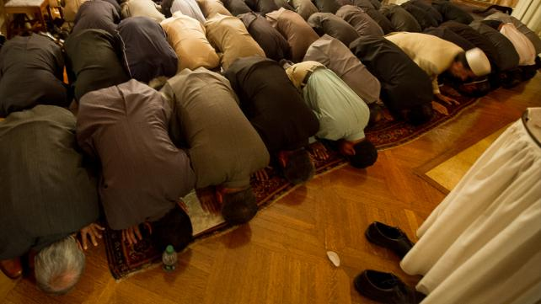
Hafsa Ahsan
It is that time of the year once again. It is the advent of a month that is filled with innumerable blessings, the thirty days which require a Muslim to observe one of the five pillars of Islam, fasting.
Ramadan is characterized not just by its obligation on every Muslim to keep away from certain things which are allowed in other months, but also by the weight of blessings attached to every good deed performed in this month.
So what are these unique features which make Ramadan such a special and sanctified month for Muslims the world over?
Probably the most significant is the fact that in this month, as we are told by Allah, the gates of Heaven are thrown open, the gates of Hell are closed and the devils are chained. This essentially signifies that, in Ramadan, the devils and their advocates have a much more difficult job diverting true Muslims from fully reaping the bounties of Allah by performing every religious duty with a pure intention.
Allah's Messenger (peace be upon him) said, "When the first night of Ramadan comes, the devils and the rebellious jinn are chained, the gates of Hell are locked and not one of them is opened; the gates of Paradise are opened and not one of them is locked; and a crier calls, 'You who desire what is good, come forward, and you who desire evil, refrain.' Some are freed from Hell by Allah, and that happens every night." (Tirmidhi).
Another significance of this month is the act of fasting itself. Fasting inculcates self-restraint and self-control as the person fasting does not only have to abstain from food and drink, but s/he must also refrain from many other things: backbiting, gossiping, fighting, using foul language etc. Very strict words have been used in this regard:
The Prophet said, "Whoever does not give up false statements (i.e. telling lies), and evil deeds, and speaking bad words to others, Allah is not in need of his (fasting) leaving his food and drink" (Bukhari).
He also said, "If one of you is fasting, he should avoid sexual relation with his wife and quarreling, and if somebody should fight or quarrel with him, he should say, 'I am fasting'" (Bukhari).
It is logical that if the aim of fasting was only to stop eating and drinking for a specific period of time, then the spiritual objectives of fasting, which have been specified in the Quran, would not have been met. In the Quran, Allah specifically says:
O ye who believe! Fasting is prescribed for you, even as it was prescribed for those before you, that ye may ward off (evil) (2:183).
As one can see from the above verse, Muslims have been commanded to fast, so that they attain righteousness. And what is meant by righteousness? The Arabic word in this verse is "Muta'qeen" taken from the word "Taqwa." To attain Taqwa or righteousness means to fear Allah and to obey His every Command. And by fasting for thirty days, we are doing just that. Fasting is never done for any material or worldly gain. Fasting is done mainly because it is the command of Allah for Muslims to follow. And it is this spirit which is the cause of instilling "Taqwa" in Muslims. Part of a saying of the Prophet reported in Bukhari is the following:
"Allah said, ‘All the deeds of Adam's sons (people) are for them, except fasting which is for Me, and I will give the reward for it.'"
Also, fasting is an action which, we are told, will act as a shield for us when we most need it, i.e. on the Day of Judgement. On that day, when we will be called to give an account of every good and bad deed done in this world, fasting will intercede for us, provided of course, that every condition about the purity of intention and refraining from forbidden activities was done. This is supported by the following Hadiths:
Allah's Apostle said, "Fasting is a shield or protection from the fire and from committing sins" (Bukhari).
Allah's Messenger, peace and blessings be upon him, said, "Fasting and the Quran intercede for a man. Fasting says, 'O my Lord, I have kept him away from his food and his passions by day, so accept my intercession for him.' The Quran says, 'I have kept him away from sleep by night, so accept my intercession for him.' Then their intercession is accepted" (Tirmidhi).
Such importance is attached to fasting, that numerous glad tidings are given in the Hadiths to those who fast truly for Allah’s sake and for the sake of obeying His Command solely to earn His Pleasure in the life Hereafter. Some of the Hadiths are:
Allah’s Apostle said, "By Him in Whose Hands my soul is, the unpleasant smell coming out from the mouth of a fasting person is better in the sight of Allah than the smell of musk. There are two pleasures for the fasting person, one at the time of breaking his fast, and the other at the time when he will meet his Lord; then he will be pleased because of his fasting." (Bukhari).
The Prophet said, "Paradise has eight gates, and one of them is called Ar-Raiyan through which none will enter but those who observe fasting." The Prophet also said, "If a person spends two different kinds of something (for Allah's cause), he will be called from the gates of Paradise" (Bukhari).
Allah's Messenger, peace and blessings be upon him, said, "There is Zakat applicable to everything, and the Zakat of the body is fasting" (Tirmidhi).
I heard Allah's Messenger, peace and blessings be upon him, saying: "He who would meet Allah (in the state) that he has not associated anything with Him, he has offered five (daily prayers), and observed the fast of Ramadan he will be pardoned."
I said: Allah's Messenger, should I not convey this happy news to them (to the Muslims)? He said: "Let them go on doing good deeds" (Tirmidhi).
Fasting also imbues in Muslims, the spirit of charity. Abstaining from food and drink gives a firsthand experience to the more privileged as to what the less fortunate may have to endure the year around. Hence, it acts as a spur for them to donate more to charity and to give out of their wealth to those who cannot afford the same luxuries that they do. The following Hadiths add to this spur:
Allah's Messenger, peace and blessings be upon him, said, "He who gives one who has been fasting something with which to break his fast, or who equips a fighter, will have a reward equivalent to his" (Tirmidhi).
Yet another blessing of this month is that every good deed done in it, whether it be giving charity or reciting the Quran, carries an extra weight of blessings. This good news is given to the people in the following Hadith:
The Prophet said, "(Allah says about the fasting person), 'He has left his food, drink and desires for My sake. The fast is for Me. So I will reward (the fasting person) for it and the reward of good deeds is multiplied ten times'" (Bukhari).
In another place it is even promised that a Nafil act will get the reward which a Sunnahact gets in other months; a Sunnah act will get the reward of a Fard (obligatory) act. And the Fard act will get the reward ten times more than that in the other days. Hence, this lure of rewards acts as a spur for us to perform more and more good deeds and refrain from more and more bad ones. Since the devil is chained, the latter becomes easier.
We have in our Prophet Muhammad, peace and blessings be upon him, a role model and
Ibn Abbas said that Allah's Apostle was the most generous of all the people, and he used to reach the peak in generosity in the month of Ramadan when Gabriel met him. Gabriel used to meet him every night of Ramadan to teach him the Quran. Allah's Apostle was the most generous person, even more generous than the strong uncontrollable wind (in readiness and haste to do charitable deeds).
Another factor, which distinguishes Ramadan from other months, is the advent of the Night of Power or Lailat-ul-Qadr. The Night of Power is said to be the one in which Allah writes the decree of His creation. In verses three to five 5 of Surah Al-Qadr, God says:
"The Night of Power is better than a thousand months. The angels and the Spirit descend therein, by the permission of their Lord, with all decrees. (That night is) Peace until the rising of the dawn."
Allah's Messenger said, "Ramadan, a blessed month, has come to you during which Allah has made it obligatory for you to fast. In it the gates of Heaven are opened, the gates of al-Jahim are locked, and the rebellious devils are chained. In it Allah has a night which is better than a thousand months. He who is deprived of its good has indeed suffered deprivation" (Tirmidhi).
Numerous blessings are promised to those who perform prayers through this night. This is the Night when sins are forgiven, Heaven is opened for certain people and the doors of Hell are closed for others. The Prophet said: "Whoever established prayers on the night of Qadr out of sincere faith and hoping for a reward from Allah, then all his previous sins will be forgiven; and whoever fasts in the month of Ramadan out of sincere faith, and hoping for a reward from Allah, then all his previous sins will be forgiven" (Bukhari).
But we have not been told exactly which night of Ramadan Lailat-ul-Qadr falls on. All we have been told is that we must search for it in the odd numbered nights, in the last ten days of Ramadan. This in itself is another of Ramadan’s unique characteristics.
Ubada bin As Samit related that Allah's Apostle went out to inform the people about the (date of the Night of decree (Al-Qadr). There happened a quarrel between two Muslim men. The Prophet said, "I came out to inform you about the Night of Al-Qadr, but as so-and-so and so-and-so quarreled, so the news about it had been taken away; and may be it was better for you. So look for it in the ninth, the seventh, or the fifth (of the last ten days of Ramadan)" (Bukhari).
Aisha said that Allah's Apostle said, "Search for the Night of Qadr in the odd nights of the last ten days of Ramadan" (Bukhari).
However, the purity of intention is stressed here as well. Only those prayers will be heard which are performed with sincerity and to get sins forgiven. If the intention is to look righteous to other people, it goes without saying that the person might as well go to sleep.
Allah's Messenger said, "Many a one who fasts obtains nothing from his fasting but thirst, and many a one who prays during the night obtains nothing from his night prayers but wakefulness" (Tirmidhi).
Ramadan is an amazing month. There is a flow of blessings and rewards from Allah to those who truly want to reap the full benefits from these thirty days. Probably the best thing about Ramadan is the fact that each and every action is done truly for Allah and each serves to strengthen our faith in Him. There are no strings attached to any action, as they normally are with most of our routine work. Ramadan is not just a month in which we refrain from food and drink for a few hours. It is a chance to make up for the time lost around the year in other work and revert to Allah, beg forgiveness for the sins done around the year, and finally, a chance to better the life awaiting in the Hereafter.
May Allah help us all to make every fast this Ramadan a shield in the Hereafter and an intercessor in the grave. May Allah not make us one of those who do not get anything from their fasts except for hunger and thirst. And May Allah guide us towards making this Ramadan a source for gathering numerous blessings and getting our major and minor sins forgiven. Ameen.
***

Understanding the true meaning of Ramadan

Omam Khalid
Wednesday March 21, 2018

Ramadan is not just about fasting. It serves a deeper purpose and brings with itself a chance to begin again.

Knowledge
Of the five pillars of Islam, Ramadan lasts the longest and is cherished deeply by Muslims all over the world. We as Muslims are expected to abstain from food, drinks and worldly engagements and desires while observing fasts. But is that all Ramadan is about? Definitely not! This is because even just the simple act of abstention makes manifest a wave of goodness that is hidden in us all.
We all must have felt it at one time or another that there is something about the spirit of Ramadan that makes us all come together as one Muslim Ummah. The whole month, there is an air of calm and serenity where people leave behind the sins of the past and try to do good that God Almighty expects of us. It is almost like turning over a new leaf.
Each year, the month of Ramadan brings with itself a chance to begin again. As it is narrated by Abu Hurairah:
“Whoever prayed at night the whole month of Ramadan out of sincere Faith and hoping for a reward from Allah, then all his previous sins will be forgiven." (3:32:227 Bukhari)
In addition to a new chance at life, the spirit of Ramadan is about forgiveness, taking care of each other and remembering the Almighty and a little more.

Reconnect and seek forgiveness in the holy month
First and foremost, when we abstain from the worldly material needs and desires, it allows us to bond with Allah (SWT) much more easily. Since Ramadan was the holy month when the Quran was sent down to the Prophet (PBUH), this month holds significance not only for the Muslim Ummah all over the world but for Allah (SWT) who has hidden in the last 10 nights of the month a wonderful treasure – the night of Qadr. The Prophet said:
"Whoever fasted the month of Ramadan out of sincere Faith (i.e. belief) and hoping for a reward from Allah, then all his past sins will be forgiven, and whoever stood for the prayers in the night of Qadr out of sincere Faith and hoping for a reward from Allah, then all his previous sins will be forgiven”. (3:32:231 Bukhari)
For this reason, the whole month of Ramadan, especially the last ten nights, is a great opportunity to reconnect with God Almighty: talk to Him, pray to Him and read His Quran with devotion and He will bring you closer to Him and grant you peace.

Practice self-discipline
Abstention paves way for keeping a check on your actions and thoughts. In the month of Ramadan, police yourself and be polite towards others. It is sometimes easy to get frustrated but the spirit of Ramadan demands something otherwise. Muslims should keep their peace within themselves and with those they interact with because not only does God love those who fulfill their duty towards Him but He also loves those who abstain from wrongdoing and care for their duty towards their brethren.

Spread goodness in Ramadan
Ramadan allows us to feel the pain of those brothers and sisters who live in poverty and cannot afford even the very basic human needs. One should remain conscientious of those around them and focus not on lavish Iftars for self but for those who deserve it most; a neighbor who has gone hungry, a beggar, a poor child, a hardworking poor man, anyone who you can help out, you should. It’s a month of sharing and if you can help even a single person out, the purpose of Ramadan is fulfilled.
So while fasting is the basis of the month of Ramadan, the spirit of Ramadan is much more than the mechanical act of abstaining from food and other desires. To reap the full rewards of Ramadan, one should keep in mind that it is a great time to reconnect with God, with our own self and with the community around us. In reaching back to these basics, we will find the true purpose of fasting and of this beautiful and holy month we so eagerly await.
***

6 ways to prepare for Ramadan before it starts

Mohammad Ahmed Shiwani
Wednesday April 18, 2018

Ramadan 2019 is almost here.

Lifestyle
Ramadan is the most auspicious month of the year for Muslims. Around the world, we aim to use the month to redevelop or enhance our connection with Allah (SWT) and so the month is of extreme importance to every Muslim. Naturally, it makes sense for us to prepare for the month beforehand, primarily so we can get the best out of the immense blessings in store for us. Here are 6 ways you can prepare for Ramadan 2018 before it begins:

1. Prepare a schedule to follow
It is not unnatural to feel lost and incoherent during the first few days of the month. With fasting, Tarawih and other practices comes a different and mostly novel format to the day. The way to make sure you are not a confused mess during the first few days is to prepare a schedule to follow beforehand, meaning that you must note down all the different practices you wish to commit to during the month and try to find a way to incorporate them with other professional and personal commitments. An easy way to do this is to think of the different pockets of free time you have throughout the day and fit in a prioritized list of deeds within those time-slots.
Be sure not to overburden yourself and set unmatchable goals and targets, you do not want to jeopardize other important aspects of your life, nor realize that you’ve created a mountain too high to climb mid-Ramadan. Take it easy on yourself, but think of goals and targets beforehand and you shall sail through the beautiful month!

2. Improve your Salah
Ramadan Kareem is all about trying your best to please Allah (SWT) and capturing as much of the tremendous blessings bestowed upon us during the month. Salah is one of the most important modes of prayer and perhaps the quintessential mode of submission to Allah (SWT), so spending some time improving different aspects of your prayer will definitely go a long way in getting the most out of the month. Be it during Taraweeh or late-night Nafls, a concentrated proper Salah will exponentially increase the pleasure you get out of praying to the Almighty. This article has some brilliant tips for enhancing the quality of your Salah.

3. Read up on the uniqueness of Ramadan
As narrated by Abu Huraira (RA), the Holy Prophet (PBUH) said:
“When Ramadan begins, the gates of Paradise are opened.” (Bukhari 1800)
This Hadith is just one of the many Ahadith that outline the immense significance of Ramadan and show how ideal of an opportunity the month is to regain one’s connection with religion. It is perhaps pertinent, then, to really understand the immense value of the month in order to be fully motivated and inspired to extract the most from it. This information will be of immense benefit during those tough fasts and tiring Tarawihs, since you will constantly be aware of the enormous rewards in store for you in return for miniscule efforts.
Reading up on the auspiciousness of the month will not only give you an increased sense of motivation to engage yourself in as many good deeds as possible during the month, but will also create an eagerness for the month to arrive. What better than to prepare for the month by displaying the same eagerness that the beloved Prophet (PBUH) would display?

4. Think of healthy Iftar meals
In the raging hunger that we feel during that helpless await for the Athan, most would testify that eating healthy is usually very low on the agenda. However, we must understand that Ramadan is more about re-establishing a commitment to Islam than about chomping down on uncountable plates of food, so it is important to be wary of what we eat during the month. It is also, of course, important to not gain a hundred kilos during the month, so it may be pertinent to think of ways through which Iftar and Sehri can be made healthier. Take a look at these effective tips for preparing healthy Iftar meals. Pre-planning for a healthy Iftaar may also be less burdensome on the wallet!

5. Complete your Eid shopping
Unless you enjoy going out to shop during Ramadan, it is perhaps a good idea to shop for Eid before the month begins. Taking time out to shop in the midst of a usually packed Ramadan schedule may be a hard thing to do, so shopping beforehand may just make your life a whole lot easier. You may also succeed in banking on some amazing discounts!

6. Take care of someone else’s Ramadan
Some of us are more privileged than others, but the Muslim Ummah is one and must take care of each other.
Abu Hurraira (RA) noted that the Holy Prophet (PBUH) once said, “ Whoever helps ease a difficulty in the world, Allah will grant him ease from a difficulty in the world and the Hereafter”
Let’s face it: Ramadan can be a real financial burden on some people, which makes it all the more important for those privileged enough to ease their burdens. There is perhaps no better feeling than knowing you have made someone else’s life more comfortable or rid them of a severe burden. If you know someone who could use a little help in preparing for the month, do not hesitate to help them out. Islam is more than just a set of rituals; a true Muslim is one who worries about and cares for his or her fellow Muslims, take this opportunity to please the Almighty and emulate the beautiful ways of our Prophet (PBUH)!
The beautiful month is very close by and we’re sure you are as excited as we are. After all, who would want to miss those scrumptious Iftars? Here is to Ramadans well-prepared and flooded with happiness and fulfillment!
***

The Dos and Don'ts of Ramadan

Omam Khalid
Wednesday March 21, 2018

There is much more to Ramadan than the mechanical act of keeping and breaking a fast.

Lifestyle
Photo credits: www.maviesaineetmoi.com
Much like everything we do – from our social interactions to as menial a task as eating – has certain rules of engagement that one must abide by. Likewise, during the holy month of Ramadan, Muslims are required to take caution and follows certain rules; which may be said or unsaid.
Of the very basic acts that are expected of a Muslim is that of abstention from food and drinks. However, this is not all. There is much more to Ramadan than the mechanical act of keeping and breaking a fast. One should keep in mind that this month is about patience, forgiveness and goodness and anything that hinders a Muslim achieving this state should be avoided at all costs.

The DO’S of Ramadan

Recite the Quran
Remember the Almighty as frequently as possible. Ramadan is the greatest opportunity to communicate with Allah because there are no barriers between man and his Almighty God. No wrath of the Satan is beset upon man during this month as the Messenger of Allah (PBUH) said:
"When the month of Ramadan starts, the gates of the heaven are opened and the gates of Hell are closed and the devils are chained." (Imam Bukhari)
Hence, it is the perfect opportunity to seek forgiveness from the Lord, reestablish ties with Him and recite Quran as much as possible.

Follow the Sunnah
It is always advisable for a Muslim to follow in the footsteps of the Holy Prophet (PBUH), however, the spirit of Ramadan requires that the Sunnah of the Prophet (PBUH) is adhered to, to reap the benefits of this holy month. The routine of the Prophet (PBUH) during this month should be a standard for every Muslim no matter where. Imitating the best of the human beings will surely make us better people and even better role models as Muslims in good faith.
“The most honored by Allah amongst you are those best in taqwa."(Q 49:13)

Taraweeh
Another essential element of this month is the performance of the Taraweeh prayer, in addition to the five daily prayers. Taraweeh prayers are to be performed after Isha each day to create a stronger bond with the Almighty and to gain the blessings of God Almighty.

Give Zakat
Zakat, being one of the five pillars of Islam, is a definite act to indulge in. Ramadan is all about helping others and feeling their pain – putting one in the shoes of another and having empathy. So, what better time to help someone than in the holy month of Ramadan? So in a month which requires from a Muslim nothing but goodness, be aware of those who need your help and give Zakat because it not only fulfills your rights towards the Lord but also towards His creation.

The DO NOTs of Ramadan

Lose patience
It is imperative that one does not lose patience with other people. It is no surprise that deprivation of food and the scorching sun can make one irritable and vulnerable – which is why keeping your calm is highly advisable. Don’t yell, fight and indulge in any destructive behavior because the Ramadan is all about patience and tolerance and it does not do a Muslim brother any good to do anything that is not in line with the spirit of this blessed month. The Prophet (PBUH) said:
And it is the month of patience, and surely, the reward of patience is Paradise. (Al-Kafi 4:66)

Begrudge anyone
Forgiveness is one of the recurring themes in Ramadan, if our Lord Almighty can forgive us for our sins that we commit throughout the year then why not follow the same suite? The Holy Prophet Muhammad (PBUH) has said:
It (Ramadan) is the month, whose beginning is mercy, its middle, forgiveness, and its end, emancipation from the fire (of hell). (Bihar al-Anwar 93: 342)
So in the spirit of Ramadan, forgive anyone who has wronged you and don’t hold grudges – this Ramadan try to let the little things pass because Allah loves those who forgive others.

Refrain from gossip
In our daily lives, we sometimes bad mouth other people and discuss their problems and lives. This is another act that one should be extra careful with, especially in this month. Watch your actions and guard yourself against the evils of gossip and backbiting. Allah wants men to refrain from food but He also loves those who make constant effort to better themselves. It is even said in hadith that:
“Whoever does not give up false speech and acting upon it, Allah has no need of him giving up his food and drink.” (Al-Bukhari)
While these are the things that a Muslim should definitely refrain from, there are many other actions that one should engage in, during this holy month.
This Ramadan, let us try and be better humans and even better Muslims and take care of the rules and regulations of this month. It is our chance to be better than we were in the past year and in light of doing good and being better, do keep these little reminders with you in Ramadan.
***

10 things you shouldn’t complain about in Ramadan

Omam Khalid
Wednesday March 21, 2018

It is common to hear people complain about a number of things in this holy month.

Lifestyle
Ramadan is indeed a month of patience and abstinence from worldly affairs. It is the time for the remembrance of Allah and for repentance of sins as well as a chance to start all over again.
This month of fasting teaches patience and urges its observers to remain steadfast in their duty to Allah. While reaping the blessings and benefits of this holy month, Muslims should not complain about the hardships of observing fast. However, it is common to hear people complain about a number of things in this holy month.
Here are some things that top the list when it comes to being patient during Ramadan.

1.The fast itself
Fasting is demanding of us on many levels, which is the real test. You should refrain from complaining about feeling hungry or thirsty during the fast. Instead one should feel the pain of others who spend each year in this state. One should embrace this month and try to reap its full benefits.

2.The weather
The fact that Ramadan this year is in one of the hottest months of the year is not in our control. As a result, there is no use in complaining about how hot it is and how the heat makes it difficult to fast. Of the many tests of this month, this is just one and it only makes us realize more of the pain of the poor who spend hours in the scorching heat, making ends meet.

3.The number of hours between Suhur and Iftar
It is understandable that it is difficult to abstain from food and drinks for 10 or 15 hours, but the whole spirit of Ramadan is found in this basic principle: to feel the pain of those who on a regular basis suffer because of poverty. So avoid complaining about how long the fasting hours are and instead focus on remembering Allah and doing good.

4.Not getting enough sleep
It so happens that during Ramadan, your sleep cycle and routine in general, gets disturbed but one should refrain from complaining about these trivial things as the message and spirit of Ramadan goes beyond this little struggle.

5.The food you eat
Always be thankful for the food you eat at Suhur and Iftar. Food for many people is a luxury that they can’t afford. Which is why always count your blessings and don’t complain about the food you eat because some people don’t even have that.

6.Worldly affairs
You should refrain from complaining about not being able to listen to music or watch your favorite show. There is a reason why Allah does not want you to indulge in worldly affairs and only remember Him and repent for your sins. Ramadan is a great opportunity to fix your priorities, so don’t miss out on it because of anything trivial and unimportant.

7.Lack of energy
Do not whine about how low on energy you are and how weak you feel. It is a test of your perseverance and patience and you must not fail it. To avoid feeling lethargic, have high energy foods during Suhur and keep yourself hydrated and most importantly, focus on the bigger picture.

8.Not having enough time
During Ramadan, a lot of your routine gets messy because of Suhur timings and sometimes it becomes difficult to manage work affairs along with Godly affairs. However, one should be able to prioritize what is important and essential especially during Ramadan. Try and fix a special routine for this month and follow it through. Make Godly affairs your priority and all else will fall into place.

9.Your blessings
One should always count the blessings and be thankful to Allah Almighty for everything. If you have a roof over your head, health, and food available at all times, you should be thankful. Do not compare your blessings with others and feel bad about yourself, instead be grateful for whatever little you have and Allah will bless you with more, most definitely. Look to those who are inferior to you and do not look to those who are superior to you, for this will keep you from belittling Allah’s favor upon you.

10.What you have to give up
The spirit of Ramadan demands utmost submission to Allah. As a devout Muslim, one should definitely not complain about having to give up anything for the sake of Allah Almighty. It kills the purpose of Ramadan if one complains at all about giving up food, water or any other worldly thing. Rather one should be thankful to Allah Almighty and remain true to the purpose and essence of this holy month.
Apart from these 10 things, one shouldn’t really complain about anything at all. This month, count your blessings and be thankful to Him for giving you another chance to become a better human being and an even better Muslim.
***

10 foods you must try this Ramadan

Muhammad Bin Khalid
Wednesday March 21, 2018

For all the Foodies fasting out there!

Lifestyle
Let’s just hope that you are not reading this article while you are fasting. Even if you are, just take notes, do not get carried away and try these foods in your Suhur or Iftar. We all know that Ramadan comes with countless blessings for Muslims around the world. Some of these blessings include the special Ramadan foods that suddenly come to surface in all the Muslim communities. As delicious as all of these foods are, some of them are actually worthy of a special mention.
The two main meals during Ramadan are suhur (served before dawn) and iftar (served after sunset). Muslims like suhur to be a hearty, healthy meal so that they have the energy to get through the day. At the end of the day, when the sun sets, the day's fast is broken with iftar. Many Muslims break their fast by eating dates and drinking lots of water or sugary juices before beginning the iftar meal. This meal is what every community tries to make special. Let’s see the meals that are famous in different Muslim communities around the world.

1.Umm Ali (Egypt)
An Egyptian delight, a soft and creamy dessert, with chewy edges and crunchy bits of pastry and nuts poking through is something that people in Egypt love to eat during Ramadan. It is traditional food that dates back to the Ayyubid dynasty and is very economical to make. It is made up of phyllo pastry, milk, double cream, nuts and is sometimes topped with raisins, powdered sugar, and coconut flakes.
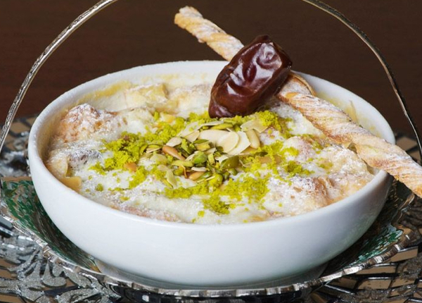

2.Ramadan Kebabi (Turkey)
A Turkish Kabab recipe made from Meat mixed with yogurt, tomato, and garlic stuffed with fresh mint or garnish on Pide bread.tomato, and garlic stuffed with fresh mint or garnish on Pide bread.

3. Qatayef (Saudi Arabia)
It is an Arab dessert very commonly eaten during Ramadan in Saudi Arabia. Qatayef is a sweet dish often filled with Akkawi cheese, or any unsalted cheese. It can also be filled with nuts. Some like it fried and others bake it, it is then drizzled with honey, sweet sugar syrup or powdered sugar. Indeed, a delicious dessert to enjoy during Ramadan.
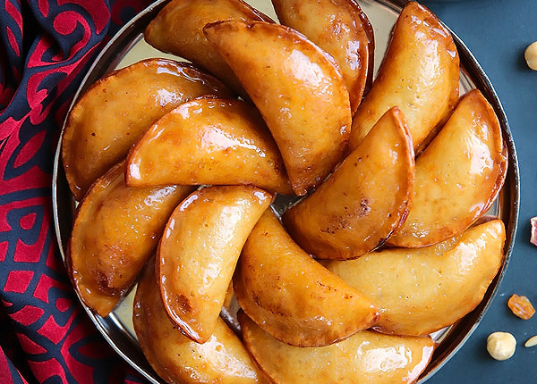

4. Haleem (India)
In India, special Haleem is prepared during the month of Ramadan and is transported all over the world through a special courier service. Haleem is traditionally cooked in large, wood-fired cauldrons.
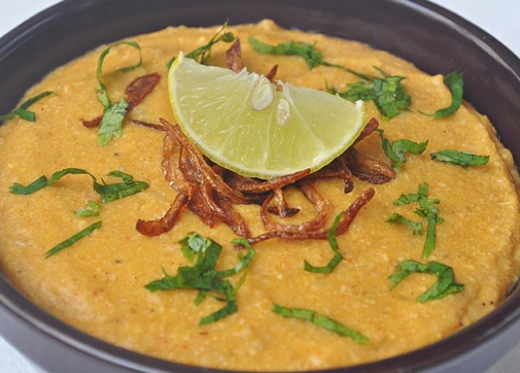

5. Jalebi (Pakistan)
Jalebi is a well-known Pakistani sweet. It's an eye-candy of sweet lovers. Jalebis are cooked at bakeries and sweet shops regularly in Pakistan however people buy it at certain events, occasions and at times of happiness. In the month of holy Ramadan, jalebi becomes significantly more in demand.
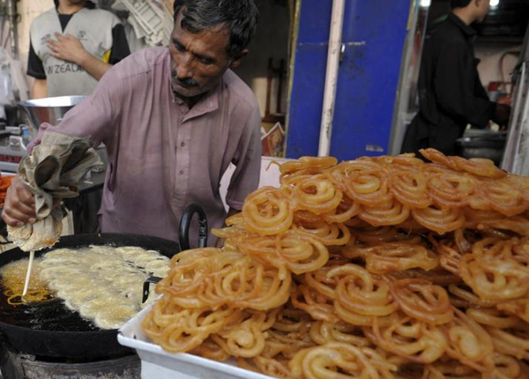

6. Chorba (Morocco)
One of the foods commonly eaten to break the fast in Morocco is chorba, which means soup in Arabic.It can be made in infinite ways, though most often chorba is associated with a hearty Moroccan soup made from vegetables and chickpeas, usually with diced lamb and some sort of pasta or grain.chorba, which means soup in Arabic.It can be made in infinite ways, though most often chorba is associated with a hearty Moroccan soup made from vegetables and chickpeas, usually with diced lamb and some sort of pasta or grain.

7. Fasulia (The Middle East and North Africa)
Filling stew made all over the Middle East and North Africa with white kidney beans, lamb or beef meat and tomato sauce, which is served with white rice or with fresh hot bread. White kidney beans are called fasulia in Libya.

8. Kolak (Indonesia)
A fruit dessert that is loved and enjoyed by locals in Indonesia made with palm sugar, coconut milk, and pandanus leaf. Fruits such as jackfruit or banana are added, or mung beans.

9. Harees (Gulf)
It is a popular dish in Arab countries of Persian Gulf and is traditionally eaten during Ramadan. A porridge of wheat (often soaked overnight) and lamb all ground up together. Just wheat and meat often sweetened with sugar and cinnamon. It will hit all your senses.
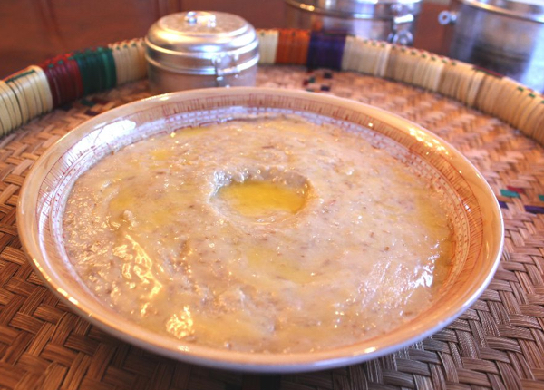

10. Bamia (Middle East and Africa)
Whether it is scorching sunlight of June or a cold night of December, bamia will still arguably be one the most famous food. Tender mutton falling off the bone, a rich immersion of garlic, tomato, lemon and okra, served with luscious fluffy and crispy rice, it ought to make it to your Iftar table.
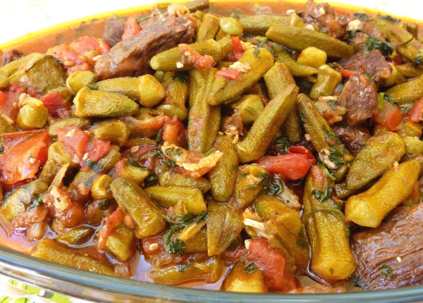
Words of Wisdom: Bamia's flavor is considerably heightened if consumed the day after it is made.
In addition to these delicious foods, fresh seasonal fruits, and seasonal vegetables are consumed in abundance in all the regions around the world. Some other foods that you must try during Ramadan are:
- Sherbet (Turkey) - the world's first soft drink made from fruit juices, extracts of flowers, or herbs, and combined with water and sugar.
- Chapatis (Pakistan and India) - wheat bread that is rolled up with vegetables and meats.
- Shami kebab (India and Pakistan) - fried patties of ground meat and chickpeas.
- Fattoush (Lebanon and Arab countries) - a salad made of vegetables and pita bread.
- Khyar Bi Laban (Middle East) - a mouth-watering cucumber and yogurt salad.
- Mujadarra (Middle East) - a dish made with rice and lentils.
- Konafah (Middle East) - a pastry made with phyllo dough and cheese.
- Ful medammes (North Africa) - fava beans cooked with garlic and spread on bread.
***

Salam Ramadan

Hamda Abdul Rauf
Wednesday March 21, 2018

This Ramadan find all your answers on IslamicFinder

Lifestyle
As Muslims worldwide are awaiting the Holy month of Ramadan, IslamicFinder has launched its distinguished Ramadan 2017 page, to help Muslims observe the Holy month with zeal and zest. In a few days, around 2 billion people around the world will welcome Ramadan, fasting from dawn to sunset and gather with families and loved ones for meals, laughter, and stories.
So, whether you want to know about the blessings of Ramadan, foods Muslims eat in different parts of the world in this holy month, or get to know the things you can do when you’re fasting, our featured page will help you connect and celebrate Ramadan with millions of Muslims.
Here are some noticeable features of the page.

Ramadan Calendar
On Ramadan 2017 page, you are going to get a customized Islamic calendar featuring suhoor and iftar times of your location. You can print the calendar and hang it in your house or a Masjid near you to help fellow Muslims.

Zakat Calculator
Finding it hard to calculate Zakat? Worry no more. Ramadan 2017 page by IslamicFinder provides an easy to use Zakat calculator to make sure you don’t face any difficulty in purification of your wealth.

Tips for Ramadan
All of us want to give our best in Ramadan and often find it hard to balance deen and dunya in this month. To help the Ummah breeze through Ramadan, we have stocked up Ramadan 2017 page with tips and information about the holy month. From best practices to addressing important issues like making up for a missed fast, Ramadan 2017 page has got you covered.

Dua and Quran
Furthermore, you can find relevant Duas for the three ashra of Ramadan, seher, and iftar. Most importantly, you can recite the Holy Quran with various translations and spend the day in Allah’s remembrance.

Islamic Places
Ramadan promotes a sense of community and motivates Muslims to go to mosques for prayers, suhoor, and iftar. To help you find a mosque near you and get you connected to the local Muslim community in case you are traveling, we have added the feature of Places on our Ramadan 2017 page.
With Ramadan 2017 page, we hope to answer all your Ramadan related questions and help you make the most of this month.
Let’s all welcome and celebrate Ramadan together. Ramadan Kareem!

Ramadan Central

Checklist for Ramadan's1 first 10 days
Samana Siddiqui
- For five minutes turn off your phone, get away from the laptop/computer, and other interruptions. Then, make a deep, sincere Dua to Allah that He make this the best Ramadan of your life, especially in terms of spiritual benefit. _____
- Start getting used to the new schedule by going to sleep early, right after Isha and Taraweeh, so you can get up in time for Suhoor. ____
- Set the Suhoor table before bed and have a list on the fridge of what you’re going to serve so you can move a little faster in your sleepy state. ___
- Start implementing a Ramadan meal plan so that the Lady of the House is not stuck in the kitchen most of the blessed month. Cooking and cleanup should be shared by all family members on a rotating basis. _____
- Finish decorating the house in time for the first day of Ramadan so you, and especially kids, can feel the excitement. ____
- Send ecards and post Facebook updates wishing everyone “Ramadan Mubarak!”. ____
- Start calculating your Zakat and brainstorm where you will give it this year _____
- Finalize a written list of Duas you want to make for yourself and others this Ramadan, especially before you break your fast. ____
- Get in the habit of taking a short nap in the afternoon. Set a timer for 15 or 20 minutes and find a safe, calm place. ______
- Put an elastic band on your wrist. Every time you feel like giving in to one bad habit you wanted to give up in Ramadan, pull on it and feel the pain of temptation. ______
- Read the increased amount of Quran you resolved to read every day of Ramadan, whether that is one verse, one page, or one Juz.
- Read Ramadan bedtime stories to the kids. ___
- Smile. It’s Sunnah. And it’s Ramadan. ___
- Forgive the one person you’ve held the longest grudge against. It could be a child, a parent, a cousin, or some other relative or friend. ____
- Squeeze in some time on chores that may come up later in the month, during the last 10 days or Ramadan, so you have that time free when it arrives. ___
- Thank Allah for His incredible Mercy toward you throughout your life and beg Him for more of it in the future, especially when we’ll need it the most, on Judgment Day. ___
- Show mercy to someone else. ___
--------------------------
Samana Siddiqui is Sound Vision's Content Manager. She is also a reporter and columnist for the Chicago Crescent newspaper.
***

5 things to do Shura about for Ramadan

Samana Siddiqui
Shura, often translated as consultation in English, is a process every Muslim is encouraged to incorporate in his or her life for matters not just relating to Masjid or organizational meetings, but within circles of family and friends as well.
When it comes to Ramadan, consulting family and friends about the blessed month can and should go beyond generalities. Here are five specific issues to discuss, debate, and agree on that can help you maximize the benefits of this special time.

1. How can we eat Iftar or Suhoor together?
For families, if you don’t normally eat dinner together, Ramadan offers a unique opportunity to eat at least one meal together, at Iftar or Suhoor. This is something Prophet Muhammad, peace and blessings be upon him, highly recommended, saying, “Eat together and not separately, for the blessing is associated with the company" (Ibn Majah).
For friends, this can be planned at a different home on a rotating basis, making the meals simple, and making it a potluck so no one gets burdened with too much cooking.

2. How often will we attend Taraweeh and where?
As an extra form of worship reserved specifically for Ramadan, Taraweeh can be offered in the home. But in the Masjid or Islamic center with hundreds of other worshippers, the sense of spirituality and community is heightened. Plan to attend Taraweeh as a family or as a group of friends at least once a week. Don’t feel you have to choose the nearest locale if it does not suit your needs. If you prefer one Imam’s recitation better, the friendly atmosphere in one Masjid over another, or the kid-friendly amenities at another Islamic center, consider making the drive out.

3. What are at least two volunteer projects we can participate in as a group?
Some Muslim organizations have already planned volunteer opportunities for individuals and families in their communities, ranging from making bag lunches for a shelter, setting a day and time to make breakfast for the homeless, or arranging a clothing drive for those in need. If no such activities are planned in your locality, consult with family and friends and organize one on your own. With Ramadan being the month of heightened spirituality and generosity, it is an ideal time to take part in such an initiative.

4. How much Quran can we read together?
While everyone tends to set their own goals of how much Quran they can read, try setting a group minimum goal, whether it’s a page of Quran with translation a day, or even half a page. By setting a minimum and holding each other accountable, family and friends can encourage and push each other to reach higher with Quran reading this Ramadan.

5. Which Duas should we read in the last 10 nights of Ramadan
Ramadan’s last 10 nights are very special, as we seek Laylatul Qadr, the night that the Quran describes as “better than 1,000 months” (Quran 97:3). While many of our Duas are usually very personal, involving our own hopes, dreams, and goals, others can and should involve our family, friends, and community on the broadest level. Consult family and friends about what Duas to make this Ramadan, whether it’s for a family member or friend facing illness, a relative coping with job loss, or a group of people suffering great hardship. Shura for Duas will help you catch Duas you may have completely forgotten to include.
***

Ramadan 2019: 10 things Muslim families can plan1
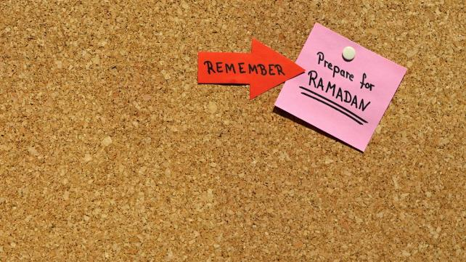
Samana Siddiqui
You are probably not the only one looking forward to Ramadan this year. Given the level of Islamophobia that has been unleashed by Republican presidential candidates, particularly Donald Trump, since last Ramadan, we are all in need of a serious spiritual boost.
The desire to turn to God and focus inward is natural. Ramadan is a time when Muslims rebuild their faith individually. But this year, we must also focus more on our families.
Why? Our children are suffering the most from the Islamophobia. A recent report related distressing incidents of Islamophobia Muslim children are experiencing in schools. Some of the anecdotes include these examples:
A teacher said, “A child of Indian heritage introduced himself to me, all in a single breath, ‘Hi, I’m Fharid but I’m not a terrorist,'” a teacher wrote. “He was six.”
“All Muslims are bad,” one first-grader told his teacher.
“We had a fifth grade student tell a Muslim student that he was supporting Donald Trump because he was going to kill all of the Muslims if he became president,” one teacher wrote.
Muslim parents, grandparents, aunts, uncles, and other family members, must be on the front line this Ramadan, healing and soothing our youth with the sweet taste of mercy and spiritual upliftment. We cannot ignore what our children are experiencing, even if they choose not to share it with us.
This is why we must urgently plan for Ramadan 2016. Here are some ways to do that.

1. Make time for Ramadan
Starting today, send requests for a schedule change at work, whether that is coming in earlier and leaving earlier or coming in later and leaving later. This way, you can adjust for sleep and productivity on the job. You will also ensure that you are home for Iftar with the family.
If you or your children are planning to take classes during Ramadan, choose those that begin later in the morning to better catch some sleep after Suhoor and allow for enough time to get home and prepare Iftar.
If you are the parent of younger children, schedule camps and activities around Suhoor and Iftar, as well as naptime.

2. Cook less, worship together more
Spend a weekend or two before Ramadan meal planning for the month. Cook some food together that can be frozen on busy days for Iftar or Suhoor. Make sure to squeeze in some one dollar a day meals too.

3. Complete all Eid gift and clothing shopping before Ramadan begins
Buy all of your Eid gifts now, a few weeks before Ramadan. Do the same for clothes shopping. Getting these things out of the way will allow you not only more time for spirituality in Ramadan, but it will give you the benefit of choosing more thoughtful gifts.

4. Get time off of work and cancel all activities in the last 10 days of Ramadan
In Ramadan, Prophet Muhammad, peace and blessings be upon him used to practice Itekaf, where he and other Muslims would remain focused on worship in the Masjid for the last 10 days of the blessed month. If possible, take the last 10 days off from work, and plan no camps, classes or other activities for the kids so that they can spend more time in the Masjid and together with the family.

5. Start saving up and encouraging kids to save money to give more charity in Ramadan
Start a Ramadan savings box and place it in the kitchen or family room. Encourage all family members to anonymously drop their donations into the fund. Once Ramadan starts, give it generously over the blessed month.
You can also set a specific fundraising goal for a particular cause. For example, you can aim to raise enough to sponsor an orphan for a year or to fund a well in a part of the world where drinking water is at a premium.

6. Tax season just ended, but start saving up enough to pay Zakat
Many Muslims choose to pay their Zakat in Ramadan as a way to get more Barakah for their buck. If you’re one of those people, start planning now by completing all the calculations and setting aside the amount you need to pay. This will free parents up from the last minute stress of doing so at the end of the blessed month.
Also, if your kids are older, sit down with them and show them the process of calculating Zakat, as well as why it’s important, and how you decide where it should be spent.

7. Parents: Don’t be a distracted parent. Put away the phone
Dr. Sherry Turkle, author of the 2015 book "Reclaiming Conversation: The Power of Talk in a Digital Age" found in her research that today's children are being deprived of important conversations with their parents due to the disruptions of technology. Too many parents are constantly checking phones instead of focusing on talking with their kids.
Such behavior also runs contrary to the Sunnah. The Prophet would give someone talking to him his full attention, looking directly at them when they spoke. Let’s revive this Sunnah this Ramadan. Our kids deserrve a listening ear. And if we don’t give it to them, they will turn to someone else who will.

8. Have the entire family pitch in and deep clean the house a week or two before Ramadan begins
Chores need to be revived in families. Having to help with household maintenance teaches all members that they are part of a team and that they have responsibilities. Nobody gets a free ride and you’re all in it together.
The added bonus is that the house will just need basic upkeep throughout Ramadan and won’t require a time-consuming, pre-Eid cleanup.

9. Set a day and time for family volunteerism
Book a date with a homeless shelter, food pantry, or any other volunteer project you would like the family to participate in during Ramadan. This is not only an excellent way to boost your spirits and spirituality, but it is also an ideal method to instill a sense of service in kids. According to United Way, adults who began volunteering as youth are twice as likely to volunteer as those who did not volunteer when they were younger.

10. Plan Iftar parties for your kids
There are two benefits to this activity. The first is that your kids can have fun while building spirituality. The second is that they can share Ramadan with other Muslim kids whose families may not be fasting, or with friends who are not Muslim.
Depending on the ages of your children, here are some ideas

For ages six and under:
a post-dinner party, with snacks, games, and ending with Iftar. Lootbags can be doled out, and for entertainment, they can watch Adam World’s Ramadan Mubarak

For ages 8 to 12:
Many kids are fasting or trying to practice fasting at this age. This deserves a more celebratory event. It should include a fun feast, prizes for the fasters and for the winners of a Ramadan trivia game, along with praying Maghrib, and if possible, Taraweeh together.

For teens:
- A party with the sleepover option would work well. The condition though would be that at least some of the night needs to be spent in worship. Taraweeh should be highly encouraged, and if a movie is desired, it has to be something clean with an Islamic theme. Also encourage them to bring a non-perishable item to the party to give to a food shelter.
- If Iftar is too difficult for this age, consider a Suhoor party at a 24-hour restaurant, followed by Fajr at a beach or scenic lookout.
***

10 tips to help you keep those Ramadan habits
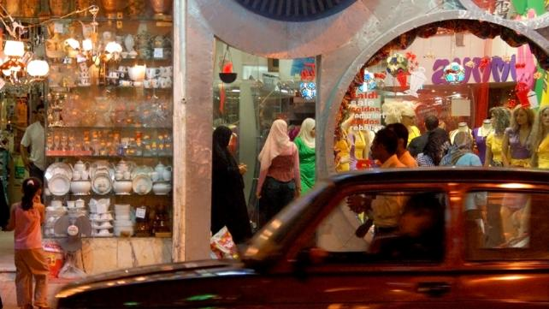
Samana Siddiqui
Ramadan was great for Sarah. She actually started praying five times a day on time. But once the blessed month is over she fears the momentum, drive and motivation that kept her going will fade out. Sarah is worried that this good habit might not last.
But it doesn't have to be that way. In fact, a number of psychologists agree that a person needs about three weeks to develop a good habit. If you've been praying regularly, fasting, controlling your temper, trying to be more patient, or keeping any other good habit during Ramadan, you're almost sure, Insha Allah, to keep up with it afterwards.
Nonetheless, we all slip up. As well, the drive that pushes us to do good in Ramadan is usually not as strong the rest of the year. Here are a few things you can do to maintain the good habits you picked during Ramadan:

1. Make Dua
It was Allah who gave you the ability to keep the good habit in Ramadan, and only He can help you maintain it afterwards. Make Dua that Allah helps you not only keep the habit, but that He accepts it and makes it a way for you to grow in closeness to Him.

2. Make it a habit
If you want to keep good habits, you've got to make sure they remain part of your daily schedule. For instance, fasting. Did you know that the Prophet (peace and blessings be upon him) encouraged fasting on Mondays and Thursdays? He said: A man's deeds are reported (to Allah) on Mondays and Thursdays and I prefer that I should be fasting when my deeds are reported (Tirmidhi).
This is a great way of maintaining the habit so you're not rusty by next Ramadan.
Or for example, were you extra generous during Ramadan? Well, maybe you can portion out a set amount of your weekly or monthly paycheck to a charitable cause to maintain the habit of giving.
Make the habit part of your daily and weekly schedule. The point is to keep the action in practice, and of course gain rewards from Allah.

3. Think about your day each night
Evaluating ourselves, our intentions, words and actions, every night is a very good way to maintain good habits (see a sample self-evaluation form).
Self-evaluation doesn't only help you see where you are and where you've got to go. It's also a great reminder of what you were supposed to do and didn't.
Add a question or two (or three or four) about your specific habit into a daily self-evaluation questionnaire. Ask yourself, for instance, how often did I pray today? What was the quality of my prayer? Did I pray on time? etc. These serve to remind you to keep up the habit and do better next time.

4. Evaluate yourself weekly
This helps you see the bigger picture. You'll be able to evaluate on a more long-term level how well you've been keeping your habit in practice. You can do the same thing on a monthly and yearly basis.
For those who are really into the technical aspect of self-evaluation, maybe you can make a graph to help you chart how well (or not so well) you've been keeping up with your good habit.

5. Get a friend to help
What are friends for anyway? If you've got a close friend you feel you can share your new habit with, let them join you in keeping up with it and keeping tabs on you while they're at it. This will not only encourage you, but Insha Allah, it'll deepen your brother/sisterhood as well.
Alternatively, look for groups where you can maintain the habit. If, for instance, you memorized Quran regularly in Ramadan and want to keep the habit, join an Islamic study circle focused on memorization.

6. Don't fall apart once you make one mistake
The beauty of Tawbah (repentance) in Islam, is that Allah blesses us with this opportunity to return back to Him after doing something wrong. We should remember that we are humans and that we will err. Only Allah is Perfect.
This is why, for instance, if we were able to pray on time all through Ramadan, but become slack afterwards, we must realize it, seek Allah's forgiveness sincerely, and try our best to get back on track, asking Allah to help us.
We should not give up trying to pray on time just because we have missed doing so on a couple of occasions.

7. Ask yourself WHY you kept the habit
Niyyah or intention is a key to Allah's acceptance of our good deeds. If we developed a habit to impress others, for instance, we may be able to keep the momentum for a while, but most probably it'll wear out afterwards.
But if we maintained a habit sincerely for the sake of Allah, Insha Allah, not only will we be rewarded for it, but our intention will help us maintain the necessary motivation to continue to do good.

8. Don't expect the same results
If you were ready to spring out of bed in anticipation for Fajr during many of the days of Ramadan, but find yourself barely waking up for the prayer afterwards, don't be surprised, but don't become slack either.
Good habits are often easy to maintain in Ramadan, the blessed month. The hard part is doing so after the "high" of Ramadan. This is where you'll have to work hard to force yourself to maintain your habit, whether it's waking up for Fajr, not smoking, eating less, being more patient, etc.
Be thankful when you're able to maintain your habit and think about practical things you can do to keep it up on a regular basis.

9. Work your way up slowly
Aisha reported that Rasulullah said: Do good deeds properly, sincerely and moderately, and remember that you shall enter Paradise only through Allah's Mercy, and also remember that the most beloved deed to Allah is that which is regular and constant even if it is little (Bukhari).
The wisdom in this Hadith is tremendous and it is one way of keeping up good habits you have picked up in Ramadan.
For example, let's say you were motivated to read Quran for half-an-hour on a daily basis in Ramadan. But now that it's over, you feel sluggish, lazy and want to give it up. Yet, you had wanted to maintain this habit after the blessed month was over.
Instead of trying to read Quran for the same amount of time, reduce the time period to as much as you are initially able to do, even if it's just five minutes a day.
If you keep up this 'five minutes a day' habit, Insha Allah, you will see the amount of Quran you read will increase slowly but gradually, perhaps even surpassing your Ramadan maximum in the long-term, Insha Allah!

10. Don't give yourself the option
What makes you get up for work in the mornings, no matter how tired you are? What makes you drag yourself out of a warm bed on a cold morning to get ready for school? It's the fact that you have no option, and you know that there are negative consequences to not going to work (you'll be fired) or school (you'll fail).
Use the same kind of psychology on yourself when it comes to maintaining your good habit. Tell yourself, for instance, that Allah will be very angry with you if you do not pray Fajr, no matter how cold your room is on a frosty December morning. That in turn can lead to more bad deeds, which could lead to decreased faith, and a downward spiral in your life. And Allah can punish you in various ways in this world as well as the next for not praying. You could lose your job; you could have a family crisis, etc.
***

What Not To Do In Ramadan
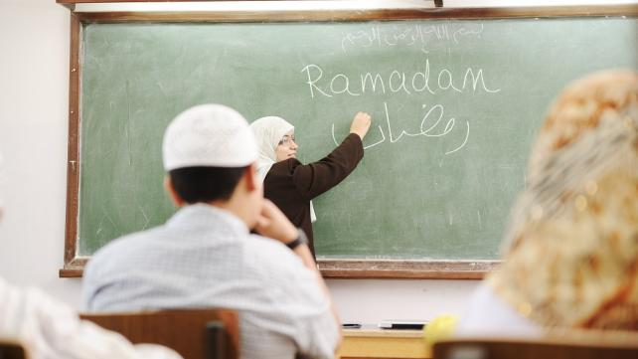
Dr. Zaher Sahloul
Ramadan is the month of mandatory fasting for all able adults without valid exemptions. Simply stated, fasting in Ramadan is the act of complete abstaining from food, drink, smoking, and intimate spousal relationships from dawn to sunset everyday for the whole ninth month of the Islamic calendar.
It is culminated in the Night of Power, when the Quran was revealed to the Prophet Muhammad, peace and blessings be upon him, and when all-night worship is equal to that of a lifetime. Ramadan is concluded in the celebration of Eid, when families and the community meet to congratulate each other of a new beginning after a month of soul-searching, worship,and reflection. It is a powerful platform for rebirth of individuals, families, and communities.
However, many observant Muslims forget that beneath the simple definition of fasting lies more complex behavioral expectations. Why would God ask the believers to abstain from life-sustaining necessities and pleasures for a whole month? Is it only to make them hungry and thirsty for His sake so they can prove that they are good believers? Or are there other achievable and beneficial goals?
The Quran says clearly speaking about fasting in Ramadan, “God does not want to make it difficult for you but He wants to make it easy”. As in all rituals and acts of worship, there are deeper purposes, or Makased in Arabic. Abstaining from food and drink is only the minimum requirement. Fasting believers are also expected to reflect on the mercy of the month in their daily interactions, behaviors, and relationships.
By changing their daily regimen for a whole month, they are expected to change themselves by breaking bad and harmful habits and quitting any addictions that have crept into their lives in the other 11 months of the year. Breaking bad habits is not easy, but Ramadan gives us a whole month to do so. God invites us in Ramadan to exert our effort to change ourselves, our families, and our community by embracing a simple paradigm: If you are able to abstain from what is lawful and life-sustaining, i.e. food and water, shouldn’t you be able to abstain from what is harmful and unnecessary?
Early believers probably understood the deep purposes of fasting intuitively, as they wholeheartedly embraced their faith. With time, and not unlike other religions, Islam and its rituals became more cultural practices than a fully embraced and understood way of life. Muslims, or the majority of them, focused on the acts of worship, not on the substance, and on the "how", not on the "why". When it comes to Ramadan, we tend to trivialize our fasting by indulging in acts and practices that run counter to the very essence of the month.
Here is a short list of trends and practices that are counterproductive to the essence and purpose of fasting. You have the whole month to cleanse yourself from them:

1. Arguing over the Hilal or moonsighting.
The Islamic, or Hijri, year, like the Jewish year, is based on the lunar calendar. The lunar year is about 11 days shorter than the Gregorian year, and that is why Ramadan keeps moving earlier and spans all seasons.
Ramadan is the ninth month of the Islamic year. The lunar month starts by the birth of a new moon. The birth of a new moon can be determined by moonsighting by naked eye, telescopes, or by scientific calculations. The beginning of the month may be different from country to country based on geography. The majority of Muslim scholars are with the opinion that Muslims, living in one country or throughout the world, should start and end the month together.
But some disagree and follow other criteria with varying degrees of flexibility or rigidity. Many Muslims spend hours arguing whether Ramadan started or ended based on which criteria, often with minimal knowledge of the topic. Don’t waste time arguing about this issue. Leave it to the experts. Instead, focus on starting your month on a strong footing. Set certain achievable goals for you and your family. Learn something that may benefit yourself and your community and avoid the unnecessary knowledge.

2. Overeating and indulging in food, drinks, and sweets.
Fasting should teach us self-control and discipline over our bodies and over what we consume. We should eat in moderation after breaking the fast and try to lose some weight. Focus on nutritious, not junk, fatty, or high calorie food. Eat local, seasonal, Halal, wholesome and green.
Learn how to cook and eat healthy. Exercise after Iftar. A brisk walk is good exercise even for 30 minutes every night. Taraweeh prayer is also good exercise. We have an epidemic of obesity and the epidemic of the "fattening of America,”. At least 66 percent of adults are overweight or obese and there is a compelling argument to be made that we should eat less, lose weight, and be more conscious of our health.
The Prophet Muhammad, God's peace and blessings be upon him, taught us moderation and self-control in all aspects of life, and forbade us to harm ourselves, others, or nature.

3. Doing what is harmful.
The concept of sin, or Haram, in Islam includes all what can harm self, family, community, or nature. In general, actions are permissible unless there is credible and corroborated evidence of otherwise. Intentional eating and drinking will definitely nullify the physical part of fasting, but there are other deeds and behaviors that will undermine the essence of fasting rendering the physical part meaningless.
Ramadan is your chance to avoid harm to your body, mind, faith, family, wealth, community, and Earth. How about quitting smoking and other addictions? How about mending the relationships with your close and extended family members?

4. Cheating, lying, backbiting, gossiping, slandering, false accusations, or spreading rumors.
Social media has made it easy to spread all kind of rumors and falsehoods. Quitting the pleasure of tasting food and water is the minimum of fasting, but what is more important is quitting what may ruin relationships and weaken ties within your family and the community. Those who lie and hurt other people while fasting gain nothing but thirst and hunger. Backstabbing, gossiping, and spreading falsehood is likened to the eating of flesh of a cadaver in the Quran.

5. Increased consumption, waste, and overspending.
Fasting is not an excuse for wasting too much food or overspending. If anything, it is a time for saving on your meals and spending on others’ meals. Feed the poor and the refugees, invite relatives and friends, but do not show off or compete in overspending. As it turns out, we waste an incredible amount of food - an estimated 27 percent of food available for consumption - and it happens at the supermarket, in restaurants, in cafeterias, and in our very own kitchens. That breaks down to about a pound of food for every American, wasted every single day. If we can cut down our calories, why not cut down our carbon production?
We are created to take care of the Earth not to take over it and ruin it. Make your Ramadan “green” by reducing your carbon footprint. Calculate your footprint in the beginning of the month and set realistic goals to shrink it by the end of the month? Global warming can be dampened by replacing your light bulbs by LED, using high efficiency appliances and reducing fossil fuel consumption. Invest in fuel-efficient or electric vehicle and carpool to the Masjid.

6. Laziness and oversleeping.
Fasting is not meant to disrupt work or change your circadian rhythm. Some people use fasting for not working, and they don’t feel motivated to perform their daily routines. Some countries slow down significantly during Ramadan. That is not consistent with the tradition of the Prophet. Don’t change your work schedule. Pray Taraweeh after Iftar, and sleep for six to seven hours at night. Beware of sleep deprivation or oversleeping. Both are harmful. A power nap in the afternoon is a good idea, but don’t nap more than 30 minutes unless you are sleep deprived. The five calls for ritualistic prayer remind Muslims to get up early in the day and succeed in work, so get busy working even if you are fasting.
Wasting time by watching TV, playing video games, and browsing social media. Social media has became the new addiction. We spend an average of four-and-a-half hours every day watching TV. Adults in the United States devote about 10 hours and 39 minutes each day to consume media, including our tablets, smartphones, personal computers, multimedia devices, video games, radios, DVDs, DVRs and TVs.
In Muslim-majority countries, TV channels compete in showing their best programs during Ramadan. There is nothing wrong in watching media in moderation. But time is precious. If people are spending over 50 hours a week with media for entertainment purposes, then there's really no time left for any of the other things we value. Too much screen time and other inactive behaviors have also been linked to the risk of obesity, especially in children. So this Ramadan, throw out those extra screens, and don't put one in your bedroom. Learn to shut down the iPads and smartphones before you go to sleep and limit the use. Read one or two books. It is much more rewarding.

7. Forgetting the poor.
Ramadan is not an excuse for inviting the wealthy while ignoring the poor. One of the main purposes of fasting is to identify with those who don’t have the means to have three meals or even one meal daily. One billion people on earth suffer from hunger and about 50 million people in the US suffer from food insecurity- a five-fold jump since the late 1960s. When you plan Iftars, remember to invite those who are usually forgotten. Invite the less privileged among your family members, neighbors, and the refugees. Volunteer to feed the homeless in your city's soup kitchens. Make a plan to visit a few refugee families in Ramadan. There are 18,000 Syrian refugees who were resettled among us in the past two years, among them about 150 families in the Chicago area. Iftar is for the family to eat together, and Taraweeh is for the community to come together.

8. Getting angry, insulting others and losing control.
Self-control is one of the main goals of fasting. It is probably a very effective method to sharpen our tools and increase our resilience. By improving our resilience, we are better equipped to deal with stress.
That is why fasting was prescribed and practiced in many faith traditions. Fasting should make us humble, down to earth, kind, and compassionate. Ramadan should teach us patience and tolerance when we are insulted or provoked. It is not an excuse for venting or violence. If you have a problem with anger, fasting might be one of the tools to manage it. Like other communities, Muslims are not immune from domestic violence. If you have a problem with domestic violence, Ramadan may be the best time to address this disease and seek professional help. There are many resources in the community. The Prophet Muhammad, peace and blessings be upon him, said “Whoever dignified women, he is dignified and whoever insulted them, he is not”.

9. Reading of the Quran without understanding.
Ramadan is called the month of the Quran, the Divine Book that was revealed to the Prophet Muhammad, peace and blessings be upon him, over 23 years. The Quran was rehearsed in totality by the Prophet in the month of Ramadan in the last year before he died. Muslims dedicate time every day for reading the Quran. They listen to it in the Taraweeh nightly prayers after breaking the fast. They are instructed to reflect on and ponder about its verses.
Like other Divine texts, it has to be comprehended before it can be implemented. Recent trends in Masjids and Islamic schools are to focus on recitation and memorization of the Quran at the expense of proper knowledge. Proper understanding requires mastery of the Arabic language, its grammar and metaphors, the reasons and purposes of certain verses, their historical context and order, how the Prophet and his Companions reacted to the revelation, and how they applied it in their lives. It is also important to know what is abrogated and what is not, what is general and what is specific, or what is termed the sciences of Quran.
The abhorrent interpretation of certain verses of the Quran by ISIS, Boko Haram, Al-Qaeda and other violent groups, stem from the disconnection between the understanding of the text and its context. These groups, not unlike the Kharijites hundreds of years before them, apply certain texts in situations that do not meet the scholarly understanding of the text. Their extremist ideology, targeting the youth, the new converts, and the vulnerable, is very harmful to Islam and to humanity. It masquerades itself as credible Islamic ideology, but it is not.2
Spend time in Ramadan with your children and discuss with them some of these difficult issues.1 Listen to them carefully and don’t disregard their concerns. Young Muslims are increasingly bullied in schools and are under intense pressure by their peers and the media. They have to feel comfortable to speak freely to their families. Ask local scholars if you are faced with difficult questions.
We must raise the bar this Ramadan and make it a month of positive behavioral and communal change. Quitting eating and drinking from dawn to dusk is only the first step, but what follows is even more significant.
***

Healthy Ramadan

The spiritual and health benefits of Ramadan fasting
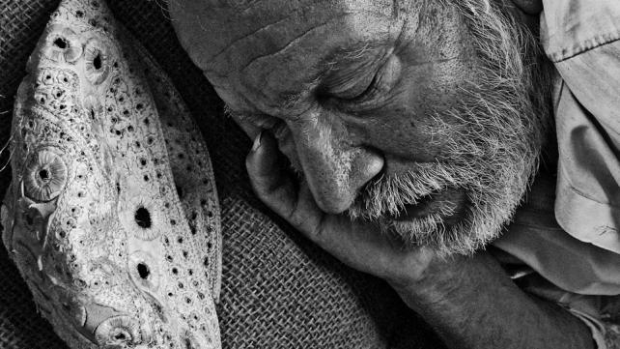
Dr. Shahid Athar
At the onset of Ramadan Muslims all over the world start fasting from dawn to dusk daily for 30 days as ordained in Quran.
"O you who believe fasting is prescribed to you as it was prescribed to those before you so that you can learn Taqwa" (Quran 2:183)1
The Arabic word Taqwa is translated in many ways including God consciousness, God fearing, piety, and self restraining. Thus we are asked to fast daily for one month from dawn to dusk and avoid food, water, sex and vulgar talk during that period.
But why do we need to fast? It is our experience that temptations and ways of the world tend to spoil our purity and austerity. Thus we indulge in food all of the time, snacking and nibbling the whole day, heading to obesity. We drink too much coffee, or tea, or carbonated drinks. Some sexaholics can not stay away from sex unless they do it at least once or more a day. When we argue, we leave our decency aside and resort to vulgar talk and even physical fighting.
Now when one is fasting, he or she cannot do all of that. When he looks at the mouth watering food, he cannot even taste it and he has to give up snacking and nibbling as well as smoking cigarettes if he does. No constant coffee, tea or Coke drinking either. Sexual passions have to be curtailed and when he is provoked to fight, he says " I am fasting that I cannot respond to your provocation". To achieve God consciousness or God nearness, a better word, we are advised to do additional prayer and read the Quran.

Medical benefits of Ramadan
Muslims do not fast because of medical benefits which are of a secondary nature. Fasting has been used by patients for weight management, to rest the digestive tract a1nd for lowering lipids. There are many adverse effects of total fasting as well as of crash diets. Islamic fasting is different from such diet plans because in Ramadan fasting, there is no malnutrition or inadequate calorie intake. The calorie intake of Muslims during Ramadan is at or slightly below the nutritional requirement guidelines. In3 addition, the fasting in Ramadan is voluntarily taken and is not a prescribed imposition from the physician.
Ramadan is a month of self-regulation and self training, with the hope that this training will last beyond the end of Ramadan.3 If the lessons learned during Ramadan, whether in terms of dietary intake or righteousness, are carried on after Ramadan, there effects will be long lasting. Moreover, the type of food taken during Ramadan does not have any selective criteria of crash diets such as those which are protein only or fruit only type diets. Everything that is permissible is taken in moderate quantities.
The difference between Ramadan and total fasting is the timing of the food; during Ramadan, we basically miss lunch and take an early breakfast and do not eat until dusk. Abstinence from water for 8 to 10 hours is not necessarily bad for health and in fact, it causes concentration of all fluids within the body, producing slight dehydration. The body has its own water conservation mechanism; in fact, it has been shown that slight dehydration and water conservation, at least in plant life, improve their longevity.
The physiological effect of fasting includes lowering of blood sugar, lowering of cholesterol and lowering of the systolic blood pressure. In fact, Ramadan fasting would be an ideal recommendation for the treatment of mild to moderate, stable, non-insulin diabetes, obesity, and essential hypertension. In 1994 the first International Congress on "Health and Ramadan", held in Casablanca, entered 50 extensive studies on the medical ethics of fasting. While improvement in many medical conditions was noted; however, in no way did fasting worsen any patients' health or their baseline medical condition. On the other hand, patients who are suffering from sever diseases, whether type I diabetes or coronary artery disease, kidney stones, etc., are exempt from fasting and should not be allowed to fast.
There are psychological effects of fasting as well. There is a peace and tranquility for those who fast during the month of Ramadan. Personal hostility is at a minimum, and the crime rate decreases. Muslims take advice from the Prophet who said, "If one slanders you or aggresses against you, say I am fasting."
This psychological improvement could be related to better stabilization of blood glucose during fasting as hypoglycemia after eating, aggravates behavior changes. There is a beneficial effect of extra prayer at night. This not only helps with better utilization of food but also helps in energy output. There are 10 extra calories output for each unit of the prayer. Again, we do not do prayers for exercise, but a mild movement of the joints with extra calorie utilization is a better form of exercise. Similarly, recitation of the Quran not only produces a tranquility of heart and mind, but improves the memory.
One of the odd nights in the last 10 days of Ramadan is called the night of power when angels descend down, and take the prayer of worship to God for acceptance.
Fasting is a special act of worship which is only between humans and God since no one else knows for sure if this person is actually fasting. Thus God says in a hadith qudsi that "Fasting is for Me and I only will reward it". In another hadith, the Prophet Mohammad (peace be upon him) has said "If one does not give up falsehoods in words and actions, God has no need of him giving up food and drink".
Happy Ramadan to all Muslims.
Shahid Athar M.D. is Clinical Associate Professor of Internal Medicine and Endocrinology, Indiana University School of Medicine Indianapolis, Indiana, and a writer on Islam.
Photo Attribution: Meena Kadri - http://www.flickr.com/photos/meanestindian/266831327/
***

Breaking the habit this Ramadan
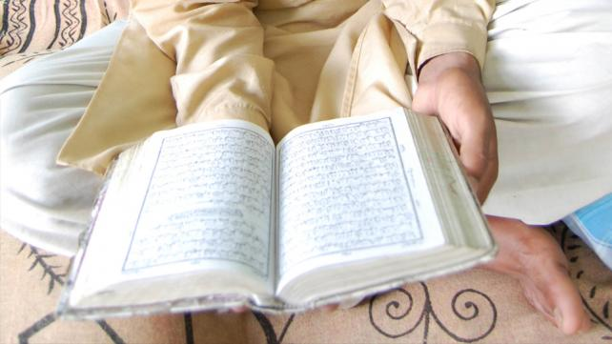
Aya Fadhli
No time of the year is more precious, more awe-inspiring than Ramadan. When it comes, the spirit of Islam is never as alive and visible as this time, when you see your neighbors power-walking to the Masjid post- Iftar so that they can be the first in line for Taraweeh prayer.
It’s no secret that the prayer lines dwindle considerably after Ramadan, as many people fall back into their old routines, leaving the best of their Islamic spirit dormant until next year’s Ramadan.
But you can break that cycle, by breaking your own bad habits. Here are some ways:

Step 1: Make the intention.
Pray that Allah guide you and help you in your goal to break your habit during this time of accepted prayers. Without the help of Allah, no endeavor will be successful.

Step 2: Stay away from things that may trigger the habit.
This includes: seeing the source of your habit or reminders of the bad habit (e.g. if you’re giving up smoking, for example, don’t hang out with smokers), your environment, etc.

Step 3: Stay occupied (at least for the time being).
Indulge in the practices that make Ramadan so special. This can mean:
a. having Halaqas (Islamic study circles) with supportive friends
b. finishing/studying the Quran or memorizing a chapter
c. volunteering at a local Masjid/shelter/school/food pantry
d. listening to educational and Islamic products
e. meditating/reflection
f. stopping by Sound Vision for needed Islamic products, or join our storytelling sessions

Step 4: Find support.
Involve friends and family in helping you break the habit by letting them remind you how badly you want to stop.

Step 5: Apply positive reinforcement.
Reward yourself every day that you stay away from the habit. This could be buying yourself a treat, or simply setting aside a short amount of time for you to indulge in a hobby or activity.

Step 6: Take it one day at a time.
Sometimes breaking a habit or giving something addictive up forever and ever can be a hard concept to wrap our heads around. We convince ourselves that staying days, weeks, and years away from something will be impossible. So don’t worry if it’s hard to break the habit at first. Research shows that it takes an average of 30 days to break a habit (and how convenient! Ramadan is just long enough to be the perfect bad-habit-breaking time of the year). So just take it one day at a time. Get through the first day, and then get through the second, and third, and so on. And before you know it, you’ve been “clean” for a whole month (or longer)!
Photo Attribution: Vishal Dutta - http://www.flickr.com/photos/39809462@N05/3866607351/
***

23 tips to help moms organize for Ramadan

Kiran Ansari
"O Allah! Bless us during Rajab and Shaban, and let us reach Ramadan (in good health). Ameen.”
When I told a friend that I was doing research for an article on preparing for Ramadan, she said: “What are you going to write? We know everything there is about Ramadan. We’ve been hearing it over and over again!”
It’s true that Ayahs and sayings related to Ramadan will be the same, because our Deen is complete and will remain so till the end of time. But the fact that we have heard them many times makes us more accountable. We have no excuse to forget the guidance. We shouldn’t tune out thinking, “Oh, I’ve heard this before.” Instead, we need to pay extra attention to revising, internalizing, applying and then sharing this knowledge.
For instance, your husband has asked you to pay the telephone bill. If he reminds you once, you could forget. But if you forget after being reminded several times and seeing that note stuck on the refrigerator, you will be left with a late fee and a lot of explaining to do. You heard the same message over and over again and still paid no attention.
Alhumdu lillah, we have been taught the basic tenets of Ramadan since we were children. Let’s make Dua to take it a step further this year. We are the selected recipients of this blessed month. There are many non-Muslims and Muslims alike, for whom Ramadan comes and goes without making an iota of difference in their lives. Allah says that unlike other acts of worship, fasting is only for ME. What an honor! We have the opportunity to do something, for which Allah will personally decide the reward.
Just like we make preparations well in advance when a favorite guest is coming, we have to prepare in advance for Ramadan, so that we don’t waste time during the precious month.

Organizing
- Gather books/CDs/Dua pamphlets in one place, so you avoid wasting precious Ramadan time looking for stuff. If you have loaned some books to a friend or vice versa, see that they get to their respective owners before Ramadan. If you know you have two hours to complete an exam, you wouldn’t want to waste time sharpening pencils or looking for erasers, would you?
- Host or attend a ‘Welcoming Ramadan’ talk and invite friends, who usually do not frequent these circles.
- Plan where you will be going for Taraweeh. Find out which venues welcome women. Make child care and transportation arrangements beforehand.

Shopping
- Make small packets of dates with the Dua for breaking the fast. Pass these out to people in the Masjid, or your family and friends two weeks before Ramadan. This way you can hope for part of the reward each time they break their fast.
- Complete your to-do list or postpone unimportant stuff for after Eid.
- Buy small gifts for the children to mark the beginning of Ramadan. Blow up some balloons and give out candy, so that they know this is a special time. Hang up a Ramadan calendar, so they can count the days till Eid.
- Complete Eid shopping for clothes beforehand. When I was in school, I used to envy my friends, who would go Eid shopping during the last ten days of Ramadan for bangles on ‘Chand Raat’. My mom made it a point to get us what we wanted for Eid before Ramadan began. We might not have understood the beauty of the lesson she was teaching us then, but, Alhamdulillah, now when I make my decisions about Eid shopping, I emulate her. If you really do need to go to the bazaar, get what you need and don’t loiter around.
- Buy Eid gifts for family, friends and domestic help and don’t forget the kids. It is up to us, how important we make Eid for our children. If you’re planning to throw an Eid party for them, do the preparations before Ramadan or schedule the party at least a week after Eid.
- Involve kids in wrapping gifts for the domestic help, so they see you giving them something new, as opposed to your old stuff all the time.

Reflecting
- Make up the missed fasts before Ramadan.
- Plan an ideal day by using the natural pegs of Salah. For example: “Between Fajr and Zuhr, I would like to memorize three Ayahs, and between Zuhr and Asr, I would like to listen to a Seerah CD.”
- Evaluate your previous Ramadan and set goals for this year. Two days of a believer’s life should not be the same, just like each day should be better than the previous one. Similarly, two Ramadan’s should not be alike. Think about what you could have done better and avoid making previous mistakes. Set special, specific goals for the last ten nights of Ramadan.
- Identify time wasters. Is it a talkative friend, an addictive computer game, the TV or surfing the Internet? Resolve to stay away from these things in Ramadan.

Household Duties
- Freeze, freeze and freeze. Samosas, rolls, Kebabs, Chutneys – whatever your family enjoys. Make it beforehand, so you spend minimum time in the kitchen.
- Practice moderation. Fasting is not postponing three meals only to make up for at Iftar. Eat what you like but in moderation, so that you are not so full that you can’t even go in Ruku at Maghrib!
- If you are obsessed about cleaning, do all the detailed tasks before Ramadan, so that you and yours can take a breather. If you are fortunate to have help around the house, plan on being easy on them, as they will be fasting, too.

Socializing
- Limit lavish Iftar parties as much as possible. When you want to share a meal, send Iftar to the Masjid, deliver it to your neighbour in advance or find a deserving family. This way, you’ll be reaping the benefits of providing Iftar without having to take out fancy tableware and wearing your prettiest clothes!
- Take out your phone book and call a relative you haven’t been in touch with ‘because she never calls.’ There might be some hurt feelings or unresolved issues that you can sort out before Ramadan.
- Offer to watch a friend’s child, when she tries a mini-Itekaf for a few hours. She could return the favour on the days she doesn’t have to fast.

Family Time
- Decide on a new Sunnah you want to adopt as a family. Miswak? Wudhu before bed?
- Provide a list of options and have fun choosing.
- Delegate chores to children according to their age. Your work load will be less, and they will get into the spirit of Ramadan.
- Make a Sadaqah box and keep it in the kitchen. Encourage family members to pitch in every day.
This very moment, make Niyah to recharge your batteries and make this the best Ramadan yet. So even if, for some valid reason, you are unable to do all that you have planned, you can get reward for your intention, Insha’Allah.
Reprinted by Sound Vision with permission from the author.

Sample Letter to Boss or Supervisor Regarding Ramadan Schedule
Sound Vision Staff Writer
With the arrival of Ramadan, the first week of the blessed month can be difficult in terms of adjusting to a different eating and sleeping schedule. Most Muslims manage to be back on track by the second week. For others, it may take longer or it may be more difficult.
At work, this can raise questions about productivity and concentration. If you feel it is helpful, inform your boss before Ramadan begins about the coming changes. Every employer is different, and while many, if not most, are very understanding and make allowances for Muslim employees, others may use it as an excuse for discrimination.
If you feel your boss or supervisor is someone who will understand your situation, consider sending this sample letter to them before Ramadan begins. You can adjust the letter according to your needs.

Monday April 23, 2018
Your Name and Department
Re: Month of fasting, Ramadan, which begins May 15
Dear Mr. Staten:
You have always been a supportive boss, and I very much appreciate all you have done for me. I also appreciate the culture of diversity and respect for all cultures and religions here at (NAME OF YOUR COMPANY).
I have prepared this letter to inform you about the upcoming month of Ramadan, a month of fasting for Muslims all around the world.
Ramadan is the ninth month of the lunar Islamic calendar. This year, it is expected to begin on May 15. Muslims are required to fast during this month. The fasting entails avoiding all food and drink between dawn and sunset each day during the month, which lasts 29 or 30 days.
Despite the physical challenges, Ramadan is a time of joy, spiritual fulfillment, and greater God-conscio1usness for Muslims. It also makes us more sensitive of our duty to share our blessings with those in need.
I have fasted for over a decade, even during work hours here at (PUT IN NAME OF YOUR COMPANY). Although this has not affected my productivity on the job, it has not been easy. Avoiding food and drink during the day, while staying awake later at night to engage in extra prayers and acts of worship during Ramadan, can make one sluggish during some parts of the day.
With this in mind, I would like to request these three accommodations during Ramadan that can make the work hours easier for me, as well as other Muslim employees at (NAME OF YOUR COMPANY):
- Allowing a work schedule change just for this month jso that an employee can come in later and leave later. Or if they prefer, arrive very early and leave early
- Set aside an empty room where employees can pray and/or take a short nap during lunch break
- Schedule work meetings in the late morning or later in the afternoon (e.g. 3 pm or afterward), when employees tend to be more tired
Thank you for your time and attention. If you would like to discuss this further, please feel free to email or call me at (YOUR NUMBER).
Sincerely,
YOUR NAME
***

A Ramadan Priority: Connecting with Neighbors
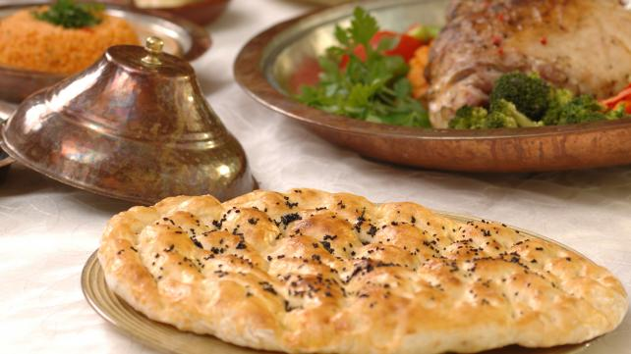
Ammarah Usmani
The current political atmosphere in the United States has been seemingly detrimental for Muslims, but a positive result has been that more and more people are becoming open-minded about Islam and speaking up in support of Muslims.
What better opportunity than Ramadan to show others the spiritual, charitable side to Muslims as well?
This time around, let’s change it up a bit. Let’s make “empathy” the theme of this Ramadan, develop good, caring habits, and keep them up throughout the year. Here are some ideas for reaching out to your neighbors during Ramadan:

1. Show them you care.
Introduce yourself to your neighbors if you haven’t already. Whether they’re Muslim or not, ask how they’re doing as they’re walking to check the mail or playing outside with their kids. It can seem preachy if you just approach your neighbors just to share information about Islam, so develop a friendly relationship first.

2. Send a card.
Everyone likes getting cards instead of bills in the mail. You can make Ramadan greeting cards and write something simple along the lines of, “Happy Ramadan from our family to yours”, or be elaborate and write a few lines about why Ramadan is special for you and your family. Small gestures like these open the door for conversation, and sometimes it’s more effective than just a pamphlet.

3. Share your Iftar.
Make some extra Iftar appetizers one day and bring them over to your neighbors. If you want to be creative, make a small colorful package using a paper container and add dates, chocolates, candies, along with the appetizers. Be sure to label each food item and as a courtesy, list the ingredients in case they have any food allergies, or ask them in person.

4. Share the experience.
You can invite over a few neighbor friends for Iftar, but better yet, if your Masjid holds Iftars on the weekend, invite them there (if they’re willing to come). That way, they’ll see what Ramadan is beyond just the food. They’ll be able to witness the community aspect, people praying together, worshipping together, so that way it’ll be a much more wholesome experience.

5. Show you are a better human being in Ramadan.
Overall, just show your neighbors that Ramadan makes you a better human being. Sometimes we might hear sarcastic remarks about Islam and terrorism, women in Hijab, or other sensitive topics, so responding with a simple smile and calm demeanor can break the strongest barriers of ignorance.
We all feel nice when our neighbors remember us during their holidays, like Christmas and Easter, so returning the favor and being even more generous during Ramadan and later on at Eid can clear the toughest of misconceptions about Muslims.
May Allah allow us to earn the full benefits of this Ramadan and build strong relationships based on mutual respect, care, and empathy with our family, friends, and neighbors. Ameen.
***

Here's how Muslims around the world are preparing for Ramadan

Omam Khalid
Wednesday April 18, 2018

Regardless of their location, Muslims all over the world are eagerly awaiting Ramadan

Lifestyle
Photo credits: blog.tourism.gov.my
The month of Ramadan, along with its many blessings, comes with a lot of joy and excitement. Each year this month comes and this feeling is renewed every time. Muslims all around the world not only fast obligatorily, they also look forward to this blissful month where the devil is chained and there is a greater than before need to be good and do good.
There are nearly 2 billion Muslims all around the world and numerous countries with a Muslim majority and while Ramadan unites the entire Muslim Ummah, each country has her own way of preparing for this sacred month.

Karachi, Pakistan
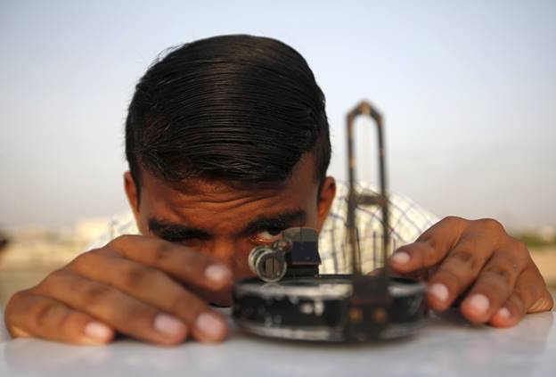
A man adjusts his compass to find the proper direction before installing a theodolite to look for the new moon that will mark the start of Ramadan. (Photo Credits: Akhtar Soomro)

Sidon, Lebanon
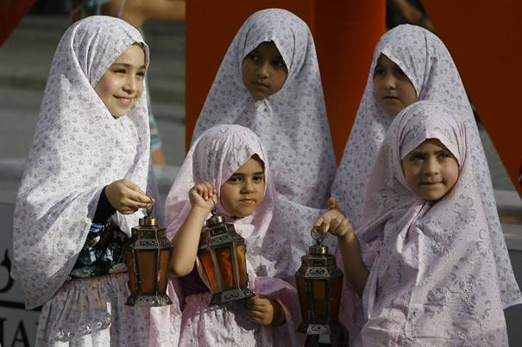
To welcome the holy month of Ramadan, Lebanese girls hold traditional lanterns during street performances in a small city of Sidon, Lebanon. (Photo Credits: Mohammed Zaatari)

Jakarta, Indonesia
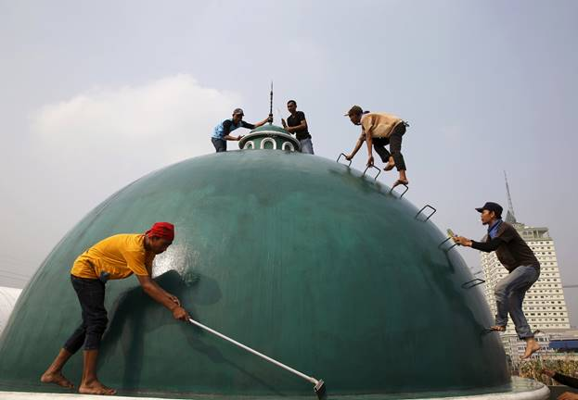
Before the arrival of Ramadan, the Youth of Jakarta clean the dome of a mosque. (PhotoCredits: Beawiharta)

Kabul, Afghanistan
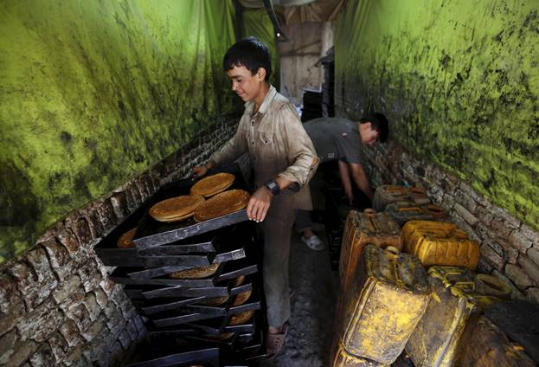
Ramadan, in addition to the blessings and goodness, brings with it a whiff of food and festivities. A young boy in Kabul prepares cookies at a small traditional factory to welcome the month of Ramadan with a tinge of sweetness. (Photo Credits: Mohammad Ismail)

Old Jerusalem, Palestine
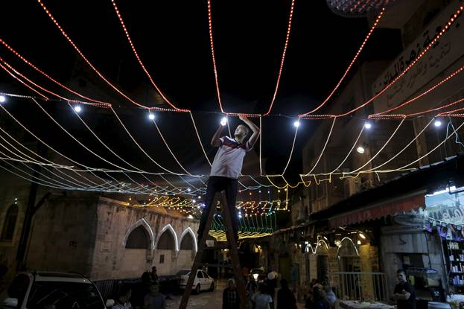
A young Palestinian man in Jerusalem’s Old City lights up his home and sets up decorations for the arrival of the holy month. (Photo Credits: Ammar Awad)

Yala, Thailand
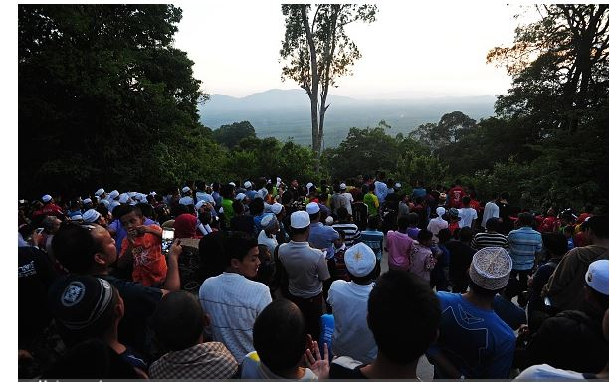
Muslims in Thailand gather around the local market to spot the first crescent of the moon, marking the beginning of the month. (Photo Credits: Madari Tahlala)

Paranaque, Philippines
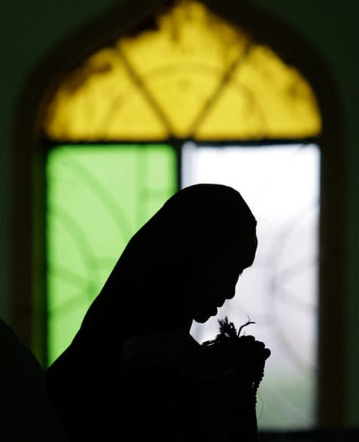
Filipino woman prays to welcome Ramadan and its blessings. (Photo Credits: AP)

Baghdad, Iraq
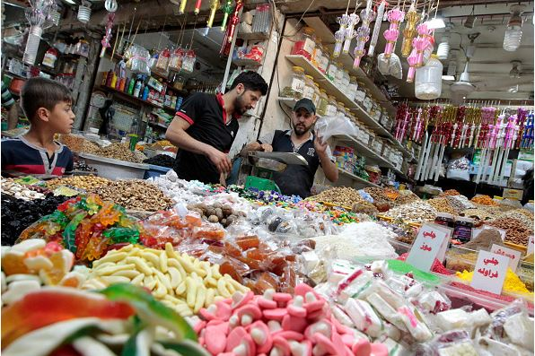
People in Iraq prepare and shop at the local market for Iftar and Suhur. (Photo Credits: Sabah Arar)

Jeddah, Saudi Arabia
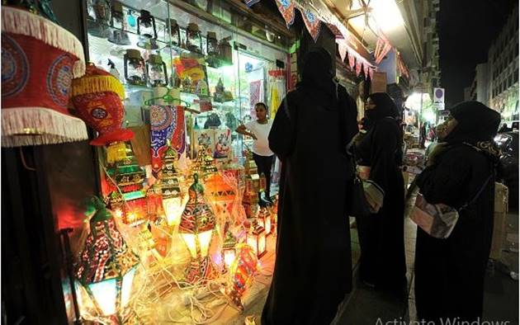
In the city of Jeddah, women look to buy ‘Fanous’ – a traditional lantern – sold specifically during the month of Ramadan. (Photo Credits: Stringer)

Amman, Jordan
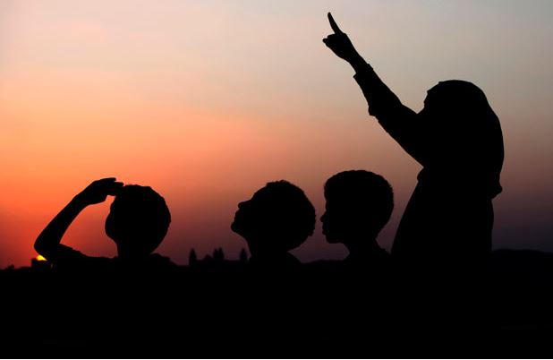
Children eagerly waiting to see the moon to begin a month of fasts and prayers.(Photo Credits: AP)

Cairo, Egypt
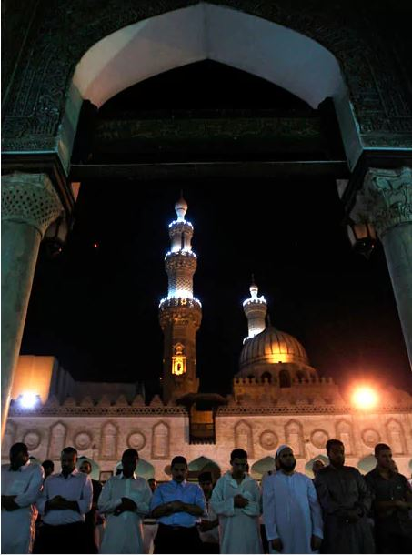
Muslim men attend evening prayer at Al-Azhar mosque in Cairo. (Photo Credits: Reuters)
It doesn’t matter which part of the world it is, Muslims all over eagerly wait and anxiously prepare for Ramadan. All month, there are elaborate Iftar and Suhur where families get together to eat and pray, to remember Allah Almighty and to cherish togetherness and sharing.
Ramadan creates in the entire Muslim Ummah a solidarity that should be cherished and an eagerness that can be seen in each and every Muslim, without any discrimination.

Salam Ramadan

Hamda Abdul Rauf
Wednesday March 21, 2018

This Ramadan find all your answers on IslamicFinder

Lifestyle
As Muslims worldwide are awaiting the Holy month of Ramadan, IslamicFinder has launched its distinguished Ramadan 2017 page, to help Muslims observe the Holy month with zeal and zest. In a few days, around 2 billion people around the world will welcome Ramadan, fasting from dawn to sunset and gather with families and loved ones for meals, laughter, and stories.
So, whether you want to know about the blessings of Ramadan, foods Muslims eat in different parts of the world in this holy month, or get to know the things you can do when you’re fasting, our featured page will help you connect and celebrate Ramadan with millions of Muslims.
Here are some noticeable features of the page.

Ramadan Calendar
On Ramadan 2017 page, you are going to get a customized Islamic calendar featuring suhoor and iftar times of your location. You can print the calendar and hang it in your house or a Masjid near you to help fellow Muslims.

Zakat Calculator
Finding it hard to calculate Zakat? Worry no more. Ramadan 2017 page by IslamicFinder provides an easy to use Zakat calculator to make sure you don’t face any difficulty in purification of your wealth.

Tips for Ramadan
All of us want to give our best in Ramadan and often find it hard to balance deen and dunya in this month. To help the Ummah breeze through Ramadan, we have stocked up Ramadan 2017 page with tips and information about the holy month. From best practices to addressing important issues like making up for a missed fast, Ramadan 2017 page has got you covered.

Dua and Quran
Furthermore, you can find relevant Duas for the three ashra of Ramadan, seher, and iftar. Most importantly, you can recite the Holy Quran with various translations and spend the day in Allah’s remembrance.

Islamic Places
Ramadan promotes a sense of community and motivates Muslims to go to mosques for prayers, suhoor, and iftar. To help you find a mosque near you and get you connected to the local Muslim community in case you are traveling, we have added the feature of Places on our Ramadan 2017 page.
With Ramadan 2017 page, we hope to answer all your Ramadan related questions and help you make the most of this month.
Let’s all welcome and celebrate Ramadan together. Ramadan Kareem!

***

EXPLORE RAMADAN 2018

Get access to Articles, Ramadan Calendar, Duas, Quran and much more!

Ramadan 2018
- Home
- Islamic Calendar
- Special Islamic Days
- Ramadan 2018

Ramadan 2018

27 Days to go
Estimated: Wednesday, May 16, 2018

Salam Ramadan

Ramadan 2018 will begin on Wednesday, 16th May 2018 and end on Thursday, 14th June 2018. Eid ul Fitr Date will be on Friday, 15th June 2018. This is the tentative date as the actual date is contingent on the sighting of the moon of Ramadan, the 9th month in the Islamic calendar. The length of the Month varies between 29 and 30 days depending on the sighting of Shawwal Moon which leads to the festival of Eidul Fitr on 1st Shawwal.

Eid al Fitr 2018
- Home
- Islamic Calendar
- Special Islamic Days
- Eid al Fitr 2018

Eid al Fitr 2018

57 Days to go
Estimated: Friday, June 15, 2018
SHARE
Eid al Fitr 2018 will be celebrated on Friday, 15th of June 2018. This is the tentative date as the actual date is contingent on the sighting of the moon of Shawwal, the 10th month in the Islamic calendar.

Eid ul Fitr is celebrated on the 1st of Shawwal, after the month of Ramadan 2018. The month of Ramadan culminates with the festive occasion of Eid al Fitr as Muslims thank Allah (SWT), celebrating the festival with religious fervor.

The month of Ramadan is full of celebration and festivity as the Muslims immerse themselves in reading the Quran and Duas and spending maximum time doing Dhikr. The Muslims fast the whole month as it teaches them the true meaning of perseverance and tolerance while being empathetic towards the poor and needy.

At the end of the month, the Muslims are rewarded with the festival of Eid al Fitr. It is important to note that it is forbidden to fast on the day of Eid.

Each country’s celebrations vary as there is an influence of thei to their traditions. Muslims all over the world celebrate the festival of Eid al Fitr by starting the day with the Eid prayer. After the Eid prayers, people greet each other with the customary Eid greeting, Eid Mubarak with a formal embrace, three times. The day is spent with friends and family as they get together indulging in eating and handing out Eidi (gifts given to kids on Eid). Everyone gets new clothes made for the special occasion as every single person wants to look his/her best. The festival revolves around the theme of togetherness and happiness. In essence, Muslims celebrate the blessings bestowed upon them by Allah (SWT).

Eid al Fitr 2017

Special Islamic Days
Eid al Fitr 14 Jun, 2018
Eid al Adha 2016 20 Aug, 2018
SEE ALL ISLAMIC DAYS
Frequently asked questions
- Q When is Eid al fitr in 2018?
- Q What does Eid al-Fitr mean?
- Q How is Eid al Adha different?
- Q How is Eid al Fitr celebrated?
- Q What is Eid in Islam?

See Ramadan Calendar 2018.
Table of Contents:
- History and Obligations
- Ramadan Practices and Blessings
- How to Fast?
- Suhur
- Iftar
- Recite Quran Kareem
- Lailat ul Qadr
- Nightly prayers (Tarawih)
- Zakat
- Itikaf
History and Obligations
Ramadan (also known as Ramzan, Ramadhan, or Ramathan), observed by Muslims worldwide, is one of the Five Pillars of Islam. The word itself comes from the Arabic root “ramida” which roughly translates as “Scorching Heat”. Fasting was made obligatory on all adult Muslims in the SecondYear of Hijri (Migration from Makkah to Madinah of Muslims). The only people exempted from keeping a fast are the ones who are travelling, aged, pregnant, diabetic, chronically ill, menstruating or breast feeding. Many children endeavour to complete as many fasts as possible as practice for later life.

Ramadan Practices and Blessings
Ramadan, the 9th month of the Islamic Calendar, is considered one of the most blessed months in Islam. Muslims fast during this month, doing maximum Dhikr of Allah (SWT). The month of Ramadan culminates with the festive occasion of Eid ul Fitr as Muslims thank Allah (SWT), celebrating the festival with religious fervor. This month is full of celebration and festivity as the Muslims immerse themselves in reading the Quran and Duas and spending maximum time doing Dhikr. The Muslims fast the whole month as it teaches them the true meaning of perseverance and tolerance. During this month, Muslims are not only supposed to refrain from eating and drinking during the stipulated timing but they are also required to curb all negative emotions like anger and prove themselves to be the perfect Muslim. Moreover, the Quran was also completed in this month.

Check our Featured Ramadan Page from last year and start preparing for Ramadan: Ramadan 2017
How to Fast?
A Fast (sawm) is kept by Muslims from dawn to sunset, timings of which varies in every region. During this time, they refrain from eating food, drinking, smoking and engaging in sexual relations. In Ramadhan, Muslims also strive hard to refrain from any sinful behaviour such as lying, cursing, false speech. The food eaten before sunrise is known as Suhoor, and the one eaten after sunset is known as Iftar. During these times, Muslims spend generously to make the food available for whole community (specially the poor one). The rewards of all Good Deeds are increased during the Month of Ramzan, whether it is praying salat or giving charity. This Hadith testifies this fact as well:
"When Ramadan arrives, the gates of Paradise are opened and the gates of hell are locked up and devils are put in chains."(Sahih al-Bukhari 1899)
Suhur
Each day, before dawn, Muslims observe a pre-fast meal called the suhur. After stopping a short time before dawn, Muslims begin the first prayer of the day, Fajr. Suhur (or sahari) is the pre-dawn meal which is very important during Ramadan since that is what one’s body thrives on all day and should be carefully planned for a steady diet plan that helps you stay healthy.
Dua for Suhur
Iftar
At sunset, Muslims get together for the iftar Meal to break their Fasts. Just after listening to Maghrib Athan, they recite the Iftar Dua to ask Allah for His sustenance. Dates are usually the first food to break the fast. Prophet Muhammad (SAW) broke fast with three dates according to some traditions. Here are the benefits of Dates:
Social gatherings very frequently happen at iftar. Traditional dishes are often highlighted, including traditional desserts, and particularly those made only during Ramadan.
Dua for Iftar
Recite Quran Kareem
In this Holy Month, Muslims are encouraged to Recite Al Quran. Ramadan is a month to remember this biggest blessing and source of guidance mankind was ever given. Tarawih is one of the way Muslims complete the recitation of Holy Quran which are held in Mosques. It is Mustahab (An action which is rewarded, but whose omission is not punishable) for the Muslim to read whole Qur'an during Ramadhan and to strive to complete it, but that is not obligatory. Some Muslims do it by Completing 1 Juz' each day for the 30 Days of Ramadan.
Here is the collection of some of the Verses in Quran about Ramadan.

Lailat ul Qadr
Lailat ul Qadr, also called the ‘Night of Power’ is one of the most coveted nights of the Islamic Year. It is one of the last ten odd nights in the month of Ramadan and is full of blessings. It please Allah (SWT) to see the Muslims fasting during the month to please Him. This month of Ibadah ends with the Muslim festival of Eid ul Fitr.
Learn How to determine the Date of Lailatul Qadr

Nightly prayers (Tarawih)

Tarawih are the extra prayers some Muslim Communities perform at night after Isha Prayers in the Islamic month of Ramadan. They are not mandatory Prayer but are still of utmost Importance.
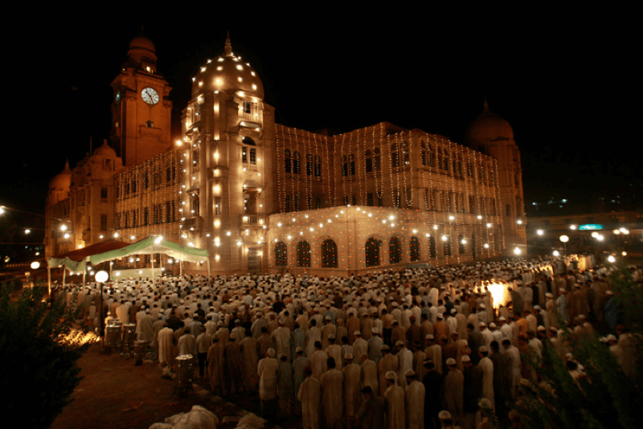
Zakat
Zakat is another Pillar of Islam, and giving Charity becomes even more important during Ramadan. It is a way to purify your wealth for the will of Allah (SWT) and is payable on assets owned over one lunar year. The collected Zakat is required to be given to the poor and deserving people. You can calculate this year’s Zakat using IslamicFinder’s Zakat Calculator. In Ramadan, all good deeds are rewarded more than in any other month of the year. This is the why many people choose give Zakat (Sadqa) to poor in this Month.
Here are the Ways to be charitable in Ramadan.

Zakat calculation and its significance

Omam Khalid
Monday April 16, 2018

Zakat purifies your wealth and brings you closer to Allah.

Knowledge
Zakat is one of the five pillars of Islam on which the foundations of the religion stand. It refers to the giving of alms to the poor and needy among the Muslim Ummah. It is obligatory on every adult Muslim who owns a specific amount of wealth and/or savings.
The Prophet (PBUH) said:
“Do not withhold your money, (for if you did so) Allah would with-hold His blessings from you” (Bukhari 2:24:513)
In another hadith, with respect to the importance of Zakat, Abu Hurairah (RA) narrated:
Allah's Apostle said, “Whoever is made wealthy by Allah and does not pay the Zakat of his wealth, then on the Day of Resurrection his wealth will be made like a bald-headed poisonous male snake with two black spots over the eyes. The snake will encircle his neck and bite his cheeks and say, 'I am your wealth, I am your treasure.'”(Bukhari 2:24:486)
The idea behind giving Zakat is that of purifying your wealth and property and giving some away in the name of Allah Almighty who is the Most Merciful and Benevolent. In the Quran, Allah says:
“[Alms are] for the poor who have been restricted for the cause of Allah, unable to move about in the land. […]”. (Quran 2:273)

Who deserves Zakat?
“The alms are only for the Fuqara (the poor), and Al-Masakin (the needy) and those employed to collect (the funds); and to attract the hearts of those who have been inclined (towards Islam); and to free captives; and for those in debt; and for Allah’s cause, and for the wayfarer (a traveler who is cut off from everything); a duty imposed by Allah. And Allah is All-Knower, All-Wise.” (Quran 9:60)

How to calculate?
Zakat is payable on the amount of savings and wealth left after expenditure for subsistence. This amount is known as Nisaab, which must be equivalent to 85 grams of gold or 595 grams of silver. In consequence, 2.5% is the amount of money which has to be given as Zakat. However, calculating the amount of Zakat on different kinds of assets is a lengthy task.
For your convenience, you should set a date each year around which you must calculate your Zakat. Zakat is payable on silver, gold, cash along with merchandise that is brought for business. Hence, when the date arrives, you should add up all the payable assets subtracting any debts or current expenditure. The 2.5% is to be paid on whatever assets remain after deduction. Zakat is payable on what remains saved on that particular date (and not on what is spent), making income irrelevant for the purposes of Zakat.
If you are confused as to how you calculate Zakat or what items should be included when making calculations, use Zakat calculator by IslamicFinder.
In the Quran, time and again Allah says:
“Eat from their fruits, and give the due alms on the day of harvest.” (Quran 6:141)
There is much emphasis on giving to the needy and poor and each year. Hence if we pay our Zakat on time, we can include these sections of society and play an active part in bettering their conditions, that too in the name of Allah Almighty.
***

Zakat Calculator
- Home
- Zakat Calculator
- Gold & Silver
- Cash & Property
- Debts & Liabilities
- Summary
Getting started
Zakat is one of the Pillar of Islam and a way to purify your wealth for the will of Allah (SWT). It is payable on assets owned over one lunar year. It is calculated as 2.5% of the total wealth.
The collected amount is paid first to zakat collectors, and then to poor Muslims, to new converts to Islam, to Islamic clergy, and others.
To start calculating your zakat this year, click on the button below.
Base Nisab on value of
STAR
***

Itikaf
Itikaf means to be in isolation in a Masjid or at home with the intention of solely dedicating your time to the worship of Allah (SWT). It is Sunnat-al-Muaqidah (Sunnah that is urged to be performed) to sit in Itikaf in the last 10 days of Ramadan. A person may commence Itikaf after sunset of 20th of Ramadan, and end it when the moon for Eid is sighted. The Sunnah stays the same if the month of Ramadan is of 29 or 30 days.
Here is All you need to know about Itikaf in Ramazan.

All you need to know about Itikaf

Hamda Abdul Rauf
Wednesday March 21, 2018

It is Sunnat-al-Muaqidah to sit in Itikaf in the last 10 days of Ramadan.

Knowledge
Picture by: Erman Aydoner
Itikaf means to be in isolation in a Masjid or at home with the intention of solely dedicating your time to the worship of Allah (SWT).
It is Sunnat-al-Muaqidah (Sunnah that is urged to be performed) to sit in Itikaf in the last 10 days of Ramadan. A person may commence Itikaf after sunset of 20th of Ramadan, and end it when the moon for Eid is sighted. The Sunnah stays the same if the month of Ramadan is of 29 or 30 days.
You may sit in Itikaf at any other time of the year for any duration. This kind of Itikaf is Mustahib (optional).
It is compulsory for men to perform Itikaf in a Masjid, where they can offer all five prayers in congregation. Women can also perform in a masjid if they have the privacy and necessary facilities. Otherwise, they can practice it at home, selecting a corner where they won’t be disturbed and can meditate in peace.
Here are some points to remember while performing Itikaf.

Daily needs
It is normal to eat, drink, sleep or get something that’s urgently needed. It is highly rewarding to provide food and drink for the people who are in Itikaf.

Ibadah
All things that are considered Ibadah (worship) can be done in Itikaf. A few good deeds are mentioned below:
- Recite Al Quran
- Recite Darood
- Read about Islam
- Make Dua
- Talk/think about the good and righteous things
- Do Taubah (repentance)
- Doing nothing and considering it Ibadah does not count in Itikaf

Leaving your place of Itikaf
You can get up from your place of meditation if you need to use the restroom or do Ghusl (bath for purification), for the Jummah prayer, to get something of need, or if you’re a Muazzin and have to give Athan.

Things to avoid
- Foul talking
- Buying or selling things in the Masjid
- Having a quarrel or fight with someone
- Disturbing other people in Itikaf around you
- Bringing in too many items

Things that nullify Itikaf
- Going out for some need and staying even after the need is addressed
- Leaving your place without any reason
- Having unwanted company while you are in Itikaf

Going for Namaz-e-Janazah
Before sitting in Itikaf, if a person made Niyyah (intention) to attend any Funeral Prayer while sitting in Itikaf, he may go. Otherwise, he shall remain in his place.
May Allah help us achieve the best in this world and the hereafter.

Special Islamic Days
Ramadan 15 May, 2018
SEE ALL ISLAMIC DAYS
Frequently asked questions
- Q What is Ramadan?
- A Ramadan is the 9th month in the Islamic Calendar. Muslims all over the world fast during this month.
- Q When is Ramadan 2018?
- A Ramadan 2018 is expected to start on the 16th of May 2018, Wednesday. The date is tentative and may change subject to sighting of the moon.
- Q When does Ramadan 2018 end?
- A Ramadan 2018 will end on Thursday, 14th of June 2018. The date is tentative and may change subject to sighting of the moon.
- Q When does Ramadan start?
- A Ramadan starts once the month of Sha’ban ends and the moon of the new month is sighted.
- Q What is Ramadan definition?
- A The word Ramadan has been derived from the word ‘ramad’ which means intensely heated by the sun. In Islam, the month of Ramadan has been named after the word ‘ramad’ because during this month, the sins of the Muslims are burned as they fast during this month to please Allah (SWT).
- Q Why is Ramadan celebrated?
- A Ramadan is considered to be one of the most blessed months. Ramadan brings about an air of festivity for the Muslims. The whole month is celebrated to thank Allah for the blessings that have been bestowed upon us and to learn self-control.
- Q What is the main purpose of Ramadan?
- A The main purpose of Ramadan is to teach Muslims self-control and perseverance. Fasting in Quran has been mentioned as an act that helps one to become a better Muslim; “O you who believe! Fasting is prescribed to you as it was prescribed to those before you, that you many learn piety and righteousness" (Quran 2: 183)
***

Ramadan Kareem: The month of blessings and it’s three Ashra

Omam Khalid
Wednesday April 18, 2018

From Allah's blessings to forgiveness to a refuge from Hell-fire, Ramadan is a blissful month!

Knowledge
“Ramadan is the (month) in which the Quran was sent down, as a guide to mankind and a clear guidance and judgment (so that mankind will distinguish from right and wrong)..” (Q 2:183)
The month of Ramadan is one of the most beloved and blessed months in the Islamic calendar. The rewards that a Muslim can reap are manifold and the chance to commit a sin decreased – because no barriers can exist between man and his Lord. The blessings of this month are countless and it is divided into three parts i.e. Ashra (of ten days each).
The three ashra of Ramadan each comes with its own sanctions and recompense: the first ashra is Rehmat which entails “Mercy of Allah”, the second is Maghfirah which involves the “Forgiveness of Allah“ and the third one is that of Najat meaning “Salvation”.

Rehmat
The month of Ramadan begins with the ashra that reflects abundance and blessings. It is indeed a beautiful start to this holy month.
For this ashra a prayer that one must always say abundantly is:

In this ashra, one must seek mercy from the Lord, Who wants nothing more than to bless His Ummah with the glories of life and the Hereafter. A great way to enter the spirit of Ramadan is to extend the same kindness to other fellow Muslim brothers and sisters that Allah extends to us all.

Maghfirah
The second phase of Ramadan is all about asking for forgiveness and peace from the Almighty Allah. Apologize to Him for the past mistakes, alter your deeds and forgive anyone who has wronged you. If Allah can forgive us for our sins and wrongdoings, then we too can extend this courtesy to our brethren who may have wronged us knowingly or unknowingly.
A Muslim should invoke God’s mercy and forgiveness throughout the second ashra via this dua:
ASTAGHFIRULLAHA RAB-BI MIN KULLI ZAMBIYON WA-ATOOBUILAIYH
“I ask forgiveness of my sins from Allah who is my Lord and I turn towards Him.”

Nijaat
Regarding the last ashra of the holy month, Hell fireUthman bin Abi Al’As has narrated that the Messenger (PBUH) of Allah said in a hadith:
“Fasting is a shield against the Hell Fire, same like the shield of any one of you in battle”. (Sunan Nasai 311:1)
When God has presented us Muslims with the opportunity to seek refuge Hellfire and wrath that we will have to face in the Hereafter, then it should be a privilege for us to accept this opportunity and do justice with it.
A prayer that should be said incessantly during this third and final ashra is:

In addition to this, one of the most significant nights of the Islamic year is also hidden in the last ten days of the month of Ramadan. It is the “Night of Power”, known as Laila tul Qadr, the night on which the Quran was revealed and which marked the beginning of the journey of the Prophet (PBUH) as a guide to the Muslim ummah.
“We sent it (Quran) down on a blessed Night. Verily, We are ever warning. Therein (in that Night) is decreed every matter of ordainment. Amran (i.e. a command or this Quran or His Decree of every matter) from Us. Verily, We are ever sending (the Messenger) (As) a Mercy from your Lord.” (Quran 44: 3-6)
Not only does the last ashra protect us from the fires of hell, but it also offers an opportunity to start over.
Another act to be done in this ashra is sitting on Itikaf and observe Nafl and pray to the Lord while distancing yourself from the worldly affairs and seek sanctuary from all that is evil, waiting for us in the Hereafter.
So utilize the opportunity this month brings with itself and create a stronger bond with Allah Almighty who is All-Merciful, All-Forgiving and Majestic.
***

Spiritual benefits of Fasting by Imam Ghazali

Mohammad Ahmed Shiwani
Monday April 16, 2018

Ramadan not only teaches us perseverance but has numerous benefits for our spiritual being.

Lifestyle
Why is it that Ramadan seems to have such a profound impact on our spirituality, particularly given the physical hardships that it entails? The most distinct feature of Ramadan is that it requires able Muslims to fast the entire month. The fact that this distinct feature correlates with the auspiciousness of the month is perhaps testament to how important and beneficial fasting is. Indeed, the activity entails immense spiritual benefits that lay the foundations for the spiritual uplift we witness during the month. Since we are often unaware of these benefits, this article aims to briefly introduce how, ironically, fasting is food for the soul.

1. It weakens your nafs
The nafs is the component of an individual that compels them towards their animalistic desires. Each individual is responsible for controlling and overcoming these desires. Imam Ghazali writes that physical easements are the source of strength for the nafs, including food and drink. The logical conclusion, therefore, is that depriving the physical body from food and drink would weaken the nafs, and hence its ability to invite the individual towards evil and sin.
Since good deeds enhance one’s spirituality and bring them closer to Allah (SWT), it is quite understandable that fasting entails a great degree of spiritual benefit, particularly with regards to weakening your ability to sin.

2. It strengthens your soul
Keeping up with the first point, weakening the nafs would naturally mean strengthening the soul, since it is the vehicle through which an individual is inclined towards good deeds and hence towards developing a stronger relationship with Allah (SWT). This is why you feel that heightened sense of closeness to Allah (SWT) during Ramadan; your soul no longer has to battle your nafs in the desire to do good, and it is empowered by the fast, hence the increased willingness to do good.

3. It brings you closer to your thoughts and emotions
You have probably felt an overarching sense of calm and serenity during Ramadan. Quite often, even though the raging hunger of a long fast bothers us, we are calmed down by an overbearing sense of peace. These emotions are the direct impact of a closer connection to Allah (SWT). This calmness also allows us to be better attuned to our own thoughts and emotions, since we slowly drift away from the hurry and fuzz of worldly desires.

4. It relieves you of worldly desires
It is quite often the case that individuals refrain from all things that invite them towards sin during their fast. The natural response is that if one is making an effort to please Allah (SWT), one best not infect that effort by engaging in activities that breed evil and sin. We try to refrain from anger and from expressing our base instincts during Ramadan for this very reason, the natural result of which is a sort of deviation from the traditional chase of our worldly desires and aspirations. Fasting allows us to be more cognizant of ourselves and our actions, which in turn makes us more aware of the unnecessary pursuit of material and inconsequential gains.
In conclusion, while there are immense, visible physical benefits of fasting, the spiritual side of the activity often goes unnoticed. Imam Ghazali and others have spent a great deal of time and effort in outlining these benefits for the Ummah, which just goes on to show how the soul is often neglected in our conception of the world. Let this Ramadan be a portal for a great cognizance of the soul and its role in developing our connection with the Almighty.
***

Ramadan Timetable Calendar Perform to Suhoor and Iftar for all Countries of the world. Printable and Free Download Ramadan Calendar for three language (English, Arabic & French):
FREE Download Ramadan Timetable Calendar by clicking on below link:
http://www.makkahcalendar.o...
http://www.makkahcalendar.o...
http://www.makkahcalendar.o...
***

5 ways to be charitable in Ramadan

Salma Zahid
Wednesday March 21, 2018

Ramadan encourages you to share your blessings with other people.

Lifestyle
Muslim Ummah all over the world is observing the holy month of Ramadan with zeal and zest. The much-awaited time of the year is about to enter its third and last Ashra, with Muslims trying to revitalize their Imaan and cleanse their soul by engaging in long hours of dedicated worship of Allah.
Ramadan is an embodiment of spiritual and physical worship to cleanse you of evil while experiencing the woes of the poor. It is a reminder for Muslims that if Allah has blessed them with abundance, they should be willing to share Allah’s blessings with their brothers and sisters. With the establishment of this fundamental pillar, Islam has asserted that no Muslim can go hungry if the Ummah is united.
Here is how you can be charitable during Ramadan in 5 different ways; little acts that may go a long way to earn you an eternal abode in Paradise.

Help the ones who cannot afford Suhur and Iftar
Be mindful of the people around you who work hard and don’t have the resources to observe Suhur and Iftar. These may be normal workers who are away from their families, working alone in the city to provide for their loved ones. These people may not have the time to make Suhur or Iftar. Please be sure to include them in your happiness, after all, additional flat bread or a plate of fruits will not hurt the household.

Help the ones preparing food for you at home
Please be mindful of the women in the house. It is not their duty to prepare food for Iftar and Suhur. Lend an extra hand; cut the fruits, knead the dough. Men are built to be more robust, make sure you prove that by doing more than your wives and daughters and get your fair share of sawab.

Do not mock the ones who cannot fast
Some people, like the manual labor, may not fast due to the arduous nature of their jobs. Builders and masons work in the scorching heat, which results in tremendous water loss. It’s difficult to fast under these circumstances. Go easy on them and do not condemn them for not fasting. It is a matter of belief. You can hand them over cold water bottles to beat the heat while they work during the day under the sun.

Remember your less privileged brothers on Eid
Save up every day for the Eid and give that money to the poor at the end of the month. They have equal rights to wear new clothes and enjoy the end of this Holy month. Make sure you include them in your happiness.

Instead of wasting food, share your meals with others
Finally, try to provide Iftar for as many people as you can. The excessive food that is mostly thrown away, if shared, might be a meal for somebody. Just by proper planning and management, you can earn a lot of sawab and right your wrongs.

Fasting for the little stars of the Ummah: A step by step guide

Amna Anwaar

Wednesday March 21, 2018

Every adult should make sure that this Ramadan serves as an enjoyable, memorable and long-lasting experience for the little first-timers.

Knowledge
Just like adults, Allah (SWT) works His way into the hearts of children through the acts of prayer and righteous deeds. Growing up in a Muslim household, every child’s curiosity is piqued by the religious traditions followed by the elders in the household but is often unaware of the purpose of these rituals and their benefits. Hence, it is our responsibility as adults to guide them, teach them and help them implement those teachings in their daily lives from a young age. Children tend to respond and evolve on a spiritual level once they are presented with the opportunity to actively participate in these religious rituals like fasting in the holy month of Ramadan.
Almost every other household has young children who decide to venture into the land of bravery and fast for the very first time in their little lives. The children find themselves amidst feelings of excitement, anticipation, and confusion- hence, it is our job as adults to enrich their first experience of fasting and hold their hands through it, steer them in the right direction, and all the while shed light on the purpose and intentions behind the act so they may understand its significance and value.
So how does one keep the youngsters engaged, motivated and excited about fasting in Ramadan? Here are a few tips:

Create a Ramadan Action Plan with them
A fun way to keep the young first timers engaged and excited is to sit down with them and create an action plan before Ramadan starts. This action plan may comprise of the type of fun foods the little ones would like to eat for their Suhurs and Iftars, the small dua’s and surahs they can learn and recite in Ramadan along with corresponding columns of the rewards of their respective recitations, a list of friends they would want to invite to their house for an iftar party etc. This action plan gives them tasks and activities to look forward to and helps them imagine the upcoming events in their month of Ramadan keeping them up and running.

Make them participate in giving Sadqa
Children can also get a good taste of the essence of Islam and experience the goodness that comes with the month first-hand if you get them to engage in Sadqa (charity). Involve them in the giving process and let them help those in need themselves. Once they know how good it feels to help the poor and feed them, they will want to keep going back and helping more. You can also make a daily routine of feeding a certain number of people every day- it will motivate the children and give them a sense of active purpose and productivity this Ramadan. Charity giving eventually instills a sense of empathy and humanity in the child, steering them to continue giving charity in their lives.

Remind them about the joyous occasion of Eid that awaits them
Adults and children alike await the joyous and celebratory occasion of Eid every year. Upon the completion of the blessed Ramadan, Muslims celebrate the festival of Eid-ul-Fitr. So start the preparations of Eid a little in advance and involve the little ones with you. Go shopping for their new clothes and shoes of their liking for the big day and help them put together their outfits- they will love it. Eid is all about exchanging celebratory greetings, gifts, and foods. If the young ones are having a hard day of fasting, remind them of what awaits them at the end of the month for all their hard work and how happy Allah (SWT) will be with them if they spearhead through it.

Give them a purpose
Like adults, children need to be given a sense of purpose. If they do not have a purpose, they will surely lose any semblance of motivation and excitement towards that particular task. Similarly, if you want your child to really dive into the essence of Ramadan, you need to make sure your child understands the significance of the actions being practiced by all Muslims in the month of Ramadan instead of having them go through the automated rituals of worship and righteous deeds. Otherwise, you will find yourself being confronted with questions like “Why are we doing this? It’s pointless” or “What good will this do?”. Hence, make it a point to discuss the importance of each act, such as the daily salah, fasting, giving charity, reciting the Quran etc. Make it easier and lighter hearted for them by telling stories about the Prophets and the Companions, which will help them relate better.

Give them responsibility
You will be surprised to know that children often take responsibility much more seriously than grownups. You can give them roles of leadership in the household so they feel empowered and useful. Assign them tasks like waking up their siblings for Suhur, reminding the household about the daily salah timings and getting everyone to say their prayers, let them plan the menu for the iftar a few times and give them daily tasks to perform in general. This will essentially keep them on their toes and help them remain active throughout the month.
All in all, be creative with your ideas and come up with refreshing and fun ways to keep your children motivated this Ramadan. Every adult should make sure that this Ramadan serves as an enjoyable, memorable and long-lasting experience for the little first-timers.

10 ways to make time for Ramadan's last 10
SAMANA SIDDIQUI
Prophet Muhammad, peace and blessings be upon him, used to exert himself in devotion during the last ten nights to a greater extent than at any other time (Muslim). That should give us the incentive to carefully plan our days and hours so we can too.
16 things you can do on the Night of Power in Ramadan
ABDUL MALIK MUJAHID
The Prophet said: "Whoever prays during the night of Qadr with faith and hoping for its reward will have all of his previous sins forgiven." (Bukhari and Muslim). Here are some tips of things we can do on the Night of Power.

What Not To Do In Ramadan
DR. ZAHER SAHLOUL
Here is a short list of trends and practices that are counterproductive to the essence and purpose of fasting. You have the whole month to cleanse yourself from them.
Fasting During Finals: 6 Ramadan Tips
SAMANA SIDDIQUI
With Ramadan falling during final exams this year, a number of students and their parents are in a tizzy. How can we study efficiently and effectively while fasting during the day and praying late into the night?

Muhammad Ali: Action Items, TalkingPoints & ThinkingPoints [Newsletter 2016-06-06]
SOUND VISION STAFF WRITER
Stay connected with Sound Vision and sign up for our weekly e-newsletter, loading with fresh articles and tips focused on practical Islamic living.

Checklist for Ramadan's first 10 days
SAMANA SIDDIQUI
Ready to dive into Ramadan? Here is a practical checklist for the first 10 days of Ramadan planning to keep you on track!

Ramadan Ready? ThinkingPoints &amp; ActionPoints [Newsletter 2016-05-19]

Ramadan & Media Relations: 18 Ways To Create Positive “Newsworthy” Stories
TAHA GHAYYUR
Creating and pitching a “newsworthy” Ramadan story requires significant planning and legwork, but it’s all worth it. Let the world see the beauty of your faith and culture. Let everyone experience it! What’s there to hide?
Khutba Ideas for Ramadan
TAHA GHAYYUR
A thoughtful and thorough planning of Khutbas in advance will multiply the benefit for millions of Muslims who lend their ears, minds, and hearts for 30-45 minutes every week, especially during the Ramadan and Eid seasons.

Ramadan 2016: 10 things Muslim families can plan
SAMANA SIDDIQUI
Ramadan is a time when Muslims rebuild their faith individually. But this year, we must also focus more on our families. Why? Our children are suffering the most from the Islamophobia. This is why we must urgently plan for Ramadan 2016. Here are some ways to do that.

5 Islamically inspired ideas for youth this summer
SAMANA SIDDIQUI
Food, friends, and fun: the three “f” ingredients of a fantastic summer for most kids. But what’s missing from this recipe is faith – and this is the ideal time to nurture it.

Eid-ul-Fitr 2015 Gift Guide
SAMANA SIDDIQUI
These ten Islamically-inspired gift ideas are an ideal way to reinforce Ramadan’s focus on spirituality, while offering Halal enjoyment and fun.

Newsletter 2015-07-03: Sprinting in Ramadan’s last 10 days & nights || Last 10 to-do list
Stay connected with Sound Vision and sign up for our weekly e-newsletter, loading with fresh articles and tips focused on practical Islamic living.

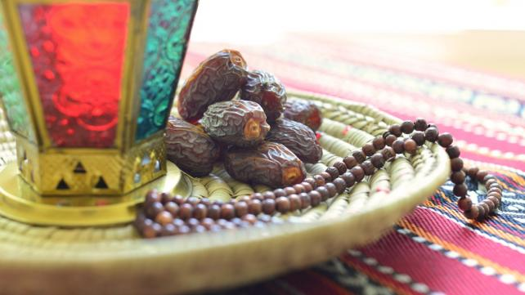

Ramadan: A Meal for Your Brain
TAUFIK ALI VALIANTE MD PHD FRCS
Dr. Taufik Ali Valiante writes, “Ramadan is like a really healthy meal for your brain. A meal that contains all those yummy ketone bodies, habit forming skills, and opportunities to remember Allah.” Find out why and how.
- Read moreabout Ramadan: A Meal for Your Brain

21 easy ways to gain free time in Ramadan
SAMANA SIDDIQUI
The only way we can truly make the space necessary for spiritual development this Ramadan is by freeing up our schedule. Dropping the unnecessary and curbing or rescheduling the necessary are among the best ways to to do that. Here are some ideas.
- Read moreabout 21 easy ways to gain free time in Ramadan

Breaking the habit this Ramadan
AYA FADHLI
It’s no secret that the prayer lines dwindle considerably after Ramadan, as many people fall back into their old routines, leaving the best of their Islamic spirit dormant until next year’s Ramadan. But you can break that cycle, by breaking your own bad habits.
- Read moreabout Breaking the habit this Ramadan

5 ways to welcome Ramadan
SAMANA SIDDIQUI
With barely a few weeks left between us and the blessed month of fasting, it’s crucial to start preparing, not just physically, but also mentally. Here are a couple of quick ways to get into Ramadan mode before it begins.
- Read moreabout 5 ways to welcome Ramadan

Countdown to Ramadan: 7 tips to welcome Ramadan
SAMANA SIDDIQUI
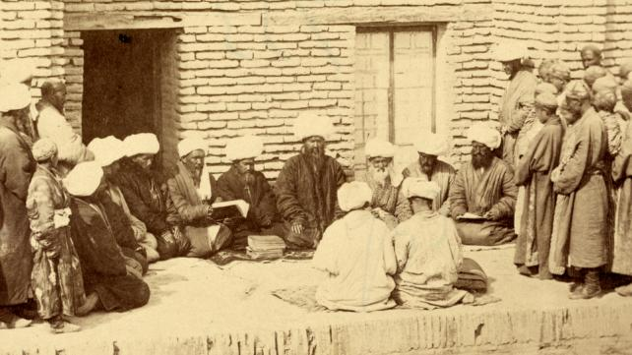

Nine reasons why we must plan for Ramadan
SAMANA SIDDIQUI
Have you noticed that each year, Ramadan goes by faster and faster? One way to make the most of Ramadan is to plan beforehand. Here are nine reasons why you should plan for the blessed month.
- Read moreabout Nine reasons why we must plan for Ramadan

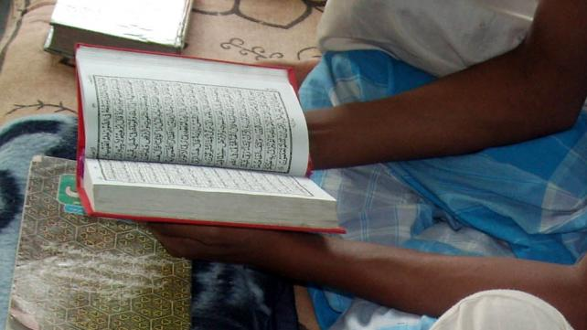

10 great goals to set for this Ramadan
SAMANA SIDDIQUI
Want to make this Ramadan different? Want to be productive? Feel the need to lift up your spirituality? Make your plan for it and set these awesome goals this Ramadan! Remember, if you fail to plan, you plan to fail.
- Read moreabout 10 great goals to set for this Ramadan

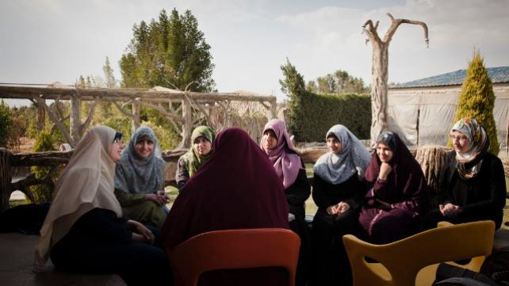

Taking Care of Single Muslims this Ramadan: 5 Ideas
SAMANA SIDDIQUI
It is imperative to reach out to single Muslims respectfully and consistently, especially in Ramadan, a time known for family togetherness and communal spirit. Here are some ways we can start doing that this year.
- Read moreabout Taking Care of Single Muslims this Ramadan: 5 Ideas

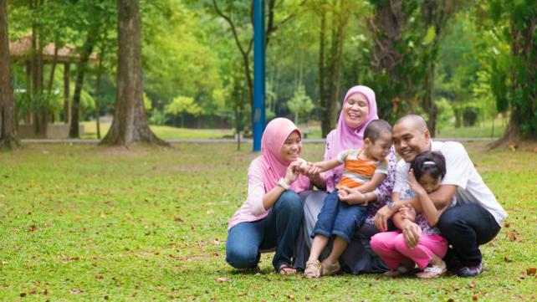

Summer Ramadan Boredom Busters
SAMANA SIDDIQUI
These are some budget-friendly ways to help kids of different ages use their time wisely during the blessed month. Please share your own at the bottom of the article.
- Read moreabout Summer Ramadan Boredom Busters

Ramadan Report Card: The First 10 Days
SAMANA SIDDIQUI
Umar ibn al Khattab, may Allah be pleased with him, once said,”Hold yourself accountable before you are held accountable, and weigh your deeds before they are weighed for you.”
- Read moreabout Ramadan Report Card: The First 10 Days

Reconnect with Family this Ramadan in 20 Minutes or Less
SAMANA SIDDIQUI
If you and your family can commit to a daily Ramadan ritual of 20 minutes or less, it will go far in strengthening not just personal faith, but family bonds as well. Here are some ideas that offer ways to do that.
- Read moreabout Reconnect with Family this Ramadan in 20 Minutes or Less

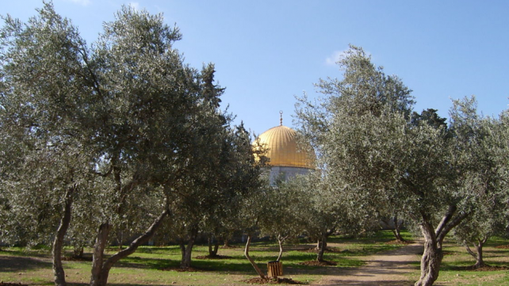

8 ways to handle a summer Ramadan with kids
SAMANA SIDDIQUI
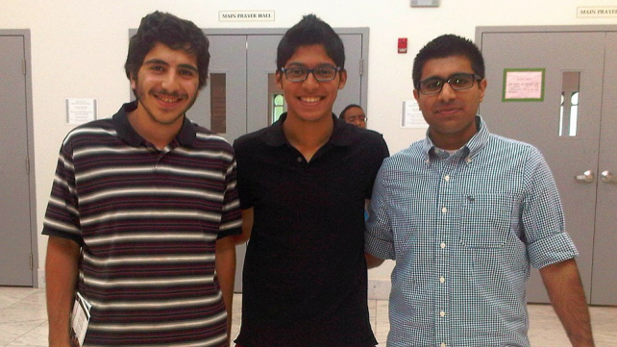

5 Ramadan party ideas for youth
SAMANA SIDDIQUI
Ramadan offers a great opportunity to gather young Muslims for some faith and fun. This is especially important during the summer, when schedules permit more flexibility.
- Read moreabout 5 Ramadan party ideas for youth

5 goals for Ramadan 2012
SAMANA SIDDIQUI
Most of us start Ramadan with great gusto, only to see our enthusiasm dwindle to desperation by the end of the month. These five are just a few examples of a few goals you can aim for in the month of Baraka and spiritual benefit.
- Read moreabout 5 goals for Ramadan 2012

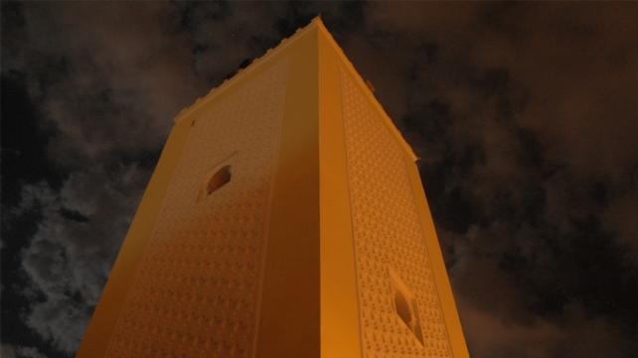

10 to do's for Ramadan's last 10
SAMANA SIDDIQUI
While it’s depressing to think that Ramadan will be over in less than two weeks, the blessed month’s last 10 days offer us a final push to do as much good as we can. Here are 10 things we can do in Ramadan’s last ten blessed days.
- Read moreabout 10 to do's for Ramadan's last 10

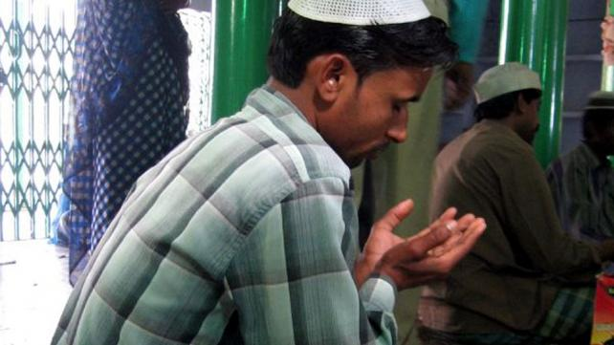

Duas for mercy
ABDUL MALIK MUJAHID
Allah, the most Merciful of all who have Mercy, understands and knows what is in our hearts even before we feel. But He has still encouraged us to ask Him for anything and everything through Dua or supplication.
- Read moreabout Duas for mercy

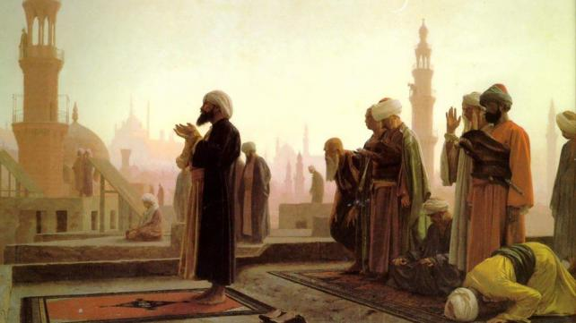

Personal Duas to choose from
ABDUL MALIK MUJAHID
Here are some examples of personal, relevant Duas you can make throughout the year. Please adopt, modify, and write your own.
- Read moreabout Personal Duas to choose from

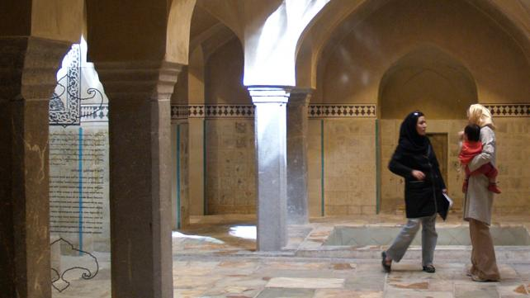

Our duty to Muslims who don't fast this Ramadan
ABDUL MALIK MUJAHID
Yes, there are Muslims who don’t fast, as well as those who don’t know how to pray. Here are some ways we can share the news of Ramadan with others this year and encourage them to fast.
- Read moreabout Our duty to Muslims who don't fast this Ramadan

Eating dollar a day meals this Ramadan
ABDUL MALIK MUJAHID
Over one billion people worldwide live on $1 a day. And that includes everything not just food. Those of us blessed to enjoy a table full of a variety of foods when we break our fasts perhaps don’t consider this.

Your body and your neighbor in Ramadan
SAMANA SIDDIQUI
The irony of fasting all day, claiming to empathize with the hungry, then overeating during Iftar. The dollars spent on lavish fast-breaking spreads and the calories consumed,. It’s an indulgence that affects our relationship with Allah, our bodies, and our neighbors.
- Read moreabout Your body and your neighbor in Ramadan

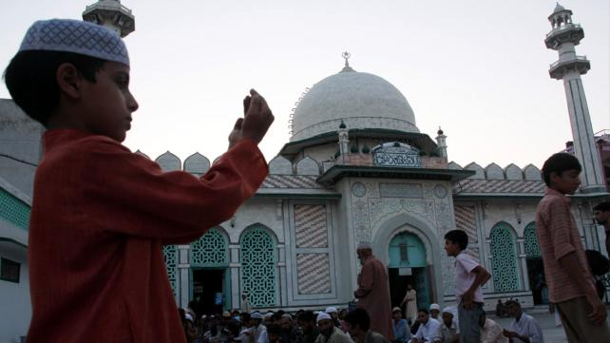

10 goals for Ramadan 2010
SAMANA SIDDIQUI
The beginning of the new year is usually considered a good time to set goals and make resolutions. Ramadan is even better. Since it’s for only one month versus one year, it’s easier to stick it out and really try to make the effort. Here are 10 suggested goals to set in Ramadan 2010.
- Read moreabout 10 goals for Ramadan 2010

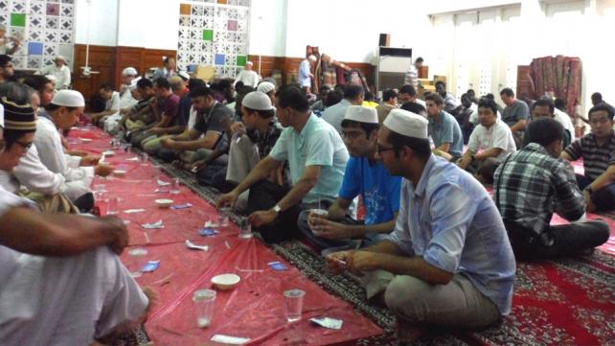

Top 8 ways to boost your Ramadan spirit this year
SAMANA SIDDIQUI
Feeling down and de-motivated about Ramadan? Not feeling the Ramadan spirit yet? Here are eight ideas on how to boost spirituality during Ramadan and ways to make it a memorable one Insha Allah.
- Read moreabout Top 8 ways to boost your Ramadan spirit this year

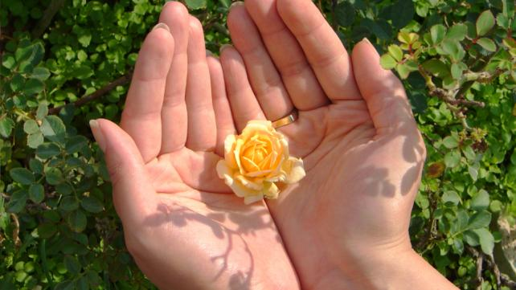

A Ramadan guide for single Muslims
SOUND VISION STAFF WRITER
For most Muslims, Ramadan is family time. You get up together, eat Iftar together, pray together, etc. But what if you don't have your family near you? Here are a couple of ideas for single Muslims.
- Read moreabout A Ramadan guide for single Muslims

A Ramadan fact sheet for teachers
COUNCIL ON ISLAMIC EDUCATION
A comprehensive fact sheet about Ramadan for teachers and educators in public schools published by Council on Islamic Education.
- Read moreabout A Ramadan fact sheet for teachers

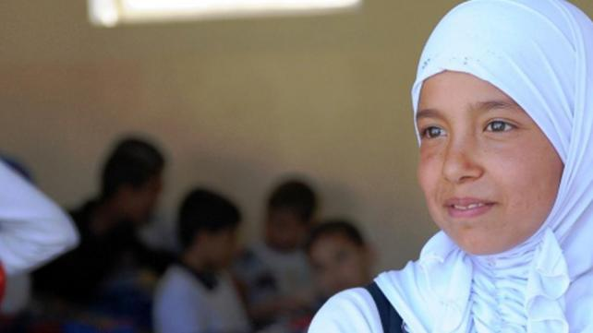

A sample letter to your child's principal about Ramadan
SOUND VISION STAFF WRITER
Muslim parents need to keep their kids' school principal informed and engaged regarding important Islamic practices and events. Here is a sample letter about Ramadan to your child's principal.
- Read moreabout A sample letter to your child's principal about Ramadan

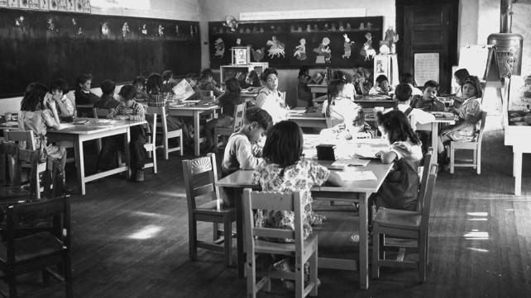

Ramadan for kids: A sample class presentation
ARIF NELSON
Here is a sample presentation for first grade students about fasting and Ramadan. You can help your child deliver a similar presentation to his or her class.
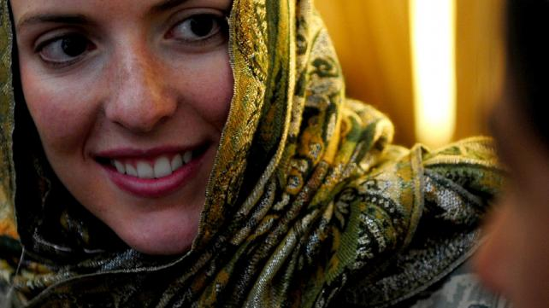

A sample letter about Ramadan to your child's teacher
Muslim parents need to keep their kids' teachers informed and engaged regarding important Islamic practices and events. Here is a sample letter about Ramadan to your child's teacher.
- Read moreabout A sample letter about Ramadan to your child's teacher

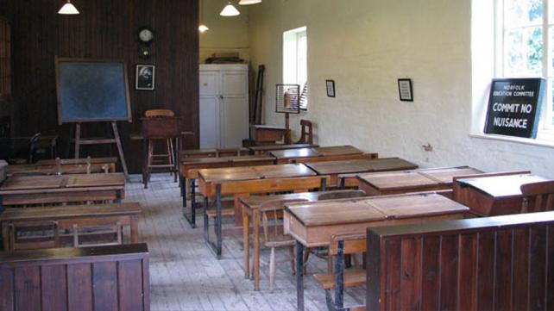

17 tips for parents to present Ramadan in their child's class
SAMANA SIDDIQUI
Parents talking to their children’s public schools about Ramadan is of immense importance. There are a couple of tips to keep in mind when approaching the school about presenting Ramadan.
- Read moreabout 17 tips for parents to present Ramadan in their child's class

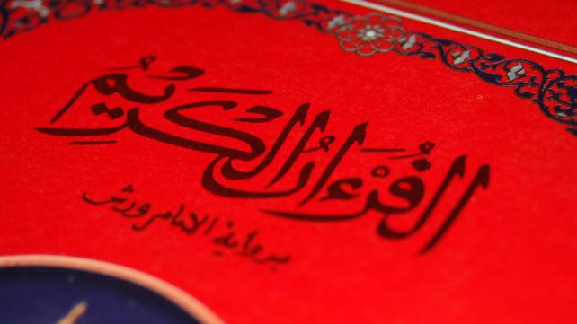

The Quran and Hadith on Ramadan
Abu Huraira related that Rasulullah said: Many people who fast get nothing from their fast except hunger and thirst, and many people who pray at night get nothing from it except wakefulness (Darimi).
- Read moreabout The Quran and Hadith on Ramadan

10 ideas for Ramadan at your workplace
SAMANA SIDDIQUI
This Ramadan, make your workplace the scenario for Dawa, especially in the current tension-filled atmosphere of misunderstandings about Islam and Muslims. Here are some ideas that can help you share Ramadan with your boss and coworkers this year.
- Read moreabout 10 ideas for Ramadan at your workplace

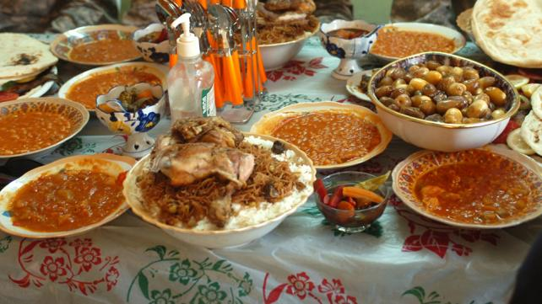

8 tips on sharing Ramadan with your neighbors
SAMANA SIDDIQUI
Ramadan is a great opportunity to share Islam and more specifically, its values of spirituality, generosity, and kindness with others, especially neighbors. Here are eight practical ways to do that.
- Read moreabout 8 tips on sharing Ramadan with your neighbors

Crescent sighting guidelines for North America
ISLAMIC SHURA COUNCIL OF NORTH AMERICA
These guidelines was adopted in the Islamic Shura Council of North America meeting in Chicago on January 19th 1995. It was signed by all the leaders.
- Read moreabout Crescent sighting guidelines for North America

Advice on moonsighting and moonfighting
SOUND VISION STAFF WRITER
Every Ramadan the Muslim community errupts into arguements over moonsighting. There are five main ways Muslims worldwide determine the Islamic dates.
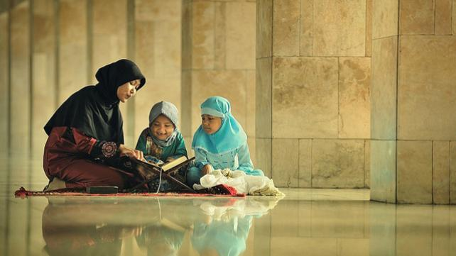

Seven strategies to train kids this Ramadan
SHEHNAZ TOORAWA
The many aspects of Ramadan - fasting, prayers, moral values, charity, Quran, family, Eid - provide a valuable opportunity to train kids. Here are some training tips to transform your children's minds and memories this Ramadan.
- Read moreabout Seven strategies to train kids this Ramadan

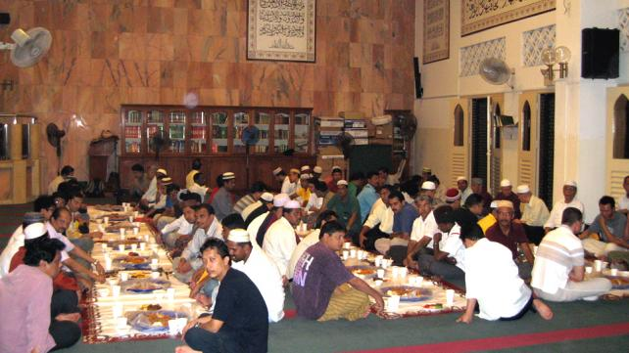

The how to's of fasting
SOUND VISION STAFF WRITER
Fasting is an act of obedience to Allah's commands through the highest degree of commitment, sincerity and faithfulness to seek Allah's mercy, to atone for sins, errors, and mistakes and to avoid condemnation to Hell.
- Read moreabout The how to's of fasting

7 tips for a healthier Ramadan
SAMANA SIDDIQUI
Ramadan is often accompanied by feasting. Food-binging on oily, sugary items in Ramadan is the norm in the Muslim communities. Read these tips for a healthier Ramadan.
- Read moreabout 7 tips for a healthier Ramadan

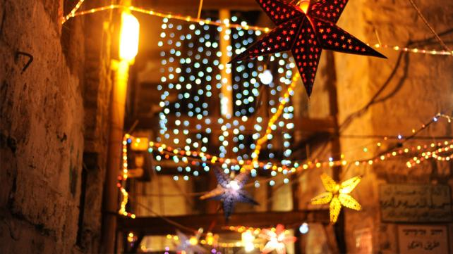

15 ways to make Ramadan special for your kids this year
SAMANA SIDDIQUI
With barely a few weeks left, there's little time for us to prepare kids for Ramadan. How can you get kids in the Ramadan mode? Here are a couple of ideas to help make it special this year.
- Read moreabout 15 ways to make Ramadan special for your kids this year

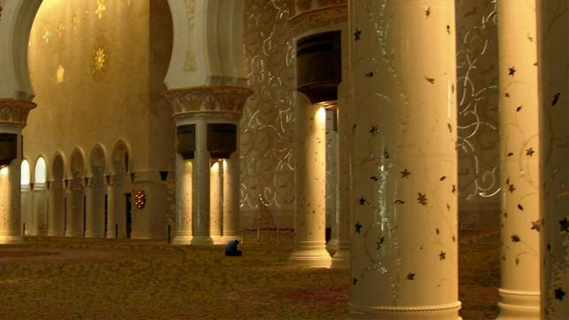

Why should you fast?
ABDUL WAHID HAMID
The main purpose of fasting is described in the Quran as "so that you may attain Taqwa or God-consciousness." Fasting is thus yet another instrument for bringing us closer to our natural state, our state of Fitrah.
- Read moreabout Why should you fast?

A Ramadan factsheet
SOUND VISION STAFF WRITER
Why to Muslims fast? Muslims fast in the month of Ramadan to develop God consciousness, self-control and willpower. They want to become closer to God through this act of worship (fasting).
- Read moreabout A Ramadan factsheet

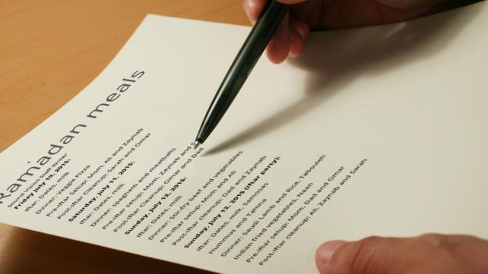

Sample chore chart for Ramadan meals
SOUND VISION STAFF WRITER
A sample chart of tasks for Ramadan meals for every family memeber to share. Planning and delegation of responsibilities is a key.

8 Ramadan ideas for your campus
SOUND VISION STAFF WRITER
Short on ideas for what to do on campus about Ramadan? Here are some things to remember and ideas you can use to bring Muslims closer together and do Dawa. None of them require a big budget.
- Read moreabout 8 Ramadan ideas for your campus

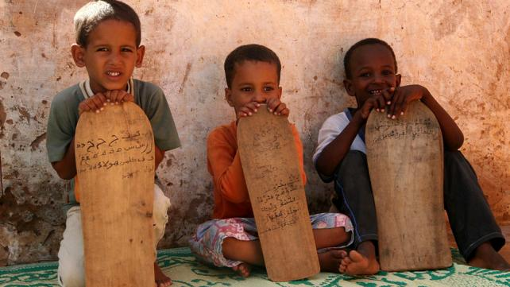

9 tips for your family and the Quran
SOUND VISION STAFF WRITER
To get the whole family involved in reading more Quran this year during the blessed month of Ramadan, here are some tips.
- Read moreabout 9 tips for your family and the Quran

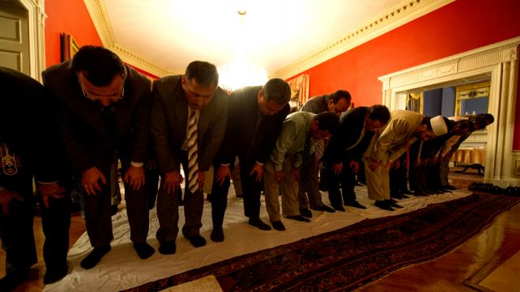

Why forgive others this Ramadan?
SAMANA SIDDIQUI
Let us use the days of forgiveness this Ramadan to open our hearts to those who have wronged us and forgive them as we beg Allah to forgive us.
- Read moreabout Why forgive others this Ramadan?

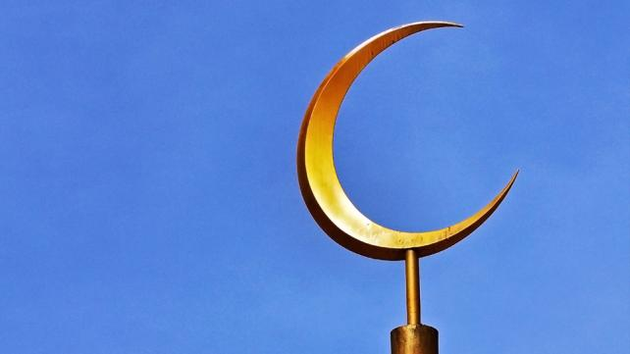

10 ways to show your Ramadan this year
SOUND VISION STAFF WRITER
No study has been conducted about it yet, nor have statistics been compiled. But there are enough Muslims out there afraid of showing their Islam nowadays than we'd like to admit.
This year, share and show your Ramadan to the world!
- Read moreabout 10 ways to show your Ramadan this year

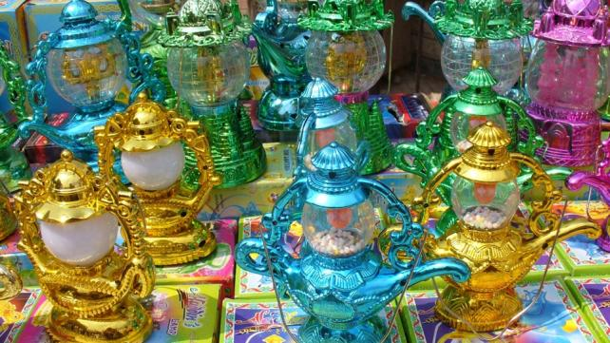

Count down to Ramadan: 5 ways to get your kids excited
SAMANA SIDDIQUI
It's only days away and most kids are too busy to really think about Ramadan. But helping kids become excited about the blessed month will help them look forward to fasting and the blessings of the month. Here are some ideas.
- Read moreabout Count down to Ramadan: 5 ways to get your kids excited

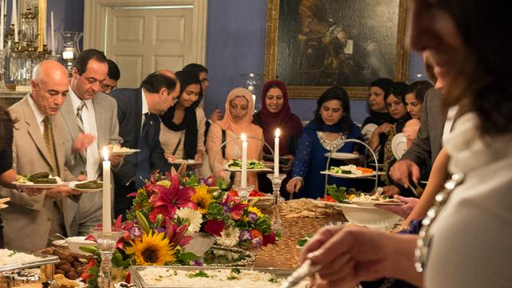

5 things you can do for Islam this Ramadan
It's important to decide how we're going to make the most of the blessed month before we're in the thick of it. Here are a couple of things you can do not only on an individual and family level but for the community as well.
- Read moreabout 5 things you can do for Islam this Ramadan

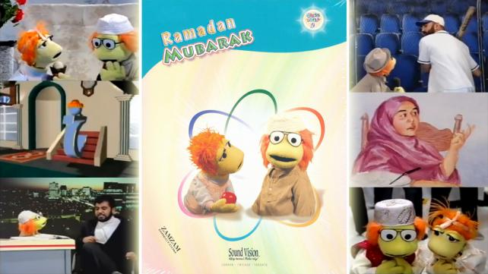

Video review: "Adam's World 9: Ramadan Mubarak"
SOUND VISION STAFF WRITER
This is a video review of "Adam's World 9: Ramadan Mubarak", in which Adam learns about the fast of Ramadan, as he tries himself to abstain, with great (and hilarious) difficulty from food and drink on the holy month's last day.

Take the Ramadan "fast from technology challenge"
SAMANA SIDDIQUI
It's not avoiding food or even the drink I'm worried about this Ramadan. Fasting from these, the core of what the Ramadan experience is about, is hard but Alhamdu lillah doable. What I'm really worried about is email and Facebook.
- Read moreabout Take the Ramadan "fast from technology challenge"

A simpler, healthier and greener Ramadan
ABDUL MALIK MUJAHID
Great tips on making this Ramadan simpler, less wasteful, and healthier for us & the environment. And this is the change where the Khalifas of the world, we stewards of God, are needed today.
- Read moreabout A simpler, healthier and greener Ramadan

New Duas for these Nights of Power
SOUND VISION STAFF WRITER
The Night of Power is a time of heightened reflection, connection to God and supplication or Dua. Here is a list of 15 sample Duas you can use in the next week during Laylatul Qadr:
- Read moreabout New Duas for these Nights of Power

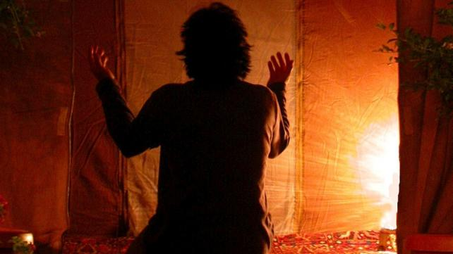

Duas for forgiveness
SOUND VISION STAFF WRITER
The Prophet Muhammad said, the one who repents for a sin is like the one who has not committed a sin (al-Bayhaqi and Ibn Majah). Peace and blessings be upon him. We have also included some suggested Duas of our own that you can use at the bottom of this article.
- Read moreabout Duas for forgiveness

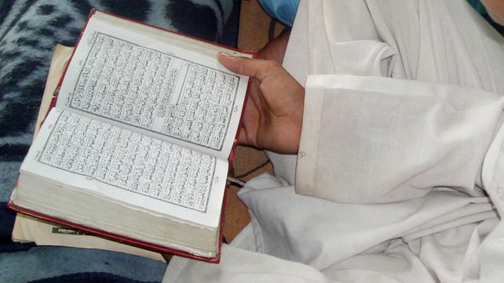

Ramadan reflections in 2004
ABDUL MALIK MUJAHID
Reflections about ramadan in the east and the west in the year by Imam Abdul Malik Mujahid, as broadcasted by BBC.
- Read moreabout Ramadan reflections in 2004

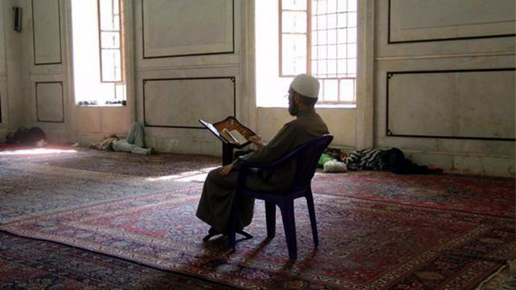

Duas for the last day of Ramadan and Eid
ABDUL MALIK MUJAHID
The last night and day of fasting is a special day of Dua, considering that the Prophet has said that Allah makes decisions about our forgiveness that day. So here are some suggested Duas.
- Read moreabout Duas for the last day of Ramadan and Eid

No time like Ramadan time
KHURRAM MURAD
How does Ramadan impart new meaning and force to Fasting? Put simply: by prescribing for it the time of Ramadan. This may sound like making things too simplistic, or trivializing the important. But Ramadan is no trivial event.

The blessings of Ramadan
HAFSA AHSAN
Ramadan is characterized not just by its obligation on every Muslim to keep away from certain things which are allowed in other months, but also by the weight of blessings attached to every good deed performed in this month.
- Read moreabout The blessings of Ramadan

I ask myself tonight!
SAMANA SIDDIQUI
Ramadan, as usual, has flown by. Ask yourself these questions and see what you can do to make the most of what's left of Ramadan this year, Insha Allah.
- Read moreabout I ask myself tonight!

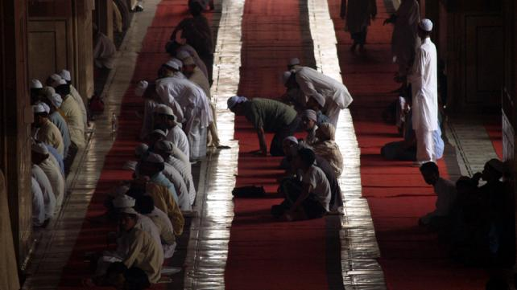

Crying in front of Allah on the Night of Power: It's not impossible
ABDUL MALIK MUJAHID
When was the last time you cried? Not a few drops of salty water from your eyes, or the odd tear that slipped down your face while watching a tragic event. I'm talking about warm tears of the heart.
- Read moreabout Crying in front of Allah on the Night of Power: It's not impossible

10 tips to help you keep those Ramadan habits
SAMANA SIDDIQUI
You have done it again! How will you make those great Ramadan habits stick once it leaves you? Here are a few things you can do to maintain the good habits you picked during Ramadan and keep Ramadan spirits alive

Khutba Ideas for Ramadan
By Taha Ghayyur
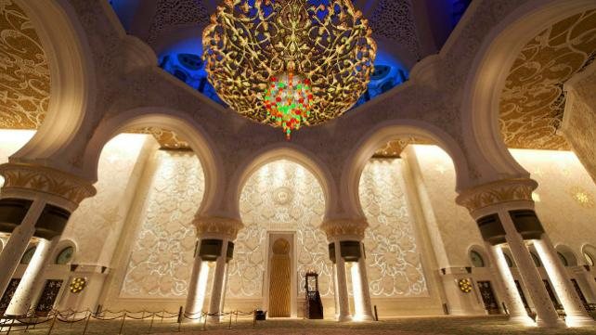
This Ramadan, it’s critical for Imams and Khateebs to focus their messaging on: Strengthening our spiritual connection with Allah; strengthening our family; and strengthening our connection with our friends, colleagues, and neighbors of other faiths. As Ramadan approaches, here are suggested Khutba themes for Imams and Khateebs to address.

Ramadan & Media Relations: How To Create Positive “Newsworthy” Stories
By Taha Ghayyur
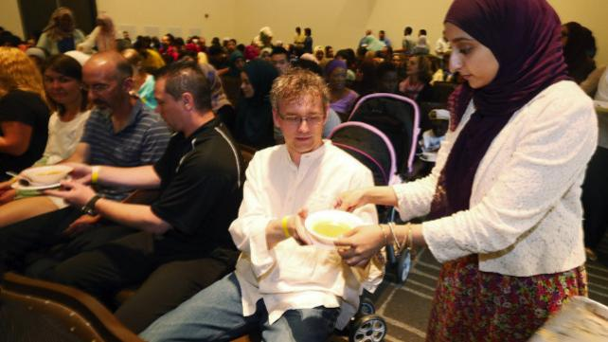
Creating and pitching a “newsworthy” Ramadan story requires significant planning and legwork, but it’s all worth it. Let the world see the beauty of your faith and culture. Let everyone experience it! What’s there to hide?

Ramadan 2016: 10 Things Muslim Families can Plan
By Samana Siddiqui
A recent report related distressing incidents of Islamophobia Muslim children are experiencing in schools. Muslim parents, grandparents, aunts, uncles, and other family members, must be on the front line this Ramadan, healing and soothing our youth with the sweet taste of mercy and spiritual upliftment. This is why we must urgently plan for Ramadan 2016. Here are some ways to do that.

Countdown to Ramadan: 7 Tips to Welcome Ramadan
By Samana Siddiqui
With Ramadan only days away, don't let the excitement of the blessed month slip by without mentally preparing for the big day. Here are a couple of ways to make the countdown to Ramadan exciting.

