CAIR Urges Court to Strike Down Arkansas' Anti-BDS Law | CAIR-MI Files EEOC Complaint against Aerospace Company | CAIR-MO: American Muslim Art Exhibition | Video: MN Protest of Trump's Tweet Endangering Rep. Ilhan Omar

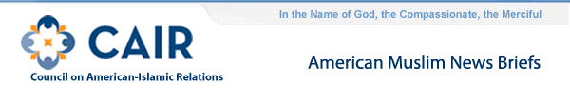
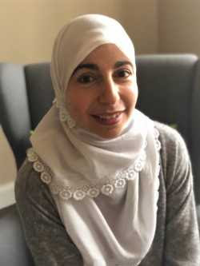
- CAIR Urges Eighth Circuit to Strike Down Arkansas' Anti-BDS Law As Violating The First Amendment
CAIR today announced the filing of an amicus (friend of the court) brief with the U.S. Court of Appeals for the Eighth Circuit.
READ CAIR's Amicus Brief
CAIR represents Bahia Amawi in a similar First Amendment challenge to Texas' anti-BDS law. Bahia Amawi is a speech language pathologist who performs bilingual assessments for Arabic-speaking elementary school students. Last fall, she lost her contract with a Texas public school district because she refused to sign the new "No Boycott of Israel" clause. A hearing on her case was held on March 29, 2019 in Austin and a decision could issue at any time.
Community members who have been affected by "No Boycott of Israel" laws or contractual provisions in any state are urged to contact CAIR's Civil Rights Department at 202-742-6420 or by visiting www.cair.com/report
- CAIR-MI Files EEOC Complaint Against Aerospace Company on Behalf of Muslim Employee Who Faced Religious-Based Harassment and Discrimination
"No person should have to be the subject of humiliating jokes and discriminatory treatment when they are doing nothing more than trying to earn a living to support their family," said CAIR-MI Staff Attorney Amy Doukoure."The discrimination Mr. Salam has faced is simply unacceptable.
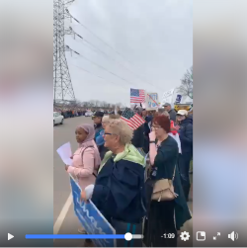
- Video: CAIR-Minnesota, Community Groups Protest Trump's Tweet Endangering Rep. Ilhan Omar and Her Family
  - Video: CAIR-Minnesota, Community Groups Protest Trump's Tweet Endangering Rep. Ilhan Omar
  - CAIR-MN: Ilhan Omar Supporters Hold Rally Outside Trump Event in Minnesota (CBS News)
The organization told CBS that they've seen an increase in threats to CAIR offices nationwide, including threats that directly reference violence against Rep. Omar.
  - CAIR: The Dangerous Bullying of Ilhan Omar (The New Yorker)
- CAIR-NJ: Muslim Student Attacked In Possible Bias Incident At New Jersey School
James Sues, Executive Director of the New Jersey chapter of the Council on American-Islamic Relations, told HuffPost that the Muslim student's family is "somewhat satisfied" with how the school and the police have handled the incident.
  - CAIR-NJ: After East Brunswick Fight, Muslim Parents Worry For Their Children
"The ongoing political climate is one where we've got a head of a state in the United States who seems to make no apologies for what we're calling nationalism," said James Sues, Executive Director of the Council on American-Islamic Relations of New Jersey.
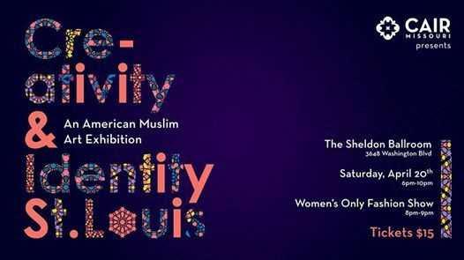
- CAIR-Missouri: American Muslim Art Exhibition and First Modest Women's Fashion Show Set to Showcase Muslim Creativity and Style
WHAT: Creativity & Identity, an American Muslim Art Exhibition
WHEN: Saturday, April 20th at 6:00 p.m. – 9:30 p.m.
WHERE: The Sheldon Concert Hall and Art Galleries, 3648 Washington Blvd, St. Louis, MO 63108
WEBSITE: www.cair-mo.org/art
TICKETS: $15 Adults, $10 Students, $5 for children 6 – 12, free for children 5 and under.
FACEBOOK EVENT PAGE: https://www.facebook.com/events/326351784684992/
- Video: Female Muslim, Hijab-Wearing firefighter puts out fires in Chesterfield

Council on American-Islamic Relations
453 New Jersey Ave, S.E., Washington, D.C., 20003
Council on American-Islamic Relations Copyright © 1994. All rights reserved.

CAIR-LA Condemns Bomb Threat | CAIR Action Alerts: Meet Congressmembers in April, Tell State Dept. Not to Withhold Visa from BDS Activist | Free Legal Clinics at ICNA-MAS Convention in D.C.

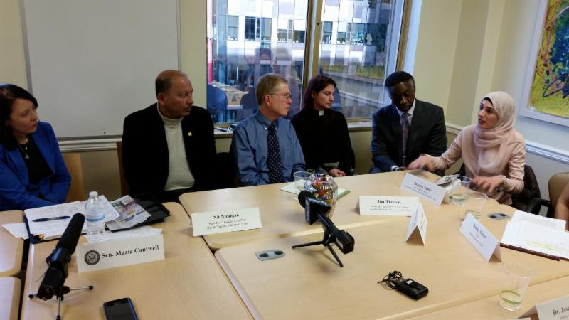
- CAIR Action Alert: Muslims Urged to Meet with Members of Congress During April Recess
- CAIR Action Alert: Tell State Department Not to Withhold Visa from Palestinian Rights Activist
- CAIR: Arizona Lawmakers Running Scared After Anti-Boycott Law Ruled Unconstitutional
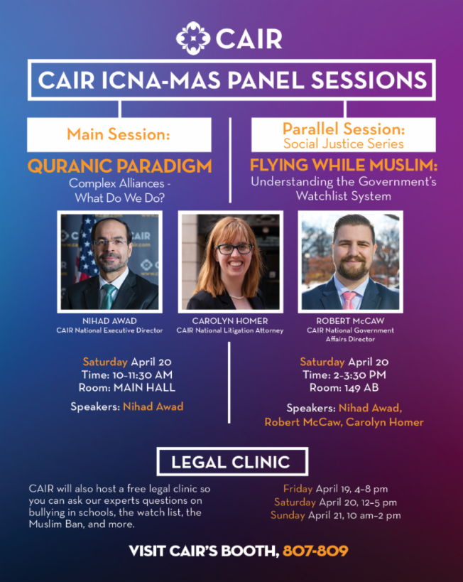
- CAIR to Offer Free Legal Clinics and Speak at ICNA-MAS Convention in D.C. From April 19-21
CAIR National Executive Director Nihad Awad will speak on Saturday, April 20 at 10 a.m. in the Main Hall on activism and building alliances. Awad with join CAIR National Litigation Attorney Carolyn Homer and National Government Affairs Director Robert McCaw on Saturday, April 20 at 2 p.m. in Room 149 AB in a panel session titled, 'Flying While Muslim: Understanding the Government's Watchlist System.'
In addition to the speaking engagements, CAIR attorneys will be offering free legal clinics at its booth in the convention bazaar (#807 - 809) on Friday, April 19, 4-8 p.m., Saturday, April 20, 12-5 p.m., and Sunday, April 21, 10 a.m. - 2 p.m. CAIR attorneys will answer questions about the Trump administration's "Muslim ban," discrimination in the workplace or in schools, bullying of Muslim students, and other topics of concern to the American Muslim community.
- CAIR-LA Condemns Bomb Threat Made Targeting Its Office
- CAIR-MN: Photo Gallery: Trump Touts Economy in Burnsville as Protesters, Supporters Rally
  - CAIR-SFBA: Young Activists Are Done with Loyalty Tests
  - CAIR-NY: Leaders of Diverse Faiths Call to End Violence
- CAIR-DFW Welcomes DoJ Settlement With Farmersville, TX Involving Denial of Muslim Cemetery
- CAIR-MI Files Complaint Against Aerospace Company, Alleging Harassment and Discrimination Against Local Muslim Man
- Video: CAIR National Board Chair Roula Allouch Interviewed on MSNBC About Trump's Tweets Endangering Rep. Ilhan Omar
- CAIR-WA: Opening Night of Social Justice Film Series to Feature Movie and Discussion of Rohingya Genocide

