10 ways to make time for Ramadan's last 10
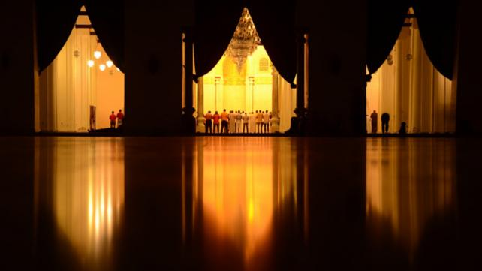
Samana Siddiqui
With Ramadan fast flying by and the last 10 days and nights approaching, we’re in the last stretch. We may have not met all of our goals, but these receding moments of the blessed month offer us a time of both heightened spirituality and a chance to catch up.
Prophet Muhammad, peace and blessings be upon him, used to exert himself in devotion during the last ten nights to a greater extent than at any other time (Muslim). That should give us the incentive to carefully plan our days and hours so we can too.
Just as we are now used to a Ramadan schedule two weeks in, once again, we will have to re-adjust if we want to benefit. Here are some ideas.

1. Take Fridays off
We’re in the thick of summer vacation, so it may be hard to get a whole week off. Still, see if you can get the last two Fridays of Ramadan off (usually a slow day at many workplaces). It can give you at least two long weekends to really focus.

2. Readjust your work schedule
See if you can come in earlier and leave earlier or arrive later and leave later. That can free up your night and early morning for Tahajjud and/or Qiyam-ul-Layl.
Also, try to reduce your workload by only focusing on the urgent and immediate projects. Save those with more flexible or later deadlines for after Ramadan. This is one time where procrastination may actually pay off.

3. Work from home
If you have a job that allows you to do this from time to time, take advantage of this in Ramadan’s last 10 days and nights. It will save you commute time, as well as the precious minutes we spend getting ready to go to work. Working from home also allows you to rest more sufficiently during breaks.

4. Before the last 10 days begin, finish any errands you have to complete
Shopping for Eid gifts, clothes, and groceries should be completed before the first of the last 10 nights. Time in stores is time taken away from worship and spiritual focus, so try to buy and freeze what you can so it lasts longer, finish off that gift list, and hold off on any non-urgent purchases until after Ramadan.
Also, if you need your car washed, cleaned, and/or serviced for Eid, do it now. A few days won’t make much of a difference.
The same is true of the house. If you complete housekeeping duties once a week, try to deep clean this week so you can avoid cleaning during Ramadan’s last 10. If you can afford it, consider hiring someone to take care of this to free up your time further.

5. Limit outside activities during the last 10 days
While those of us with kids are often shuttling them to and fro activities, classes, and other places during the summer, try to limit outside excursions as much as possible. This is a drain on energy, which is put to much better use worshipping Allah during the last 10 days and nights of Ramadan.
At most, find out which parks are nearest to your home and take the kids there. It won’t be too far, and a new park offers just as much excitement as a trip to something further away.

6. Complete your Eid plans
If you normally get together with extended family during Eid, finalize the plan and menu now. Decide where you’re going to pray Eid Salah, whose house you are gathering at, as well as your contribution to the menu. You will probably have to cook the day before, but you can at least buy the required groceries beforehand.

7. Try to commit to a technology fast
This one can be difficult, and a total fast is probably impossible for most of us. However, choose times of the day when you turn off the phone or laptop and focus only on worship. It can be in the early mornings during Tahajjud, for a few hours in the afternoon, or right after Fajr. The constant distraction of a ping or a ring takes away from deep conversation with God in ways that erode our spiritual advancement.

8. Plan in-home activities for the kids
This can include their own good deeds schedule or some pre-planned arts and crafts (for which you have already bought the supplies). But it can also mean a trip to the library this week to take out any good books to read and occupy them while you focus.

9. Hire a babysitter
Consider this option especially if you have younger kids who need constant attention. A reliable babysitter who can engage your kids effectively offers you an opportunity to worship without interruption, or take them out of the house to an activity for part of the day.

10. Avoid Iftar parties
Socializing is nice, but Ramadan’s last 10 days and nights are about focusing on our individual relationship with Allah. If you have already committed to an Iftar party, see if you can back out politely without causing hurt or offense. If not, try to leave early.
If you planned a party at this time and your guests have already confirmed, minimize the work as much as possible. Cook beforehand or get it catered, keep the menu simple, and clean up the house this week so you don’t have to do it during Ramadan’s last 10.

10 to do's for Ramadan's last 10
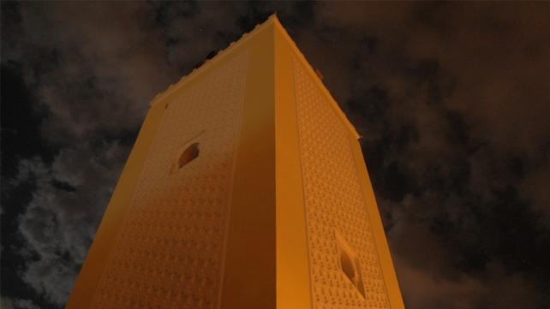
Samana Siddiqui
While it’s depressing to think that Ramadan will be over in less than two weeks, the blessed month’s last 10 days offer us a final push to do as much good as we can. We cannot let our enthusiasm wan like the moon that marks this special time‘s end.
Prophet Muhammad, peace and blessings be upon him, used to strive hard (in worship) during the last ten days of Ramadan in a way that he did not strive at any other times (Muslim).
Here are 10 things we can do in Ramadan’s last ten blessed days.

1. Pay Zakat
Many Muslims plan to pay this obligatory pillar of Islam yearly at some point in Ramadan, to benefit from the greater spiritual reward attached to charity during the month. If you haven’t already, do so this month, keeping in mind needy relatives, neighbors, as well as current hot spots of suffering (this year, please consider East Africa, where millions are enduring a famine, many even as they fast).

2. Pay Zakat al-Fitr
Zakat al-Fitr allows needy families to enjoy the Eid holiday. Pay this to your local Masjid or an organization of your choice well before Eid-ul-Fitr in these last 10 days of Ramadan.

3. Up your giving
With news of a possible double-digit recession and a roller coaster stock market, it’s tempting to withhold or limit our giving this year. But don’t let that stop you from being generous. Remember that Allah is al-Razzaq, the Provider, and that that the Prophet reminded us that “charity does not decrease wealth” (Muslim).

4. Attend Tarawih more than you have all month
If you haven’t been able to attend Tarawih prayers most of the month of Ramadan due to work or other commitments, make a special effort to go in these last 10 days. Even if you decide to pray only eight units of prayer in a Masjid that normally offers 20, you will benefit from the sense of community and the blessings of congregational prayer.
To be able to stay awake for Tarawih, try your best to take a short nap after coming home from work or during your lunch hour. Also, try not to overeat during Iftar, making it more likely you will be sluggish and sleepy come Tarawih time.

5. Connect to Laylatul Qadr with more Quran reading
Muslims are encouraged to seek the night of Laylatul Qadr in the odd nights of the last ten days of Ramadan. This is the night that is described as better than a thousand months (Quran 97:3), and it is the one on which the Quran’s revelation began.
Apart from seeking to do more good than usual, in specific, push yourself to finish reading at least a couple of parts of the Quran, preferably in Arabic and English. Cut or drastically reduce television, Facebook, and socializing time to accomplish this goal.

6. Call your relatives to make Eid plans
Islam puts a premium on maintaining family ties. If you haven’t been able to keep in touch with relatives, use these last 10 days to call or shoot them an email or text about getting together for Eid-al-Fitr.

7. Shop and give
As you shop for Eid or back to school items for yourself or your kids, pick up a few extra clothes or supplies and drop them off at various sites collecting these things for those in need.

8. Make your last fasts really count
If you’ve caught yourself succumbing to un-Ramadan-like habits while fasting, make an extra special effort in these last days of the month to become conscious of these behaviors and stop them before they start. These can range from swearing, backbiting, talking about frivolous things, watching television shows or movies with sexual innuendo or jokes, etc.

9. Set your alarm for Tahajjud
It’s hard getting up for Suhoor, so why make the effort for Tahajjud? This blessed time is one in which Allah is very close, answering prayers and offering forgiveness, in particular (Bukhari). Multiply that by the fact that it’s Ramadan and you’ve got an exceptional opportunity to really connect with God and ask for all that you need or want.

10. Dua, Dua, Dua
Use as many of Ramadan’s last minutes to make plenty of Dua. These include not only the standard supplications recommended for everyday use (e.g. before and after eating, dressing, entering and leaving the home, etc.), and those seeking God’s Mercy and Forgiveness. Truly pour your heart out, asking from the One Who already knows your needs and wants and faces no barriers to fulfilling them. Don’t forget to ask for not only the big things (e.g. Paradise, job security, good family life) but even the smaller ones (e.g. an amazing SAT score or getting the iPod Touch for Eid).
Photo Attribution: Zakaria ElQotbi - http://www.flickr.com/photos/zskdan/2901874980/
***

Crying in front of Allah on the Night of Power: It's not impossible
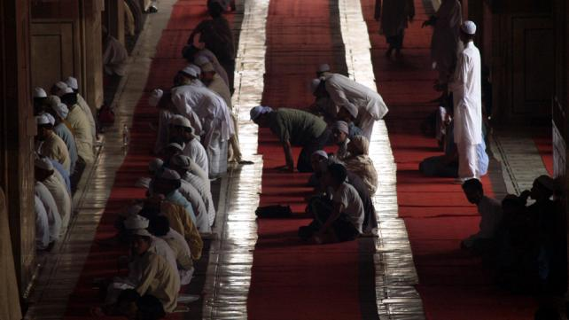
Abdul Malik Mujahid
When was the last time you cried? Not a few drops of salty water from your eyes, or the odd tear that slipped down your face while watching a tragic event.
I'm talking about warm tears of the heart. Tears that sting your face because they've been there so long, their bitter saltiness hurts your skin.
When was the last time you cried like a baby?
Aisha, may Allah be pleased with our mother, relates that: In the last ten of Ramadan, the Prophet, peace and blessings be upon him, used to tighten his waist belt, pray all night, and wake up his family for the night prayers (Bukhari and Muslim).
Almost two thirds of Ramadan is gone. We powerless people will soon be looking for the Night of Power (Laylatul Qadr), which we are advised to seek in these last ten nights of Ramadan.
Aisha related that the Prophet said: Look for Laylatul Qadr on an odd-numbered night during the last ten nights of Ramadan (Bukhari).
We can't afford not to be crying in front of Allah, the Merciful, All-Aware.
Tears flow when we remember how much Allah has blessed us with and how much we disobey Him. We can never repay Allah for everything we have, yet we still blatantly commit sins both big and small: whether it's backbiting, hurting other human beings, not standing up for the truth, treating our family badly, lying, doing good deeds to show off, cheating, etc.
Allah opens ways out of problems for us, easing our burdens. Yet, we still disobey Him and take His Mercy for granted.
Abdullah ibn Umar, may Allah be pleased with him, said he would rather shed two tears from the fear of Allah than give a thousand dinars in charity.
And the most telling example of a man who few would think would cry because of Allah is Umar, may Allah be pleased with him. He was known for being strong, fearless, and uncompromising when it came to matters of faith. Yet, Abdullah ibn Isa said that Umar had two black streaks on his face bec1ause of constant weeping.
He feared Allah so much that he once said, "If someone announced from the heavens that everybody will enter Paradise except one person, I would fear that that person would be me."
Umar was one of the strongest believers. Yet he cried and feared Allah. And Abu Bakr, he was simply known for his crying. These people loved to serve human beings in the day and spent time begging God to save humanity at night. May Allah be pleased with them.
Let's be more contemplative and pray for an awareness of and forgiveness for our sins, as well as softness in our hearts. If Umar the brave and pious did it, we have even more need and urgency to do it.
Human beings are in turmoil. Connecting with God with our hearts and begging for His Mercy for His Creation will bring us Closer to Him and human beings.
***

I ask myself tonight!
Samana Siddiqui
"Oh how swiftly, it's mid-Ramadan now
I sit here, wondering and thinking how,
Have I spent my first days of Ramadan fruitfully?
Or have I wasted the time unknowingly?"
[...]
Ramadhan comes, for a short month it's here
Will I ever meet the Ramadan next year?
Allah Oh Allah, help me guide my heart through
For only You know, if I've devoted enough to You."
-excerpts of the poem "Not done enough this Ramadan" by Udiana Jamalludin
Ramadan, as usual, has flown by. Despite planning beforehand, many of us may have gotten caught up in a routine after accustoming ourselves to the change in schedule the blessed month brings.
This may have affected our initial plans to increase our worship, contemplation and to seek Allah's Forgiveness and Mercy with greater fervor. But the last ten days and nights of Ramadan are still ahead for us to benefit from. Ask yourself these questions and see what you can do to make the most of what's left of Ramadan this year, Insha Allah.
- Have I kept pace with the amount of Quran I wanted to read, or have I fallen behind?
- If so, how much do I have to read on a daily basis the rest of Ramadan to catch up?
- Have I tried to attend Tarawih regularly, or did I use weak excuses to get out of it?
- Did I ever pray the night prayer?
- Did I try praying my five daily prayers with more sincerity, concentration, and focus than usual?
- Did I invite anyone over for Iftar (breaking the fast)?
- Did I help any needy person, even a panhandler or beggar, when I was fasting?
- Did I regularly seek Allah's Forgiveness and Mercy with sincerity, fear and hope?
- Did I encourage my family to fast or participate in regular opportunities for more rewards that come with Ramadan (i.e. good deeds in general, but also Tarawih, more reading of the Quran, etc.).
- Did I memorize any more Quran than what I knew before Ramadan started?
- Did I try to be more patient in Ramadan than I normally am?
- Did I try to control my anger, especially while fasting?
- Did I try harder to avoid backbiting and slander?
- Did I constantly check my intentions, to make sure that my good deeds were for the sake of Allah alone, not to impress others, gain their favor, or to show off?
- Was there even an atom of pride in my heart?
- Was I quieter and more contemplative?
- Did I cry in my prayers?
- Did I read more Islamic literature apart from the Quran?
- Did I make sincere repentance to Allah, really feeling sorry for my sins?
- Did I forgive those who hurt me?
- Did I avoid hurting anyone with my attitude, words, intentions or actions?
- Did I give any more Sadaqah (charity) than I normally give?
- Did I share the message of Ramadan and Islam with a non-Muslim?
- Did I share the message of Ramadan and Islam with a non-practicing Muslim family member or friend?
- Did I feel annoyed at being hungry while fasting or did I rejoice?
Photo Attribution - Abhinav Hasija - http://commons.wikimedia.org/wiki/File:Peace_Bridge_-_at_Moonrise.jpg
***

Duas for the last day of Ramadan and Eid
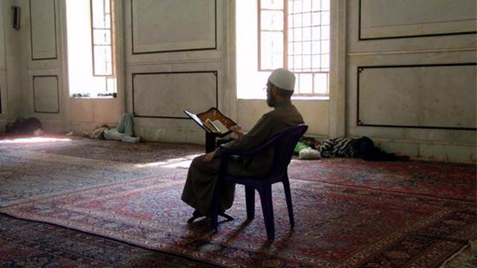
Abdul Malik Mujahid
As Ramadan comes to an end, so do the increased opportunities for prayer. We may or may not get another Ramadan in our lives. This may be our last Iftar. Just before Iftar is a special time to ask Allah for everything you want. He loves hearing from us. The last night and day of fasting is a special day of Dua as well, considering that the Prophet has said that Allah makes decisions about our forgiveness that day. So here are some suggested Duas.

Duas before the last Iftar
If everyone in your family can break fast together, it will be great to make Dua together.2
- Oh Allah, please accept all of my prayers, fasting, and remembrance of You during this blessed month.2
- Please forgive me for the shortcomings in my worship and help me improve by next Ramadan.
- Ya Allah, help me continue the good habits I have acquired during Ramadan.
- Oh Allah, please make me of the righteous, the guided, and those You love.
- Ya Allah, please guide me and my family to the Straight Path and help us become excellent Muslims for Your sake.
- I worship only You and only from You do I seek help. Please increase Your bounty for me
Do remember your loved ones, friends, coworkers, neighbors, and classmates by name in your Dua.

Duas for the last night of power
- Ya Allah, You are the embodiment of forgiveness, You love to forgive, Please disregard my shortcomings, O Forgiver, Ghafoor, the Forgiving Lord.
- Oh Allah, make it easy for me to do good and help me avoid the bad in all situations.
- Oh Allah, grant me success in all of my affairs in this life and the Next.
- Please increase me in knowledge and bless me with excellent teachers.
- Ya Allah, let me die in the highest state of Iman.
- Oh Allah, bless this Ummah, guide us, and unite our hearts.
- Ya Allah, lift my heart, relieve my burdens, and make me of those who put their full trust in You for all of their affairs.
- Oh Allah, please bless me with the opportunity to see many more Ramadans and to perform much better worship of You than I have done this year and in the past.

Duas for Eid
Approach your Imam before Eid Salat and hand him a couple of requests based on the following Duas so he can lead all in Dua;
- Ya Allah, open our hearts towards our neighbors.
- Ya Allah, open the hearts of our neighbors towards us.
- Ya Allah, unite the Muslims in the USA and the world to serve Allah's creation to please Him.
- Ya Allah, give Sabr (patience) and freedom to the innocent prisoners and guide those who are at fault.
- Ya Allah, You take care of the oppressed. Please help the oppressed in Palestine, Kashmir, Afghanistan, Iraq, India, Chechnya and other parts of the world.
- Ya Allah, guide oppressors to the right path and move the hearts of extremists from the harmful path.
- Ya Allah, give wisdom to our leaders; accept their sacrifice; bless them with more courage.
Photo Attribution - James Gordon - http://commons.wikimedia.org/wiki/File:Main_prayer_hall,_Umayyid_Mosque,_Damascus_-_4.jpg

Ummah: Islamophobia, Radicalization & Youth Disengagement.
Contribute to Sound Vision financially today so that we can continue working on it, Insha Allah! Please DONATE NOW! >> Read more...

Assalamu alaikum:
What’s the difference between a sprint and a marathon?
Sprinting lasts just a matter of seconds. A marathon goes on for hours. While a marathoner’s focus is on endurance, a sprinter’s is on maximizing every muscle movement to improve speed.
Today is the 15th of Ramadan. We are in the last stretch. The time for endurance is waning, and it is now time for the sprint.
While many of us at this juncture shake our heads in disappointment at the unmet goals and continuing bad habits, hope is on the Ramadan horizon: The last 10 nights of the blessed month, and Layaltul Qadr, the Night of Power, are on their way.
In the last ten of Ramadan, Prophet Muhammad, peace and blessings be upon him, used to tighten his waist belt, pray all night, and wake up his family for the night prayers (Bukhari and Muslim).
We may not have finished that one reading of the Quran; we may not have been as generous as we wanted to be; we may have spoken ill or lost our temper too often. But these last 10 days and nights are the hope and healing we need.
We may have fallen behind in the race, but we now have a chance to sprint ahead - if we plan and use our time wisely.
Freeing up our precious hours, minutes, and even seconds will make all of the difference if we want to truly win the Ramadan race this year - what could be our very last Ramadan.
Like the sprinter, the finish line is near and we want to move ahead quickly to catch up. This can only be done if we free our time and plan our worship and good deeds, pushing ourselves as we may never have before.
Please take time to recommit to Ramadan today, and switch from being a marathoner to a sprinter. Every second counts for the win.
Peace
Sound Vision Team

