A Parental Guide For Newly Fasting Kids
Posted in Ramadan By admin On June 13, 2014
The auspicious month of Ramadan is just days away. This month is the month of blessings, forgiveness and endless rewards from Allah Almighty. Therefore, Muslims all over the world observe this month with equal reverence and try making the most out of it by fasting and increasing their worship of Allah Almighty.
Every year when the Ramadan comes there are young children who are to fast for the first time. The children are both eager and confused at the same time, therefore, the responsibility rests upon the parents to assist the children and help them in getting a good fast and Ramadan experience for the very first time in life.
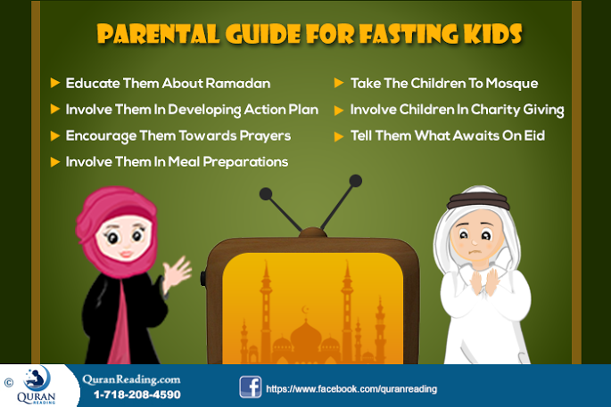
Muslim parents in general and Muslim mothers in particular follow to make sure that the first time fasting children have a good experience. These tips comprise of both preparations before and during Ramadan. The lines below discuss few such major tips.
Explain The Place Of Ramadan:
A month or a few weeks before the start of Ramadan, you must try telling your children about Ramadan. You can tell them its importance, the significance it has in the Islamic history, the place it has among the rest of the Islamic months and what major events took place in the month of Ramadan. Moreover, in this regard, if you want to make it entertaining for the children, you can personify the month of Ramadan and then build a story around the month to develop better and greater feelings in the children. Therefore, the more you make your first time fast keeping children aware about Ramadan and its importance, the more will they anticipate its arrival and will experience the month with more religious zest. Since your kid will be fasting for the first time, you are advised to teach him about things to do and things not to do in the holy month of Ramadan.
Involve Them In Developing Action Plan:
The other thing that Muslim parents can do to make sure that the first timers have a memorable Ramadan which they enjoy to the core is to involve the children in making an action plan for Ramadan before the month starts. In this regard, the parents can involve the children in selecting the kind of foods they want to have for Suhoor and Iftaar, the kind of prayers they want to learn during the month, the guests they want to invite for Iftar during the month and the places they want to go on the weekends. This way, the children start imagining how Ramadan is going to be like and thus nothing happens as a surprise to them which could make it difficult for them.
Encourage Them Towards Prayers and Quran Learning:
In Ramadan, fasting is not the only thing which parents have to be conscious about pertaining to the first time fast keeping children, rather, the parents also have to make sure that the children also offer prayers as well. In this regard, it is the responsibility of parents to create an imagery related to prayers in Ramadan leading through the opened doors of paradise. Children are highly imaginative, therefore, instead of just showing them the ayahs of Quran and hadiths of Prophet (PBUH) about prayers in Ramadan try creating an imagery out of the hadith and then bring the children in to imagine all the rewards they will receive for offering prayers during the month of Ramadan. Also, you can start telling him how to perfectly offer the salaat. For that, you can choose the interactive mobile application i.e. Step by Step Salaat which will help your kid to learn how to perform Namaz on his/her own.
Ramadan is the month in which environment is utterly religious which opens many opportunities for Muslims to completely learn Islam. Regarding your Kids, you are advised to start teaching your Kid Quran. Tell him how to read the Holy Quran. And if you do not have time, or you do not know how to teach him, you can opt for Online Quran Tutoring Classes for Your Kids where He/She will learn how to read the Holy Quran.
Involve Them In Meal Preparations:
Once Ramadan is there, the thing you can do to keep your first timers interested in the fast and to help them in experiencing fast in a better way is to involve them in meal preparations. When the new fasters get involved in preparations for Suhoor and Iftaar, they actually consider it a part of the fast and anticipate in it because it all is what they have to eat and what will help them go through the fast or rejuvenate the energy reserves. Therefore, for the sake of their interest and fascination it is important that you as parents involve children in the meal selection and preparation process during Ramadan.
Moms Can Make it Fun for Kids
There are many other ways parents especially mothers can adopt to indulge Kids in activities that in the end will result Kid being able to learn a lot during this blessed month. To know what does it include, you are suggested to read 7 ways moms can make Ramadan fun for Kids.

Take The Children To Mosque:
Another great thing that can be done to inspire the children who have kept the fast for the first time is to take them to the mosque. In addition to the fact that going to the mosque and offering prayer in congregation brings them closer to Islam, the other thing that this does is make children interested in going to the mosque. At the mosque there are other parents who bring their children, thus, when your children also go there and meet them, they actually find friends and get a chance to share their fasting experience with them. Therefore, if you wish to make the first time fasters continue their process, you should take them to mosque with you.
Involve Children In Charity Giving:
Another message that you as Muslim parents need to do in order to keep your first timing fasting children to stay motivated and enjoy the essence of Ramadan is to involve them in charity giving process. When you give some money to the children to give to some poor person, or have your children give food to the people who are hungry, the children actually feel good about and it motivates them towards doing better during Ramadan. Moreover, when children give charity they actually get to know about human feelings when someone does good and brings smile on the face of another person. Therefore, this practice, besides making their Ramadan better also helps them in becoming a better Muslim after Ramadan as well.
Tell Them What Awaits On Eid:
The month of Ramadan ends with the festival of Eid. Muslims all across the globe after observing a full month of fasts celebrate the festival of Eid. It is a joyous occasion where Muslims visit each other and eating and drink and spread happiness by exchanging gifts. Therefore, the children who are keeping the fast for the first time can be motivated in this regard by involving them in the preparations of Eid festival. Involve them in buying dresses and gifts, which they can buy for themselves and, also for friends and family. Thus, this way the fasting goes on in the month of Ramadan in anticipation of Eid.
Conclusion:
In a nutshell, it is imperative for parents to make special preparations of the children who are keeping fast for the first time so that they enjoy Ramadan and have their first experience of fasting as a memorable and cherished experience.
- See more at: http://www.quranreading.com/blog/a-parental-guide-for-newly-fasting-kids/#sthash.7iLVG8Wq.dpuf
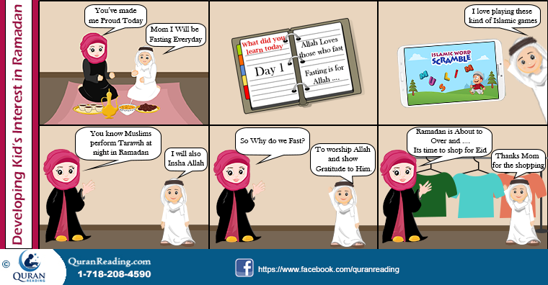
***

7 Ways Moms Can Make Ramadan Fasting Fun for Their Kids
Posted in Ramadan By admin On June 12, 2014
The greatest of influence on the life of Muslims is that instead of just providing them with a religious framework to follow, Islam is a complete code of life and has actually given Muslims a living style. Therefore, all the actions which Muslims take in daily life, all the things they do and all the relations they develop and maintain, all have instructions that can make them close to Islam.
Pertaining to the parent children relationship in general and mother children relationship in particular, Islam has put great emphasis on strengthening of the relationship. In this regard, there is a great duty on the shoulders of parents pertaining to teaching their children about Islam and bring them up in a way that makes them a better and practicing Muslim.
With regards to the month of Ramadan, Muslim mothers have a great role to play pertaining to encouraging their children towards fasting. Children are usually playful and joyful, therefore, a strict Ramadan routine can make fasting boring for them, therefore, it is imperative that Muslim mothers play their role and try making fasting attractive for their children.
The lines below give some tips that can help Muslim mothers make fasting and Ramadan interactive and fun for children.
Meals Of Fast:
The first thing that Muslim mothers can do to make sure that children enjoy fasting is to make special preparations for the two meals of the fast i.e. Suhoor and Iftar. In this regard, mothers should make sure that they make special dishes on the liking of kids so that they go for Suhur or Iftar with more liking and joy. Moreover, when these meals are taken with all the family together, it also makes it a sort of occasion to which children look forward to and anticipate with joy.
Role Playing:
It is obvious that children that keep fast, find it difficult to enjoy their regular games because of fast. Therefore, it rests upon the mothers to come up with games, which the children could enjoy whilst keeping fast so that they stay interested in fasting. In this regard, role-playing is an excellent game which the mothers can arrange for their children to play. Mother can instruct the children to be any of the characters in the Islamic history and perform any of the respective historical event. This way, in addition to learning about Islamic history, the children also get to enjoy the fast by playing the role playing game. In addition to that, a mother can install popular Islamic Kids learning games in the cell phone and instruct the kid to play. For example, if you are a mother of a newly fasting kid, you can make use of the Islamic Word Scramble Game. This game is an interactive Islamic mobile app which would help your kid to know the common Islamic terminologies. All you have to do is to teach your kid for about 30 minutes and then he will automatically be getting it.
Encourage Ramadan Journal:
Another thing that Muslim mothers can do to make fast interesting and fun for children is to recommend them to keep a Ramadan journal in which they record their daily experiences and feelings regarding fasting. This way children will have a platform on which they can express their feelings, desires and experiences. Besides serving as a punching bag, the journal can also help children revive their memories about fast when they will read it at the end of Ramadan or the next year when they are going to fast.
Traweeh In Congregation:
Another thing that Muslim mothers can do to keep their children interested in Ramadan and bring them close to Islam is to arrange a congregation in the house for Taraweeh prayer by keeping the children along. This way children will get a chance to pray with their mother, which will make offering prayer a joyful activity for them and will increase the mutual bond of love. Moreover, pertaining to teaching the right way of offering prayer to children, in addition to correcting them, mothers can also make use of technology and install Step-by-Step Salat application on their smartphone, which tells the children the right way of offering prayer.
Islamic Competition:
Further to making Ramadan and fasting fun and joyful for children, whilst bringing them close to Islam, Muslim mothers can arrange an Islamic competition among the children to keep them motivated towards Islamic learning. The mothers can tell them to read a particular chapter from a Muslim history book, remember facts about Quran, educate him about the Friends and Family of Prophet Muhammad (PBUH) or any such topics and then arrange a competition where children are asked question about them. Moreover, the quiz can also comprise of Islamic Duas as well which children can remember from any Dua book or Kids Dua Series app. This competition should obviously have some element of prize associated with it, thus, this way, the kids will learn Islam in addition to remaining joyful and interested throughout the fast.
Arrange Iftaar Dinners:
In Ramadan it is quite common that Muslims invite other Muslims to Iftaar dinners where all friends and family sit together and break the fast. Such occasions are highly looked forward by the children as they get to meet other children from their family. Thus, by arranging Iftaar dinners, the children get to celebrate their happiness in the same way as elders do.
Eid Decorations:
With the start of Ramadan, the one thing that children look forward to the most is the Eid celebration. Children want this joyful occasion to be memorable for them, therefore, they are eager to go shopping and buy clothes and other things of their liking for Eid. In the last ten days of Ramadan, Muslim mothers can manage to keep the spirit of children high by taking them to shop for the stuff required to decorate the house or the rooms of children for Eid. This can invoke great interest in children pertaining to the left fasts and for the auspicious occasion of Eid.
Conclusion:
In a nutshell, although fasting is compulsory upon children who are of the age when they can keep a fast. However, it does not mean that it must be boring; rather, Muslim mothers with little smart work can make fasting interesting, fun and an Islam learning experience for the children.
- See more at: http://www.quranreading.com/blog/ways-of-making-ramadan-fun-for-kids/#sthash.9etHx4lM.dpuf
***

Preparing for Ramadan
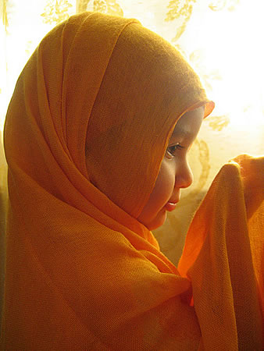
O you who believe! Observing al-sawm (the fasting) is prescribed for you as it was prescribed for those before you, that you may become al-muttaqoon (the pious).
(Qur’an al-Baqarah 2:183)
As the beautiful month of Ramadan approaches this year, there are several things Muslim women can do to prepare themselves spiritually and physically for the month-long period of fasting which is obligatory upon all able-bodied Muslims who have reached the age of maturity.
Giving some thought to the unique concerns that Muslim women face during this month can help us prepare for them and make the month a more successful one. This is especially true for new converts to Islam (because Ramadan is such a new experience) and for married women in general because of the extra responsibility they typically have to make sure that the iftar (the fast-breaking meal served at sunset each day) is ready on time for their families and any guests in addition to continuing to take care of the home, children and other obligations as usual. It is crucial, then, that women take the time to plan for their sleep, health and other concerns before the month even starts.
It is recommended for Muslims to eat a pre-dawn meal (called sahoor in Arabic) each day before the fast begins. The Prophet, may the peace and blessings of Allah be upon him, is reported by Anas (may Allah be pleased with him) to have said,
"Eat a pre-dawn meal for there are blessings in it." (Bukhari and Muslim)
Other traditions report the Prophet (peace be upon him) as saying,
"You should eat [the] pre-dawn meal for it is a blessed nourishment" (an-Nasa'i),
and
"The pre-dawn meal is blessed so do not neglect it even if you only take a sip of water. Verily, Allah and His angels pray for those who have pre-dawn meals." (Ahmad)
The pre-dawn meal provides energy and other benefits to the fasting Muslim during the day so it makes good sense to plan on getting up early to have sahoor. Of course this is better accomplished if you also sleep early so try to think about how you will arrange your schedule once Ramadan begins. If you typically have trouble waking up for the fajr (dawn) prayer, a new schedule in Ramadan may be the motivation you need to change your habits for the better even after Ramadan has ended. Ramadan is a great opportunity that comes once a year to renew your relationship and commitment to Allah
If you are accustomed to drinking tea or coffee in the morning or during the day, be aware that caffeine withdrawal can cause severe headaches while you are fasting. Take some time before Ramadan to wean yourself from caffeine (perhaps gradually) and decide whether it will be necessary to have any caffeine during the non-fasting hours in Ramadan. It may seem like a funny thing to worry about compared to the greatness of this Holy Month but many Muslims have experienced the phenomena of caffeine withdrawal and know to prepare themselves ahead of time to ensure they do not get sick from it.
Women should also know the times that they are prohibited from fasting, such as when they are menstruating or bleeding after childbirth.
Pregnant and breastfeeding women have special permission not to fast during Ramadan if they feel that they or their babies will be harmed by it, but they are not prohibited from fasting if they feel they can handle it. This is something best discussed with a doctor and depends on each woman's unique circumstances. However, it is very important that pregnant and breastfeeding women take care to eat properly during non-fasting hours if they choose to fast. It is also important that women do not feel any shame or guilt in breaking the fast if they feel they must; no one has the right to put pressure on the pregnant or breastfeeding woman to exceed her body's limits. In fact this allowance not to fast should be considered a mercy from Allah and not a punishment.
Likewise, women should not fast just because they do not want to have to make their fasts up later: health should be the prime consideration in deciding whether or not to fast. Take the fast one day at a time: it is not a competition with others but an act of worship for the sake of Allah Most High.
Of course women who are ill or must take medications during the day need to consult their doctors in order to see if it will be possible for them to fast and to change the schedule of their medications. Discuss the issue with a sheikh if you are not sure about your situation.
Whether a woman misses days of fasting due to menstruation, childbirth, pregnancy, breastfeeding or illness, these missed days should be made up before the next Ramadan comes. Insha’Allah. Depending on her circumstances and on different schools of thought, making up the fast may be as simple as fasting one day for each day missed during Ramadan, or it may require that she feeds one poor person each day either in addition to, or in place of, fasting herself. Women should consult reliable books or scholars to understand their obligations in this regard. Fiqh us-Sunnah by As-Sayyid Sabiq is an excellent source of reliable information on how to make up missed days of fasting.
Understanding and respecting your body's physical needs and limits during Ramadan will help you to have more energy for taking care of your home, family and other responsibilities
Spiritual preparation is also something that needs to be done before Ramadan comes around – it might seem silly really when you consider we should be spiritually “in tune” 12 months a year. We all seem to get caught up with our hectic schedules and all of a sudden you hear Muslims say: “oh no” Ramadan is in 2 weeks and its “panic time”! Some women busy themselves with spring-cleaning their homes but often we forget to warm up and fine-tune our selves in readiness for this mighty month
Cleanliness - Whenever a guest comes, we prepare in advance for his arrival by vacuuming the carpet, dusting the shelves, and scrubbing the sinks. We should do this for our guest called Ramadan. But the scrubbing should not just be of our physical surroundings; it should include the scrubbing of our sins.
Listen to the words of our Prophet Muhammad (peace be upon him), speaking about those people that don't want to clean up for Ramadan,
"Whoever doesn't desist from speaking falsehood and acting upon it, Allah has no need that he desist from his food and drink." (Bukhari)
Fasting in Sha'baan (this Month that we are now in) - The biggest downfall of many Muslims is that they are not properly warmed up for Fasting, some people only do it once a year making their bodies very foreign to going without food and drink.
From here we see the following Sunnah: Umm Al-Mu'mineen Aisha (may Allah be pleased with her)- observes, "Allah's Messenger never fasted an entire month other than Ramadan and I haven't seen him fast more than he did in Sha'baan."
This is a good way to prepare for Ramadan by fasting in the moth before. The Prophet (saws) also fasted Monday and Thursdays every week. We should make fasting something we do all year round not just in Ramadan so it becomes second nature to us.
As for the Prophet (peace be upon him), he used to give glad tidings to his Companions of the coming of Ramadan, like what is narrated from Imam Ahmad and An-Nisaai from the hadeeth of Abu Hurayrah (may Allah be pleased with them), who said: “Allah’s Messenger (peace be upon him) said to his Companions,
‘The month of Ramadan is coming, the blessed month wherein Allah has made fasting binding on you. In it, the gates of Paradise are opened, and in it, the gates of Hell are locked, and the devils are enchained. In it is the beneficent night of a thousand months (i.e. Laylat ul-Qadr). Whoever denies goodness in it has indeed been deprived.’
Ma’la Ibn al-Fadhl said about the Salaf (the pious predecessors): “They used to call upon Allah for six months until Ramadan reached them, then they would call on Him the other six months that Allah may accept it from them.” And Yahya Ibn Abee Katheer said, “Their supplication used to be,
‘O Allah, keep me safe until Ramadan, and make Ramadan faultless for me, and secure it for me as an accepted (month of virtue).’”
The early generations of the Ummah used to make Du'a 6 months after Ramadan that Allah accept their deeds in Ramadan. And for the next 6 months, they would make du'a to Allah to grant them the blessing of being alive in the coming Ramadan.
Some of the many important lessons we learn from Ramadan are:
v Developing Taqwa
Fasting has been legislated in order that we may gain taqwa, as Allah – the Most High – said:
"O you who believe! Fasting is prescribed for you, as it was prescribed upon those before you in order that you may attain taqwa." [Qur’an al-Baqarah 2:183]
The Prophet (peace and blessings be upon him) said: "Fasting is a shield with which the servant protects himself from the Fire." (Hasan: Ahmad, authenticated by al-Albani in Saheeh ut-Targheeb)
So we should ask ourselves, after each day of fasting: Has this fasting made us more fearful and obedient to Allah? Has it aided us in distancing ourselves from sins and disobedience?
v Seeking Nearness to Allah
"Whosoever reaches the month of Ramadan and does not have his sins forgiven, and so enters the fire, then may Allah distance him." (Ahmad and al-Bayhaqee)
v Acquiring Patience
What is meant by the month of Patience is the month of Ramadan …so fasting is called patience because it restrains the soul from eating drinking, conjugal relations and sexual desires." (At-Tamheed of Al Haafidh ibn Abdul Barr)
The Prophet Muhammad (peace and blessings be upon him) said:
"O youths! Whoever amongst you is able to marry, then let him do so; for it restrains the eyes and protects the private parts. But whoever is unable, then let him fast, because it will be a shield for him." (At-Tamheed of Al Haafidh ibn Abdul Barr)
So fasting is a means of learning self-restraint and patience. With patience we are able to strengthen our resolve to worship Allah alone, with sincerity, and also cope with life’s ups and downs. So – for example – with patience we are able to perform our Prayers calmly and correctly, without being hasty, and without merely pecking the ground several times!
With patience we are able to restrain our souls from greed and stinginess and thus give part of our surplus wealth in Zakaah (obligatory charity). With patience we are able to subdue the soul’s ill temperament, and thus endure the ordeal and hardships of Hajj, without losing tempers and behaving badly. Likewise, with patience we are able to stand firm and fight Jihad against the disbelievers, hypocrites and heretics – withstanding their constant onslaught, without wavering and buckling, without despairing or being complacent, and without becoming hasty and impatient at the first sings of hardship. Allah – the Most High – said:
"O Prophet, urge the Believers to fight … So if there are one hundred who are patient, they shall overcome two hundred; and if there be one thousand, they shall overcome two thousand, by the permission of Allah. And Allah is with the patient ones." [Qur’an al-Anfaal 8:65-66].
Thus, without knowledge and patience, nothing remains, except zeal and uncontrolled emotions, shouts and hollow slogans, speech that does not strengthen, but rather weakness, and actions that do not build, but rather destroy! So in this month, we should strive to develop a firm resolve for doing acts of obedience, and to adorn ourselves with patience – having certainty in the saying of our Messenger sallallahu `alayhi wa sallam: "And know that victory comes with patience, relief with affliction, and ease with hardship." ( Saheeh: Ahmad, at-Tabaraanee in al-Kabeer, authenticated by al-Hilaalee in as-Sabrul Jameel)
v Cultivating Good Manners
Fasting is not merely abstaining from eating and drinking. Rather, it is also abstaining from ignorant and indecent speech. So if anyone abuses or behaves ignorantly with you, then say: I am fasting, I am fasting." (Saheeh: Ibn Khuzaymah and al-Haakim, who authenticated it.
v Sensing Muslim Unity
As Muslims from all around the world commence Ramadan we realise that we are part of a community our hearts and actions united in pursuing Allah’s pleasure. There are many ahadith mentioning the blessings of breaking the fast together and there is also much reward in feeding a fasting person. So let us unite in this month of Mercy.
So Ramadan – it is that light in the souls of the righteous and the truthful, and in the hearts of the devout and sincere it gives happiness; for it is the month of obedience, and in it there are beautiful reflections for us all. Indeed, it grants victory to the soul over the body and flesh and gives us a wonderful opportunity to straighten ourselves up with our Lord.
During this month of Sha’baan we should find out more about the traditions of the prophet Muhammad (peace be upon him) related to Ramadan and make a sincere effort to implement them this year. We should also try to purify our hearts and intentions before the commencement of Ramadan to make this fast successful for our families and ourselves. Insha’Allah
Ramadan is also an opportunity to renew relationships that may have been broken during the year and we should try and clear up any disputes or bad feelings with other Muslims so we may start this month a fresh.
So we ask Allah to grant us the ability to change ourselves for the better, during this blessed month, and not to be of those who are prevented from His Mercy and Forgiveness. Indeed He is the One who Hears and He is the One to Respond.
http://www.missionislam.com/ramadan/prepare.htm
***
By Muslema Purmul
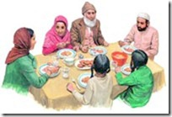
Umar bin al-Khattab (may Allah be pleased with him) relates that: â€œI heard The Prophet, peace be upon him, saying, â€œVerily actions are by intentions, and for every person is what he intendedâ€¦â€ (Bukhari; Muslim)
In a hadith Qudsi, the Prophet, peace be upon him, tells us that Allah (SWT) said,
â€œAnd My servant does not draw near to Me with anything more loved to Me than the religious duties I have obligated upon him.
And My servant continues to draw near to me with nawaafil (extra good) deeds until I Love him.
When I Love him, I am his hearing with which he hears, and his sight with which he sees, and his hand with which he strikes, and his foot with which he walks.
Were he to ask [something] of Me, I would surely give it to him; and were he to seek refuge with Me, I would surely grant him refuge.â€ (Bukhari)
Ibn Al-Qayyim said, â€œThose who are the closest to Allah are the ones who have their Mubaah (allowed acts like sleep) turned into acts of worship and into a means of approach to Allah, on account of their good intention (Niyyah). They no longer have a Mubaah that is equal on both sides (where doing or abandoning it are the same). All their deeds are leaning to one side, (that is, they always gain a reward).â€
Practical Steps
The first thing we need to do in preparing for the month of Ramadan is renewing our intentions, yes all the way from now! One of my teachers in Egypt had mentioned to me that the companions in order to increase the amount of reward they would get for a single good deed, would compete in seeing who can come up with the most amount of good intentions for that deed. Our practical tip for the day in renewing our intentions is two-fold:
1- The first part is to make a list of all that you want to accomplish in Ramadan. This includes doing acts that are obligatory, recommended, and allowed as well as staying away from discouraged and prohibited acts.
This list should cover every aspect of your life: your spiritual relationship with Allah, your knowledge, your activism and volunteering in teamwork in the community, your relationships (family, bonds of brotherhood, sisterhood, your neighbors, etc.), your speech and character, your career, your finances, everything. And think about making each goal something you seek sincerely for Allah (SWT)â€™s pleasure. Make your goals challenging but within reach. If they are too easy you will take them for granted and if they are too difficult then they may discourage you. It has to be doable for you.
After you make your list, spend a few minutes making dua that Allah (SWT) grants you success in achieving each and every intended act, and in achieving sincerity in them all. Give yourself at least 15-20 minutes for this tip! Also keep in mind, some of the goals you have will be covered in our Count-Down, and some wonâ€™t be. Try to practice in a gradual way the goals you have set for yourself all throughout the Count-Down days, and as such you will have habituated your soul on the good action even before entering Ramadan insha Allah!
Just by renewing your intentions constantly, you will also find yourself speaking to Him more and making more dua
2- The second part is something you can practice today and continue practicing during the count-down. That is try to renew your intention for everything you have to do today as many times as possible.
When you eat, seek Allahâ€™s pleasure by intending to gain energy through the food in order to serve Him better. When you sit down at the internet, seek to gain or deliver beneficial knowledge that would draw you and others closer to Him (SWT). When you send an email, seek to increase your bonds of ukhuwwah (brotherhood) and better the relationship with the other person for the sake of Allah (SWT). When you pray, seek to have the most concentration in order to increase the reward of that prayer, etc. etc. etc.
You will find, insha Allahâ€”the more you renew your intentions, the better each act becomes, and the more blessings you find in them. Even chores will have a sweetness to complete when the remembrance of Allah (SWT) is present in the heart. You will find that just by renewing your intentions constantly, you will also find yourself speaking to Him more and making more dua. Remember and rejoice in Allahâ€™s Generosity! There is reward and Allahâ€™s pleasure just in having good intentions, even if we were not able to accomplish the specific actions we wanted!
In a hadith Qudsi, the Prophet, peace be upon him, mentioned,
â€œHe who has intended a good deed and has not done it, Allah (SWT) writes it down with Himself as a full good deed; but if he has intended it and has done it, Allah (SWT) writes it down with Himself as from ten good deeds to seven hundred times, or many times over.
But if he has intended a bad deed and has not done it, Allah (SWT) writes it down with Himself as a full good deed, but if he has intended it and has done it, Allah (SWT) writes it down as one bad deed. (Bukhari and Muslim)
May Allah (SWT) bless both the quantity and quality of our intentions, and grant us success in them in this life and in the hereafter.
Ameen
http://muslimobserver.com/preparing-for-ramadan-renewing-our-intentions/
***

How to Get Your Kids to Look Forward to and Love Ramadan4
< Previous
Susan Carland June 1 Ramadan & Productivity 34 Comments GET ARTICLES BY EMAIL
Image Credit: yeowatsup https://www.flickr.com/photos/yeowatzup/3886769225/
Ramadan is nearly upon us In sha Allah, and for those of us who are parents, the month brings with it a desire to imbibe a love and excitement in our children for fasting and the unique ibadah that comes with this month. In this article, I share my tips and advice on how to prepare your children for Ramadan.
Unlike Muslim countries, where markets, streets, television and the general population all foster a sense of connection to Ramadan, parents who live in non-Muslim countries have the added challenge that there is little recognition of this holy time outside of our homes and mosques. Muslim parents have complained to me about how hard it is when Christmas is a massive and exciting public event, while Ramadan and Eid pass by mostly unnoticed. Christmas, with its beautiful decorations, magical themes and catchy tunes blaring over loud speakers in every mall for weeks on end, can make Ramadan and Eid look dull in comparison to children. Whilst I don’t believe we should view it as a competition, as parents I firmly believe we have a responsibility to make all religious obligations meaningful and, as much as possible, enjoyable for our children.
I say this as someone who has limited craft skills: I can’t use a sewing machine, I do not own a hot glue gun, and there is no such thing as a “craft cupboard” at my house. I’m also busy like so many of you with work and volunteering and the demands of family. You simply need an enthusiastic mind and a heart that desires iman for your child.
The following ideas are things I came up with over the years for both my own children and for the children at my Saturday madrasah. They are very basic, and generally you can get the kids to do it themselves. They are also often designed for the whole family to be involved, as it is in doing so that memories are made, family traditions are started, lessons are taught, and faith is sewn.

1) Buy decorations
Decorations remind everyone who enters the home that this is a special time. I found that there were some decorations I simply could not stand to look at for 30 straight days (slowly deflating balloons in particular), so I chose something I could enjoy for a whole month. I purchased a range of colourful Chinese paper lanterns from my local discount store and strung them up in my living room. They were cheap, looked great, and were not the kind of decorations my kids automatically associated with other celebrations (i.e. tinsel for Christmas or balloons and streamers for birthdays). I also cover windows with Ramadan messages and drawings made with coloured window chalk, and we have a special scented candle we light every night at Maghrib in Ramadan that changes colour every few minutes. You know best what decorations will make your family happy, so go for it! Get everyone to help you decorate a day or two before the month starts, while blasting Ramadan anasheed.

2) Start a Ramadan calendar
Marking off the days of Ramadan is a lot of fun for kids. The simple calendar I made for my children (felt pieces glued on to a black board) has little pockets, where I put a note with either a sweet or a date for the kids. The notes have changed over the years based on the age and knowledge of my children. When they were very small, the notes just said things like “Allah loves you so much!” and “In Ramadan, adult Muslims don’t eat or drink anything from before sunrise until sunset!”. As they grew older, I put in more advanced lessons or Qur’an verses. If we have guests, I ensure there are enough sweets or dates in the pocket for every child who visits. The children are not allowed to get the note or sweet until Maghrib time, as this helped create a sense of excitement for this time of day, even when they were too young to be fasting. If you’re not keen on making your own calendar, you can buy beautiful handmade silk and wool calendars or even just print these great ones for free, and cross off the days as you go.
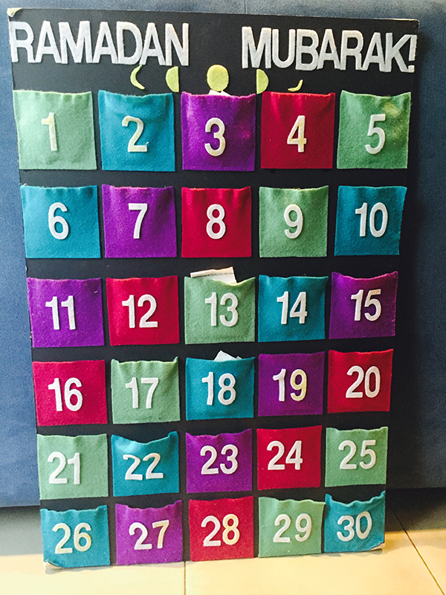
Image Credit: Susan Carland

3) Plan Ramadan goals
We all need a plan for Ramadan, otherwise it’s easy for the month to whiz by without much change in us other than increasing bad breath. Kids should be encouraged to have goals, too! As parents, it’s important that we explain to kids why Ramadan goals matter, and the importance and reward of extra ibadah in this month.
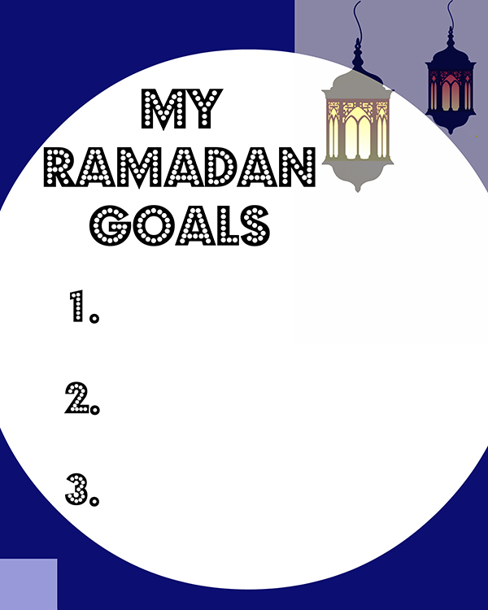
Image Credit: Susan Carland
For very little children, have them make three goals for the whole month; any more than that is just too much for little ones. The goals can be things like “learn a new dua”, “memorise three new surahs”, “fast for two hours once a week”, or “help mummy everyday”. The sheet can look something like this:
Slightly older children can benefit from more structure, and for that age I created a 30-page notepad to check off each day. This visual reminder gives them ideas of things to do each day when they often forget, and also provides the satisfaction of not just ticking things off at the end of each day but reviewing all they achieved at the end of the month. A page from the notepad looks something like this:
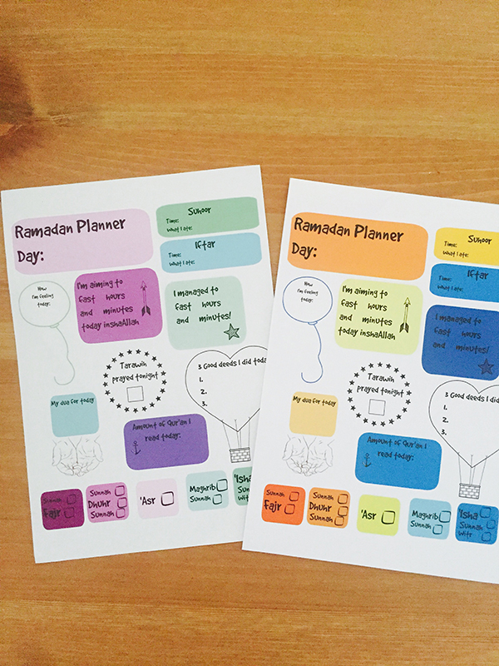
Image Credit: Susan Carland
On the other hand, teenagers can benefit from a Ramadan diary: buy them a funky notebook or get a plain one and allow them to decorate it themselves. Tell them it’s for them to record not just their goals at the start, but their feelings, thoughts and prayers to Allah as the month continues. I do check them to see that they are writing in them regularly, but I never read specifics (I generally only flick through the pages), as privacy is important at this age.
Keep any goals the kids have close to where your family eats or prays, and be sure parents and any elders who live at home have somewhere to write their goals too. Remind and encourage each other as the month progresses, and be sure to warmly praise children as they achieve or maintain Ramadan goals.

4) Get the kids to give sadaqah
Teaching your children about sadaqah during Ramadan is one of the best ways to implement this trait in them from an early age, as they learn the importance of charity and the need to share with those who have less than they do. Giving in charity does not just have to be raising money for charities, but can be as simple and sincere as sharing iftar food with your neighbours. This has the added benefit of your children actively participating in da’wah and teaching others about Islam.

Baking for others
Kids often want to share about Ramadan with their non-Muslim teachers, neighbours, friends or family members but don’t know how. We make cookies each year (or to make it even easier, you can buy plain round sweet cookies and decorate them with icing and sweets), put them in clear little bags and attach a little note about Ramadan with string or ribbon (be sure to list ingredients on the back of the note in case of allergies). Then we deliver them with a smile!

Spread the joy of reading
If your children attend a secular school, donating good quality books about Ramadan is a lovely way to ensure the correct image of and information about this time of year is available in the school to any teacher or child who may want to know more about Ramadan. School libraries are always grateful for donations of good books! Books such as “My First Ramadan” and “Rashad’s Ramadan and Eid al Fitr” are great for very little children. Books such as “Ramadan Moon”, “Under The Ramadan Moon”, and “A Party In Ramadan” are good for older children. Even if your children attend an Islamic school or are homeschooled, why not consider donating a good book about Ramadan to your local library for the benefit of everyone?
I also leave a collection of nice Ramadan books out at home for my own kids to peruse throughout the month.

The ‘sadaqah box’
Get a large box and have the kids decorate a sign for it that says “sadaqah box”. Throughout the month, encourage everyone in the family to put both money and food donations in the box. Do the kids have good quality toys they would be willing to part with to go to a charity shop? Praise kids when they add to the box, and ensure they see you putting things in the box too. As a family, decide where you will donate the money and food, and be sure to take it before Eid so the recipients can enjoy the donation on Eid.

5) Get crafty!
Crafts are a fantastic way for your children to get excited for Ramadan; it allows them to express their creativity, learn and get messy at the same time! Have a look at my ideas for different Ramadan crafts for your children and get the whole family involved.

Ramadan placemats
These can easily become a Ramadan tradition! They are easy to make and a great way to help kids learn the iftar and suhoor dua. Print out the dua on A4 paper (we always do Arabic, Arabic transliteration and English), then let them decorate it to their hearts’ content. Laminate to seal everything and they will last for years (older children and teens love to see the cute pictures they drew on their Ramadan placemats all those years ago). If you do not have access to a laminator, you can use long pieces of sellotape to cover the decorated page entirely– a great and cheap alternative to lamination! Another idea is to make them from felt, with a little pocket on one side for cutlery, and another pocket on the other side to slip in dua cards. Kids can decorate them with coloured felt shapes, and the mats can be gently washed when they get dirty.

Good deed jars
We all want to do good deeds in Ramadan, but sometimes it can be hard to know what to do, especially for kids. Good deed activities are a great way to remind everyone about the need to keep aiming to do good deeds. It can be as simple as a bowl in the middle of the dining table with folded-up notes of good deed suggestions, or as fancy as a Good Deed Tree like this or this.
Gather as a family and write down a big collection of good deeds that everyone in the family can manage: learning a new portion of Qur’an, helping an elderly neighbour or family member, praying two extra raka’hs etc. Everyone in the family takes a good deed from the bowl each day and completes it, and chats about their experience over iftar; what they found fun or hard or interesting about doing it. Doing this will help children realise that their parents do good deeds regularly, because often as parents we forget the need to consciously model such behaviour for our kids. It also teaches them that struggling with doing good is both normal and acceptable, and allows parents to model how they deal with these situations without giving up.

‘Alhamdulillah’ chart
This is a lovely family activity to do in Ramadan that beautifully introduces young children to the idea of dhikr.
Write “this Ramadan, we say Alhamdulillah for…” on the top of an A3-sized poster paper which is put up near to where the family gathers to eat or pray. Leave a stack of coloured sticky notes and markers next to the poster, so each person in the family can write at least one thing they are grateful for, every day of Ramadan. It can be as important as their life, family or faith, or as small and funny as chocolate, coffee, or tickles! Encourage visitors to contribute too. At the end of the month, your poster will be covered in sticky notes and your family will have not just a gorgeous record of gratitude to Allah , but a tangible proof of the abundant blessings in their life.

Date jar gift
This is a fun activity to do with kids after teaching them about the sunnah of breaking one’s fast with dates and the reward of helping someone else to break their fast.
Have children count 30 dates into a jar, and then attach a chalkboard label and piece of chalk with string for the recipient to count down the days till Eid. If Ramadan is only 29 days this year, the recipient can use the remaining date to fulfil the sunnah of eating a date on Eid morning! Your children can create these jars to give to friends and family at the beginning of Ramadan.
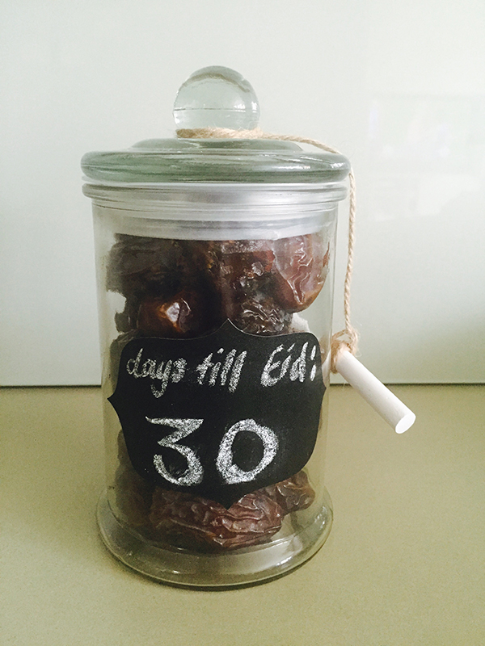
Image Credit: Susan Carland

I’tikaf tent
I wanted to introduce my children to the idea of i’tikaf in Ramadan while they were still small in a fun and special way. They were too young to do a proper i’tikaf in the masjid, so I purchased a tent and decorated it with fairy lights and stars on strings and left it in the living room for the whole month. I told them it was their own special place (no grown-ups allowed!) for thinking and dreaming and praying in Ramadan.
Inside, I placed child-sized prayer mats, prayer beads, mushafs on stands, picture books about Ramadan and the prophets, Qur’anic stories for children, and their Ramadan notebooks. They could go in and out of the tent whenever they wanted, but it wasn’t a place for playing Angry Birds on the iPad! I wanted them to get used to the idea of a place of retreat that was only for their time with Allah , even if they just laid on their backs and daydreamed about life and the universe while they were there.
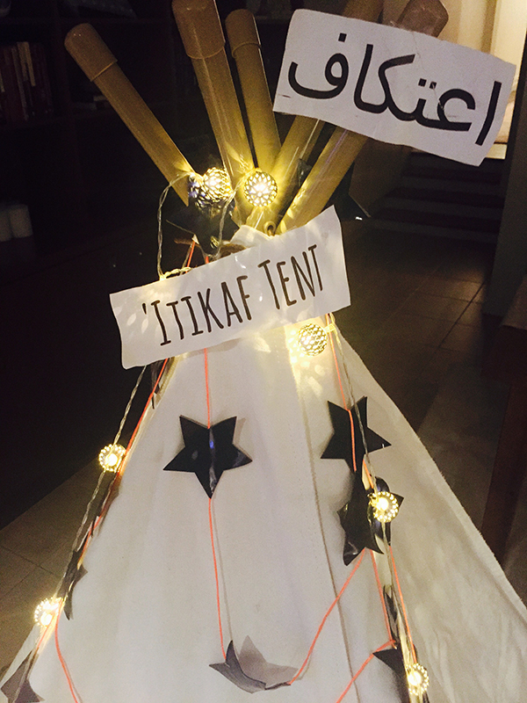
Image Credit: Susan Carland
There are many more amazing ideas available online for ways to make your Ramadan special for your kids (Pinterest is a great place to start). Choose what works for you and your family and makes you feel excited and happy; it should not feel like another burden or hassle in your life. Don’t feel overwhelmed, and keep in mind that teaching and sharing all these things with your children, with the right intention, is ibadah for you.
Finally, remember that your children don’t care about crafty perfection in these things, but will care about the warm feelings you nurtured in them towards Ramadan and their faith. May your Ramadan be full of blessings, happiness and sakeenah. Ameen!

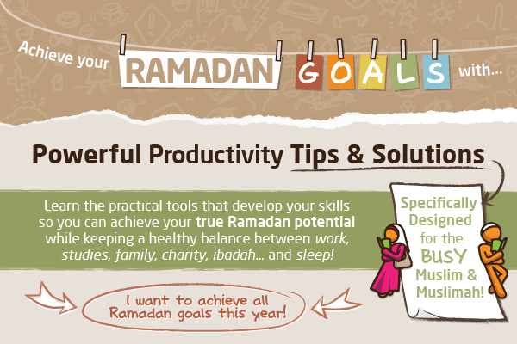
3.8k Shares
Click to read more: http://productivemuslim.com/get-your-kids-to-love-ramadan/#ixzz3cAbfEFpw
Follow us: @AbuProductive on Twitter | ProductiveMuslim on Facebook
***

