Syrians are silently crying out for help!

Arshia Nisar
Friday February 09, 2018

The sad state of affairs in Syria.

Current Affairs
Syria has been in the news for a long time now given the atrocities inflicted on them on the hands of various entities. Ever since the civil war in Syria started in 2011, the people have been having a hard time. The conditions in the area are so bad that many people are fleeing the country. The number of internally displaced people has been increasing by the day with millions on the run to save their lives!
In the latest news, the bodies of around 10 refugees were found frozen in Lebanon near the Syrian border! As they tried to run away from the bombing and violence on their native land they had no idea of the hardships they’d have to experience and sadly met their doom. This is just one of the many miserable occurrences experienced by the Syrians.
A lot of Syrians have already fled their country leaving behind everything they owned due to the conditions in their homeland. Of the people who have successfully reached other countries, a huge majority is without any place to live and is devoid of the basic necessities of life. While around 5 million Syrians are seeking refuge in neighboring countries like Lebanon, Jordan, Iraq and Turkey, around 6 million people are displaced with around 13.5 million still in need of financial and medical assistance.
A lot of NGOs are working hard to get aid across to these people in need helping the IDPs to settle in places they have migrated to. However, there are not many organizations working for the IDPs within Syria. HCI (Human Concern International), an NGO working for the betterment of people all over the world, is one of the few NGOs which are not only providing aid to the Syrian IDPs in other countries but are also helping the people in need within Syria!
Since 2012 HCI has been working hard helping out the people of Syria. However, in order to continue helping these distressed people out, HCI needs your help to assist them in their mission of providing aid to these people. You can easily help your Syrian brothers and sisters out with just a click of the button! Click on the link below to donate:
https://www.humanconcern.org/2017/06/01/syria-crisis/#
"Zakah expenditures are only for the poor and for the needy and for those employed to collect [zakah] and for bringing hearts together [for Islam] and for freeing captives [or slaves] and for those in debt and for the cause of Allah and for the [stranded] traveler - an obligation [imposed] by Allah . And Allah is Knowing and Wise." (Quran 9:60)

Attacks on Eastern Ghouta, Syria!

Arshia Nisar
Friday March 09, 2018

The Syrians need your help.

Current Affairs
Syria has graced the headlines of all news outlets yet again as its Eastern Ghouta province has been made victim to attacks amidst aims to reach a truce, the main purpose of which was to facilitate the evacuation process of the Syrians trapped in the region. Several air raids were launched in Douma and Harasta by Syrian warplanes, with help from the Russians. The people in the region are being made victims to shelling, barrel bombs, chemical attacks and missiles! According to reports, within the past week, more than 550 civilians have been killed while several others have been injured.
Eastern Ghouta has been under rebel control since around 2013 after which the government imposed a siege on the area in an attempt to drive out the opposition fighters. It has been ridden by bombs and bad conditions for around 5 years now with no signs of improvement in the region. The latest attacks have destroyed several medical facilities, forcing the doctors to use expired drugs to treat the wounded.
It is difficult for the NGOs and humanitarian agencies to reach the area and help the people out. A lot of NGOs are working hard to get aid across to these people as they are in dire need of food and medical facilities.
HCI (Human Concern International), an NGO working for the betterment of people all over the world, is one of the few NGOs which are not only providing aid to the Syrian IDPs in other countries but are also helping the people in need within Syria!
HCI has been working hard helping out the people of Syria. However, in order to continue helping these distressed people out, HCI needs your help to assist them in their mission of providing aid to these people. You can easily help your Syrian brothers and sisters out with just a click of the button! Click on the link below to donate:
https://www.humanconcern.org/2017/06/01/syria-crisis/#
“The believing men and believing women are allies of one another. They enjoin what is right and forbid what is wrong and establish prayer and give Zakah and obey Allah and His Messenger. Those - Allah will have mercy upon them. Indeed, Allah is Exalted in Might and Wise.” (Quran 9:71)
So let us help our Muslim brothers and sisters out by following the example of the Ansar of Madina as they are in devastating conditions and in need of our support.

Ahmad • 11 days ago
Please get your facts right:
- The civilian population in Eastern Ghouta are being held hostages by the armed rebels who are affiliated with Alqaeda and supported by the US
- The armed rebel groups have been shelling Damascus for years with minimal media coverage
- Be aware that the situation in Eastern Ghouta is being used to support the agendas of external countries and not to assist the Syrians
We as Muslims have to stand together and be smart and aware of the wicked plans that are prepared for our regions. You are obligated to check both sides of the story before publishing your writings otherwise you are biased and politicized.
  - 2
  - •
  - ReplyBandrui Ahmad • 10 days ago
Thank goodness. I am disgusted that this site is publishing this pure nonsense. so many people have been brainwashed into thinking this way.This is exactly what the west wants people to think. Assad and Russia have opened a humanitarian corridor to help civilians escape from the rebels. Many are being held hostage.
I have seen much propaganda targeted at Arabic speakers via Messenger network and unfortunately many are buying into it without question.
Divide and Conquer is the name of the game there.
Us, Israel and allies are after the resources and the land per the Oded Yinon plan.
    - 1
    - •
    - Reply
Karam Bandrui • 10 days ago
Do you actually believe that the Assad and Putin are the good people. Please make sure that what you're saying is true , because we're talking here about an whole nation which is getting bombed at one and the other time. How do I know that?? BECAUSE I am Syrian, and I've been through this, I saw with my own eyes helicopters shooting rockets randomly to the ground without even having a main target to focus the shooting at. I do really feel sad when some people like you doesn't feel sad for the people who are getting bombed. I flew Syria in 2011-2012 and all I can remember back in 2011 was that when I used to play on my computer I used to hear suddenly a very loud sound.... Do you know what that sound was? It was the sound of bombs landing to the ground and every time I would hear that sound I would be terribly scared and start just saying Dua's. I hope that you don't believe everything the news/ media says because they only want you to see what benefits them. Instead ask the Syrian people who've been through this whole madness.

      - •
      - ReplyBandrui Karam • 7 days ago
I have and I have today published a comprehensive report from someone who has seen what the terrorists are doing. Holding Syrians hostage, comandeering hospitals and now even targeting the safe humanitarian corridor created by Assad to allow civilians to escape. Go and actually check your facts. You are wasting my time.

        - •
        - Reply
        - •
        - Share ›

Adil Ahmad • 10 days ago
All these started in 2014 when Bashar used chemical weapons and killed over 1500 children. That is the reason for the origin of all extremist groups in Syria. That time there were no hostages taken by rebels. Even this time Bashar is attacking only aerial strikes (without thinking about civilians) since he doesn't have the backbone for direct fight. But you are sympathizing this evil man.

    - •
    - ReplyAhmad Adil • 10 days ago
Even the US Secretary of defense said there is no proof Assad used chemical weapons. Also independent investigators say it is highly probably that the so called armed rebels (which are not all syrian so not sure they can be called rebels) are the ones used these chemical weapons possibly to provoke US to attack Syria. When are you going to wake up and be aware of the plans they have to invade Syria. İf you care about Syria why don't you speak out about the illegal US army presence in Syria in rich oil regions. The truth is very simple to see but you're either too blinded by secterianism or you are an agent of the west or you are a fool that believes everything without questioning. Unlike you I provide proofs to what I say, see clip below to backup what I said earlier.
İf you truly care about Syria and Syrians then you are obligated to watch and double check what you say to make sure it is truthful. You also should not say anything that will help the enemies of Syria by supporting their story. What you said can cause further division in Syria and the Muslim world so instead let's focus our efforts in bringing together Syrians and the Muslim world. To do that we have to be responsible of every word we say and only say things that will genuinely help unite us not the opposite.
see more
      - 1
      - •
      - ReplyAdil Ahmad • 9 days ago
I respect your efforts to unite the Muslims. But unfortunately I have seen too much of disturbing pictures and videos on social media to accept that Bashar is a good man. For your information I am no where close to middle east. I am from Sri Lanka. Yet I am so worried about whats happening to the Ummah.

        - •
        - ReplyBandrui Adil • 7 days ago
The videos you have seen, the pictures, are complete fakes. Most of the pictures used aren't even of Syria. Have a brain people. Research.

          - •
          - ReplyAdil Bandrui • 7 days ago
I am from a country which suffered a civil war for 30 years. From the civil war in my country I learnt one important thing. No rebel group or terrorist group can survive without the support of the locals. For locals to support an extremist terrorist group instead of the government, the government should be extremely worse than the terrorist group.

            - •
            - ReplyBandrui Adil • 7 days ago
Lies.

      - •
      - ReplyKaram Adil • 10 days ago
It started actually in the year 2011, because that's when I left my country (Syria) seeking for a safe place to live in.

      - •
      - Replykazi islam Ahmad • 10 days ago
As salamu alaikum brother Ahmad and those who may read my comments. Some reason I don't see the nonsense bombing of the rebels. I know Western media doesn't show it, but I watch RT(Russian Television) as well, didn't see much there as well. These days social media is in power, not a single video of rebel bombing/shelling the civilians popped up my screen. It maybe on my friend list I don't have anyone from other side. It is possible.
Regardless, I am not here to blame Assad or the rebels; rather the blame will fall on to both sides. How many lives had to be lost to stop this madness? How many families had to be broken? How much destruction the country need to see to stop this? Both Assad and the rebels should say enough is enough. Sit together without any foreign parties and have it stopped. We are Muslim brothers & sisters. For the sake of Allah, this need to be stopped immediately.
Even though the stories may be claimed to be politicized but the deaths are real, isn't it? Since Assad is in power with Russia and Iran on his side, he cannot shrug off the bigger responsibility to establish peach and stop this massacre. By authentic hadith, before Dazzal appears Iraq, Syria and Egypt must be destroyed. It is all meant by Allah, because Muslim nation become so corrupted and the good souls are dormant instead of establishing the truth and justice. But so long this civilization continues world will see Assad as a person for whom over half a million people lost their lives.
Again, no offense if I hurt any of your feelings by any way. I am not an Arab, neither Iranian. I gain nothing from it. It saddens me every moment when I see my brothers/sisters, kids bleeding and dying wherever it may be, whichever sides they may be. May Allah guide us to the straight path. May Allah give us His guidance and be Merciful to us. May Allah see us the truth as true and false as falsehood. May Allah help us establish the truth and destroy the falsehood.

    - •
    - ReplyBandrui kazi islam • 7 days ago
You people are absolutely brainwashed.

      - •
      - ReplyAli Ahmad • 11 days ago
do not listen to this guy. He works with Russia.

    - •
    - ReplyAhmad Ali • 10 days ago
Sorry but your reply is very dumb. İnstead of spreading lies that lead no where why don't you contribute useful substance to the conversation and tell me what your point of view is so we can understand each other. Try harder to use your brain and say something useful based on facts.
İf your name is truly Ali then I consider you my brother and I truly wish you the best even if we have different opinions. Let's work together for each other not against each other. İt's about time we learn from our mistakes and know that we only have each other's.
      - 1
      - •
      - ReplyMahomed Salim Cassim Ahmad • 10 days ago
I wish that many of our Muslim Brothers and Sisters thinks this way as we are being
blinded and bombarded with pro western propaganda about the situation in the middle east,
It is time WE THE MUSLIM UMMAH who say that we love and follow the prophet of ISLAM (Nabi MUHAMMAD saw) and recite the SHAHADAH, to unite and stand as ONE UMMAH for TRUTH AND JUSTICE and fight the enemies of ISLAM.
Something to think about : We talk about the middle eastern countries as being ISLAMIC?
BUT there is only ONE country in that region which is ISLAMIC viz:- THE ISLAMIC REPUBLIC OF IRAN.strange would you say that the majority of these countries calls these muslim brothers and sisters kaffirs (nauzobilla).What right have we to call these people that,when ALLAH swt gave us Sura Kaffiroon.
Look at Saudi Arabia THE custodians of the two most holiest sites in ISLAM and see what they are turning this holy land of the Muslims into?
Are they not the ones who with their western friends causing all this havoc and destruction in the Middle East,(Reminds me of Yazid bin Muawiyya
        - 1
        - •
        - ReplyKaram Ahmad • 10 days ago
Mr.Ahmad I am from Syria and I do know that they've used chemical weapons in Syria, because I've been through this whole thing, so please don't watch the news because they only want to show you what's good for them. Instead ask the Syrian people the ones who've been living and suffering all through this.

        - •
        - ReplyBandrui Karam • 7 days ago
You are either a liar or a fool.

          - •
          - Replyziad ashami Karam • 10 days ago
brother Karam don t waste your time with people like Ahmad who believe that the US it criminal but Russia and Iran are peace doves with this strange mind its difficult to let them understand the case

          - •
          - Reply

Bandrui ziad ashami • 7 days ago
Oh, because the US hasn't killed millions in Afghanistan, Iraq, via NATO in Libya, via KSA in Yemen. Get a life.

            - •Ahmad Karam • 10 days ago
Mr. Karam, I am from the Levant too and we seem to have a different point of views. We both agree that it is our people that are suffering for Anwar that may not be entirely theirs. But I would like to ask you this: did you not see what the US did to Iraq based on the lie that supposedly Iraq had wmds? Did you not see what the US did to Libya? Do you not see what is happening to the Yemeni people with the support of the US? Do you really believe that the US would not do the same to Syria? I am not saying that Russia or Iran or angels but regardless, did you see lately Iran or Russia invading another country? At least the Russians and the Iranians are in Syria at the request of the elected government is it not? Moreover, do you really not see how the US invasion to Iraq caused the rise of Isis? Do you really not see that Isis members are not at all syrian and therefore cannot be called rebels? Can you tell me who defeated Isis for the most part in Syria? Was it not the government with the support of Russia and Iran? Are you not grateful for that? Do you really not have questions when you see Israel aiding the armed anti-government forces in Golan Heights? Do you think Israel wants what's best for Syria? Did you forget the war that occured between syilria and Israel when Israel occupied illegally our Golan Heights? Dont you have questions when you see illegal US military forces in rich oil parts of Syria? These and many more questions you have to answer before you truly see what's going on in Syria. Unfortunately our people are suffering but I do not agree at all with you when you say that it is our government that is doing this .. to me it is clear that the US wants chaos in Syria to bring a government that is friendly to Israel and also friendly to the US (a puppet government) that will allow them to loot the Syrian people's resources and gain major control to the area. Why do I think this? Because the US have done so many times over the world. You don't have to spend too much time researching to find that out. Finally, I agree that the syrian government made some mistakes but we should never stand with any body against our own people. İt is about time we learn from our history.
see more

          - •
          - ReplyAli Ahmad • 10 days ago
wow it looks like you have lots of time to spend on social media.
maybe this is your job. working with Russia to help them kill children in Syria.

        - •Callisto26 Ali • 9 days ago
Yo mate you're a dickhead. Thank you Ahmad for sharing that video.
          - 1
          - •
          - ReplyAli Callisto26 • 9 days ago
Another Russian fake account.

            - •
            - ReplyAhmad Ali • 10 days ago
Arguing with close minded people like you does require a full time job. Since this is not my job I will stop talking to you. İnstead, if your name is truly Ali I will pray for you to be guided. İf your name is not truly Ali and you're in disguise then I will pray that you be exposed.
          - 1
          - •
          - ReplyAli Ahmad • 10 days ago
Please Please Please do not pray for me.

            - •
            - ReplyBandrui Ali • 7 days ago
How pathetic you are. To see the brainwashed people posting on here has brought this whole website into question for me.

          - •
          - ReplyAli Bandrui • 7 days ago
you should improve your English. As a Russian agent you should be more fluent in English and learn more words than brainwashed.

            - •
            - ReplyAli Ali • 7 days ago
to help you this is a website help you to learn englishhttp://www.rustran.com

              - •
              - Replysami geberabi • 10 days ago
I pray to Allah to help them and make them enter jannah without any pain and gather all of us to jannah
Ameen
  - 1
  - •
  - Replysami geberabi • 10 days ago
Wallahi I want to help them but I don't have a credit card

  - •
  - ReplyKaram sami geberabi • 10 days ago
Brother praying and saying Dua for them is more than enough.

    - •
    - ReplyMasood Ali Mohammad • 10 days ago
blob:https://web.whatsapp.com/89...

  - •
  - ReplyMasood Ali Mohammad • 10 days ago
Dear Brothers and Sister السلام عليكم و رحمة الله و بركاته
Now we want pray for Syrian people in every Salah. Muslims rulers are thinking that this is not their issue. They must think this is all muslims issue and try to solve this pending problems. In this hard ship Allah only help them. As muslims we want to pray and give charity for them. May Allah help them and who died, May Allah forgive thrm and enter in Firdous Jannah and give their families patient and solve their families problems. Ameen.

  - •
  - Replydaniel ahmed • 10 days ago
oh, all mighty ALLAH HELP THEM

  - •
  - Replydaniel ahmed • 10 days ago
ameen

  - •
  - Replyfiroz khan • 10 days ago
it's very sad & disgusting news coming every day from last Five years, the mass killings of syrian civilian population. The world body & Muslim world unable to stop this civilian mass killing from last five years. Whatever the reasons may be but civilians are victims ( including children's, women, old age people) We pray to Allah subhanahu ta'ala to help the Muslim Ummah and relieve all sufferings of us from the oppressors. Amen

  - •
  - ReplyAda Halablab • 10 days ago
How can I help the children of E.Ghouta?

  - •
  - Replysami geberabi Ada Halablab • 10 days ago
Make Dua for them

Attacks on Eastern Ghouta, Syria!

Arshia Nisar
Friday March 09, 2018

The Syrians need your help.

Current Affairs
Syria has graced the headlines of all news outlets yet again as its Eastern Ghouta province has been made victim to attacks amidst aims to reach a truce, the main purpose of which was to facilitate the evacuation process of the Syrians trapped in the region. Several air raids were launched in Douma and Harasta by Syrian warplanes, with help from the Russians. The people in the region are being made victims to shelling, barrel bombs, chemical attacks and missiles! According to reports, within the past week, more than 550 civilians have been killed while several others have been injured.
Eastern Ghouta has been under rebel control since around 2013 after which the government imposed a siege on the area in an attempt to drive out the opposition fighters. It has been ridden by bombs and bad conditions for around 5 years now with no signs of improvement in the region. The latest attacks have destroyed several medical facilities, forcing the doctors to use expired drugs to treat the wounded.
It is difficult for the NGOs and humanitarian agencies to reach the area and help the people out. A lot of NGOs are working hard to get aid across to these people as they are in dire need of food and medical facilities.
HCI (Human Concern International), an NGO working for the betterment of people all over the world, is one of the few NGOs which are not only providing aid to the Syrian IDPs in other countries but are also helping the people in need within Syria!
HCI has been working hard helping out the people of Syria. However, in order to continue helping these distressed people out, HCI needs your help to assist them in their mission of providing aid to these people. You can easily help your Syrian brothers and sisters out with just a click of the button! Click on the link below to donate:
https://www.humanconcern.org/2017/06/01/syria-crisis/#
“The believing men and believing women are allies of one another. They enjoin what is right and forbid what is wrong and establish prayer and give Zakah and obey Allah and His Messenger. Those - Allah will have mercy upon them. Indeed, Allah is Exalted in Might and Wise.” (Quran 9:71)
So let us help our Muslim brothers and sisters out by following the example of the Ansar of Madina as they are in devastating conditions and in need of our support.

These pictures from Syria will make you sad...

Arshia Nisar
Tuesday March 06, 2018

The sad state of affairs in Syria is heart wrenching.
The situation in Syria is rapidly deteriorating for the worst. The image below depicts the sad reality of the region currently.

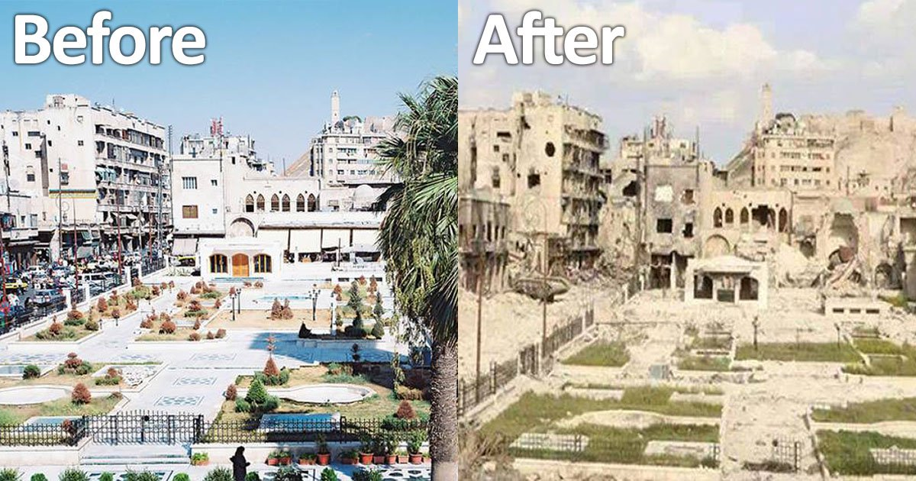

People have been facing miserable conditions. The worst part is that small kids are being affected in the most brutal of ways. From being killed in bombs to losing their parents to being under the attacks of chemical gas, the situation has exacerbated. The images below give an insight into the terrible conditions in Syria.

A child sleeps under the open sky in between the graves of both his parents.

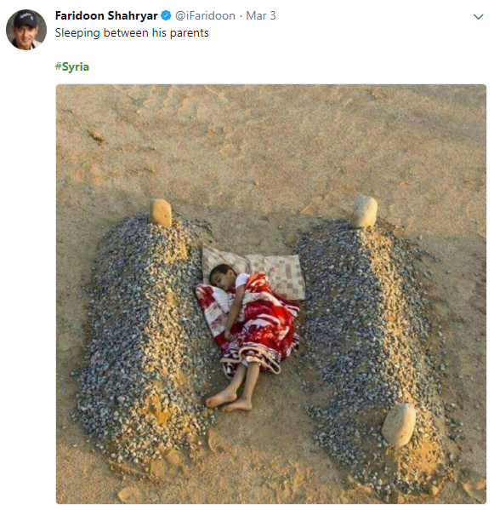

People are calling out the UN as it was supposed to help bring peace to the region and is badly failing to keep up with the promises it had made.

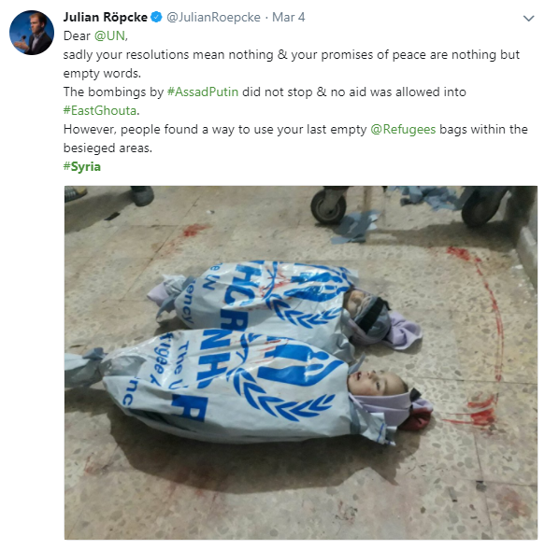

The people who have survived are facing shortage of food as the decrease in supply has caused the food prices to soar high.

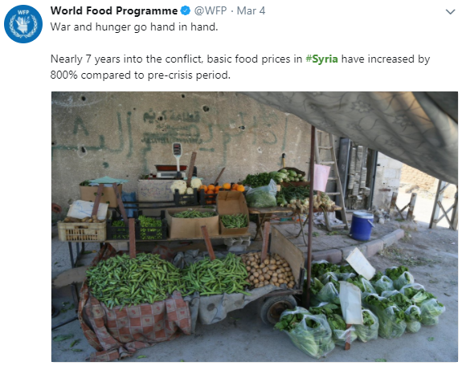

Some images of Israel extending support to the entities fighting in the region have emerged and people are questioning Israel’s role in the situation.

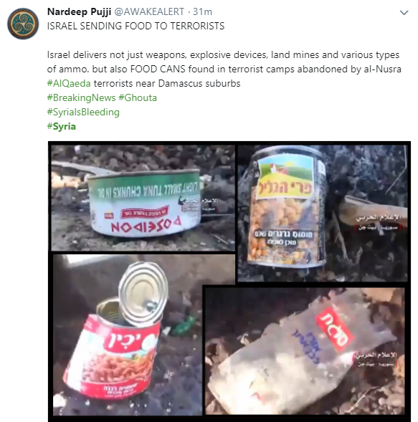

The people in the region are living in fear as closed ones around them fall prey to the horrendous bombs and chemical gas attacks!

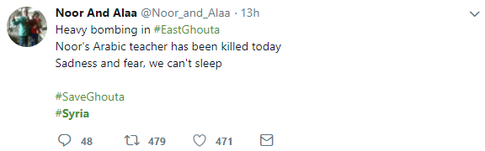

Let us raise our hands in Dua for these people to ease their suffering. You can either make dua for them or you can help them out through charity with the help of HCI (Human Concern International).
Recite the Tasbih e Yunus now for our Syrian brothers and sisters;
“La ilaha illa anta, Subhanaka, Inni kuntu minaz-zalimin”
There is none worthy of Worship besides You, You are far exalted and above all weaknesses, Surely, I am from among the wrongdoers.

How to make tough decisions

Amna Anwaar
Tuesday February 20, 2018

What should you do when you are facing a dilemma?

Knowledge
Do you often find yourself at a crossroad, not knowing which way to go? Do you find yourself against a wall, not knowing whether to climb it or dig under it? Do you find yourself facing certain life decisions and not knowing which one will be better for you? You must have. We all have, it is all part of our test in this world. Without trials, without decisions, this world would not serve its ultimate purpose; to find Allah (SWT) and turn to Him at the end of every road in life.
As humans, we tend to think that we are enough, and we do not necessarily need anyone else in deciding any course of action in life. But alas, the truth is that our life would be an utter and complete mess without the guidance of Allah (STW). When faced with difficult decisions, Allah (SWT) has blessed His believers with a direct communication channel, the prayer of istikhara, through which His guidance can be attained and executed in our everyday life.
So if you’re facing a dilemma, what do you do?

1- Consult a fellow believer
The first thing you should do is consult a reliable, pious and knowledgeable person, who you trust. Get their sound opinion regarding the matter at hand and consider their advice while making the final decision. For Allah has said:
"And consult them in the affair. Then when you have taken a decision, put your trust in Allah." (Quran 3:159)

2- Istikhara
In Arabic, the word istikhara denotes “seeking guidance for the best course of action”. When one cannot make up one’s mind, regarding any or all matters one may face in this world, Allah (SWT) tells us to seek His support. Istikhara in itself is a blessed Sunnah, which was readily practiced by the Holy Prophet (PBUH) himself. Narrated by al-Bukhaari from Jaabir Ibn ‘Abdullah:
“The Messenger of Allah (peace and blessings of Allah be upon him) used to teach his companions to make istikhaarah in all matters, just as he used to teach them surah from the Quran. He said: ‘If anyone of you is deliberating about a decision he has to make, then let him pray two rak’ahs of non-obligatory prayer. Then say:
O Allaah, I seek Your guidance [in making a choice] by virtue of Your knowledge, and I seek ability by virtue of Your power, and I ask You of Your great bounty.You have power, I have none. And You know, I know not. You are the Knower of hidden things. O Allaah, if in Your knowledge, this matter (then it should be mentioned by name) is good for me both in this world and in the Hereafter (or: in my religion, my livelihood, and my affairs), then ordain it for me, make it easy for me, and bless it for me. And if in Your knowledge it is bad for me and for my religion, my livelihood and my affairs (or: for me both in this world and the next), then turn me away from it, [and turn it away from me], and ordain for me the good wherever it may be and make me pleased with it).” (In Bukhaari, Saheeh 1166).
If you’re turning to Allah (SWT) and calling out to Him for His help with every fibre of your being, there is nothing, absolutely nothing, better for you. Appeal to Him with deep sincerity and with complete and utter faith in the fact that Allah (SWT) always wants best for you and He will guide you to whatever is best for you, in this world, and the Hereafter. The beauty of istikhara lies in the complete surrender to the Divine Will. Allah (SWT) wants us to share our burdens with Him, so He may vanquish those burdens for us. What can be more beautiful?

3- Decide and have Tawakkal
Once you have done the istikhara, you should follow whatever you feel yourself being tilted towards. There is no set manual for how one knows what the right decision is, but what is certain is that Allah (SWT) embeds the right decision in the heart of the believer, and therefore, guides the steps taken by the believer following of the istikhara. What matters is that the believer constantly turns to Allah (SWT) to continue guiding him through each and every step that he takes and has ultimate faith in the Divine plan.
Man does not possess the ultimate knowledge of things, for only Allah (SWT) holds that attribute. He tells us time and time again that it is Him, and Him alone, who knows what is good for His servant and what is not. Allah (SWT) promises us that He will never forsake us and if we turn to Him, He will take care of us, for He knows best. So if you find yourself lost, or confused, or in despair at the hands of difficult situations, turn to Allah (SWT) and seek His guidance, for His guidance is perfect.

