CAIR-Columbus to Seek Hate Crime Probe, Arrest of Suspect Following Beating of Ohio Muslim Woman ICJARORG
aving trouble viewing this email? Click here

- CAIR Statement: CAIR condemns Saturday's terror attacks in London, offers condolences to the victims' loved ones and prays for the speedy recovery of all those injured.
- CAIR-Colorado Condemns Hate Vandalism Targeting Jewish Family's Home
"We condemn the hate-filled actions of those who seek divide our nation with fear by targeting members of minority communities." said CAIR-CO Co-Chair Krista Cole. "CAIR-CO offers its solidarity and support to the family and to all Coloradans targeted by hate in these trying times."
  - CAIR-MA: Walpole Candidate Accused Of Islamophobia Loses Planning Board Race
  - CAIR-MN: Muslim Advocacy Group Calls for Investigation of Incident Involving Apple Valley High School Student and Staff
- Video: VOA News Interviews CAIR Rep Ibrahim Hooper About Spiritual Benefits of Ramadan Fasting
MEDIA ADVISORY
CAIR-Columbus to Seek Hate Crime Probe, Arrest of Suspect Following Beating of Ohio Muslim Woman
Alleged attacker reportedly screamed 'you all will be shipped back to Africa' prior to beating
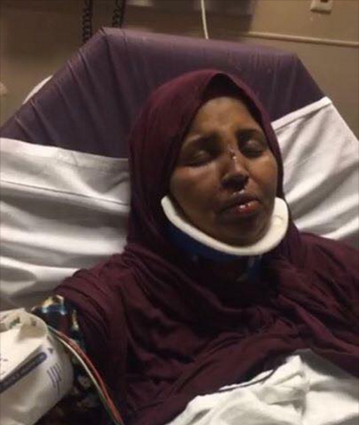
(COLUMBUS, OHIO, 6/4/2017) – Later today, the Columbus, Ohio, chapter of the Council on American-Islamic Relations (CAIR-Columbus) will hold a news conference to call on law enforcement authorities to investigate an attack yesterday on a Muslim woman in that city as a possible hate crime and to urge police to arrest the alleged assailant.
The woman, who reportedly intervened to protect another Muslim woman from harassment by the alleged attacker – a white male - was beaten unconscious, resulting in facial fractures and the loss of several teeth. According to the victim, the alleged attacker reportedly screamed "you all will be shipped back to Africa" prior to beating. CAIR-Columbus is her legal representative in the case.
According to witnesses, the alleged attacker was interviewed by police, but released without charge. He had reportedly made racist statements to neighbors in the recent past.
WHAT: CAIR-Columbus News Conference to Call for Hate Crime Probe of Attack on Muslim Woman
WHEN: Sunday, June 4, 4 p.m.
WHERE: Outside Riverside Methodist Hospital, 3535 Olentangy River Road, Columbus, OH 43214CONTACT: CAIR-Ohio Legal Director Romin Iqbal, 614-783-7953, riqbal@cair.com; CAIR-Columbus Executive Director Jennifer Nimer, 614-946-9675, jnimer@cair.com
A third party has set up a fundraising page to assist in the victim's medical expenses.
GO TO: https://www.launchgood.com/project/stand_with_sister_rahma#/
CAIR's national headquarters in Washington, D.C., has noted an unprecedented spike in hate incidents targeting Muslims and other minority groups since the November 8 election.
The Washington-based Muslim civil rights group is asking Muslim community members to report any bias incidents to police and to CAIR's Civil Rights Department at 202-742-6420or by filing a report at: http://www.cair.com/civil-rights/report-an-incident/view/form.html
CAIR is America's largest Muslim civil liberties and advocacy organization. Its mission is to enhance the understanding of Islam, encourage dialogue, protect civil liberties, empower American Muslims, and build coalitions that promote justice and mutual understanding.
La misión de CAIR es mejorar la comprensión del Islam, fomentar el diálogo, proteger las libertades civiles, capacitar a los musulmanes estadounidenses, y construir coaliciones que promuevan la justicia y la comprensión mutua.
- END -
CONTACT: CAIR-Ohio Legal Director Romin Iqbal, 614-783-7953, riqbal@cair.com; CAIR National Communications Director Ibrahim Hooper, 202-744-7726, ihooper@cair.com

