Another School Shooting- A CALL TO ACTION: Gun Violence Prevention Advocacy Day
Greetings Friends and Community Leaders

​​Maryland's school shooting, today, at Great Mills High School marks the 17th school shooting this year and were are only in March.

​On Friday, March 23rd, young people from all over are convening​ ​a Gun Violence Prevention Advocacy Day on Capitol Hill; flier attached. Please add your voice to the Young People's movement in the fight against gun violence and join ​the many voices from Parkland, Sandy hook, Columbine and other ​gun violence prevention ​coalitions who will be on the Hill on Friday working together​ to advocate for sensible gun legislation. ​
​
​​RSVP here on Eventbrite. We need a large turnout on Friday to ensure we visit each Member and Senator who is an affiliate of the NRA and who opposes sensible gun legislation. Please share the flier, far and wide, with as many youth and school communities.

Thank you!

Nadia S Hassan, MBA
​Young Leaders Institute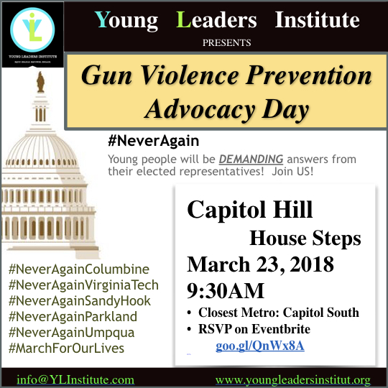
nadia@ylinstitute.com
www.ylinstitute.com​
FacebookTwitter

