Your kind contributions will help GainPeace tackle Islamophobia, share Islam and clear up misconceptions

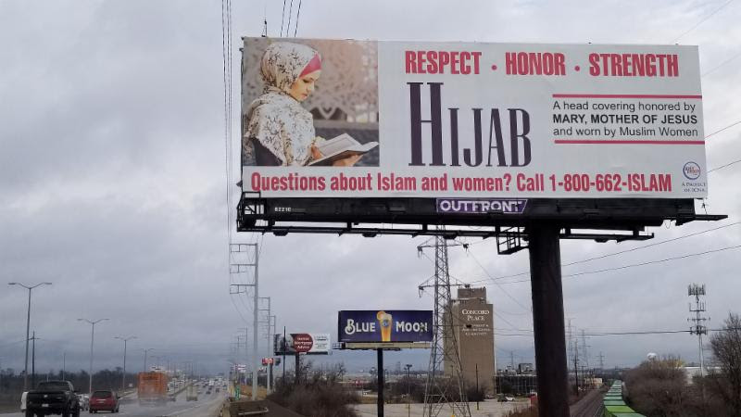
support the HIJAB billboard
In an era in which harassment, immodesty and objectifying of women are prevalent, let the Muslim community project a voice of reason, a voice of chastity and a voice of modesty.

Alhamdulillāh this is the latest Gain Peace billboard which has gone up a week ago in Chicago, and is viewable from i290 and i294 on i294 Northbound where the two highways run in parallel. These billboard messages are designed to help clear misconceptions of Islam, and this one especially recognizes the challenges our sisters may face on a daily basis.

The billboard has GainPeace's 800 number where people can call and ask questions about Islam and clear up their misconceptions. The calls can also request to read Islamic literature, which is sent free of cost to them.

Brothers, Sisters, Each of us has an obligation to share Islam and dispel misconceptions. GainPeace request you to support this billboard and other ongoing dawah project. Please share the message within your circle of contacts.

Please Donate
DONATE ANY AMOUNT

CONTINUE YOUR SUPPORT

Alhamdulillah, the dawah projects of GainPeace would not be possible without the help of Allah,swt, and your support. Please continue your duas and financial support. JazakAllahu khair.

Checks Payable to:
GainPeace
1S270 Summit Ave, Suite #100, Oakbrook Terrace, IL 60181

Your kind contributions will help GainPeace tackle Islamophobia, share Islam and clear up misconceptions
JAZAKALLAHU KHAIRAN!

ABOUT GAINPEACE
GainPeace is an outreach project of the Islamic Circle of North America, whose goal is to share the authentic message of Islam with humanity. More here

GainPeace - ICNA, 1S270 Summit, Suite 100, Oakbrook Terrace, IL 60181
SafeUnsubscribe™ icjmasjid@gmail.com

info@GainPeace.com | About our service provider

Sent by info@gainpeace.com
***

FacebookFlickrTwitterYouTubeEmail
Ask about Islam! 1.800.662.ISLAM info@gainpeace.com
- 2018 Annual Banquet
- Tickets
- Sponsor
- Reverts Registration
- Project Highlights

Tickets
Home/2018 Annual Banquet/Tickets

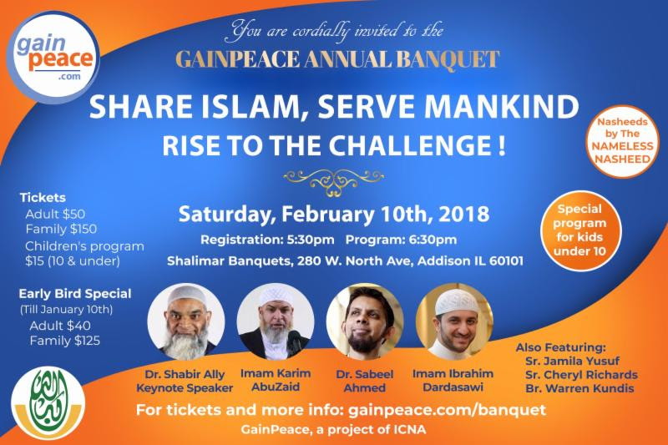

2018 GainPeace Annual Banquet Tickets
Event Date: Saturday February 10, 2018
Registration Starts: 5:30 PM
Program Starts: 6:30 PM
Tickets – EARLY BIRD REGISTRATION TILL JANUARY 20TH
- Adults: $40/Person | 11 Years and Older
- Children: 15$/Child | 4-10
- Toddlers: Free Baby Sitting | 3 & Younger
- Family: $125
Venue:
Shalimar Banquets
280 W North Ave,
Addison, IL 60101
Instructions:
- Please fill out the form below to purchase the ticket
- Once you fill out the form and click on the Buy Tickets button, you will be asked to complete payment using PayPal
- Reach out to us at info@gainpeace.com if you run into any issues
Go to:
http://gainpeace.com/services/2018-annual-banquet/tickets/?utm_source=Support+the+HIJAB+billboard&utm_campaign=dawah+training+bolingbrook&utm_medium=email
*******

