What Is my Islam My Islam Freedom and Responsibility
BY: INGRID MATTSON SOURCE: ISLAMICA NOV 15, 2007 15 COMMENTS
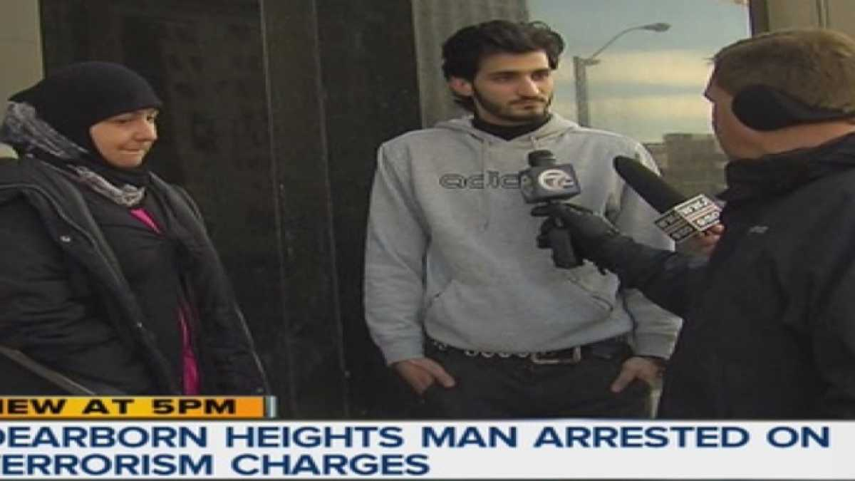
Share on Facebook | Share on Twitter | Share on Google+
Category: Americas, World Affairs Channel: Opinion Views: 4938

Muslims in America today seem to have lost the right to be individuals. We are treated as a collectivity - responsible as a group for any crime committed by another Muslim or done in the name of Islam.
Shortly after 9/11, I wrote an article stating that Muslims have the greatest obligation to reject terrorism and political violence committed in the name of Islam. I still believe this is the case. Islam does not have a centralized authority; there is no universally recognized council of scholars or clerics who speak on behalf of all Muslims.
With freedom from clerical authority, however, comes the responsibility to engage in the debate over the true meaning of Islam. Islamic law states that silence is an indication of consent. If Muslims do not reject the perverted interpretations of the Qur'an proffered by terrorists, they will have shirked their responsibility to define the real meaning of Islam.
At the same time, clarifying our own position does not mean that we have to "speak out" against each and every statement issued by terrorists or every criminal action taken by groups claiming to represent Muslim interests. Once we have defined what we stand for, and what we stand against, then any particular action that violates those guidelines are clearly rejected by us. American Muslim organizations have made extraordinary efforts to publicize their rejection of terrorism and extremism in the name of Islam: we have organized petitions, written fatwas and position papers, distributed brochures, held conferences, organized press briefings, published op-eds, spoken on the radio and television.
Advertisement
Still, we are asked, "Why have moderate Muslims not spoken out against the extremists?" We have spoken, but we have not been heard-primarily because good news does not get much coverage.
Even worse, we have spoken, but we have not been listened to. There are many people who are ideologically opposed to Islam-to the most benign interpretation of Islam-because of their own extremist religious or political ideologies. No matter what conscientious Muslims do to live as peaceful citizens who contribute to the welfare of society, these groups will attack us and our religion.
Most objectionable is what I call the, "non-Muslim Islamic fundamentalist." What I mean by this is a non-Muslim who applies a literalistic, decontextualized hermeneutic to the Qur'an and Islamic tradition. This is not how I read my scripture (maybe it is how they read theirs), so who are they to tell me that this is what Islam "really" says?
Being judged as a group, rather than as individuals, also means that the negative experience of one Muslim is considered to be representative of all Muslims and all of Islam. I do not deny the right of any individual to tell his or her own story. We all have that right, and I must learn from the pain, hurt and anger of women and men who were mistreated in the name of Islam.
But these negative experiences are not shared by all Muslims - indeed, not by most Muslims. This is why such authors have little or no constituencies within the Muslim community - because large numbers of Muslims do not feel they represent their interests or perspectives.
The burden of collective guilt, the oppressive weight of stereotyping, and the violence of hateful anti-Muslim discourse is difficult to bear. It is even more difficult to see how this affects our youth.
But there is hope. Hope lies in the goodness of ordinary Americans who try to overcome their prejudices and reach out to their Muslim neighbors. Hope lies in the solidarity shown by other groups - like Japanese Americans - who have faced similar situations. Hope lies in the extraordinary moral leadership shown by many American religious leaders to guide their congregations to the path of understanding and compassion.
More than anything, I see these challenges as opportunities to examine myself and my community, to see if we are responding with enough courage and moral leadership when we witness discrimination against others. Are we able to avoid burdening other groups with collective guilt? The Qur'anic revelation, "no soul bears the sins of another" is directed first at our community. We are all human, and all of us have to struggle with our own selfishness, prejudice and will to power.
As a Muslim, my struggle for my community's rights should be only the starting point of a wider struggle - a struggle for the dignity of all people. Being a Muslim in America today means having the opportunity to work towards this goal in solidarity with compassionate individuals of all faiths and good will.

Dr. Ingrid Mattson is an "On Faith" panelist and professor of Islamic Studies and Christian-Muslim Relations at Hartford Seminary. She is the first woman to be president of the Islamic Society of North America.
Source: Islamica
Get Free Islamica Magazine with your IslamiCity Membership. IslamiCity is a public benefit membership supported Islamic media.

15 Comments COMMENT
- jaffer from ethiopa April 1st, 2008
it is very nice message
- Ghazali Tukur from Northern Nigeria November 28th, 2007
Assalam Alaikum,i come from an islamic community in the northern part of Nigeria where the majority are muslims. It is only when i read comments from fellow muslims from other parts of the world that i thank the Almighty having made me come from an environment where one can practice his deen without any molestations suspicions etc.The unfortunate thing is that not every one of us realises our fortune. in any case it has turned to mis fortune because we have started taking a lot to do with our religion for granted. We are praying and also encouraging you to continue the daawah, Allah in his infinite mercy will grant you peace and the way forward to practice your religion in peace and harmony, but it will not come easy. We know and we believe all the stereotyping of muslims all over the world is a planned organised set up to discredit and disorganise us , but this is equally a trial from our creator. You will have multiple reward for remaining steadfast in the practice of your religion. The conspiracy against our religion started at the very beginning and will remain so, no matter what we do or say. Please do your best to educate your community, but as muslims ,as more treachery is planned against you, think ahead of more answers and solutions . Bis salaam
- Abusalaheddeen from USA November 24th, 2007
For some reason or another there are those who will continue to bash Islam and the Quran no matter what Muslims do or say. Muslims in general have spoken out against terrorism and violence and as a matter of fact Muslims suffered from terorism more than any other people or nation on earth. It's time for Muslims to stay united and leave the differences behind them and speak as one voice. We as Muslims also need to participate in the media and do what we can to have a voice in the media. Many Muslims in America are scared to speak out because of the attack on their opinion by the right wing extremists who are working very hard to isolate Muslims and make the religion of Islam look bad.
- Rushdina Khan from Bangladesh November 24th, 2007
Assalamu Alaikum
thank you for this great article.... i've been reading articles from Islamic City regularly that gets posted to me now and then....and I feel that it is more important to bring in these awareness and clarity in beleif among the youth, who are, I should admit, being carried away by the anti-Islamic media coverages and campaigns. therefore I would suggest that we should all take the intiative to sent such articles, or any good ones at all, to the heads of schools in the Muslim countries, who can circulate them to the students.
May Allah bless all of u...
Rushdina
- afaqali from ksa November 24th, 2007
what we need is to learn that islam means in addition to five pillars, peace, tolerance, helping others, research in science, morality,sacrifice.wallah nobody can harm us.allah will be always with us
as of now we are not ready tolearn basic teachings of islam.
- Amatallah from United States November 23rd, 2007
As a muslim living in America all my life, I am indifferent to making or convincing anyone that 9/11 was totally wrong. Terriorism comes in many forms, and America has proffered its share of terriorism on ever level. No one ever talks about the terriorist act that was committed in Oklahoma before 9/11. It was a similar act with the same impact, except it was supposingly one white male that was easily characterized as just crazy. Well, we do not know what was in the hearts of any of the men that committed 9/11 and why they took what was in their hearts to such extreme, nor do we know what was in the heart of Timothy McVeigh that allowed him to take such extreme measures, however we know the acts were the same, so we should not hate a religion or its followers, but hate the acts individuals or people commit because anyone is capable of becoming an extremist.
- R. A.M. from U.S>A. November 22nd, 2007
I agree with you, we Muslims need to think in the broader sense, and not overlook the humanity on the whole. Unless we don't show compassion for our fellow beings (regardless of their ethnicity, beliefs and race) we cannot hope to spread the message or understanding of Islam (peace)
- Kris MacPherson from Malaysia November 22nd, 2007
Assalamualaikum,
Just to place it on record, I agree with Dr. Ingrid Matson as a whole but with not unconditionally or without any reservations as I had mentioned in my earlier post.
Anyway I have a high respect for her credentials and achievements and I wish her every best and pray that the Muslim Organisation that she is leading will strive and continously achieve success for the sake and betterment of the ummah in America. ( including Canada too )
Wassalam,
- Kris MacPherson from Malaysia November 22nd, 2007
I am a non American but I share the feelings that most Muslims in America felt, being looked upon and held responsible, collectively for some things or acts which most do not really agreed to in the first place. I share their agony, their dilemma, and as a Muslim I should.
But then again, let us examine ourselves, reflect upon certain issues that matters, on where we stand on many areas. While we condemn terrorism outright, but Muslims should be careful to draw the definition on what acts constitute terrorism in nature, and what do not. For instance in the previous era of Irish struggle, not all Irish agree with the tactics of the IRA but the majority of them wanted to rid of the British, it's that simple.
Of course, such a comparison is not applicable in the today's context of Islamic struggle. Our Muslim struggle is for religion and GOD, and it doesn't shorn of the need to free Muslims regions that are occuppied by foreign powers, whoever and which ever they might be. But I emphasise here that for there to be any form of struggle for Islam, it must not bereft itself of dignity and humanity, as displayed by those in the era of Prophet Muhammad ( pbuh ) and the companions. Thus, any violence against civilians nowadays and at the present day must be outrightly condemn. ( see the sermons and reminders of Umar ( r.a. ) on the ethics of Muslims in entering into a foreign country )
And or but having said that, let us not forget that it is the policy of the U.S government abroad that encourages aggresive response. The whole world is not just about America, and the American people, it's also about justice, equality and equity aamong nations and people. Is the U.S government really the advocate and proponent of freedom and democracy ? I don't think so, Pal.
While I may have a bit of reservations on Hamas, but their victory in the Palestinian's election was not respected at all by the U.S government.
- ibrahim shehu from nigeria November 22nd, 2007
Iam strongly convinced by mrs mattson,muslim in America should enlighten the public the diffrence between jihad and terrorism.it's a challenge and responsibily of every muslim,we should emulate Dr zaki naik for his effort explaning islam,the religioun of peace.ma'assalam
- Sofia Shums from USA November 22nd, 2007
Dr. Mattson is doing a juggling act and "playing politics" in her article.
She has glossed over the severity and viciousness of innumerable anti-Islam and anti-Muslim attacks since 9/11.They must never be pushed under the carpet-- out of sight, out of mind--as the non-Muslim world seems to be aiming for. Why? Because it has destroyed far too many innocent human lives, and because anti-Islam and anti-Muslim propaganda has a centuries-old history in the Christian Church-- from the 8th century down to the present. Pope Benedict XVI was only continuing the tradition of the Christian Church when he attacked Prophet Mohammed and Islam.
- Shabana Tabassum from United States of America November 22nd, 2007
Assalaam o alaikum wa rahmathullahi wa baraka thuhu...
Sister,I totally agree with you...especially we muslims should see these challenges as oppurtunities and represent Islam with the highest tolerance, dignity , will power and working towards their goal in solidarity with compassion with all faits and goodwill, in the most appropriate way, which is a duty of every Muslim according to what Prophet Mohammed(pbuh) has taught us...
Wasalaam...
- Zainon from USA November 19th, 2007
You are right, Ms Mattson, we do need to struggle for the dignity of all people. First and foremost for the Palestinians.
We do need to reject all terrorists - all of them, including governments and militaries who are doing the bulk of the terrorizing.
- Zainon from USA November 19th, 2007
If Muslims in America today seem to have lost the right to be individuals then maybe it's for the best! I came to America 2 decades ago to be an individual; to have "my space." Guess what I found out, Ms. Mattson - I found out there's a decay here in family and social life because Americans are individualistic. I am so glad I don't want to be an individual any more and I am so glad to repeat what our Rasul said before he died, "We are one ummah."
***

What Is my Islam?
BY: TAUFIQ RAHIM SOURCE: HUFFINGTON POST MAR 10, 2015 5 COMMENTS
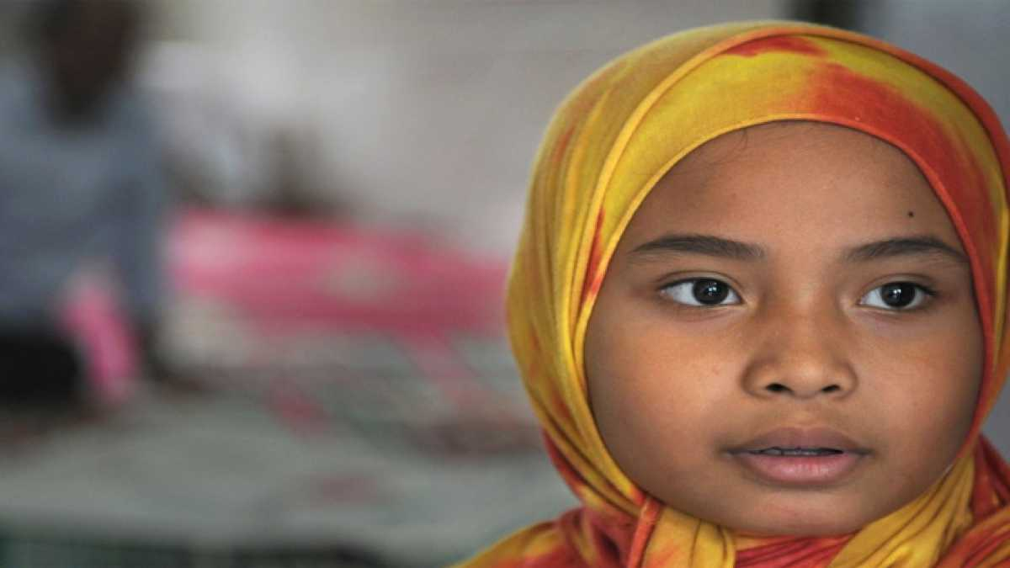
Share on Facebook | Share on Twitter | Share on Google+
Category: Faith & Spirituality, Featured, Life & Society Topics: Islam Channel: Opinion Views: 4772

As President Obama looks to foster a new dialogue with the Muslim world, I want to give voice to an Islam that is too often ignored in the media in both East and West. It is the Islam that I have grown up with. It is the religion that inspires countless friends, colleagues, former classmates, and relatives of mine.
I wish to tell you about the beliefs of the many Muslims, with whom I have been around whether as a leader of Muslim Student Associations at Princeton and Harvard universities, or living in or traveling to the mountains of Tajikistan, the streets of Kabul, the alleyways of Damascus, the villages of South Lebanon, the madrasas of Uzbekistan, the towns of the West Bank, and even in corners of Riyadh. Of course it would be folly of me to claim that this Islam I describe is predominant. Yet, it is authentically Islam, and it is part of the ethic of the faith of millions of Muslims around the world.
My Islam is foremost about reason. It is about harnessing one's capacity to understand the complexities of this world and beyond. The mind and the pursuit of knowledge are central to comprehending, to the extent that is possible, what is the divine. One also cannot make conscious decisions about right or wrong without exercising his own judgment. Blindly following the edicts of scholars, is not choosing a path except one that is not your own. When I refrain from consuming alcohol, it is not because I am backward, or uncultured. I refuse drugs because they hinder our judgment and our ability to reason, the trait that God endowed us with that distinguishes humankind from all other beings.
Advertisement
The pursuit of knowledge that emanated from Islam brought to bear the tradition of universities. Much of modern science and philosophy was shaped by Muslim intellectuals, and the centers of learning that were Bukhara, or Cairo, or Baghdad. Putting aside the tangential and abstract, however, there is no one who is more energetic about education than the Muslim immigrant parent (in the West). The most respected word in the Arab world is 'doctor'. Count the innumerable Muslims at the world's leading educational institutions.
My Islam is about the equality of women, where paradise as the Prophet said (the Prophet whose first convert was a woman, who was his wife but also his employer), is found at the feet of our mothers. Islam is the faith that gave women legal status, the right to divorce, and the path to financial independence. Inspiration is found in the women leaders of the three most populous Muslim countries of Bangladesh, Pakistan and Indonesia, who found their way into the modern political space long before their counterparts in North America. This Islam is about the strong, independent Muslim women, some who wear hijabs, and others who do not, who balance the needs of families with their rights to be full and equal participants in all aspects of society.
My Islam is about tolerance. It is about a religion that told its adherents that all persons performing good deeds can find a just place in the hereafter. For Muslims, believers of other faiths should be respected and protected. I believe in the traditions of Fatimid Egypt, Andalusia, and the Ottoman Empire, which gave sanctuary to Jews fleeing from the West. In my faith, discrimination and prejudice along race or ethnicity is an abomination, while equality is a requirement. It is a religion that sees all peoples living in mutual respect, working towards the common good.
My Islam is about compassion. Empathy is not a virtue but an attitude that permeates every aspect of my life. The condition of your neighbor or a stranger is a reflection of you. The mosque is the center not for organizing people for bombastic shouting sessions of anti-Americanism but rather for mobilizing persons of faith to serve their communities to develop an ethos of compassion for all. My Qur'an exhorts in countless verses that spending on the less fortunate is the true measure of an individual.
My Islam is about humility. It is an Islam that means submission to something greater than oneself, and forces the recognition of our smallness in the face of the wider world and beyond. It is about co-existence with all creation that surrounds us be they our compatriots or persons living in a distant land. It is about sustainable stewardship of the resources that God has endowed this world with.
I do not naively believe that what I see as Islam is the status quo in every Muslim country or family. Nor do I consider my vision as a monopoly on what is right, for true religion is about the ability of each follower to forge his or her own path. Yet, the next time someone remarks that Islam is irrational, violent, and hateful, know that there are countless millions whose practice and beliefs of Islam prove otherwise.
Taufiq Rahim is a strategy and management consultant, and political commentator based in Dubai. He is a graduate of the Harvard Kennedy School and Princeton alumnus.

5 Comments COMMENT
- Milgo from Canada June 21st, 2009
This is a beautiful article. As a muslim women, growing up in a Christian country and going to missionary schools throughout my childhood, I have come to realize that it is not what I listen to in the media that provides me with knowledge and the truth about things, but how much I READ (IQRA). I say so because because growing up I did not have the luxury of knowing about Islam, but I chose to read and I read a lot about Islam. This gave me an understanding of my religion and how wonderful it is. So dear people read and seek knowledge. Do not depend on the media to tell you what Islam is. Listening to and/or too much TV will make you intellectually lazy, and biased in everyway because whoever is talking might have no idea of what they are saying. All in all, my point is: "Islam is a beautiful religion if you understand it" As such, I also believe that my Islam is also what exactly this author has stated.
- Hajjah Alaisa Mukasa from Uganda June 16th, 2009
Assalaam aleikum to all. Taufiq's message is honest and has covered almost all aspects of Islam (complete way of life). We sincerely need to check the way we relate to human beings and all that is on earth because in life we meet all different kinds of people who earned their right to live the minute they were born. Just because someone is not of the same religion, skin colour, same origin excetera doesnot make them any less human than you and I. We should learn to respect humanity and all that is on earth and care for those less fortunate than we are, be humble in our creation, be grateful for what we have and never forget that it is all by the will of Allah, only then shall we become true believers.
May Allah keep us on the path of those on whom He Has bestowed His Mercy. Ameen
- Ismael from USA June 15th, 2009
Hi, Dear:
I did not read your website carefully yet; however, tonigh I feel sad for our Islam faith. I feel upset for some Muslim brothers who try to cheat for the tax, lied for their income report and have a bad public manner. You will see all these terrible things happen in everywhere in the United States. I am upset while most of formal Muslims did the bad things while they wear their specific Muslim clothes.
Ismael
- shahnaz muhammad from United States June 15th, 2009
well put could be our islam
- Madinah from USA June 14th, 2009
As-Salaamu-Alaikum, Only a Muslim who truly loves Al-Islam wrote this. I just left Dubai in April of this year. I feel the same about Al-Islam as you do, and Allah has bless me to travel to many different places.
***

