Black History Month and the contributions of Islam
BY: MOHAMMED KHAKU SOURCE: MORNING CALL FEB 20, 2008 10 COMMENTS
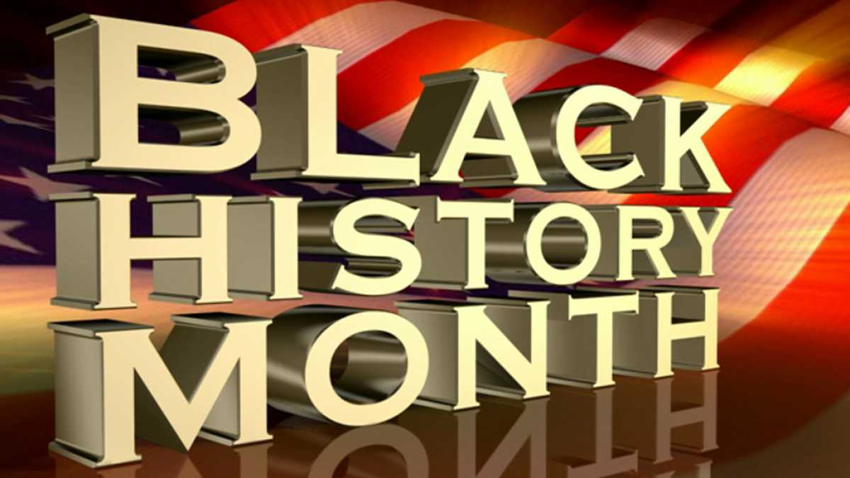
Share on Facebook | Share on Twitter | Share on Google+
Category: Americas, Faith & Spirituality, Life & Society Topics: History, Islam Channel: Opinion Views:7835

Celebrating Black History month in February is an excellent opportunity to learn about the struggle and achievement of African Americans, and their creativity and contribution to human civilization, and also to reaffirm the struggle and determination to fight prejudice and racism.
The Quran says: "O people, we created you from a single pair of a male and a female, and made you into tribes and nations so that you may know each other. Verily, the most honored of you in the sight of Allah is the one who is most righteous of you." (Quran 49:13)
Today, Islam is the fastest growing religion in the United States; the majority of the populations embracing Islam are African Americans.
Why are African Americans embracing Islam in such large numbers? Is it because of Malcolm X's pilgrimage (Hajj) to Mecca or the intrinsic nature of Islamic human equality.
When people think of Africa they think of blacks, civil wars and the AIDS epidemic. The intellectual discourse on topics like African history in the Islamic context is inadequate and absent from the history books.
Today more than 50 percent of the people in Africa are Muslims. And of the Africans brought over to America in the slave trade, many came from Muslim families.
Advertisement
With this spirit in mind, Bilal Ibne Rabah, an Ethiopian slave living in Mecca, became a leading companion of Prophet Muhammad. Very little is known of Bilal.
Bilal was a slave freed by Prophet Muhammad. Who at the time of slavery in Arabia used to buy slaves and then free them? Bilal is associated with a very important decision taken by the Prophet Muhammad concerning the issue of race and color.
Prophet Muhammad chose a black man to perform the Azan -- the call of the faithful to prayers. His decision was based on the Quranic teaching against racial discrimination, which explains the rationale behind God's creation of humanity in different tribes, color, religion and race, so that we know each other.
Prophet Muhammad chose Bilal to be the first Muezzin (caller to prayer) not because of his racial lineage nor his power or wealth, but because Bilal possessed neither.
He was chosen because of his piety, character and honor even though his pronunciation of Arabic was not accurate. Bilal was to become one of the greatest people in the history of Islam. His name adorns the pages of Islamic history as a reminder to all those who incite discord and disunity among people, races and nations -- but especially to Muslims -- not to transgress the will of God in their behavior and thinking.
Sadly, as we reflect on the current religious practices and social conditions of so many Muslim communities in the United States, we find them divided along artificial lines of nationality, families, ethnic identity and culture.
In celebrating Black History Month, we should be able to include that rich Islamic history that has been hidden from us in the midst of Islamophobia that has marked out Muslims and Islam as "medieval and uncivilized."
American Muslims need to know that in these times of deliberate misrepresentation and spin, Islamic scholars were the inheritors, keepers and developers of Roman and Greek learning.
Islamic learning and culture first illuminated the Dark Ages in Europe.
Africa and Islam have more in common than we think. Islam entered Africa 100 years before Columbus. The ancient and renowned city of Timbuktu in modern Mali was the crossroads of West African and Islamic civilization and learning.
Timbuktu was a city where Muslim scholars would travel to acquire knowledge. African Americans have been in America for a long time, not as takers but as contributors, and it is worth celebrating this rich heritage, and as an American Muslim, I hold dear to my heart to enlighten both young and old, the black and non-black toward the truth and social justice and pursue the vision of making America not red or blue or black or white states, but rather a better place to live with equal opportunity for all.
Mohammed Khaku is past president of Al Ahad Islamic Center in Allentown.

10 Comments COMMENT
- DALHATU IDRIS from babadady media production May 7th, 2014
PLEASE TAKE CURRECTION WRITE PROPHATE MUHAMMAD S.A.W OR PROPHATE MUHAMMAD SALLALLAHU ALAIHM WA SALLAM OR PROPHATE MUHAMMAD PEACE BE UPON HIM INSTEAD OF MUHHAMMAD ONLY, PLEASE RESPECT HIM HE IS GREAT HOUNOR IN ISLAM TAKE CURRECTION, Surely, we Muslims love Muhammad (S.A.W) more than our life because he is loved by Almighty a lot. imminent THANKS
- Jaabir Abdul-Lateef from United States February 27th, 2008
Wa salaam, I'm quite intrigued by the article. It has immense substance from an African-American perspective. It also quells many of the misinformation about ISLAM and The Africans. Shukran, jazakallaah.
- Stanley Jones (Jibril al Hamisi) from USA February 26th, 2008
Salam, This such an interesting dialogue. I do aree with Abu Khalil yes the Prophet(pbuh)did send followers to Abssynnia(Ethiopia)which is a part of eastern Africa however , let's not forget that the whole Arabian pennusla was populated by Hamitic people of our Race and is considered Africa, and not the European version of the Middle East.If you talk to any of the brothers of that region and if they ate being really honest they we tell you Oh, you are from our land. Yes our land. Now that's a lot of respect that I have not heard from any American. Our Land don't that sound strong too you.
- Sister Dee from Canada February 25th, 2008
Dear Brother, I applaud your initiative. As a scholar and student of Islam in Africa, I would like to let you know that there are many books written on the history of Islam in Africa and on the African American experience of Islam. Authors such as Louis Brenner, Sulayman Niang, John Hunwick, and the classic works by Spencer Trimingham, David Robinson, Mervyn Hyskett, and Levtzion are also excellent sources on Islam in Africa. About Islam among African Americans, please see Beverly McCloud, and in particular Sylviane Diouf's Servants of Allah.
Best wishes and as-salaam alaikum.
For anyone who may be interested.
- GEORGE JOHNSON ( AKA) GT MUSTAFA from USA February 25th, 2008
AS A AFRICAN AMERICAN, WE BELIVE IN THE WORLD OF GOD, ALLAH, AND THE TRUTH WILL BRING PEOPLE TO ISLAM, NOT OUR BRO. MALCOLM.
- Imran from USA February 24th, 2008
Excellent article even if some facts needed to be vetted first.
Remember those who enter ALLAH (SWT)'s religion should be grateful to HIM for the Blessing, for it is a blessing indeed.
However the one thing those who don't wish Black Americans prosper want is for them to be over possessed with Black History month and not worry about drugs, violence, sex, rap music, and gang warfare that is destroying future generations.
Time for Black Americans to show real leadership.
Use the inherent beauty of the ISLAMIC way of life to teach positively.
- Wissem from USA February 24th, 2008
Assalaamu Alaikum and bless you all I agree with this article. Embracing Islam makes the religon a bigger community and if we do so it will end Islamophobia. Thank Allah for everything
- Stanley Jones ( Jibril al Hamisi) from United States of America February 22nd, 2008
Dear Brother, remember that we help conquer Spain so we were in Europe and Muslims well before Columbus. We rule parts of Europe for well over 700 hundred years and correct me if I'm wrong. I like to use the term reverted to Islam because I do believed that 30 % or more of the Africans that was brought to this land were of the religion of Islam. I tell people that and they are so munipalated by today's society it's pathetic however, I'm over joyed because "ALLAH " has choosen me to be a Muslim and I'm proud of it.It took 35 years but I'm here..
- Muhammad Tukur from nIGERIA February 21st, 2008
Salam,your article makes an interesting reading.I believe that one of the reasons why more African-Americans are converting to Islam is because Christianity have failed to solve the problems they are facing.They found that it is only Islam that will get them out of that bondage,hence the massive conversion to Islam.
- Abu Khalil from Norway February 21st, 2008
Assalaamu Alaikum! Great article. However, the writer says, "Islam entered Africa 100 years before Columbus." Did he mean to say "America"? Islam actually entered Africa during the very ealy days of the Prophet's (saw)Da'wa in Makka when a small band of the first Muslims migrated to seek refuge in Abyssinia (Ethiopia)from persecution in Makka. It was as a result of this that An-Najashi (Negus), the then king of Abyssinia described by the Prophet (saw) himself as a just, non-oppressive ruler became Muslim. Was-Salaam.
***

Black History Month: Recognizing Black Contributions and Atoning for Our Past
BY: JAMES ZOGBY SOURCE: IVIEWS FEB 6, 2018 NO COMMENTS
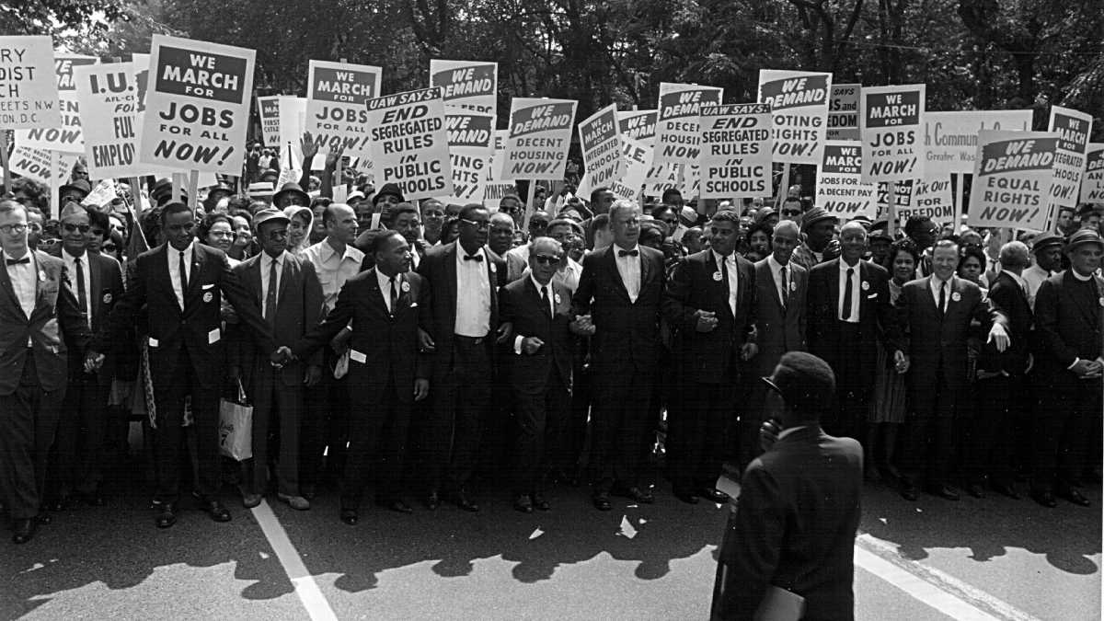
Rev. Martin Luther King and other civil rights leaders march at a civil rights rally August 28, 1963 in Washington. (Photo by National Archive/Newsmakers)
Share on Facebook | Share on Twitter | Share on Google+
Category: Americas, Featured, Highlights, Life & Society Topics: African-American History, Racism, Slavery In The United States Values: Equality

This is Black history month, an important time to reflect on the contributions African Americans have made to the history of the United States of America. It is important because, as we have discovered, in too many instances these contributions have been either deliberately ignored or are just not known or recognized. More than that, however, this month should provide also us with an opportunity to learn more about the shameful legacy of white America's treatment black Americans. By this, I mean, not just the major crimes - slavery, mass lynchings, Jim Crow, and segregation - that have defined our history. I also mean the countless lesser known but still devastating "little crimes" that have been inflicted on the black community.
I recently became aware of one of these crimes. It took place a century ago, literally, in my own back yard.
For the past four decades, I have lived in Northwest Washington. When we bought our home, we noted that in the deed’s historical record there was a "covenant" stipulating that the property could not be sold to “colored people”. That covenant had been overturned in the 1960’s by national civil rights legislation, but it remained in the deed as an uncomfortable reminder of my city’s racist history.
What I didn’t know then, and only discovered this month, was that Washington's past was marked by other troubling instances of racism. A neighbor sent me a copy of a fascinating piece of academic research entitled “Free Black People of Washington County”. It tells the story of the forced evacuation and destruction of two settlements of hundreds of free black families that had lived just blocks from my home.
Advertisement
These settlements had been founded in the mid-19th century by the descendants of former slaves who had been residents of Washington for generations. They had built businesses, started schools for their children, and, during the civil war, many had served, with distinction, in the Union Army defending the Capital from the Confederacy. Back then, the areas where these settlements had been established were somewhat rural and so, in isolation from white Washington, these black American families prospered. All of that was to change in the early 20th century.
With the advent of the streetcar, and the extension of telephone and electricity services, this once “far reaches” of Washington became more accessible and, therefore, more attractive to whites wanting to move out of the crowded downtown area of the Capital city.
During the first two decades of the 20th century, the areas surrounding the black settlements were developed into white-only subdivisions that included the "whites-only” provision I had found in my deed.
As more white families moved into the area they demanded that schools be built for their children. A combination of this need and the discomfort that many whites felt at their proximity to the black settlements, led the District of Columbia to take a fateful decision.
In 1928, the government used “eminent domain” and authorized the “purchase” of the black-owned properties in both of the black settlements and the eviction of the African American community from these areas of Northwest Washington. In the place where these black settlements had existed, the city built two all-white schools and parks for the children of new residents of the area.
As profoundly disturbing as this history is, even more troubling is that it is largely unknown. One of my children went to Lafayette School, and one of my grandchildren is currently enrolled at Alice Deal School - both of which were built on the ruins of those once-vibrant black communities. Not only have they been erased, but our memory of them has, as well. As the author of the article I read noted, a 1938 Washington Post article included this sentence: “Lafayette School which stands on the site of once barren ground is the hub of a thriving community life.”
So America needs Black History Month, not only to teach us about African American scientists, inventors, political leaders, and scholars who have made significant, though all too often unacknowledged, contributions to our collective history. We also need it to remind us of our forgotten crimes, born of our nation’s original sins of slavery and racism and the price African Americans have paid for our behavior. We cannot, as a nation, atone for our past when we remain unaware of the horrible crimes that defined it.
Disclaimer: The views and opinions expressed in this article are those of the author and do not necessarily reflect the position of the Arab American Institute. The Arab American Institute is a non-profit, nonpartisan national leadership organization that does not endorse candidates.
***

Related Topics: Allah | American Muslims | Barack Obama | Conflicts And War | Egypt | Environment | Fasting (Sawm) | Hajj | Human Rights | Iman (Faith And Belief) | India | Interfaith | Muslims | Prophet Jesus | Prophet Muhammad (S) | Quran | Ramadan | Terrorism | United States Of America | Women

ABBASID

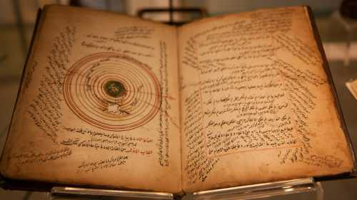

Islam and Islamic History and The Middle East
Ismail I. Nawwab, Paul F. Hoye, Peter C. Speers
CHRISTIANITY

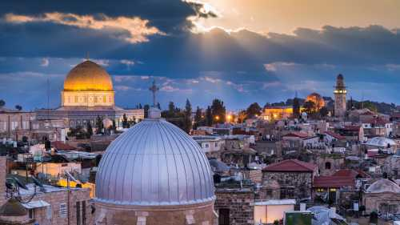

Islam and Christianity: A Misunderstood History
Harrison Akins
HISTORY

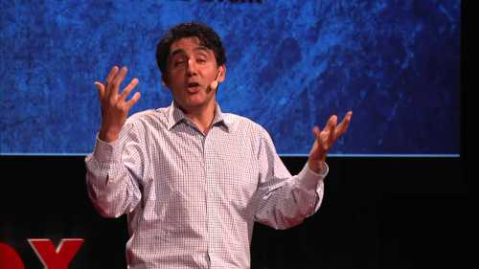

What's in a name? Islam, History, and Identity
Omar Hamid Ali
CHRISTIANS

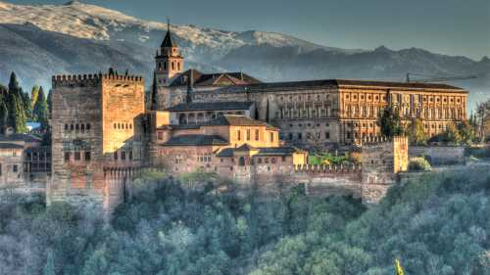

Tolerance in Islam (Lessons from history)
Muhammad Marmaduke Pickthall
CRUSADES

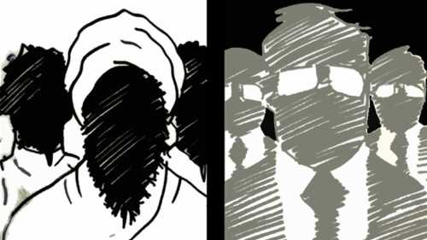

Real history of Islam and the West
Karen Armstrong
HISTORY

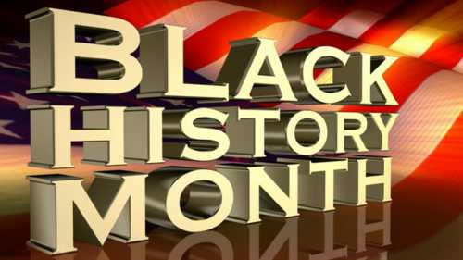

Black History Month and the contributions of Islam
Mohammed Khaku
EUROPE

How Did We Become So Hateful?
James Brooks

