Religious Principles Drive Muslims to Respond to Disasters ICJARORG
| CAIR Threatened for Stance on Removal of Confederate Statue in D.C. | CAIR-NJ to Join Vigil Condemning Anti-Semitism

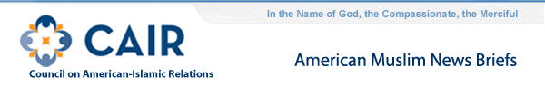
- Online Registration Now Available for CAIR's 23rd Annual Banquet
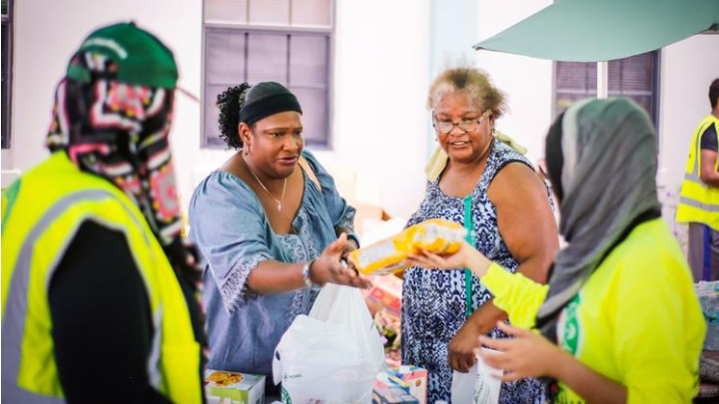
- CAIR: Religious Principles Drive Muslims to Respond to Disasters (Orlando Sentinel)
Even as they are targeted for their faith, American Muslims exemplify their religious principle of being a benefit to society by supporting the country they reside in. As M.J. Khan eloquently said, "This is an obligation, a religious obligation to help others."
Zainab Arain is coordinator of the Department to Monitor & Combat Islamophobia for the Council on American-Islamic Relations, based in Washington, D.C.
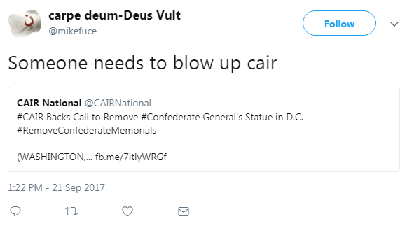
- CAIR Backs Call to Remove Confederate General's Statue in D.C.
"Those who betrayed our country and supported the institution of slavery should not be honored with statues in our nation's capital," said CAIR Government Affairs Director Robert McCaw. "We join the call by public officials to remove this and all other statues and symbols that honor the Confederacy or its defenders."
CAIR recently called Americans of all faiths and backgrounds to contact their state legislatures to request the introduction of CAIR's template resolution calling for the removal of all Confederate symbols.
  - CAIR Threatened for Stance on Removal of Confederate Statue in D.C.
  - Anti-Muslim Attack on Texas Lyft Driver
  - CAIR: An Alarming 22 Percent of Americans Don't Believe Muslims Have Rights
- CAIR-Sacramento: Documentary Follows Stories of Japanese Internment
Filmmaker Abby Ginzberg and CAIR director Basim Elkarra discuss the new documentary "And They Came For Us" about the internment of Japanese-Americans during World War II.
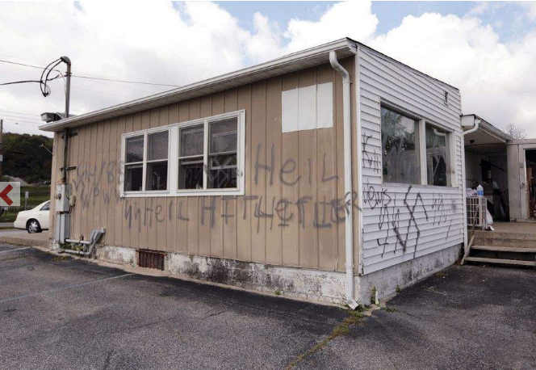
- CAIR-New Jersey to Join Interfaith Vigil Condemning Anti-Semitic Vandalism
On Sunday, September 24, the New Jersey Chapter of the Council on American Islamic Relations (CAIR-NJ) will take part in an interfaith vigil by Action Together Sussex County to condemn anti-Semitic vandalism discovered last Sunday at the Airport Diner in Wantage, N.J.
Religious leaders from various faiths will come together to make a strong statement of unity against acts of anti-Semitism and hatred at the vigil.
WHAT: Unity Vigil Against Hate in Sussex County
WHEN: Sunday, September 24th at 3 p.m.
WHERE: The Green in Newton, NJ (In front of the courthouse)
CONTACT: CAIR-New Jersey Executive Director James Sues 908-668-5900, jsues@cair.com
"There is no place in a civilized society, which was founded on the principles of justice and religious freedom, for acts of hate-filled vandalism like those exhibited in this community last weekend," said Jim Sues, executive director of CAIR-NJ. "In times like these, we must stand united and demonstrate that love for your neighbors is what makes this country great."

