Arkansas 'Muslim Free' Gun Range Owner Exploring Run for Governor | CAIR-Columbus to Hold Muslim Ban 3.0 Workshop | Tell Congress to Condemn Genocide Against Rohingya Muslims

- Hadith of the Day: Acts of Kindness
The Prophet Muhammad (peace be upon him) said: "Acts of kindness protect one from ruin wrought by evil." Fiqh-us-Sunnah
The Prophet also said: "God is kind and He loves kindness. . .Kindness is not to be found in anything but that it adds to its beauty." Sahih Muslim
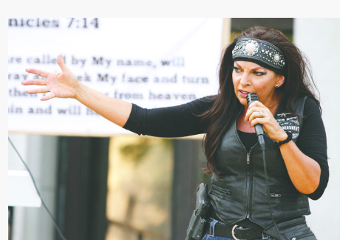
- Arkansas Woman Who Declared Her Gun Range a 'Muslim Free Zone' Exploring Run for Governor
  - Backgrounder: CAIR Welcomes DOJ Decision to 'Monitor' Arkansas Shooting Range Declared 'Muslim-Free Zone' by Owner
  - Video: CAIR Calls for Hate Crime Probe of 'F**k God & Allah' Vandalism Targeting Virginia Mosque
  - TN: Gibbs, Stout Plead Not Guilty in Mosque Vandalism Case
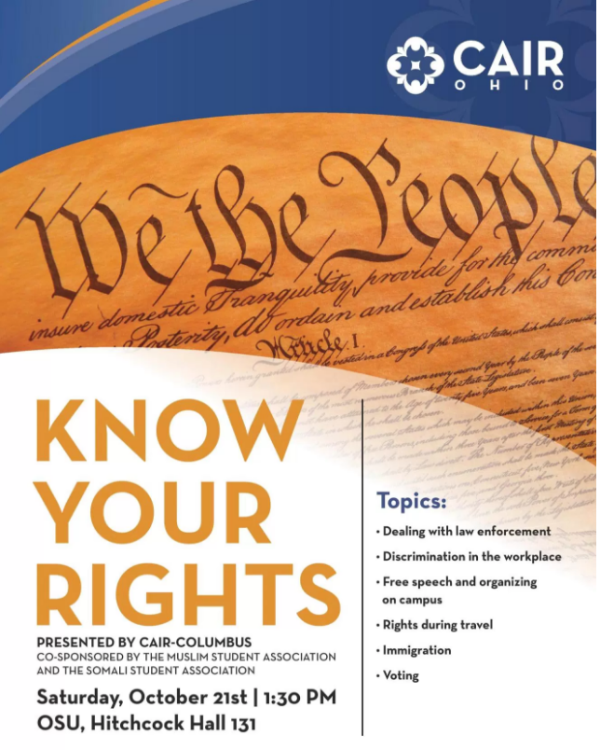
- CAIR-Columbus to Hold Muslim Ban 3.0 'Know Your Rights' Workshop at OSU
CAIR's free workshop, to be conducted by CAIR-Columbus Legal Director Romin Iqbal, will cover issues such as an individual's rights when interacting with law enforcement or the FBI, religious rights in the workplace, the rights of Muslim students, and the rights of Muslim travelers -- with a special focus on the newest iteration of President Trump's "Muslim Ban 3.0."
The event is co-sponsored by CAIR-Columbus, the Muslim Student Association and the Somali Student Association.
- CAIR to Host Baltimore Town Hall Meeting on 'Muslim Ban 3.0'
CAIR's #NoMuslimBanEver town hall meeting, organized in collaboration with BMore Indivisible, will offer community members the opportunity to meet with national elected officials, legal experts and individuals impacted by the ban.
"This event will bring together impacted individuals, issue experts and legislators to share experiences and to brainstorm our response to the latest Muslim ban," said CAIR Maryland Outreach Manager Dr. Zainab Chaudry.
WHAT: #NoMuslimBanEver Town Hall Meeting
WHEN: Wednesday, October 18, 6:30 p.m. (Doors open at 6 p.m.)
WHERE: Baltimore War Memorial, 101 N. Gay St, Baltimore MD 21201
CONTACT: CAIR Maryland Outreach Manager Dr. Zainab Chaudry, 410-971-6062, zchaudry@cair.com
  - CAIR: Stand Up Against Trump's Attacks on Immigrants of Color October 17 in Silver Spring, Maryland
- CAIR-SFBA: 'No Muslim Ban Ever' Vigil Attracts 200+ Protestors to City Hall
Last night, dozens of dove-shaped posters were held aloft in Civic Center Plaza by more than 200 protesters calling for an end to President Donald Trump's immigration policies.
The candlelit vigil, titled "No Muslim Ban Ever," was planned by the Council on American Islamic Relations (CAIR), the Asian Law Caucus, the Arab Resource and Organizing Center, the National Iranian American Council and the Black Alliance for Just Immigration.
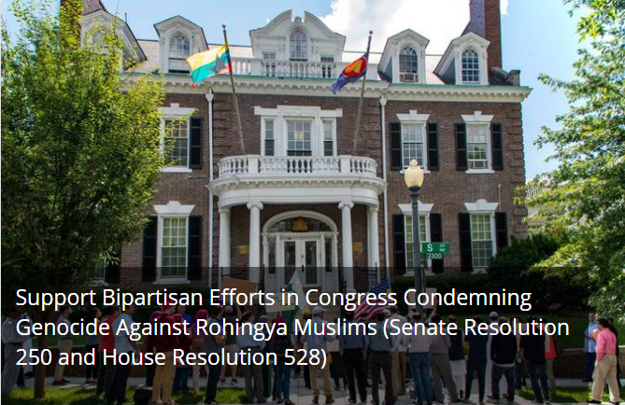
- CAIR Action Alert: Tell Members of Congress to Support Bipartisan Efforts Condemning Genocide Against Rohingya Muslims
The Council on American Islamic Relations (CAIR), the nation's largest Muslim civil rights and advocacy organization, today urged all citizens to contact their members of Congress to ask them to support Senate Resolution 250 and House Resolution 528.
These bipartisan measures call for the restoration of citizenship for the Rohingya Muslims, protection of their economic and social well-being and their freedom of movement. The resolutions also ask Aung San Suu Kyi, a Nobel Peace Prize winner who was awarded for her resistance to injustice in Myanmar, to condemn the brutal military crackdowns and to allow the delivery of aid into the Rakhine State.
"Congress must demand that the Burmese government immediately end the genocide campaign targeting Rohingya Muslims and eliminate that nation's 1982 Citizenship Act, which is a major source of the oppression faced by that minority community," said CAIR National Government Affairs Department Coordinator Amineh Safi.
TAKE ACTION, CLICK HERE.

Council on American-Islamic Relations
453 New Jersey Ave, S.E., Washington, D.C., 20003
Council on American-Islamic Relations Copyright © 1994. All rights reserved.

