5 powerful secrets to achieve happiness! Islamophobia Is Not Simply About Intolerance Of Muslims but and others

5 powerful secrets to achieve happiness!

As-salaamu 'alaykum wa rahmatullah,
Happiness - Have you ever wondered what it is?
Is it a mood, a delusion, a state of mind or a way of life? What makes us happy? Does happiness actually exist in this world?
In the Qur’an, Allah [Allah Subhanahu-wa-Taala] mentions happiness several times. When Allah [Allah Subhanahu-wa-Taala] mentions utter and complete happiness, He [Allah Subhanahu-wa-Taala] talks about the happiness of the next life. However, what about the happiness of this life? You can find several ahadith in the authenticated Sunnah and ayat from the Qur’an, which speak about happiness in this life – and we can learn a lot from them!

Here are five powerful secrets to achieve happiness.

Prayer!

The very most important step to happiness is prayer. We have seen the evidence for this statement in the prayer of Prophet Ibrahim [AS] .

Stay away from prohibited deed!

The very most important step to happiness is prayer. We have seen the evidence for this statement in the prayer of Prophet Ibrahim [AS] .

Be grateful – even for the smallest of things

The sight of a butterfly, the fresh breeze of the morning air just before the sun rises, the blessing of being able to stand in prayer and touch the ground with your face directly… these are all tremendous blessings from our Lord to be thankful for!

Help others!

We must go out of our way to help others – especially when we are not fine ourselves. Abu Hurairah radiyallahu anhu reported: The Messenger of Allah (pbuh) said, “Look at those who are inferior to you and do not look at those who are superior to you, for this will keep you from belittling Allah’s favor on you.”

Sojood! Extra prayers

Last but definitely not least: When you are happy, do not forget or refuse to do sajdah (and thank Allah Allah Subhanahu-wa-Taala for what He Allah Subhanahu-wa-Taala has given you) because in sajdah, you are nearest to Him!

Our deen provides several doors towards happiness and contentment. The more we learn about our religion, the more peace and tranquility we will find pouring into our lives.

Here is your chance to learn about Islam from authentic sources, sitting in the comforts of your home. Join Islamic Online University now and begin your journey!

Islamophobia Is Not Simply About Intolerance Of Muslims, Says Expert
BY SWATI BHASIN ON 09/15/17 AT 6:10 AM

If you thought Islamophobia was simply about intolerance of Muslims due to religious bias, you probably need to go beyond its literal meaning to better understand the cause of rising prejudice across the world against the community.
A lecturer in sociology from Rice University, Craig Considine — who reviewed more than 40 news articles and referenced dozens of academic studies relating to the experiences of American Muslims and the stereotypical depictions of Muslims — stresses upon the role race plays in Islamophobic hate crimes in a research paper titled “The Racialization of Islam in the United States: Islamophobia, Hate Crimes and 'Flying While Brown.”To dismiss the role that race plays in anti-Muslim racism is to adopt a “colorblind” understanding of Islamophobia, the author says.
“We often hear that because Muslims are not a race, people cannot be racist for attacking Muslims,” Considine was quoted as saying in a press statement published Thursday by Rice University that has its campus in Houston, Texas. “This argument does not stack up. It is a simplistic way of thinking that overlooks the role that race plays in Islamophobic hate crimes.”
inRead invented by Teads
According to the sociologist, Islamophobia represents a form of racism mixed with cultural intolerance as a whole and it has been misrepresented as a form of religious bias.
To further emphasize his argument, he stresses that population of Muslims in the U.S. is heterogeneous. No single racial or ethnic group represents more than 30 percent of the 3.3 million Muslims living in the U.S., of which 81 percent Muslims are American citizens. While 30 percent of these Muslims describe themselves as white, 23 percent identify themselves as black, 21 percent as Asian, 6 percent as Hispanic and 19 percent as other or mixed race.
“Despite the racial, ethnic and cultural diversity of the U.S. Muslim population, they continue to be cast as potentially threatening persons based on perceived racial and cultural characteristics,” the author said.
Considine also established the argument using statistics. In 2015, more than half of the hate crimes reported in the U.S. (59.2 percent) were linked to race or ethnicity or ancestry bias. And only 19.7 percent of the hate crimes were associated with religious bias.
A surge has also been observed in anti-Muslim hate crimes in the U.S. In 2016 alone, incidents of Islamophobia, including acts of violence and nonviolent harassment, rose by 57 percent.
The paper also underlines that “Islamophobia is also exacerbated by the Islamophobia industry.”
Citing the Council on American-Islamic Relations, the author highlights in the paper that “anti-Muslim groups and organizations have enjoyed access to at least $205 million to spread fear and hatred of Muslims.”
“In 2011, the Center for American Progress (CAP), a public policy research and advocacy organization based in Washington, D.C., found that seven charitable foundations spent $42.6 million between 2001 and 2009 to support the spread of anti-Muslim and anti-Islam rhetoric in the United States,” the paper reads.
For the growing anti-Muslim sentiment in the world, the author also refers to the role of the media. “In a study on news coverage from LexisNexis Academic and CNN for all terrorist attacks in the United States between 2011 and 2015, researchers found that news outlets gave drastically more coverage to attacks by Muslims, particularly foreign-born Muslims — even though these attacks are far less common than other kinds of terrorist attacks,” the author writes in his paper. He observed how the alleged attacks by Muslim perpetrators received 449 percent more news coverage than those allegedly perpetrated by non-Muslim attackers.

Promoted Links

We Can Guess Your Education Level with Just 10 Questions
Topix

Diabetes Breakthrough Leaves Doctors Totally Speechless (Try This Tonight)
Life Advice Daily

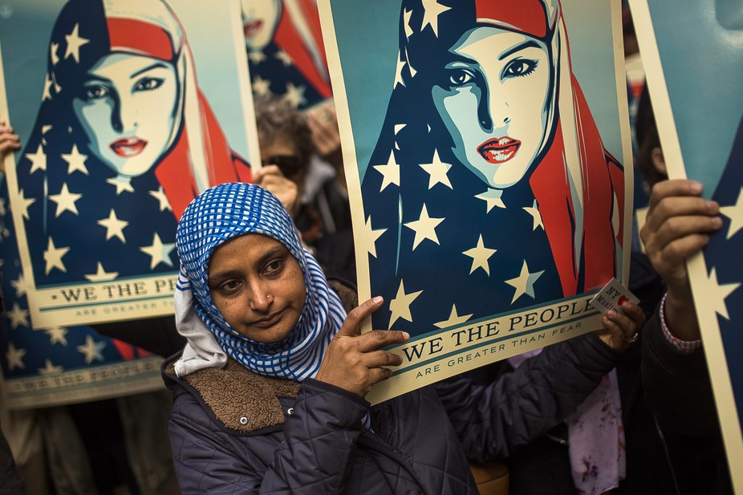

How Muslim Americans are fighting Islamophobia and securing their civil rights

Controversial children's author turns over book profits to pro-Islam group; resigns school post
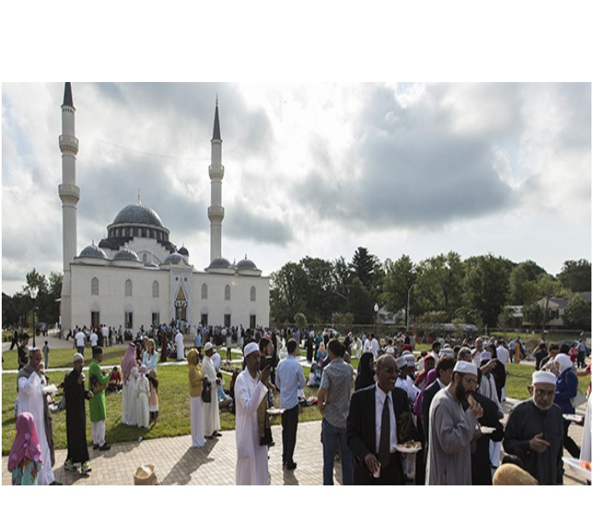

U.S. Muslims are religiously observant, but open to multiple interpretations of Islam

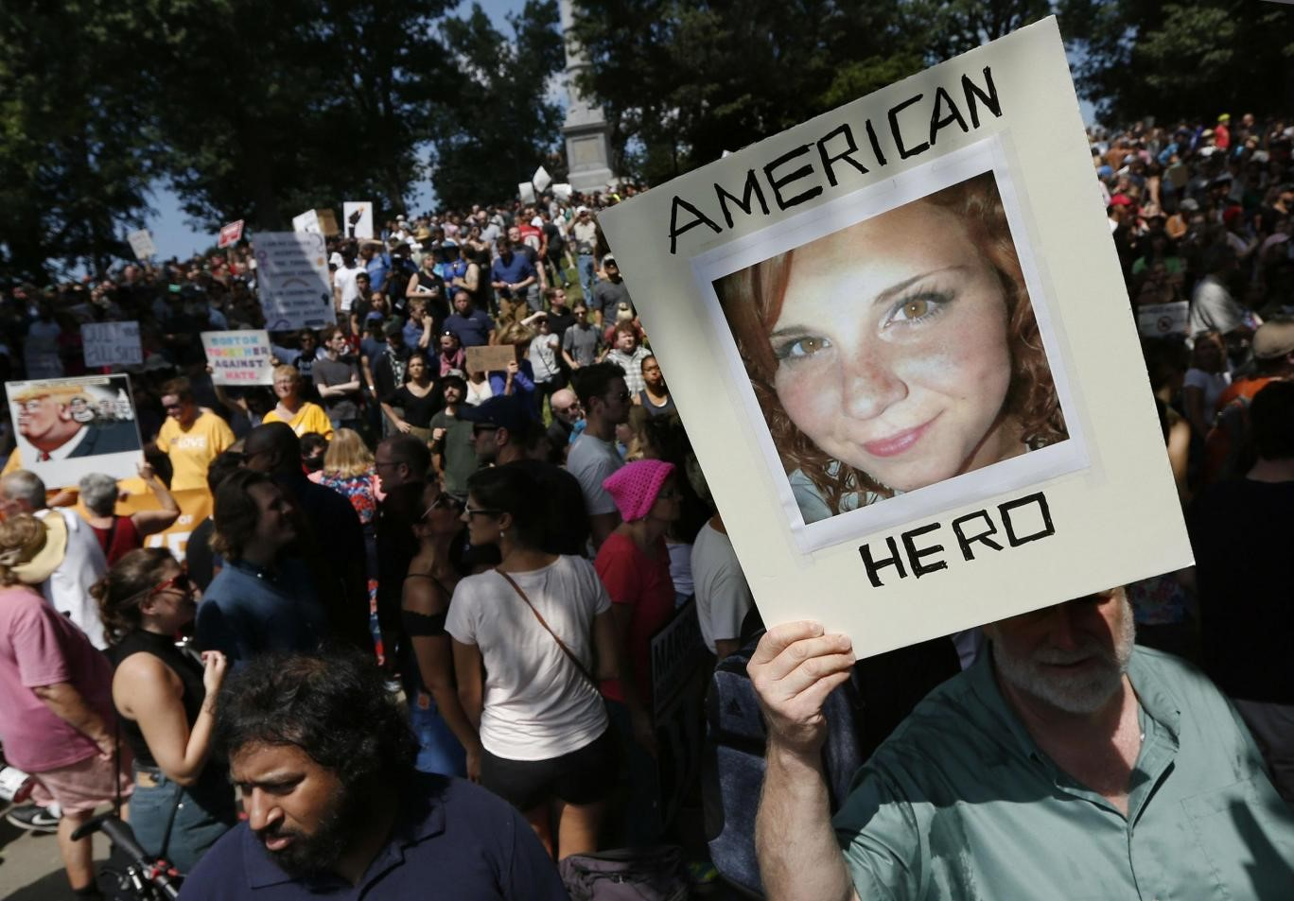

US's largest anti-Muslim group cancels dozens of rallies after seeing size of anti-fascist crowds in Boston

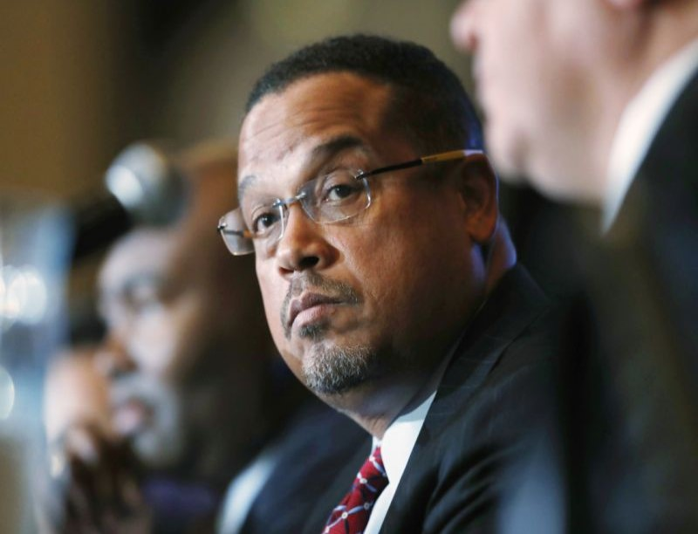

Ellison calls on Trump to condemn Minnesota mosque bombing
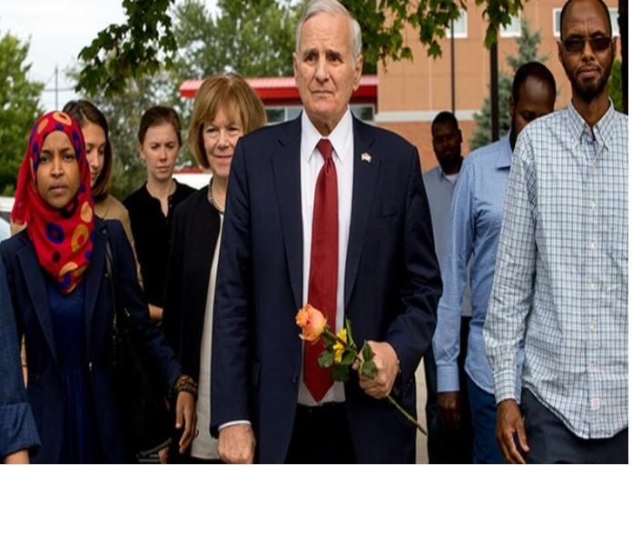

Minnesota officials visit Islamic center hit with explosive attack
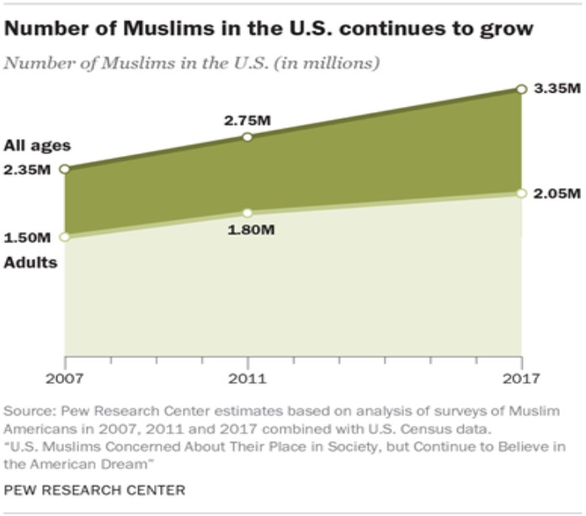

Demographic portrait of Muslim Americans
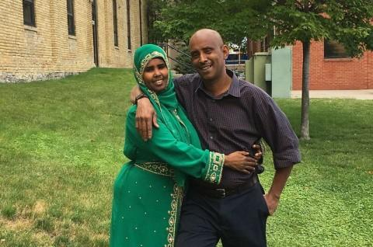

U.S. family suing federal government after 11-hour detention on Canadian border

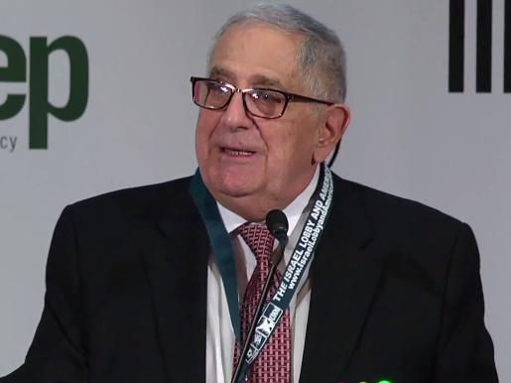

A Powerful Voice Against Arab Stereotyping, Jack Shaheen, Dies

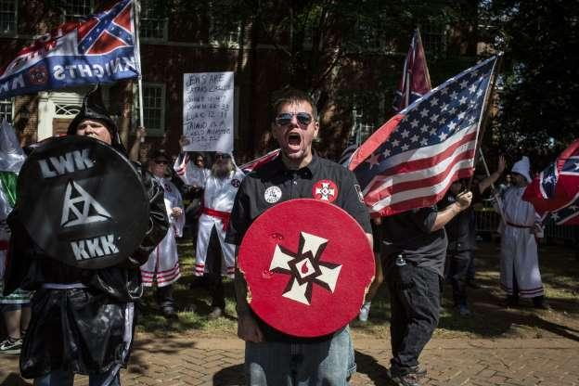

The state of hate in America

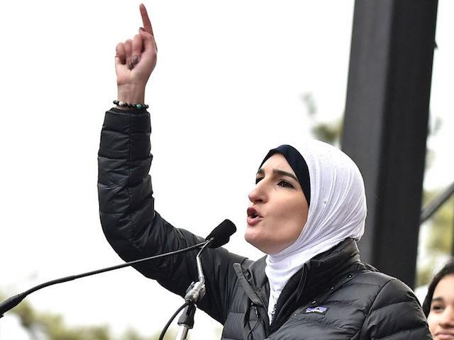

Muslim activist Linda Sarsour’s reference to ‘jihad’ draws conservative wrath

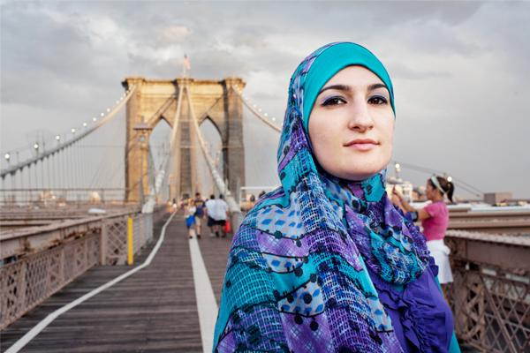

Muslim activist speaker cheered at NY graduation

The mass incarceration of Japanese Americans offers a lesson for Muslims and allies

More Than 100 Federal Agencies Fail to Report Hate Crimes to the FBI’s National Database

Community to mourn Muslim teen attacked near mosque

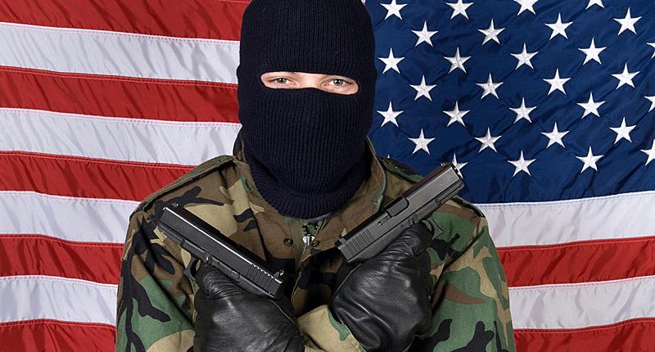

Domestic Terrorism in the Age of Trump
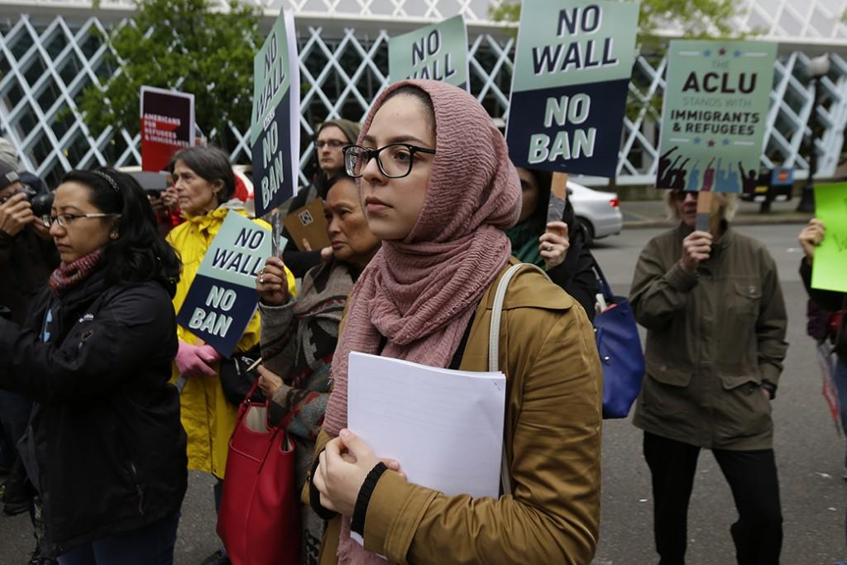

The Courts Have Halted Trump’s Bigoted Policies, But the Senate Wants to Confirm All His Judges

The silly American fear of sharia law

Muslims 'outraged' by billboard that insults prophet Mohammed

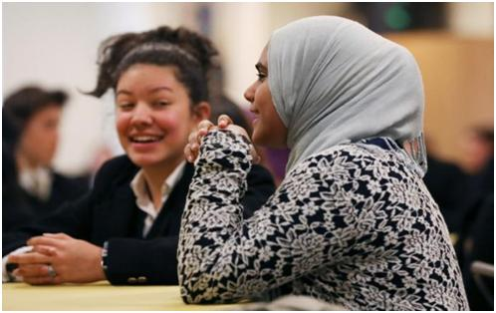

To ease fears, U.S. Muslim schools reach out to neighbors

HOPE NOT HATE: A Reflection

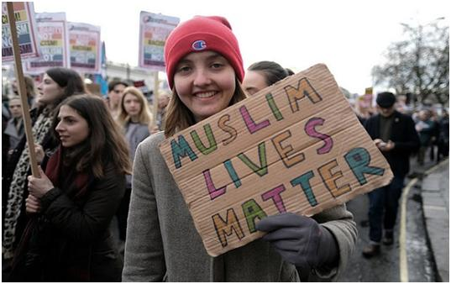

SAN DIEGO SCHOOLS FIGHT AGAINST ISLAMOPHOBIA

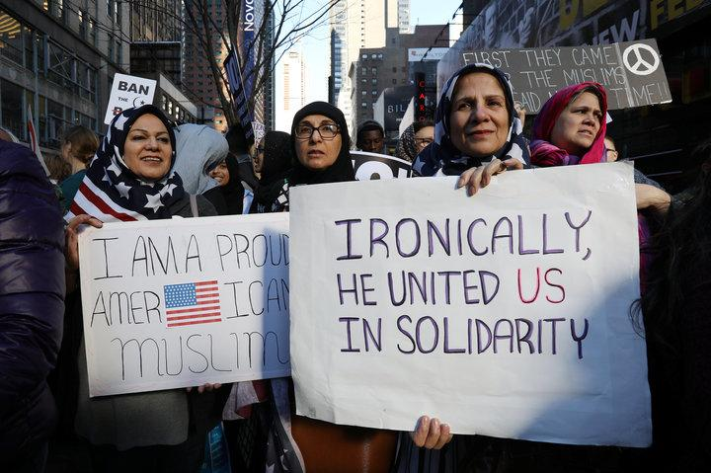

Bias And Fear Are The Norm For Many Muslim Americans

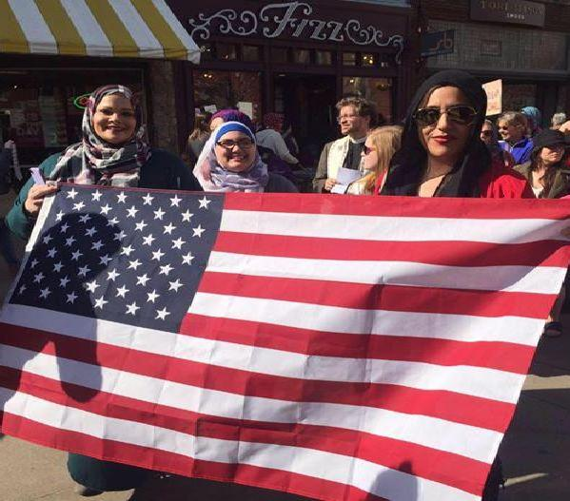

STAND FOR ALL!

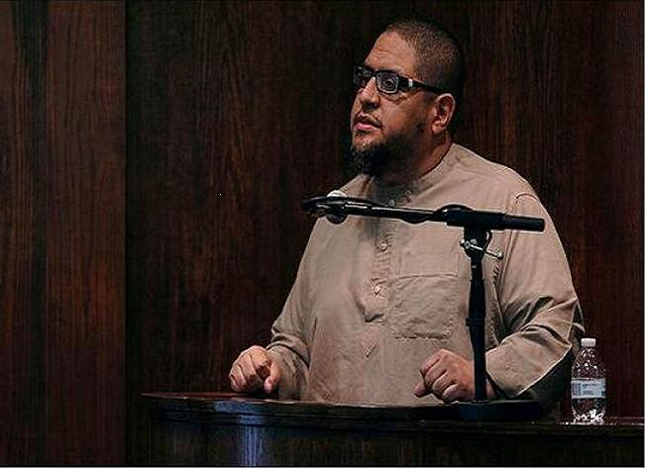

Trump's immigration policies have 'changed everything'
Top Stories
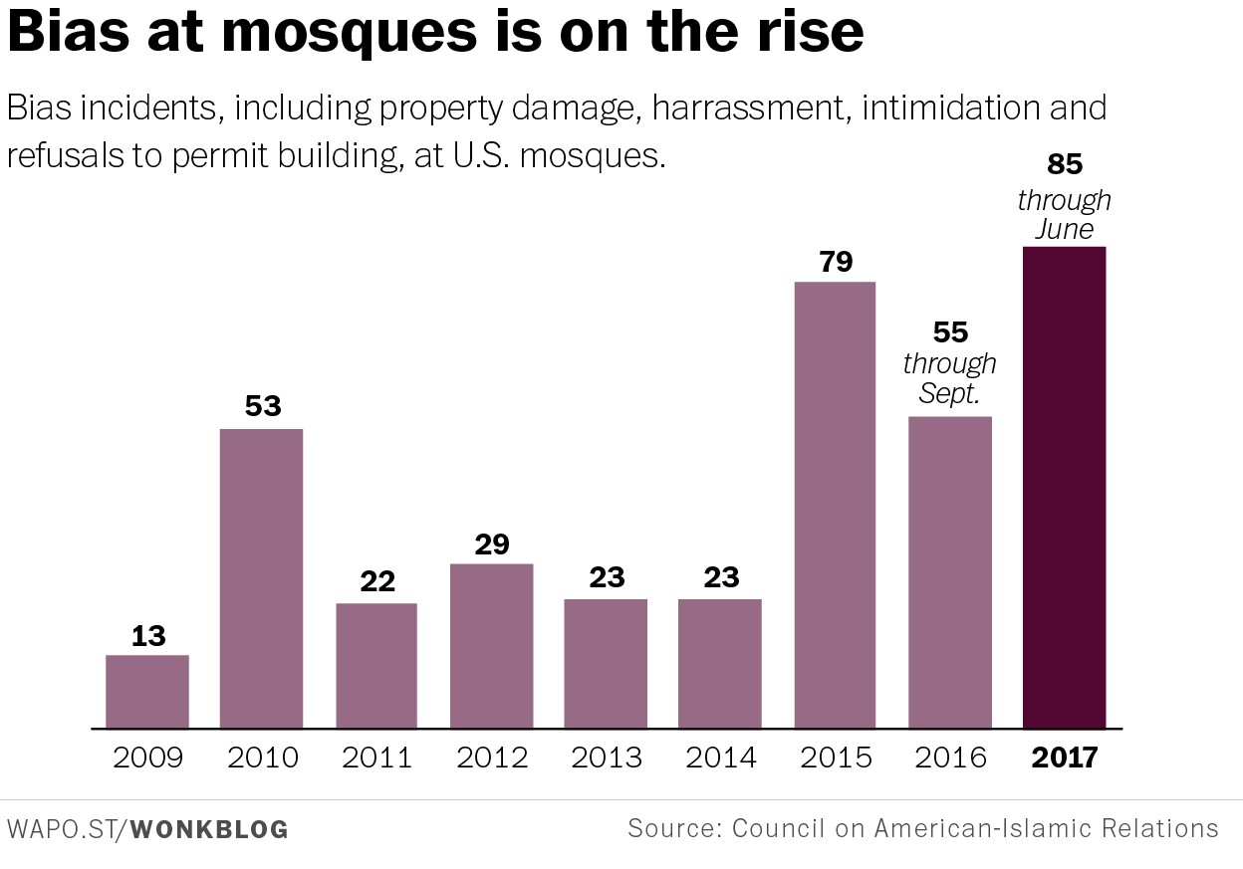

American mosques — and American Muslims — are being targeted for hate like never before

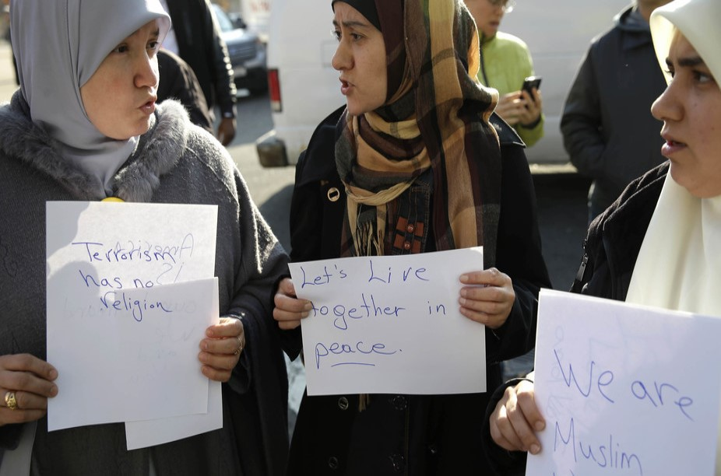

Explaining the rise in hate crimes against Muslims in the US

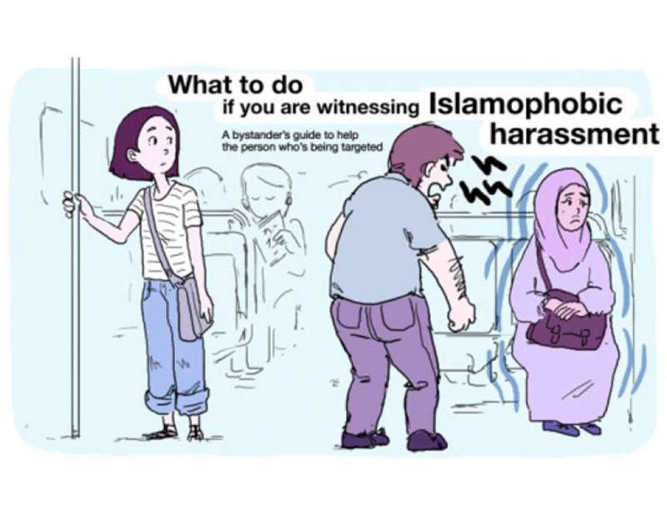

Boston launches poster campaign to combat Islamophobia

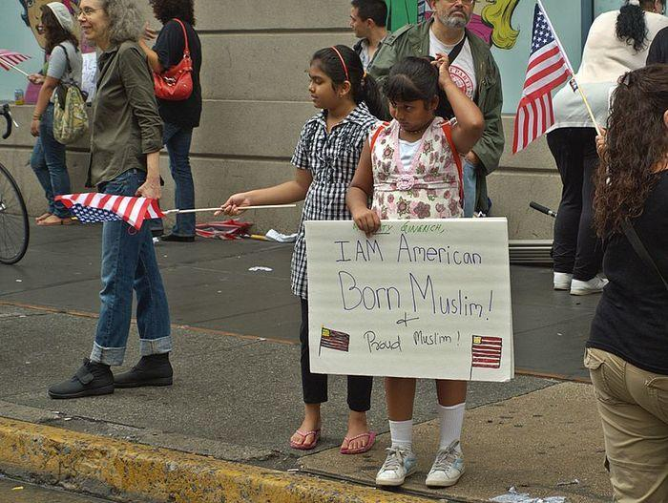

US media write 449% more news stories about 'Muslim' terrorist attacks than others

July 4th: Muslims have been an integral part of the United States of America since her birth
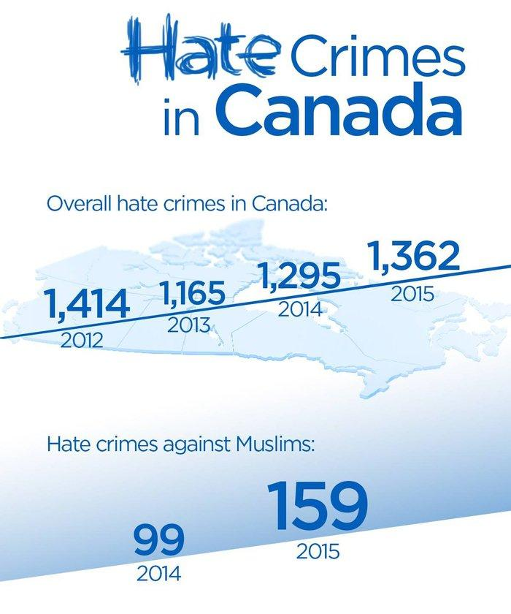

Canada also has a big Islamophobia problem, hate crime statistics reveal
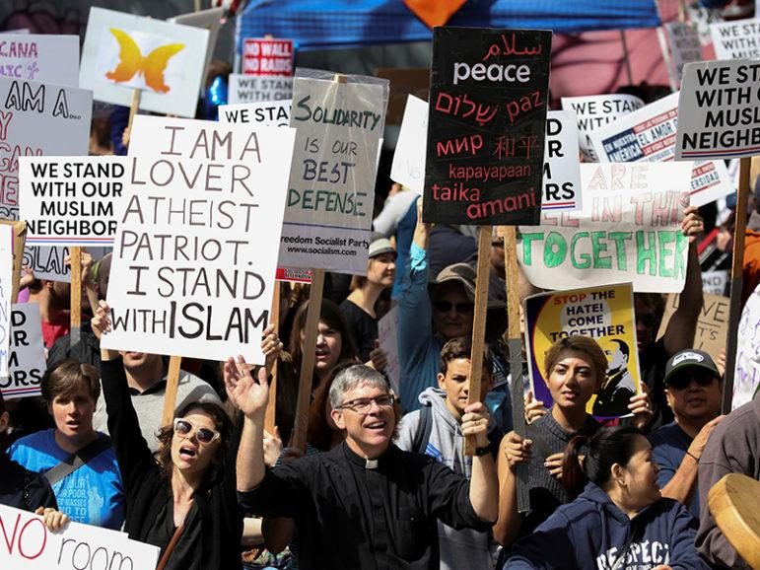

Anti-Shariah rallies nationwide ‘intended to manufacture fear’

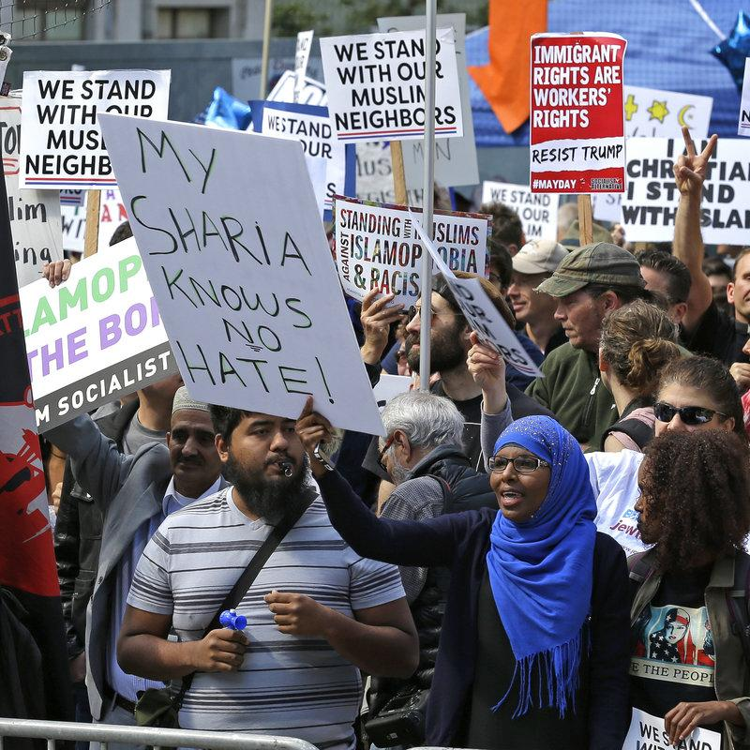

'Anti-Sharia' Marchers Met With Counter-Protests Around The Country
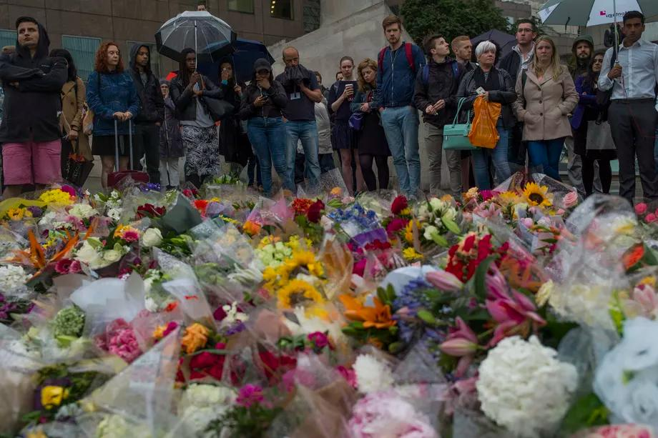

Trump is quick to blame Muslims for terror attacks. He's slow when Muslims are the victims

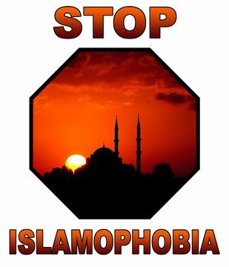

Muslim-Bashing Bigot John Guandolo to Train Cops in Mesa, Arizona

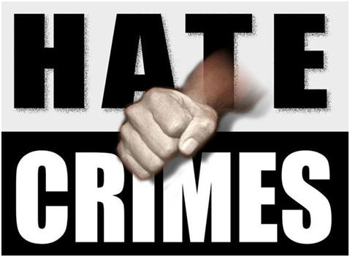

American Muslims report “unusual surge” in visits from the FBI in 2016

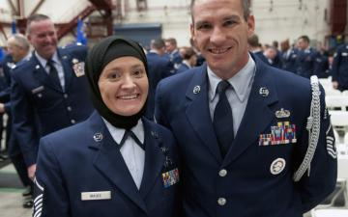

Nevada ANG chaplain: 'I want people to know Islam is not evil'
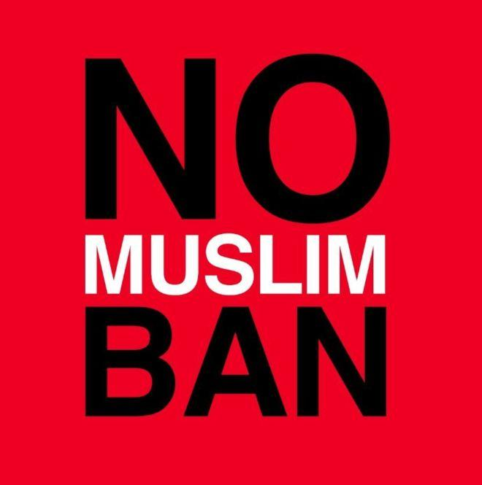

Trump travel ban defense met with protest

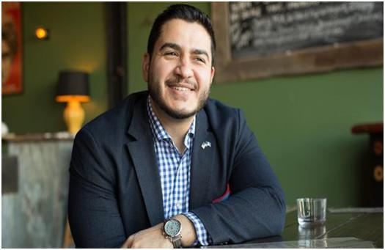

AFTER BACKING TRUMP, MICHIGAN CONSIDERS ITS FIRST MUSLIM GOVERNOR
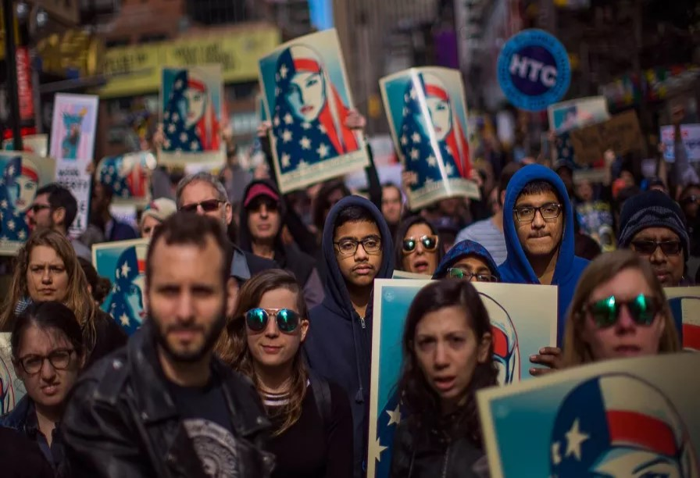

Too Many Americans Think Patriotism Means Racism and Xenophobia
Inspiring America

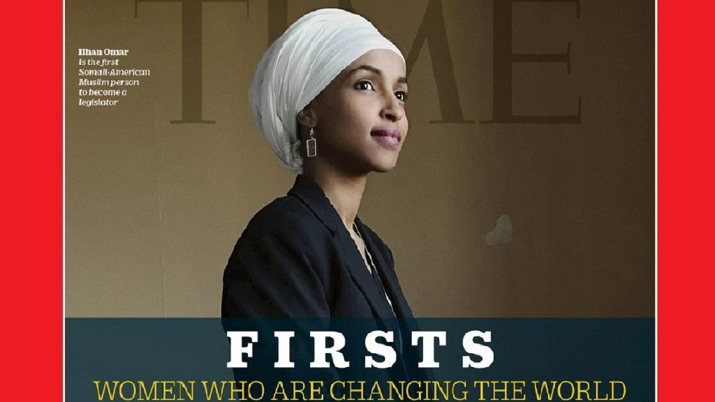

First Somali-American Muslim lawmaker covers TIME mag special edition

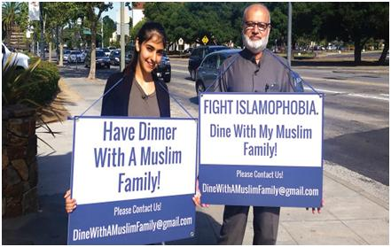

Palo Alto student fights Islamophobia, one dinner at a time

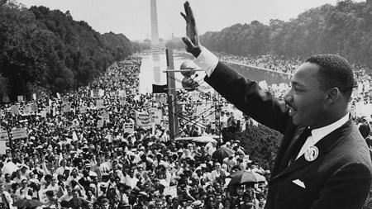

Islam’s contributions to American civil rights
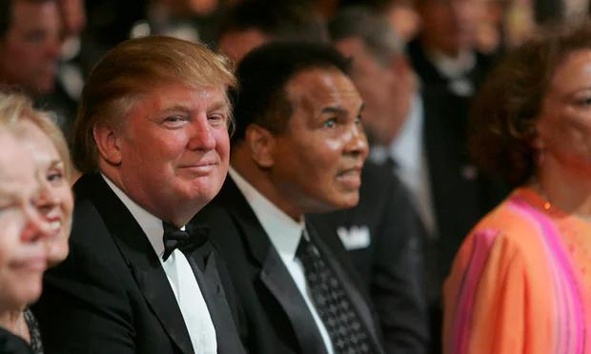

The Muslims who shaped America – from brain surgeons to rappers

A patient says something hateful, and here’s what a Muslim medical student does

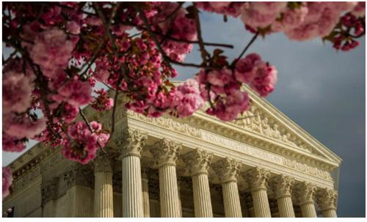

The Holy Prophet Muhammad Recognized, as a Great Law-Giver, by US Supreme Court in 1935
Featured

Read George W. Bush’s “Islam is peace” speech, delivered days after 9/11

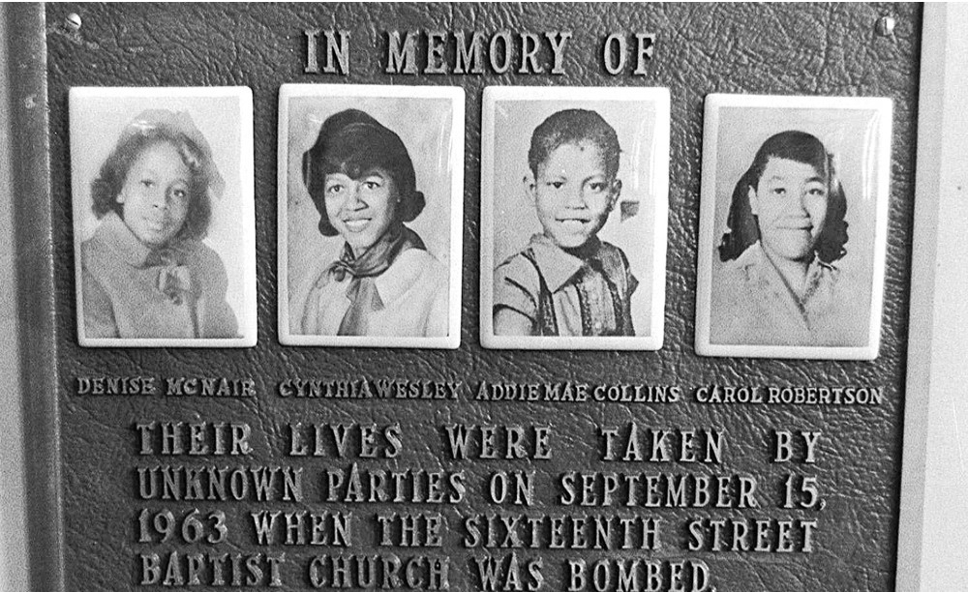

Know your history: Understanding racism in the US

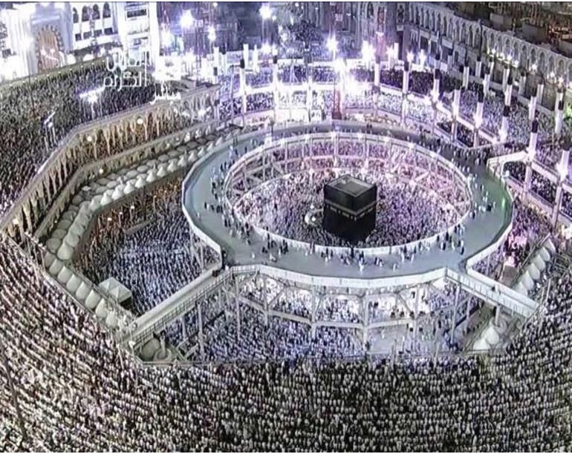

A journey through Hajj, Islam's special pilgrimage

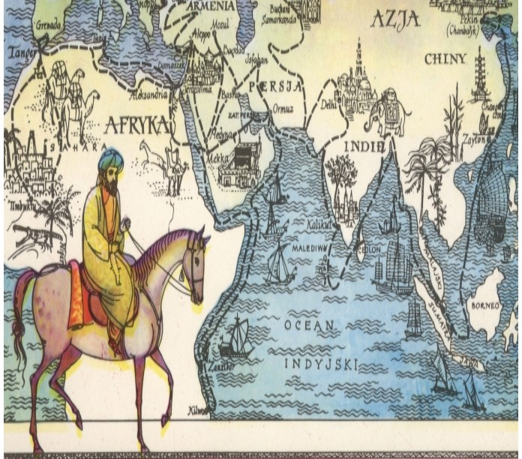

Why Arab Scholar Ibn Battuta is the Greatest Explorer of all Time
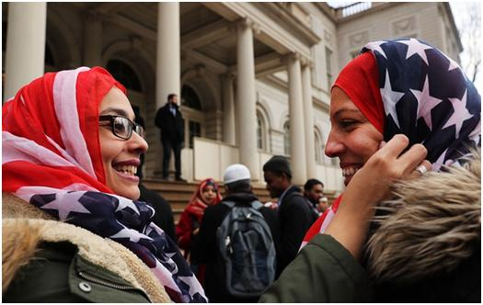

Why We Need To Stop Portraying Muslim Women As Either Victims Or Rebels
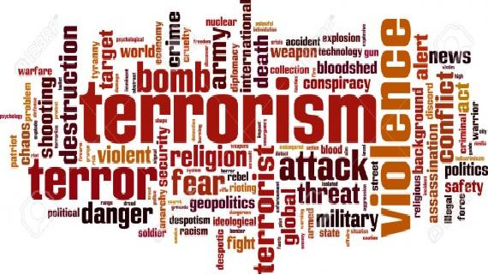

We need to stop using the phrase ‘radical Islamic terrorism’

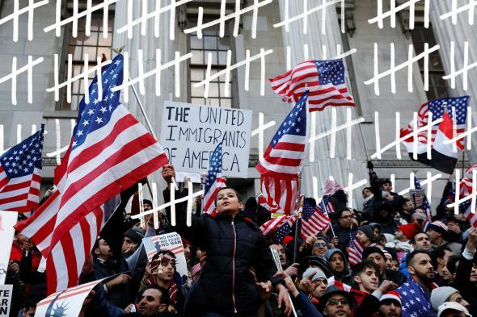
Donald Trump Has Made Me Feel More American

How Islam Created Europe
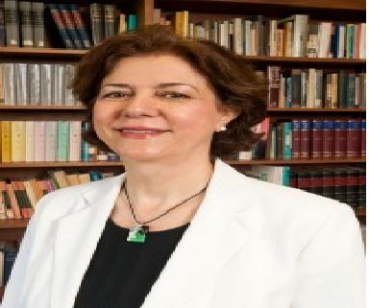

Professor Ponders What It Means to be Muslim in America

Here’s what one Muslim thinks about practicing Shariah law in America

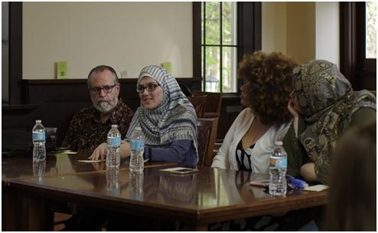

Panel on Muslim Americans sought to end misconceptions
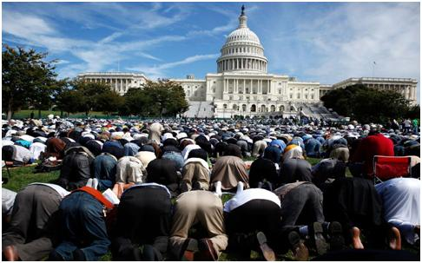

A brief history of Islam in America
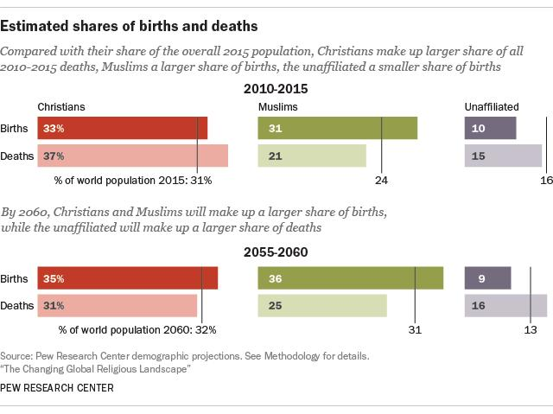

Why Researchers Say Islam Is The Fastest-Growing Religious Group

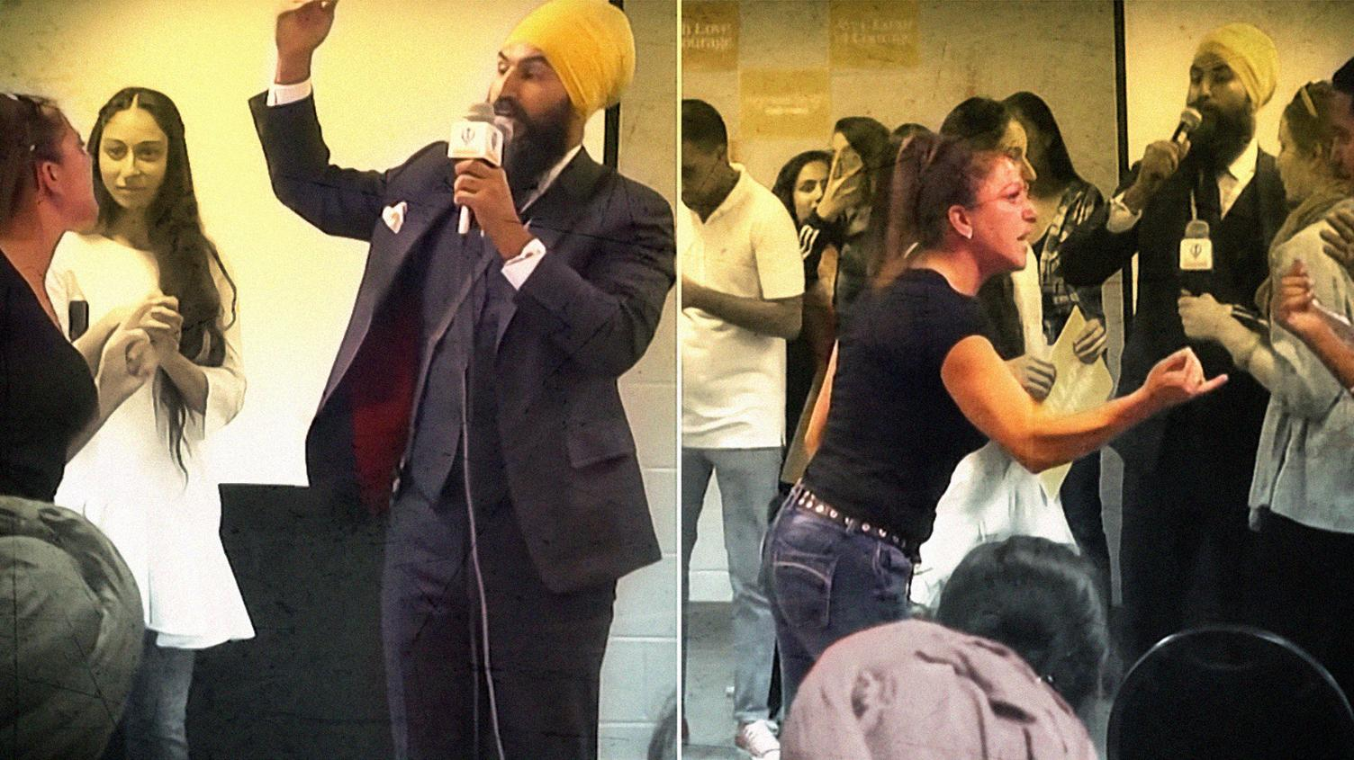

Jagmeet Singh’s reaction to a heckler has been a viral sensation, but some people of color think the praise has been telling.
- This article originally appeared on VICE Can.
When someone is hurling racist insults at you, keeping your composure is no easy feat, but finding it in your heart to tell them that you love them and hear them is something else entirely—it's safe to say not many people could do it. That's why a video of Canada's New Democratic Party leadership hopeful Jagmeet Singh remaining unbelievably chill as woman yells at him for supporting Sharia law and being "in bed" with the Muslim Brotherhood has been seen tens of millions of times. It's earned him an outpouring of support well beyond party lines, and his approach has been lauded as "inspiring" and "instructive."
But online, some young people of color are dispelling the notion that Singh's reaction—calm and compassionate in the face of blind hatred—should be the template for how to respond to a racist. "Are we not allowed to feel the pain from those attacks? And to express that pain as complex human beings? To expose the trauma?" wrote activist designer Sheila Sampath in a Twitter thread.
The video has garnered Singh publicity on par with Justin Trudeau, shared outside of Canada by people like CNN's Van Jones and Jake Tapper, and Martin Luther King's daughter Bernice King, who wrote that Singh had "demonstrated [her] father's belief that love is a powerful force in the face of hate."
But compare that widespread approval and admiration to how the media and members of the public have treated less forgiving approaches to racism, like Black Lives Matter, Idle No More, and Antifa. It becomes pretty obvious that Canadians are much less willing to lend their voices to support activists who are justifiably angry.
Remember the vitriol hurled at BLMTO co-founder Yusra Khogali when she tweeted a prayer for the strength "not to cuss/kill these men and white folks out here"? After the then months-old tweet was unearthed—in the wake of a fruitful two-week protest by BLM demanding police accountability—the backlash was fast and furious. Many on Twitter demanded that Khogali step down and journalists tripped over themselves to get an explanation for the controversial remark.
Khogali had written the tweet after being bombarded with messages from "white men asking [her] to prove that racism, Islamophobia, and misogyny exist," she explained in an op-ed. For many, her defense—that she'd used "a rhetorical flourish, to voice [her] frustration" —wasn't enough.
Those people may not understand how devastating it is to be on the receiving end of racism, how intensely people of color feel it, or how infuriating it is to have your response to it questioned and policed. Many of us won't be as patient as Singh, nor should we be expected to as that impatience comes from a real place.
While the media rushed to condemn Khogali, they drowned out BLM's peaceful efforts to hold police officers who have killed black people to account. When the focus is on tone, more important conversations often get derailed.
Many have made the argument that calling out racism doesn't work—we've just spent a year debating the ethics of punching Nazis, and whether it's even productive to call neo-Nazis "Nazis." But it doesn't appear that Singh, who did the opposite, succeeded in changing the mind of the woman screaming at him. In a video taken after the incident, the woman, since identified as Jennifer Bush, says she came to the event to ask why Singh supported a Liberal MP's motion to condemn Islamophobia, and why he opposed the niqab ban in 2011, calling both policies "Sharia." Then she added that she isn't a racist. At no point did she apologize for her outburst or acknowledge Singh's kindness.
Singh, who is hoping to become Canada's next Prime Minister on a platform of inclusiveness, has spoken out about dealing with racism growing up, but now has to grapple with it in the national spotlight. And it won't come just from people like Bush, but also from the mainstream, in places like Quebec where the NDP worries it'll be abandoned by voters if the party's leader is a devout Sikh, as progressive community leader Andray Domise wrote in Maclean's. But Singh has built his brand on the idea of championing a "politics of love to fight the politics of hate." His actions in this instance are on message and palatable to every kind of audience—this is crucial since he now faces the monumental task of impressing not just people of color, but also white liberals. And as a politician who's dealt with racist hecklers in the past, he's probably deeply aware of how a turbaned brown man being anything less than gentle towards a white woman would fulfill a racist stereotype. Would everyone be fawning over Singh in the same way had he yelled back at Bush, or had her immediately escorted out of the room?
It's easy to root for someone whose slogan is literally "Love and Courage," and who can stay so positive in the face of open hostility. As a potential leader, Singh's reaction is commendable and makes sense. But it shouldn't be treated like the only and right one—that creates an impossible standard for visible minorities, dealing with the blows of subtle and overt racism every day, to live up to. Canadians should get used to people being less gracious about racism—because the truth is, the work of dismantling racism, in most cases, is much harder than loving the racist.

