Can the hater preacher Franklin Graham reciprocate the true tolerance of Muslims by naming his son after Prophet Mohammad so many of Muslims their names are Easa

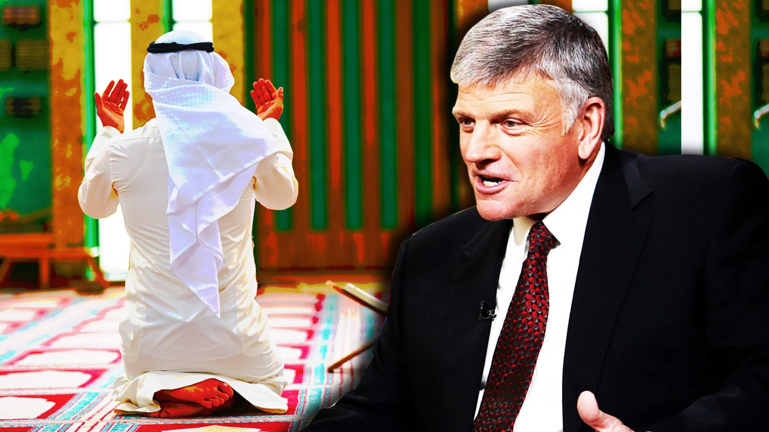

Hey, Franklin Graham: Muslims Already Do Love Jesus

RACISM

CASTER OF STONES
Hey, Franklin Graham: Muslims Already Do Love Jesus
The hate preacher went on another screed the other day. Either he’s an ignoramus, or he’s lying to his gullible flock.
DEAN OBEIDALLAH
08.24.17 12:00 AM ET
Trump-supporting Evangelical leader and part time anti-Muslim activist Franklin Graham is once again spewing hate of Muslims in the name of Jesus. If ISIS were holding a fantasy draft of people who could best help them start the holy war they dream of, Graham would clearly be taken early in the first round.
Graham’s latest bit of beyond-ignorant comments came over the weekend when he took a break from defending Trump’s response to the white supremacist terror attack in Charlottesville to lash out against all Muslims after the horrific incident in Barcelona. Graham, who in the past has called Islam “a very wicked and evil religion,” began by warning of the “spread of the dark and dangerous teachings of Islam” and claiming that Islam is a religion that controls its followers by use of “fear and intimidation.” Graham then tried to appear fair by noting that there are “millions” of good Muslims, but he added that these “good Muslims” are trapped in our faith and “can’t leave the religion.” (BTW there are over a billion Muslims so he’s really telling you be afraid of just about every Muslim.)
The cherry on the Graham’s hate sundae was his prescription for how he wants to save us poor Muslims from our wayward path to the dark side: “I pray that Muslims everywhere will come to know Jesus Christ, the Son of God who loves them and can truly set them free.”
These comments again expose Graham’s lack of understanding of Islam, but the last one about Muslims need to find Jesus is truly astounding. Here’s some breaking news for Graham: Muslims already “know” Jesus, and we love him.
“To put it bluntly, you cannot even be a Muslim if you don't both believe in and love Jesus (peace be upon him),” well-known Imam Omar Suleiman and President of Yaqeen Institute for Islamic Research explained by email while at an airport waiting to board his flight to Medina, Saudi Arabia to go on hajj (pilgrimage.) Suleiman continued, “Muslims share the love of Christ with their Christian brethren while still upholding a unique understanding of monotheism that is shared with Judaism.”
While Muslims don't view Jesus as the son of God, New York City based Imam Shamsi Ali explained that, “Jesus is one of the central figures and a 'mighty prophet' in Islam, together with Mohammed, Abraham, Noah and Moses.”
Islam is one of the three Abrahamic faiths along with Judaism and Christianity and these three religions are intertwined. While it may come as a surprise to some that Jesus is a very important part of Islam, I’m sure Graham—a man who has been studying religion for decades—is very likely aware of the truth but has chosen to mislead his followers.
So why is Jesus important to Muslims? Well as Edina Lekovic of the Muslim Public Affairs Council explained, “Both Jesus and his glorious mother, the Virgin Mary, are sacred and revered figures, and their stories are shared in great depth in the Quran.” In fact, as Imam Ali noted, Jesus is mentioned more frequently in the Quran than the Prophet Mohammed, and there are two chapters dedicated to the Virgin Mary that praise her as being "chosen above the women of all worlds.”
Lekovic added, “Along with 1.5 billion other Muslims, I'm inspired by Jesus and the Virgin Mary’s sacrifice, devotion and unshakeable belief in God and service to humanity." That’s why my cousin and countless other Muslim women are named “Mariam” after the Virgin Mary. Same goes for why there are Muslims named “Issa,” which is Arabic for Jesus.
I wish we could simply laugh off Graham’s bigotry and ignorance but we can’t. He’s part of Trump’s Evangelical council. In fact, Graham was calling for “total and complete ban” on all Muslims coming to the United States long before Trump did in December 2015 and may have actually been Trump’s inspiration for this.
And worse, Graham is otherwise misleading good Christians to hate Muslims. Graham, in addition to spreading lies about Islam and suggesting that President Obama may be a secret Muslim, has even fought against American Muslims having the same religious liberty as those of other faiths. We saw that in 2015 when Duke University had decided to allow a short one-minute call to prayer on Fridays from the school chapel. Well that one minute was one too much for Graham.
Graham took to Facebook, writing first that “the followers of Islam are raping, butchering, and beheading Christians, Jews, and anyone who doesn’t submit to their Sharia Islamic law.” Once again Graham makes no distinction between the extremists like ISIS as opposed to mainstream Muslims. He then called on his followers to contact Duke University to rescind their promoting of “religious pluralism,” as he put it. Apparently many of Graham’s flock followed his words and called Duke resulting in the school cancelling the call to prayer.
Top of Form
Bottom of Form
And the responses to Graham’s latest Facebook post demonizing Muslims shows us again how he’s radicalizing good people to hate. One of his fans wrote in response to Graham’s diatribe about Islam, “AMEN we need to wake up before this satanic religion consumes America.” Others commented, “Fight Islamic Communism and those individuals who wish to subjugate our country to this totalitarian rule” while another lumped in Muslims with the anarchists: “Islam is also working through antifa's war against America.”
Thankfully, there were also comments from self-identified Christians standing up to Graham’s words such as, “You're disgusting! Too bad you're not a decent man and good Christian like your father.” While others denounced Graham as “an unabashed religious bigot - scary!”
Being a person who greatly admires Jesus and his teachings, I feel confident in saying that those pushing back against Graham’s hate truly represent what Jesus stood for. While Graham’s hateful words are the opposite- they are a horrible perversion of Jesus’s philosophy. It’s no different than when we see radical Muslim clerics pervert Islam for their political agenda. And just as Muslims have and must continue to denounce those extremist voices in our community, my hope is that even more Christians denounce the hateful teachings of the Franklin Graham’s in America. That is what Jesus would've done.

