Tips on Enjoying The Ramadan Taraweeh Prayer
Posted in Ramadan By admin On June 16, 2014
The month of ramadan comes with fasting, the preparations of Suhoor and the joys of Iftaar. Moreover, in this month there is no Satan to tempt nor any doors of hell open. Rather, the only thing that is open in this month is the door of Paradise. Therefore, by being good in this month and worshipping Allah Almighty more than normal, a Muslim can increase the chances of entering paradise.
One of the major Ramadan worshiping prayer besides the mandatory prayers is Taraweeh. It is the prayer which Muslims undertake generally in congregation after the prayer of Ishaa and consists of various Rakats in which Quran is recited. The number of Rakats usually varies from eight to 20, therefore, for some of the Muslims the offering of Taraweeh becomes tedious and boring.
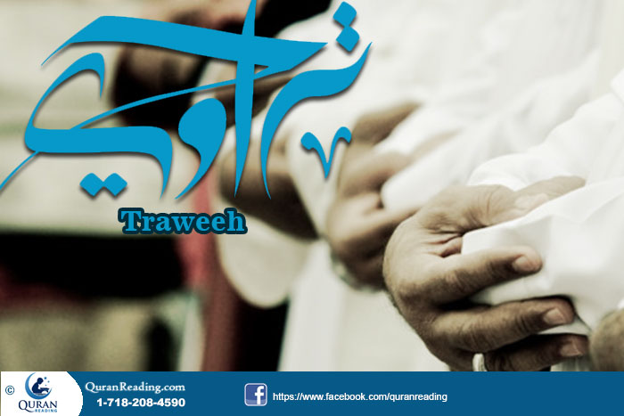
The essence of prayers is to enjoy them while performing them and not feel bored or grave. Therefore, it is imperative that a Muslim makes special preparations for Taraweeh in order to enjoy the prayer and not just go through it as a set of tedious postures.
It Comes Once In a Year:
If you cannot find the motivation to enjoy Taraweeh, then perhaps the thing that can help in motivating you and keeping full of spirit during the whole Taraweeh period is thinking of the fact that it is a one time in a year opportunity. When you think of it like this way, then you try to make the most out of it and try enjoying Taraweeh in the best manner possible. When you have such a thought, you enjoy each and every word recited in each and every Rakat. Therefore, try thinking of the Taraweeh prayer as once in a year opportunity to praise Allah and seek forgiveness, which will help you in enjoying your worship.
Choose the Perfect Mosque
It goes without saying that listening to heart touching recitation of Holy Quran is actually enlightening and enchanting to heart and soul. Since basic purpose of performing Taraweeh prayer is to listen the Quran, it would be feasible to spot a Masjid in which there has been arrangement of special Reciter (Qari). This would double the taste of listening the holy Quran.
Leave The Stresses At Home:
Although it may seem impossible to do, however, the essence is that you leave all your stresses and tensions at your home before you leave for the mosque. When you go with burden on your head and heart, it naturally becomes difficult for you to have concentration in the prayer during the course of Taraweeh, therefore, avoid it by keeping your mind clear of stressful thoughts before you stand for Taraweeh prayer. If there are some chores and tasks that might haunt you during the Taraweeh, then finish them off before its start or set them for after Taraweeh session.
Go With Friends And Family:
Another factor that can keep you motivated and help you perform Taraweeh with interest is going to the Taraweeh congregational prayer with friends and family. Having your friends and family go with you to the mosque and then standing beside them during the whole Taraweeh session keeps you motivated and gives you a feeling of enthusiasm about Taraweeh. Therefore, the next time you go to Taraweeh prayer try going with your friends or family members and it will contribute positively to your interest.
Arrive Early:
When you reach the mosque on the nick of time, then obviously you are in a hurry to join the prayer and your mind takes time to prepare and accept the atmosphere it has become a part of, therefore, it is imperative that you arrive early at the mosque. When you arrive early at the mosque, you actually start preparing for the Taraweeh mentally, you get accustomed to the atmosphere and start thinking that you are going to stand in front of Allah and praise Him. Thus, this way your mind gets the motivation and interest for Taraweeh prayer and you remain in the same stance throughout the prayer.
Eat The Right Foods In Iftaar:
Although standing in prayer is a matter of soul and heart, however, after all a person is standing, therefore, the body of a person is also of importance. In this regard, the kind of Iftaar you have has direct impact on the kind comfort you face during the Taraweeh prayer. Therefore, in this regard it is of grave importance that you eat the right and light foods in Iftar so that when you stand during the Taraweeh, your stomach doesn’t get upset neither do you feel uncomfortable in performing the postures of Taraweeh prayer.
Focus On Recitation:
Another way in which you can increase your interest in Taraweeh is by focusing on recitation of Quran. Pertaining to recitation of Quran in Taraweeh, there is a specific pattern followed that starts from the beginning of Quran and ends at the end of ramadan with the end of Quran. Therefore, you can keep track of the recitation of Quran and if you are familiar with reading Holy Quran in Arabic, then at home when you recite Quran during the fast, you can read the translation of the excerpt that is going to be recited in the Taraweeh during the night. This way, your focus on the recitation of the Quran improves which automatically brings you joy and happiness and increases your interest in the whole Taraweeh session.
Carry Water With You:
The Taraweeh sessions are long and all the repetition of movement during the session is no less than an exercise, which can obviously dehydrate you. Therefore, it is of grave importance that you carry a bottle of water with you to the mosque. This way by drinking water whenever you feel thirsty within the prayer break, you ensure that you stay hydrated, which consequently leads to better focus and energy.
Bottom Line:
In a nutshell, Taraweeh is the jewel in the month of ramadan. The fasting of the whole day is further charmed and garnished with the Taraweeh session during the night. Therefore, it is imperative that every Muslim offers Taraweeh during the night and does so with true heart and actually enjoys the prayer instead of just getting over with it.
- See more at: http://www.quranreading.com/blog/tips-on-enjoying-the-ramadan-taraweeh-prayer/#sthash.oUL8CJmF.dpuf
***

The Night Of Qadar: Significance, Prayers And Worship
Posted in Ramadan By admin On July 6, 2014
Besides fasting and the Taraweeh prayer, the one other thing Ramadan is most known about is the Layla tul Qadr. It is the blessed night in the last ten days of Ramadan and every good deed and act of worship committed during this night gets rewarded with an exponential increase, hence, every Muslim tries to catch this night and do acts of righteousness in this night.
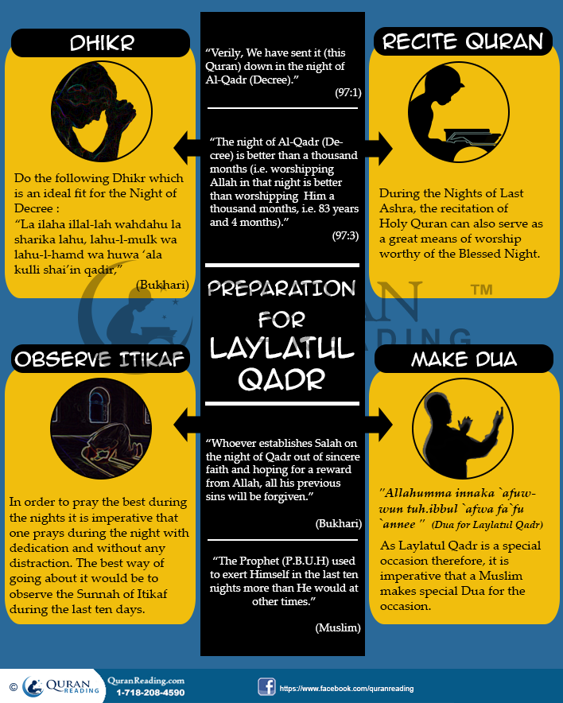
Muslims who are born Muslim and live in an Islamic culture and surrounding have a knowledge about what Laylatul Qadr is and how they ought to observe it, however, those who convert to Islam or are born in a non-Muslim culture, for them it is imperative that they understand the importance of this night and get accustomed with the right ways of observing this night in the best manner. The lines below give some tips to Muslims about the virtues of the Blessed Night and the preparations they should make to observe it in a better way.
The Virtues:
Laylatul Qadr is one of the most blessed nights of the Islamic calendar and perhaps there is no other night that stands equal to it in sacredness and Holiness in Islam. This night usually resides in the last ten days of Ramadan and within those days it is in the odd nights of the Ashra. The lines below give some major virtues of the Night in the light of different Ayaah and hadith.
In Quran, Allah Almighty says:
“Verily, We have sent it (this Quran) down in the night of Al-Qadr (Decree).” (97:1)
From this ayah of Quran it is more than clear that perhaps the biggest virtue associated with Laylatul Qadr is that in this night Allah Almighty bestowed Quran upon humanity, which is perhaps the biggest gift that Allah has sent upon humanity. Therefore, if a Muslim is to celebrate the Night for any reason, the biggest one can be perhaps the fact that Allah has sent down His biggest gift upon Prophet Muhammad (PBUH) on this night, hence it ought to be celebrated for this very gift. There can be many ways you can celebrate it, however, the ultimate option would be to start learning to read and understand the Holy Quran from this very blessed night. For that, you can Join QuranReading.com for online Quran Classes and begin with comprehending and reading the Quran with perfect Tajweed and meanings.
At another place in Quran, Allah Almighty says:
“The night of Al-Qadr (Decree) is better than a thousand months (i.e. worshipping Allah in that night is better than worshipping Him a thousand months, i.e. 83 years and 4 months).” (97:3)
Tin this ayah of Quran, Allah Almighty shows the kind of stature and sanctity the Laylatul Qadr enjoys over the rest of the nights of the year. Moreover, the ayah also tells that the reward or the effectiveness of praying in this night is definitely better than prayers in a thousand months. Ergo, every Muslim must try offering as much prayer in this night as possible in order to receive uncountable and extensive reward.
Prophet Muhammad (PBUH) also spoke about this Night in one of His hadiths in the following way:
“Whoever establishes Salah on the night of Qadr out of sincere faith and hoping for a reward from Allah, all his previous sins will be forgiven.” (Bukhari)
This hadith again emphasizes on the great virtues of Laylatul Qadr. This hadith tells that this Night is the best option for a person to seek forgivness for the previous sins. All a Muslim has to do is be sincere at heart and seek forgiveness from Allah, which He will definitely grant on this night. Therefore, Laylatul Qadr can best be utilized as a means of seeking forgiveness.
Preparing For The Night:
The aforementioned virtues make it clear that Laylatul Qadr is the most blessed night and it can be found in the odd nights of the last ten days of Ramadan. Due to its sanctity and sublimity, it is imperative that a Muslim makes special preparations for this night and makes sure that this night is observed in the best possible manner. The lines below give some tips for preparing for this Night.
Take Vacation – Due to extensive prayer during the night, it is quite natural that the day afterwards would have a disturbed routine. Most of the Muslims do not pray long during the odd nights of the last ten days of Ramadan as they have to go to work or do any other chore in the morning. For such people it is recommended that they take vacations from their work for the days after the odd nights. Although for some it might be too much to ask for, however, if you sincerely want forgiveness and worship Allah in the best possible manner, then you must try taking a few days off to observe the night in the best possible manner.
Observe Itikaf – In order to pray the best during the nights it is imperative that one prays during the night with dedication and without any distraction. The best way of going about it would be to observe the Sunnah of Itikaf during the last ten days. When you are in Itikaf, it means that you have left all the distractions of the worldly life and for ten days, your only focus is prayer and recitation of Quran throughout the days and nights. Thus, when you are in such a state of mind, you pray the best without any worry or distraction.
Recite And Reflect On Quran – During the Nights of Last Ashra, the recitation of Holy Quran can also serve as a great means of worship worthy of the Blessed Night. In addition to reciting Quran and receiving reward against every word of it, one also needs to reflect on the words of Quran as well because they can open the new horizons of meanings for a Muslim. Therefore, in the Nights of Last Ashra try reading as much Quran as possible and whenever you get the chance also try pondering over its meanings in order to grasp the true purpose and gist of the reason why the particular verses were revealed and what message and preaching they entail.
Dua/Prayer For Laylatul Qadr:
As Laylatul Qadr is a special occasion therefore, it is imperative that a Muslim make special Dua for the occasion besides the daily Ramadan duas. Pertaining to the special Dua which a Muslim is to make during the Laylatul Qadr, Aaishah (RA) reported that she asked Allah’s Messenger (PBUH):
“O Messenger of Allah! (sallAllahu `alayhi wa sallam), If I knew which night is Laylat ul-Qadr, what should I say during it?” Noble Prophet (SallAllaahu Alayhi Wa sallam) advised her to recite:
“Allahumma innaka `afuwwun tuh.ibbul `afwa fa`fu `annee ”
Translation: O Allah! You are forgiving, and you love forgiveness. So forgive me. (Tirmidhi)
Conclusion:
In a nutshell, it is imperative that a Muslim strives for finding the Laylatul Qadr during the last ten days of Ramadan and in all the odd nights of the last ten days, a Muslim prays heavily, and asks forgiveness from Allah Almighty with the truest intention and be among the Blessed ones.
- See more at: http://www.quranreading.com/blog/the-night-of-qadar-significance-prayers-and-worship/#sthash.scCfh1Ir.dpuf
***

How to Develop Good Character During Ramadan
Posted in Ramadan By admin On June 16, 2014
Besides being a month which comes with the doors of hell closed and the doors of heaven open for all those who seek forgiveness, Ramadan is also a month in which Muslims can go for increasing self control and try to make their soul and body pure by resisting all the evil temptations and moving on the path of righteousness.
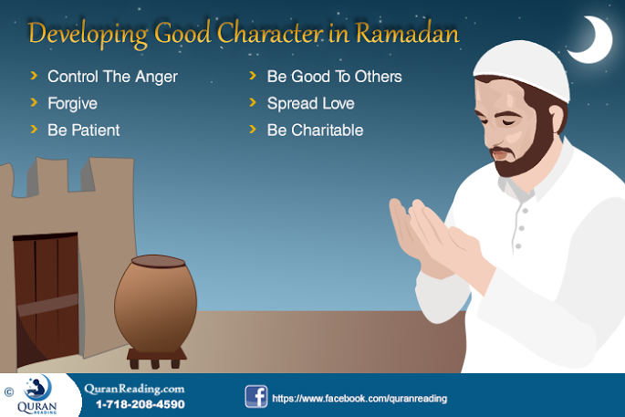
The character of a person is directly proportional to his or her spiritual standing and transcendence. Therefore, if a person is good in character, it automatically is a reflection of his or her soul. Therefore, improving character during Ramadan is one of the best ways of spiritual elevation and purity. The lines below discuss the major measures that a Muslim can take during Ramadan to improve one’s character.
Forgive:
In the month of Ramadan, Allah Almighty opens the doors of forgiveness for all those who fast, therefore, if Allah Almighty starts forgiving people then it is imperative that a Muslim also forgives people of relation. Fasting during the day and prayers during the night are done with the objective of purifying the heart and soul, therefore, the question is to be asked that how can the heart of a person be pure if he or she holds grudge or malice against some other person in the heart. Therefore, the purification of soul can only be made when a person purifies and clears his or her heart from all the grudge and malice by forgiving people. When one forgives the other, only then the heart gets lightened and purified, and one finds peace and tranquility in the prayers and fasting.
Control The Anger and Avoid Common Mistakes
The first thing that a Muslim has to do pertaining to improving the character is controlling the anger. It is one of the worst human qualities that spoil all the good that a person does and demolishes the deeds. Moreover, fasting in Ramadan teaches tolerance and humility, therefore, there is no point in being angry during the Ramadan. Rather, a Muslim must try controlling the anger and whenever the rush of anger hits a Muslim, he or she must remember that it is the Holy month of Ramadan and in this month he or she has to be good and being angry and its outcomes are never good. In addition, you must avoid common mistakes that include: frequently getting angry, sleeping all the day, and not taking care of the speech. To read about these in detail, check common mistakes to avoid in Ramadan.
Be Patient:
When a person is in state of fasting, he or she does not eat or drink no matter how many times he or she is offered food or even when there is no one looking. It means that a person is actually practicing self-constraint the closest form of which is patience. Therefore, fasting teaches being patient and forbearing things no matter how strong a person craves them or how provoking they might seem to a person. Hence, during Ramadan, a Muslim need to incorporate and increase the quality of patience in his or her personality. With this patience a person is better able to deal with other human relations and the judgment of a person gets better during hard times.
Be Good To Others:
Although being patient, forgiving and controlling one’s anger are all qualities that can be classified as the ones that are related to being good to others. However, in addition to the specific qualities that one needs to develop during Ramadan to be good to others, a Muslim ought to be good to others in general as well. In this regard, a Muslim must commit towards good and helpful deeds, for instance, helping someone in need, carrying the burden of someone, giving someone a lift, assisting them in doing some chore and all such matters in which a person can be assistance to others can be classified as being good to others. Therefore, a Muslim must try being of as much assistance as possible to others so that the life of others becomes easy. As a result of all this, the good person will get blessings and prayers of others in addition to internally feeling satisfied and peaceful.
Be Charitable:
Another attribute that can help make the character of a person strong and better is being charitable. Ramadan is the month of blessings and mercy; it is in this month that by fasting a person experiences the suffering of the people who don’t have access to the necessities of life such as food three times a day and clean water for drinking. Therefore, when a person goes through such an experience it surely is to serve as a metamorphosis where a person should then work towards making the life of others in general and the less fortunate ones easy. In this regard, a Muslim should try being as much charitable as possible during the month of Ramadan. This charity can then help provide provision for those who find it hard to earn their bread and butter for the month of Ramadan to keep fast. Therefore, try being as much charitable as possible. Read What is Zakat and How to Pay It to know the Zakat deserving people in your society.
Follow What Prophet Muhammad (S.A.W) Used to do In Ramadan
One of the best way of developing a good character in the month of Ramadan can be try to follow the way Holy Prophet Muhammad (P.B.U.B) used to spend His Ramadan while fasting. Since Prophet’s deeds are the primary example of becoming the perfect in the society, following them would surely result in developing a good character of you. Following are the common deeds Muhammad (S.A.W) used to do in the month of Ramadan:
- Studying Quran
- Taraweeh
- Nawafil
- Night of Decree
- Itekaaf
- Charity
You can also try doing these deeds in this special month which would ultimately help you in achieving a happy soul. To read in detail, Check Special Deeds of Our Beloved Prophet Muhammad (S.A.W) in the Month of Ramadan.
Spread Love:
Above all the greatest character attribute that a Muslim must incorporate in his or her personality during the Holy month of Ramadan is the spreading of love. During Ramadan one needs to be loving and caring towards others as well as the people who are close to you. Help them, care for them, assist them, be charitable to them, listen to them, involve them, feed them, provide clothes to them, and give the message of peace and joy to all. The spreading of love and peace is the greatest of character attributes that a Muslim can incorporate and disseminate in Ramadan as it provides ample chance of being caring and loving.
Conclusion:
In a nutshell, in addition to praying and fasting during the month of Ramadan, the month also serves as a training platform in which a Muslim can improve his or her character and rise to a higher pedestal of spirituality as well as greatness of character.
- See more at: http://www.quranreading.com/blog/how-to-develop-good-character-during-ramadan/#sthash.UWyvQhXI.dpuf
***

