Tips For Optimal Utilization Of Moments Of Ramadan How To Strategize Ramadan Schedule and prepare Ramadan Kareem 2017
- See more at: http://www.quranreading.com/blog/ramadan-2015/#sthash.rNTZgESj.dpuf
http://www.quranreading.com/blog/ramadan-2015/

Get Prepared To Gather Blessings In Ramadan
Posted in Ramadan By admin On June 23, 2014
The thing with humans is that we like to plan each and every thing that we expect from the future. We like to plan how we are going to be when we grow up, the kind of career we should chose, the kind of education we should have to follow the career path, the kind of friends that can help in our goal and so on. Therefore, when it comes to anything of future with which the element of willingness is associated, the ultimate result is planning and devising up of strategies to make the objectives easier to attain.
For Muslims the Holy Month of Ramadan is right around the corner. Although Muslims respect and revere this Holy Month from the bottom of their hearts, however, when the month starts Muslims find it hard to adjust with its routine of fasting and excessive prayer and Quran reading. The probable reason behind which is the fact that rest of the year Muslims follow a different routine, and when suddenly a month full of blessings and rewards is upon, they find it hard to change their routine and adapt once at all. Thus, due to the disturbance caused by adaptation the initial days of the month are not spent the way every Muslim wants them to, therefore, there is a grave need for getting ready for the month of Ramadan beforehand.
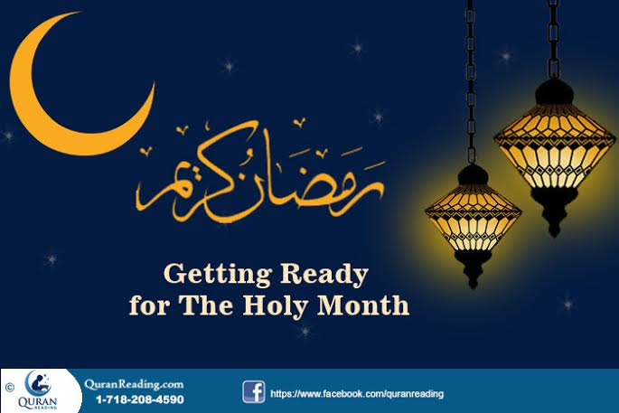
The lines below give some tips that can help in preparing for the month of Ramadan beforehand, so that maximum blessings could be extracted from each and every day of the month.
Countdown:
Keeping a countdown for the month of Ramadan is one of the best strategies that can help in getting ready for the month of Ramadan. When you keep record of the days left in the start of Ramadan, it actually creates hype in your mind regarding the month. The more the month gets near, the more the mind starts preparing for it, therefore, when the month is finally upon you, it is not a surprise, rather you are mentally fully prepared to welcome the month with full zest and vigor. Therefore, start keeping a countdown of Ramadan a month before.
Get Hold Of Information:
Another factor that can help in making yourself mentally and spiritually ready to welcome the month of Ramadan is getting as much information and knowledge about the month. When you start getting knowledge about the month, the nights it has, the blessings of fasting, the happiness in breaking fast, the joy of prayers, the exponential increase in reward, all these help build the momentum and make you eagerly await the arrival of Ramadan. Therefore, in addition to counting down the days for Ramadan, you must also get as much information about the month as possible as it will expose the true blessings of the month to you, which will keep you motivated and make preparation for it easier for you.
Plan for It:
There is no denying the fact that planning is an integral part of getting ready for something. The other thing about planning is that it is done beforehand, therefore, if you wish to get ready for Ramadan and observe it in a blissful and easy way, then you need to plan each and every thing pertinent to the month. You need to plan the kind of foods you are going to eat for the two major meals, the people you are going to invite to have Iftaar with you, the time when you will go for Taraweeh prayer, the time when you will read and recite Quran. Therefore, when you have all these things planned, the ultimate result is a smooth transition into Ramadan, and from the start of the month you celebrate every single day with full spirit and zest.
Consider Other Events:
Pertinent to planning for the month of Ramadan, another thing that you need to keep in mind is the other events that may take place during or after Ramadan, which can affect the way, you go through the month. You can have exams or marriage of someone for which you have to prepare during Ramadan, all such events are what you need to consider when preparing for Ramadan. Try to allocate time to the other events and adjust them within your fast and worshiping routine so that you don’t have to sacrifice any of them or make things tough for yourself.
Cut Down On ‘Bads’:
Everyone knows that Ramadan is a month in which Muslims exhibit and observe self restraint and try avoiding and refraining from all that is bad whether from the spiritual or physical perspective. Therefore, when it comes to getting ready for Ramadan, you need to start cutting on the ‘bads’ before the month even starts which ultimately leads you to developing good character in this holy month. In this regard, start avoiding bad company, try controlling whatever ill thoughts come to you, if you are addicted to something edible try cutting down its intake and so on. Thus, when you cut down the ‘bads’ before the month even starts, then the only thing that you will be left to do during the month is goodness and virtuous deeds and thoughts, which perhaps is more closer to the spirit of Ramadan.
Recommended Reading – Do’s and Don’ts for Fasting in Ramadan
Remember The Hours Of Worship:
When you are getting ready for Ramadan, the one thing that is more than mandatory for observing the month in its true spirit is worship. In Ramadan, there is additional Quran recitation and the Traveeh after the prayer of Isha. Therefore, the hours and the time spent on worshiping Allah Almighty definitely increases in the month of Ramadan. Hence, when planning for the month, you need to identify the hours of worship and then change your daily life schedule in such a way that the hours of worship easily fit within your routine.
Conclusion:
In a nutshell, Ramadan is one month in the whole year, therefore to make the best out of it and observe and enjoy it in the true spirit it is imperative that a person starts preparation before the month starts. In this regard, the aforementioned tips can help in better and effective transition from normal routine to a worship based Ramadan routine.
- See more at: http://www.quranreading.com/blog/get-prepared-to-gather-blessings-in-ramadan/#sthash.omfn5fhL.dpuf
***

Ramadan Preparation and Reflections Before Its Arrival
Posted in Ramadan By admin On June 11, 2014
Ramadan is one of the eagerly awaited months of Islamic calendar. The month is full of blessings and mercy that showers upon Muslims from Allah Almighty. Therefore, in order to increase their fair share in the feast of blessings and mercy, Muslims try preparing for the month before hand, so that the transition remains easy for them and they make the most out of the whole month.
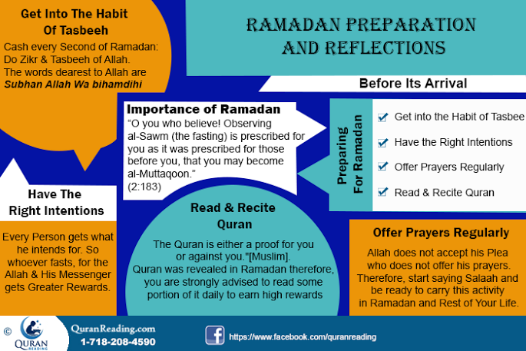
Pertaining to the arrival of the month, it is imperative that a Muslim prepares for it before hand and be reflective of all that the month carries and how one can extract the maximum blessings and mercy from it. The lines below discuss the importance of the month of Ramadan, the way a Muslim must reflect upon it and how one should prepare for it before it actually arrives.
Importance of Ramadan:
There are numerous hadith of Prophet Muhammad (PBUH) and ayahs of Quran that emphasize on the importance of Ramadan in Islam. For the sake of general understanding, the ayah of Quran that stresses on the importance of Ramadan is mentioned below:
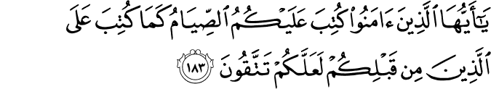
“O you who believe! Observing al-sawm (the fasting) is prescribed for you as it was prescribed for those before you, that you may become al-muttaqoon (the pious).” (2:183)
From this ayah of Quran, it becomes clear that fasting is nothing new or special that was bestowed upon Muslims, rather the earlier nations of the earlier Prophets also kept fast. Moreover, in this ayah Allah Almighty also mentions the objective of fasting in Ramadan, and which is to make one’s self pious. Therefore, for Muslims fasting is of grave importance as it helps them purify their souls and transcend to a higher level of piety.
Reflecting Upon Ramadan:
When a Muslim hears about the arrival of Ramadan, the first thing he or she needs to do is to reflect upon the purpose of Ramadan. Allah Almighty does not need the fasting, the thirst and hunger of a Muslim, rather it is all for the personal good of a Muslim and the well-being of a society.
Although in the aforementioned ayah of Quran, Allah Almighty has mentioned the purpose of fasting, and that is to make a person more pious. However, if one reflects upon the reasons behind fasting, there may come numerous other objectives as well.
- Firstly, in Ramadan, all the Muslims pray extensively and cordially, therefore, it is quite natural that this month presents a chance for increasing the reward balance and seek forgiveness for the sins that a person has committed.
- Secondly, the hunger and thirst in the month of Ramadan help a Muslim relate with the other people in the world who are unfortunate and don’t have access to ample food and drinking water. When a Muslim keeps a fast, actually he or she empathizes with such people and feels the way they feel and the way go through the day with such limited provision.
- Thirdly, when a Muslim goes through the day with limited energy, although it effects at a physical level, however, the real effect of it is seen on the attitude of a person making him or her more humble and patient. Therefore, during a fast, a Muslim is supposed to be at the best of his or her character in terms of patience and humility.
In addition, we advise you to read do’s and don’ts of fasting in Ramadan as well to avoid bad things and follow good habits.
Preparing For Ramadan:
Muslims anxiously await the arrival of Ramadan so that they can get on with the process of praying and gaining blessings, mercy and forgiveness from Allah Almighty. The arrival of Ramadan brings a complete or at least a major change in the routine of a person, therefore, those who don’t prepare beforehand, find it difficult to settle in and get used to with the Ramadan routine once its upon them. Therefore, the objective of preparations is to make a person transit into the routine of Ramadan and waste not any of its precious moments. The lines below give the major tips that can help in preparing yourself better for the Holy Month.
Have The Right Intentions:
The first thing that a Muslim needs to do pertaining to preparation for Ramadan is having the right intentions. You must really intend to make the most out of this month only then will you be able to enjoy Ramadan and gain the blessings it offers. On the other hand, if you just want to go through the month, then nothing will come to avail and despite whatever situations of ease you create for yourself, Ramadan will be futile and hard for you. Therefore, try having right intentions pertaining to preparing for the month.
Get Into The Habit Of Tasbeeh:
Tasbeeh is a verbal praise of Allah Almighty which a Muslim does by either reading phrases or words of praise of Allah Almighty. In Ramadan, each and every moment gets sanctified, therefore, to get the maximum reward from the days of Ramadan besides prayer, a Muslim must do Tasbeeh as well. When you start performing Tasbeeh a month before the arrival of the Holy month, then by the time the month comes, you are already in the habit of recitation of Tasbeeh, while sitting, walking, or doing any work.
Make Your Prayers Regular:
In Ramadan, the number of people in congregational prayer gradually increases. However, there are people who initially find it hard to make time to go to a mosque and offer prayer in congregation in the beginning days of Ramadan. Therefore, in order to make sure that you offer prayers with congregation at the first day of Ramadan, start making time for congregational prayer a month before the arrival of the Holy month. For those who do not know how to accurately perform the Salaat, Step by Step Salaat is a perfect guide in form of mobile app to learn namaz on your own. In addition, to learn in depth, you must know the key elements to consider while offering Namaz.
Try Keeping Few Nafli Fasts:
The initial few fasts of Ramadan are quite hard on Muslims, as they suddenly get exposed to hunger and thirst and don’t know how it is to spend a day on low energy. They don’t know the foods that make them feel satiated for longer, they don’t know the drinks that keep the thirst in control and they don’t know how they should adjust their routine during fast. For this very reason, it is imperative that a Muslim keeps a few Nafli fasts before the Ramadan in order to know about the changes that are to come during the fast, so that when Ramadan comes, he or she is prepared for it.
Quran Reading:
Quran recitation brings blessings and reward from Allah Almighty, however, in order to read Quran, it is imperative that a Muslim has sufficient time. Therefore, in order to make the most out of Quran reading in Ramadan, it is imperative that a Muslim starts reading Quran before Ramadan so that he or she knows that how much they can read in a particular time and when do they have time for it. This way, when Ramadan comes, they already know when to read and how much to read. And for those Muslims, who are naive to reading Quran in Arabic, it is the perfect time to start learning to read Quran as the reward of learning In Ramadan is 70 times higher than learning in any other month. So, to help you cash this much reward, Online QuranReading.com Academy is here to help you. Register yourself now and start learning to read the Holy Quran.
Conclusion:
In a nutshell, it is imperative for a Muslim to contemplate over the purpose of Ramadan, so that he or she is able to experience and incorporate that purpose into his or her personality. Moreover, the preparation of the Holy month before its start also helps in enjoying the month in a better way and experience the true essence of it with minimal hassle.
- See more at: http://www.quranreading.com/blog/ramadan-preparation-and-reflections-before-its-arrival-3/#sthash.b2UtqDGP.dpuf
***
- 10 Ways to Prepare for Ramadan
The blessed & most beautiful month is near and what better time to prepare for it than right now. Some of us deceive ourselves into thinking that when Ramadan comes we will suddenly change and worship Allah night and day but we are only decieving ourselves in thinking like this.
The Sahaaba used to prepare for Ramadan six months in advance. So if we really want to make the best of this Ramadan then we need to prepare for it now!
This may be our last Ramadan for life is so uncertain. Then there is NO doubt that we must make the best of it for the Reward of EVERY good act in the month of Ramadan is multiplied many times over:
The Prophet (Sallallahu Alaihi Wasallam) said: “Whoever draws near to Allah during it (Ramadan) with a single characteristic from the characteristics of (voluntary) goodness, he is like whoever performs an obligatory act in other times. And whoever performs an obligatory act during it, he is like whoever performed seventy obligatory acts in other times.” (Sahih Ibn Khuzaymah, no. 1887)
If there was a 75% sale on in the shops surely people would go crazy and even cue all night outside in order to be the first in the store to take advantage of this special offer. So in the same way why should we not take advantage of the immense rewards that are available in Ramadan?
The best way we can make the best of this Ramadan and grab the immense rewards that are available is to prepare for it NOW.
The following are 10 ways in which we can prepare for this beautiful month starting from NOW:
1. Voluntary Fasts
What better way of preparing ourselves to fast for 30 consecutive days in Ramadan than to fast the voluntary fasts.
Fasting Monday and Thursday:
Abu Hurairah reported that the most the Prophet, (Sallallahu Alaihi Wasalam) would fast would be Monday and Thursday. He was asked about that and he said: “The deeds of people are presented to Allah on every Monday and Thursday. Allah forgives every Muslim except for those who are deserting each other." He says: "leave them for later”. (Ahmad; Hasan)
Another is to fast the white days (13, 14 &amp; 15th of each Islamic month):
Abu Tharr Al-Ghefari said: “The Messenger of Allah (Sallallahu Alaihi Wasallam) said "O Abu Tharr! If you fast three days of every month, then fast the 13th, the 14th and the 15th [these are call the al-ayaam al-beedh, the white days]". (Ahmad, an-Nasaa'i & at-Tirmithi; Sahih)
Therefore we should fast these days in order to prepare for the fasting of Ramadan and even after Ramadan we should continue to do so for fasting will intercede for us on the day of judgement:
Rasulallah (Salallahu Alaihi Wasallam) said: "Fasting and the Qur’an will intercede for the slave on the Day of Resurrection.Fasting will say: “O My Rabb! I prevented him from food and desires, so accept my intercession for him.’ And the Qur’an will say: “I prevented him from sleep during the night, so accept my intercession for him.’ He (Sallallahu `Alaihi Wasallam) said: ‘And they will (be allowed to) intercede.’” (Ahmad, at-Tabarani, Al-Hakim, Sahih)
2. Reciting Qur’an
Allah the exalted says:
“The month of Ramadan is the one in which the Quran was sent down, a guidance for mankind, clear proofs for the guidance, the Criterion; so whoever amongst you witnesses this month, let him fast it." (Surah al-Baqarah 2:185)
Ramadan was the month in which the Qur'an was first revealed so it is the month of the Qur'an. We should devote much of this blessed month reciting the Qur'an.
Az-Zuhri used to say upon the coming of Ramadan, “It is only about reciting the Qur’an and feeding the poor.”
Abdur-Raziq said, “When Ramadan came, Sufyan Ath-Thawri would give up all acts of (voluntary) worship and devote himself to the recitation of the Qur’an.”
But for many of us the Qur'an has gathered a lot of dust since the last time we picked it up.
As Ramadan is fast approaching we must blow off the dust and start to build a close relationship with the Qur'an for it will intercede with us on the day of judgement:
"Recite the Holy Qur’an as much as we can for It will come as an intercessor for its reciter’ on the Day of Judgement" (Muslim)
The Recitor will be in the company of Angels:
‘Aa'ishah related that the Prophet (Sallallahu Alaihi Wasallam) said: “Indeed the one who recites the Quran beautifully, smoothly, and precisely, will be in the company of the noble and obedient angels. As for the one who recites with difficulty, stammering or stumbling through its verses, then he will have twice that reward.” (Al-Bukhaari & Muslim)
There are Ten Rewards for Every Letter Recited from the Quran in normal times but in Ramadan these rewards are multiplied:
“Whoever reads a letter from the Book of Allaah, he will have a reward, and this reward will be multiplied by ten. I am not saying that 'Alif, Laam, Meem' (a combination of letters frequently mentioned in the Holy Quran) is a letter, rather I am saying that 'Alif' is a letter, 'Laam' is a letter and 'Meem' is a letter.” (At-Tirmithi)
So what better time for us to get into the habit of reciting the Qur'an than to begin to do so right now. We should recite the Qur'an with its meanings and try to understand and implement it into our daily lives.
We should set ourselves realistic targets for how much we should begin to recite each day for e.g. we will recite 1 or 2 pages a day, half a juz (chapter), or 1 juz etc. We should recite however much we can manage and then build up gradually.
3. Praying Superogatory (Nafil) prayers
In Ramadan every voluntary prayer carries the reward of a Fard prayer in normal times and there is nothing more rewarding than a Fard prayer so one can imagine the immense rewards that are available in Ramadan for every voluntary prayer we pray.
The Prophet (Sallallahu Alaihi Wasallam) said: “Whoever draws near to Allah during it (Ramadan) with a single characteristic from the characteristics of (voluntary) goodness, he is like whoever performs an obligatory act in other times. And whoever performs an obligatory act during it, he is like whoever performed seventy obligatory acts in other times.” (Sahih Ibn Khuzaymah, no. 1887)
In order for us to take advantage of these immense rewards we should start begin now by praying all of the daily Sunnah and Nafil prayers so by the time Ramadan comes we will already be in the habit of praying all of our Sunnah and Nafils and so we cna increase our voluntary prayers even more so during Ramadan. This would be difficult if we were not in the habit of praying Sunnah and Nafil prayers in normal times.
By increasing our voluntary worship we can gain closeness to Allah as well as the company of Rasulallah (Sallallahu Alaihi Wasallam) in Jannah:
Rabi'ah ibn Malik al-Aslami reported that the Prophet (Sallallahu Alaihi Wasallam) said: "Ask (anything)." Rabi'ah said: "I ask of you to be your companion in paradise." The Prophet (Sallallahu ALaihi Wasallam) said: "Or anything else?" Rabi'ah said:"That is it." The Prophet (Sallallahu Alaihi Wasallam) said to him: "Then help me by making many prostrations (i.e., supererogatory prayers)."
4. Making Dua
Many of us do not spend as much time as we should do in Dua. Even if we do we rush our dua and our hearts and minds are not present whilst supplicating to Allah.
Many of us rush our Dua's and our hearts are often not present whilst we are supplicating to Allah. Therefore we lose out on much of the benefits and blessings of Dua. We must give more attention to our Dua's and try to concentrate more and be more sincere in our Dua's imagining Allah watching us supplicate to him. We should humble ourselves making ourselves low and not worthy in front of Allah. We should try to cry if we can and have FULL hope that Allah will accept our Dua's if not in this world then in the hereafter.
Allah Almighty says in the Qur’an: "When my servants ask you concerning me, (tell them) I am indeed close (to them). I listen to the prayer of every suppliant when he calls on me."
The place of Dua is so honourable to Allah that the Prophet (Sallallahu AlaIhi Wasallim) said:
"Nothing is more honourable to Allah the Most High than Du`a." (Sahih al-Jami` no.5268).
It is the most excellent of worship:
He also said: "The most excellent worship is Du’a." (Sahih Al-Jami` no. 1133)
So let us get into the habit of making sincere Dua's from deep within our hearts and let us not be heedless when supplicating to Allah. What better time than now for us to get into the habit of making more intense and sincere Dua's. So by the time Ramadan arrives we would have already got into the habit of making the long, sincere and intense Dua's which will readily be accepted during this blessed month especially whilst we are fasting and in the latter part of the nights during Tahajjud.
It may help to make a list of what we should ask of Allah suring dua's which we can refer to as a reminder as this may help us to make our dua's longer and more sincere covering everything we want to ask of Allah.
5. Sincere Repentance
Ramadan is the month where we can gain mercy and forgiveness from Allah for all of our sins past and present.
We should know that Allah is most merciful and most forgiving and loves to forgive:
Allah says: O son of Adam, if your sins were to reach the clouds of the sky and you would then seek My forgiveness, I would forgive you.
When a person sins and then sincerely turns to Allah for forgiveness, one will find Allah ready to accept his repentance and to forgive him, as this verse indicates: And whoever does a wrong or wrongs himself, but then seeks forgiveness from Allah, he will find Allah forgiving and merciful. (Surat an-Nisaa 4:110)
Allah loves repentance and loves those who turn to him in repentance:
Truly Allah loves those who turn [to Him] in repentance, and He loves those who keep themselves in purity. (Qur'an 2:222)
Therefore we should get into the habit now of repenting to Allah so that in Ramadan we will make the best of repenting to Allah and continue to do so throughout everyday of our lives.
How unfortunate is a person who after the end of Ramadan does not gain any forgiveness of his sins from Allah but ends up piling more sins onto his account.
6. Generosity & Charity
Rasulallah (Sallallahu Alaihi Wasallam) became even more generous in Ramadan than he already was.
Ramadan is a time for generosity and giving. It is a time when we think about those who have less than us as well as thank Allah for everything he has given us. Ramadan is an honourable and blessed month, and the rewards for generosity are multiplied in it.
The Prophet (Sallallahu Alaihi Wassallam) said, “The best charity is that given in Ramadan.” (At-Tirmithi).
Prophet (Sallallahu Alaihi Wassallam) said, “He who feeds a fasting person will gain the same reward as he will, without decreasing from the fasting person’s rewards.” (Ahmad).
Therefore we should get into the habit of giving in charity now so by the time Ramadan arrives we would increase in our generosity, giving to those less fortunate than ourselves. We should give whatever we can afford as Allah looks at our intentions.
Surely in there hereafter we will regret that which we did not spend in the path of Allah.
7. Controlling the tongue
Ramadan is a time where we must control our desires (nafs) aswell as our tongues:
Rasulallah (Sallallahu Alaihi Wasallam) said: “Fasting is not (abstaining) from eating and drinking only, but also from vain speech and foul language. If one of you is being cursed or annoyed, he should say: ‘I am fasting, I am fasting.” (Ibn Khuzaimah, Ibn Hibban)
Therefore we must protect our tongue from vain speech and foul language. Protecting the tongue is preventing it from lying, back-biting, slander, tale-carrying, false speech and other things that have been forbidden in the Qur'an & Sunnah.
Those who control their tongues are of the best of Muslims:
The Prophet (Sallallahu Alaihi Wasallam) was asked: “Which Muslim is best?” He responded, “One who the other Muslims are safe from his tongue and his hand.” (Tirmidhi, #2504)
We must not deceive ourselves into thinking that by the time Ramadan comes we will all of a sudden break a lifetime habit and control our tongues. Again this is another big deception. We must start controlling our tongues now for we cannot for changing lifetime bad habits is not an overnight process.
So how can we begin to control our tongues? This can be done by "THINKING BEFORE SAYING ANYTHING". Not just talking without even thinking what we are going to say.
We must think before we speak and before saying anything we should think whether or not what we are going to say is going to please or displease Allah.
If we doubt that what we are about to say may anger or displease Allah then we should refrain from saying it. If we have nothing good to say then surely it is better NOT to say anything at all. Remember we WILL be accountable for everything we said in our lives so we MUST start taking responsiblity for what comes out of our mouths NOW otherwise we will regret it later when it is too late. Therefore we must get into the habit of "thinking before speaking".
So let us begin to control our tongues now so that by the time Ramadan comes we would have adopted good habits and would have been used to controlling our tongues and refraining from saying anything which may anger or displease Allah.
REMEMBER: If we do not protect our tongues then our fasts will be in vain:
Rasulallah (Sallallahu Alaihi Wasallam) said: “Allah does not need the fast of one who does not abandon false speech or acting according to his false speech.” (Sahih Bukhari)
8. Improving Character & manners
Rasulallah (Sallallahu Alaihi Wasallam) came to perfect the character of man and the best of this Ummah are those wioth the best of characters:
Rasulallah (Sallallahu Alahi Wasallam) used to say: "The best amongst you are those who have the best manners and character.” (al-Bukhari)
Rasulullah (Sallallahu Alaihi Wasallam) said: "There is none heavier in the scales of the Hereafter than good character (Tirmidhi & Abu Dawud).
Rasulallah (Sallallahu Alaihi Wasallam) also said: “The best loved by me and the nearest to me on the seats on the Day of Resurrection are those who have the best manners and conduct amongst you, who are intimate, are on good terms with others and are humble, and the most hated by me and who will be on the furthest seats from me are those who are talkative and arrogant."(Tirmidhi)
Again as with making any big change perfecting our character and manners cannot be done overnight but we must make a start now so that by the time Ramadan comes we would have gained momentum in making the necessery changes to our characters in order for us to be the best of this Ummah and those closest to Allah.
Surely if good character and manners are the heaviest on the scales then can you imagine how much more heavier they will be if we behave with good character and manners during Ramadan?
So let us strive to perfect our manners, character and conduct towards others and know that these good deeds will be of the heaviest on the scales and will enable us to reach the highest ranks of Jannah and the closest to Allah.
9. Moderation in eating
On the authority of Al-Miqdaam ibn Maadiy-Karib who said: I heard the Messenger of Allah saying: "No human ever filled a vessel worse than the stomach. Sufficient for any son of Adam are some morsels to keep his back straight. But if it must be, then one third for his food, one third for his drink and one third for his breath." (Ahmad, At-Tirmidhi, An-Nasaa’I, Ibn Majah )
Ibrahim al-Nakha’i, on of the teachers of Imam Abu Hanifa, may Allah have mercy on them both, mentioned: “The people ruined before you were done in by three characteristics: too much talking, too much eating, and too much sleeping.”
There is no doubt that excessive eating is not only a cause of many diseases but is also a major factor in stopping us from maximising our worship to Allah.
Ash-Shafi’I said: I have not filled myself in sixteen years because filling oneself makes the body heavy, removes clear understanding, induces sleep and makes one weak for worship.
Many of us fast during Ramadan fast during the day and after Iftaar make up for all the food we missed throughout the day by binge eating.
Surely this goes against the very purpose of Ramadan which is to be moderate in eating and to remember those who have less than us. How will we remember the unfortunate when we constantly over eating before and after our fasts?
By controlling what we eat now we will not only benefit our health in the short and long term but moderate eating will make us less heavier and enable us to maximise the amount of worship we do everyday during Ramadan and the rest of our lives.
Al-Hassan Al-Basri: “The test of Adam (AS) was food and it is your test until Qiyamah.
And, it used to be said: Whoever takes control of his stomach gets control of all good deeds.
And: Wisdom does not reside in a full stomach.
One day, Al-Hassan offered some food to his companion who said: I have eaten until I am no longer able to eat. To which Al-Hassan said: Subhaana Allah! Does a Muslim eat until he is no longer able to eat?
10. Implementing Sunnah's into Daily life
Following the Sunnah is a command from Allah:
"Say (O Muhammad to mankind): "If you (really) love Allah, then follow me (i.e. accept Islamic monotheism, follow the Quran and the Sunnah), Allah will love you and forgive you your sins. And Allah is Oft-Forgiving, Most Merciful." (Quran: 3:31)
Surely if we follow the Prophet (Sallallahu Alaihi Wasallam) in every aspect of our lives then everything that we do will become a worship to Allah, even going to the toilet, having a bath, dressing and undressing etc
Reviving the Sunnah into our daily lives:
Prophet (Sallallahu Alaihi Wasallam) said: “Whoever revives an aspect of my Sunnah that is forgotten after my death, he will have a reward equivalent to that of the people who follow him, without it detracting in the least from their reward.” (Tirmidhi)
The best habit we can ever have in our lives is to implement the Sunnah into EVERY aspect of our lives so that our whole life and everything we do during it can become a worship to Allah.
We can do this by gradually learning all of the Sunnah's and dua's of every aspect of our day waking up, leaving and entering the Masjid and house, dressing and undressing etc. So let us get into the habit right now of implementing every Sunnah's into our daily lives so by the time Ramadan comes we can continue to implement Sunnah's and gain even more rewards for them.
Download Comprehensive Sunnah collection to implement everyday of our lives: http://www.scribd.com/doc/26863499/B...to-Do-Everyday
May Allah enable us to make the best of this Ramadan and make it a salvation for us in the Hereafter. Ameen

Ramadan Kareem – Life Transforming Time Of The Year
Posted in Ramadan By admin On May 18, 2015
Ramadan is the most sacred month in the Islamic Calendar in which Muslims all over the globe keep away from eating, drinking and fulfilling other physiological needs from dawn to dusk just for the sake of Pleasure of Allah SWT. It is deduced from the Arabic word, “Ramada” which means “extreme heat”. As it is commonly known that intense high temperature can twist and curve even the strongest metals, same is the case with this Holy Month which is a great source of shaping the lives of believers for their own betterment. The Almighty Lord says in the Holy Quran:
“O you who have believed, decreed upon you is fasting as it was decreed upon those before you that you may become righteous.” [Quran, 2: 183]
The above mentioned Ayah Kareema clearly suggests that Ramadan is not any normal time of the year rather it is an absolute blessing from the Gracious God which makes Muslims more productive through “Taqwa”. It comes from the Arabic root word “Waqa” meaning “to guard or protect”, which implies that Taqwa is the name of Consciousness of the Exalted One through actions. More specifically, it tells us to do what pleases Him and avoid anything that displeases the Most Merciful. The modern science also advocates that a normal individual needs about 4 weeks time in order to change its habits. Similarly, Ramadan serves as fixing up the bad patterns of a Muslim through a highly disciplined schedule of fasting, performing Salah, Quran Reading, and giving charity and so on.
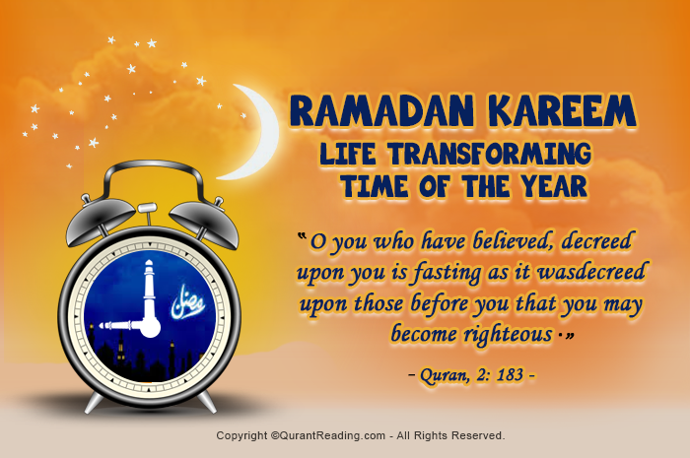
Now let us take some considerations to keep in mind in this consecrated period to benefit from it to the fullest.
Inconceivable Amount Of Reward For Fasting
The biggest incentive for anyone in Ramadan could be that the return as a result of restraint from all kinds of daily necessities for the Creator of the universe is unimaginable. No one has the idea about how great in number and magnitude the reward could be because this deed is solely for Allah SWT and He is the One Who knows about its worth. Narrated by Abu Hurraira that the Messenger ﷺ of God said:
“By the One in Whose hand my-self is, the smell of the breath of a man fasting is better with Allah than the scent of musk.’ He leaves his desires and his food and drink for My sake. Fasting is for Me and I reward it. Every good action is rewarded by ten times its kind, up to seven hundred times, except fasting, which is for Me, and I reward it.’ “(Muwatta Malik)
It means that the Almighty Lord loves His servant who is a state of fasting many more times than the one who is not performing it. This Hadith also shows that “Soum” is the action that is only done for the sake of attaining pleasure of the Most Beneficent by refraining from good and water throughout the day. Although it seems like a very extreme kind of activity but it is also a great test of one`s faith which is to be fulfilled through deed of fasting. In Ramadan, each good action is rewarded from ten to seven hundred times in return and that is concerning normal acts. On the other hand, fasting is rewarded to a degree that no one can even dream about. Thus, fasting in Ramadan is an immense means of encouragement and motivation in terms of its greatest number of rewards.
Drawing Closer to Allah SWT Through Night Prayers
As compensation for normal deeds increase manifold in Ramadan, there is also a very important task to accomplish during this holy month, i.e. Night Prayers. Compulsory Salah itself is a great source of attaining closeness to Allah SWT, which results in His Mercy and Forgiveness. But praying in the dark hours (Nawafil/non obligatory prayers) when most of the people are asleep, it shows one`s determination on its religious conviction. The Apostle ﷺ of God is reported by Abu Hurraira (R.A) to have said:
“Whoever prayed at night in it (the month of Ramadan) out of sincere Faith and hoping for a reward from Allah, then all his previous sins will be forgiven.” (Bukhari)
It shows that during Ramadan, Nafl Ibadah with honest conscious causes one`s pardoning of all of its past wrongdoings. This routine will also result in constant memory of the Almighty Lord even in other months and will serve as benchmark for bringing one near to Him.
Building A Habit Of Reading Quran
The Sacred Book of Quran Majeed is nothing but a great source of clarification and enlightenment in all walks of life. The demise of Muslims in this day and age is also due to negligence about teachings of Furqan e Hameed and living in darkness. Ramadan provides a great opportunity for all believers to learn the Holy Quran and know about their purpose of life. It is also the Sunnah of Rasulullah ﷺ to recite this Highly Revered Manuscript in Ramadan regularly.
“Jibreel used to come to the Prophet (PBUH) every night in Ramadan, and study the Quran with Him.” (Bukhari)
It means that Jibrael (A.S) used to visit the Holy Prophet ﷺ every day in this hallowed period of the year and study Quran Kareem with Him which he did not do in normal days frequently. Reading this Sanctified Scripture in Ramadan will not only fulfill the Prophetic ﷺ tradition but also help in developing a custom of understanding and learning the Holy Quran daily.
Caring For Others And Thankfulness to Allah
Ramadan is the time when Muslims come to realize about the good things like assets and money which Allah SWT has blessed them with. It is also the occasion when believers all over the world pay Zakah (Charity) to the poor families from their own wealth to a certain proportion.
Narrated by Anas (R.A):“The Prophet PBUH was asked which fast was most virtuous after Ramadan. He said: “Sha’ban in honor of Ramadan” He said: “Which charity is best?” He (PBUH) said: ‘Charity in Ramadan.’”
The previously stated account of conversation of the Holy Prophet ﷺ suggests that aiding deprived ones in Ramadan is indeed the best of the charities one can ever accomplish. This act not only teaches one to feel for others` needs but also be grateful to the Gracious God for everything.
Adopting A Well Balanced Diet and Routine
For all those who complain about their fitness problems, Ramadan is that time period which automatically gives those best results. Developing right kinds of eating habits at Suhoor and Iftaar make one able to know about its finest possible dietary plans. Thus, Ramadan is not only a name of fulfilling religious responsibilities alone, rather it provides a complete package in order to make one`s routine more fruitful and well disciplined. In short, the holy month of Ramadan comes up with many lessons that eventually transform the lives of Muslims in the best way.- See more at: http://www.quranreading.com/blog/ramadan-kareem-life-transforming-time-of-the-year/#sthash.FF6AnKwc.dpuf***

Simple Plan To Carry On The Spirit Of Ramadan Rest Of Year
Posted in Ramadan By admin On August 6, 2014
Ramadan – The Holiest of Islamic months just ended. In this month, Muslims made special arrangements to worship and praise Allah Almighty. Muslims all over the world kept fast, offered regular prayers, maintained Taraweeh and did as much charitable deeds as possible to ensure that they make full use of this month and gather blessings and mercy. However, like all good things the month also ended a week ago.
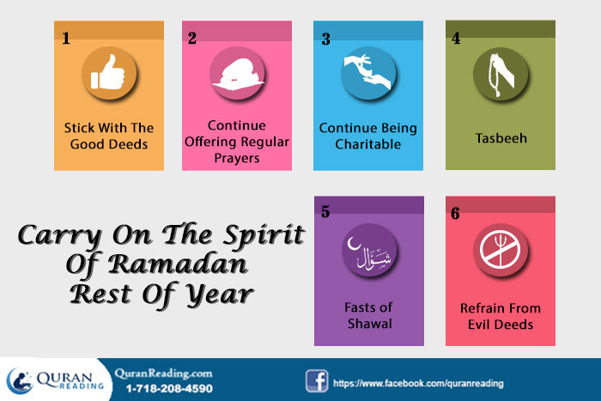
Ramadan comes with special religious zest and spirit. However, when the month ends most of the Muslims find that spirit diminishing and decreasing with the passage of time. Every Muslim tries to keep the same spirit going throughout the year, however, when the atmosphere around changes, most of the people find it hard to continue with the same passion and attitude. That being said, there are still others who manage to stay in the same spirit and continue on the path of righteousness with the same spirit. The lines below give some tips for those who wish to carry on the spirit of Ramadan throughout the rest of the year.
Stick With The Good Deeds:
Ramadan brings an overall in the routine of Muslims. They shift their attention and focus towards good deeds of all kinds and sorts. They start praying with regularity; learning the Quran, bringing kindness in their attitude, helping each other out, giving more in charity, standing in Taraweeh prayer and try praising Allah in the form of Tasbeeh as much as possible. However, when the month ends, the fasting obligation is relieved which creates a domino effect and Muslims under the impression that Ramadan has ended also end the Ramadan good deeds with it as well. Thus, the spirit of Ramadan ends with this attitude of theirs.
A Muslim must understand that all the good deeds that he or she undertakes in Ramadan are not reliant on the act of fasting, rather these good deeds are independent and can also be performed in isolation.
Continue Offering Regular Prayers – The prayers that a Muslim performs during Ramadan are obligatory for the rest of the year as well. Therefore, there should be no excuse for missing prayers which were regularly performed during Ramadan. Hence, a Muslim must make sure that the habit of offering regular prayers with congregation is continued after Ramadan as well.
Continue Being Charitable – Although the reward of being charitable is far more in Ramadan, however, there is no reason that a Muslim cannot be charitable after Ramadan. The poor are there after Ramadan, the sufferings of people require relief even after Ramadan there are still people that require help and rescuing after Ramadan, therefore, charity cannot be limited to the month of Ramadan only. Rather the happiness a Muslim experiences by being charitable in Ramadan can be used as a foundation upon which a Muslim can construct the building of charity for the rest of year. Once a Muslim experiences the joy of giving he or she tends to continue with it and it should be continued after Ramadan to remain in the same spirit.
Tasbeeh – Due to the intensified and magnified religious atmosphere during Ramadan, Muslims start doing Tasbeeh, which refers to praising Allah Almighty. The Tasbeeh basically refers to praising Allah, thanking Him for all He has bestowed and seeking forgiveness for whatever sins one has committed. Therefore, there is no reason that Tasbeeh also remains specific to Ramadan and it cannot be continued forward. Ergo, a Muslim must try carrying on the habit of Tasbeeh to the days after Ramadan and make it a regular part of the daily routine.
Fasts of Shawal:
In addition to the obligatory fasts of the month of Ramadan, the six fasts in the month of Shawal are also of great importance and reward. Prophet Muhammad (PBUH) used to keep six fasts in the month of Shawal and He also encouraged the followers to do the same as well. Prophet Muhammad (PBUH) said in a hadith:
“Whoever fasts in the month of Ramadan and then follows it with six days fasting in Shawal has done as if he has fasted for life.” (Muslim)
From the hadith it is clear that the fasting of Ramadan when complemented with the fasting of Shawal helps a person achieve reward equal to fasting for whole life. Therefore, one can easily carry on the spirit of Ramadan in general and fasting in particular to the month of Shawal and fast for six days to earn greater reward.
Refrain From Evil Deeds:
Besides the fact that in Ramadan a person can easily observe an increase in the good deeds committed by Muslims, the other noticeable thing is the decrease in the number of bad or evil deeds during Ramadan. The intensity and passion with which Muslims commit good deeds, they refrain from the bad deeds with the same passion and spirit. Like all other things, refraining from evil is not specific to Ramadan, rather it is something which a Muslim has to observe and practice other than Ramadan as well. The avoiding of sin or evil during Ramadan lays a great foundation for forming a habit of avoiding evil deeds as during the month the fear of Allah develops in the heart of a Muslim. Hence, a Muslim can use this fear of Allah and keep on avoiding bad deeds after Ramadan as well. However, if still some bad deed gets committed by a person, then he or she can nullify it by doing a good deed. Prophet (PBUH) said in His hadith:
“Fear Allah wherever you are, follow up the evil deed with good one, it will remove it and relate with people with good conduct.” (Tirmidhee)
Therefore, the fear of Allah that strengthens during Ramadan should be used as a source for refraining from evil, and if something does happen from a person, it should be removed by doing a good deed.
Conclusion:
In a nutshell, there is no denying the prominence, significance and the impact Ramadan has on the lives of Muslims. However, a true Muslim must understand that being good and following the path of righteousness does not end with Ramadan, rather Ramadan helps revitalize a person and help him or her continue on the right path throughout the rest of the year.
- See more at: http://www.quranreading.com/blog/simple-plan-carry-on-spirit-of-ramadan-rest-of-year/#sthash.2ftqqKxb.dpuf

***

10 Hugely Rewarded Deeds to do in Ramadan 2017
Posted in Ramadan By admin On July 3, 2014
For a Muslim, the golden opportunity of earning countless blessings and rewards comes in the Holy month of Ramadan. It is the month in which Muslims indulge in prayers and good deeds with greater intensity and frequency compared to what they do in normal days. Thus, Muslims wish to make the most out of each and every moment of Ramadan.
In order to make the most out of Ramadan, Muslims try undertaking deeds that offer the most reward possible. Therefore, in addition to being virtuous, Muslims target special prayers and deeds during Ramadan to get the maximum reward possible.
This post, by The Quran Reading Academy for Online Quran Tutoring, highlights the 10 hugely rewarding deeds that a Muslim must try undertaking during the month of Ramadan.
Before moving on to the rewarding deeds, consider the following hadith of Prophet (PBUH):
“Whoever draws near to Allah during it (Ramadan) with a single characteristic from the characteristics of (voluntary) goodness, he is like whoever performs an obligatory act in other times. And whoever performs an obligatory act during it, he is like whoever performed seventy obligatory acts in other times.” (Sahih Ibn Khuzaymah)
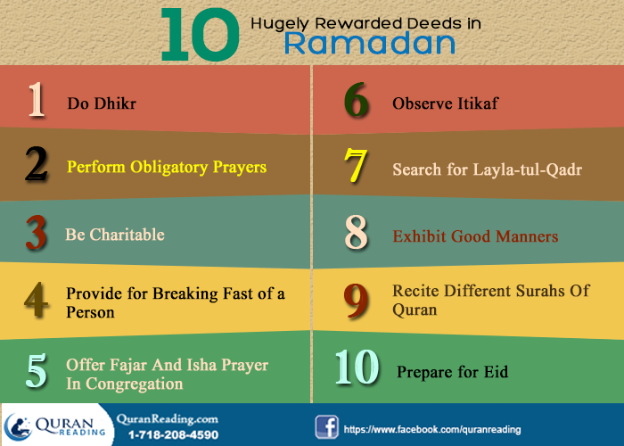
Therefore, any special deed performed during Ramadan get reward more than special reward which they are to offer during ordinary days. Some special deeds in this regard are discussed as follows.
1. Dhikr:
Dhikr refers to the remembrance of Allah Almighty. On contrary to the regular prayers, Dhikr is not time specific, rather one can do it anytime and anywhere one finds time to do so. Moreover, when it comes to Dhikr, there are numerous types of Dhikr prescribed in Islam and each and everyone of them carries a different significance and specialty. Some of the most rewarding Dhikrs which a Muslim must try doing during the fasting in Ramadan.
Prophet (PBUH) said:
“Whoever enters a market and says:
‘Laa ilaha illallah wahdahu la shareeka lah, lahul mulku wa lahul hamdu yuhyi wa yumeetu wa huwa hayyun laa yamoot, bi yadihil khair, wa huwa ‘ala kulli shayin qadeer’
Translation: (There is nothing worthy of worship except Allah, alone without partner, to Him belongs dominion and praise, He causes life and death and He is the living and does not die. In His Hand is all the good, and He is over all things competent)
… Allah will write for him or her a million good deeds and erase a million bad deeds and raise him a million levels.” (Tirmidhi)
From this hadith it is clear that reciting this particular Dhikr helps write million good deeds and at the same time remove million bad deeds that also come with a raise in million levels of spirituality. Therefore, if a Muslim wishes to earn huge reward by performing a simple Dhikr then this is the Dhikr one must recite throughout the month of Ramadan.
Some other Dhikr that can offer great reward which makes them an ideal fit for the month of Ramadan are :
“La ilaha illal-lah wahdahu la sharika lahu, lahu-l-mulk wa lahu-l-hamd wa huwa ‘ala kulli shai’in qadir,” (Bukhari)
“Subhaan Allaah’, ‘Alhamdulillaah’ and ‘Allaahu Akbar’ thirty-three times each after every (compulsory) prayer.’” [Al-Bukhari]
2. Obligatory Prayers:
Ramadan or no Ramadan, the importance and significance of the obligatory prayers stands apart from all the additional deeds of virtue that a Muslim does. Therefore, during Ramadan, it becomes imperative that a Muslim offers the obligatory prayer with more regularity and better spirit and zest. Regarding obligatory prayers, Prophet Muhammad (PBUH) said in His hadith:
“….And whoever performs an obligatory act during it (Ramadan), he is like whoever performed seventy obligatory acts in other times.” (Sahih Ibn Khuzaymah)
From this hadith the gravity of the offering of obligatory prayers along with other obligatory acts in Ramadan becomes clear. Therefore, if a Muslim offers the obligatory prayers regularly during Ramadan, they are sufficient to earn huge reward compared to ordinary days.
In addition to the performing the regular obligatory prayer, Tahajjud is the prayer that also comes with great reward. Moreover, the benefits of it are also mentioned in hadith in which Prophet (PBUH) said:
“The best fast after the fast of Ramadan is the fast of Muharram and the best Salah after the obligatory prayer is the prayer performed at night.” (Muslim)
From hadith it becomes clear that after the obligatory prayers, if a Muslim still wishes to go for greater reward, then the best option available is the Tahajjud prayer. Therefore, any Muslim who offers the obligatory prayers regularly should opt for offering Tahajjud prayer regularly as well, especially in the month of Ramadan.
3. Being Charitable:
Besides the prayers and different kinds of Dhikr, being charitable and giving Zakat is another deed that offers huge reward during the month of Ramadan. Pertaining to charity in the month of Ramadan, Prophet Muhammad (PBUH) said:
“The best charity is that given in Ramadan.” (Tirmidhi)
Therefore, whether a Muslim wants to have the sins forgiven, earn greater reward and purify the wealth he or she has at present and increase it by receiving Barakah from Allah Almighty, then the best option in this regard is to be as charitable as possible in the month of Ramadan. Hence, if any of your intended charity is pending, then the best way and time to offer it is in the month of Ramadan.
4. Provide For Breaking Fast Of A Person:
Providing food for the opening of fast of a fasting person is another deed that can help earn humungous reward. Prophet Muhammad (PBUH) said in this regard:
“Whoever provides food for breaking of the fast for a fasting person receives the reward of the fasting person, without the reward of fasting person being reduced in any way.” (Tirmidhi)
From this hadith it is clear that providing food for a fasting person to break the fast is a win-win situation in which the one who offers food receives the reward of the fasting person, whereas the one who is invited for the dinner keeps the reward to him or herself as well. Therefore, in order to get maximum reward possible, you can invite multiple people at an Iftaar party and earn blessings and rewards beyond count.
5. Offering Fajar And Isha Prayer In Congregation:
Once a group of Companions came to Prophet Muhammad (PBUH) and said:
“O Messenger of Allah, the wealthy people will have higher grades and will have permanent enjoyment and they pray like us and fast as we do. They have more money, which they give in charity.”
The Prophet (PBUH) replied:
“Has Allah not rendered for you the ‘Isha’ prayer in congregation equal to Hajj, and the Fajr prayer in congregation equal to ‘Umrah’?” (Muslim)
The significance of standing at night offering regular Isha prayer along with Taraweeh prayer cannot be overlooked. It is the best ibadah Muslims can perform in order to seek the blessings of Allah. Therefore, if you as a Muslim wish to earn reward equivalent to Hajj and Umrah, then the best and simplest way of doing so would be to offer Fajr and Isha prayer with congregation in Ramadan. This way, the reward associated with an obligatory prayer will rise to the level of Hajj and Umrah.
6. Observing Itikaf:
Observing Itikaf in the last ten days of Ramadan is one of the most renowned Sunnahs of Prophet Muhammad (PBUH) pertinent to the month of Ramadan. Regarding the reward associated with observance of Itikaf in Ramadan, Prophet Muhammad (PBUH) said in His hadith:
“He who observes the ten days Itikaf during Ramadan will obtain the reward of two Hajj and two Umrah.” (Bayhaqi)
Therefore, observing Itikaf is an excellent option for those who cant afford to go on Umrah or Hajj. By observing it, they not only earn the reward of Hajj and Umrah, but the reward is doubled as well.
7. Praying On Lylatul Qadr:
Another marvel of the month of Ramadan that is the best option for earning greatest possible reward is the praying on the night of Lyltatul Qadr. It is the night that resides in the odd nights of the last ten days of Ramadan and any prayer made in this night is far and above the reward of the prayers made in any other night throughout the year. Prophet Muhammad (PBUH) said regarding Laylatul Qadr in the following way:
“Whosoever worshipped on Layltatul-Qadr, with faith and with a sincere intention, all of his previous sins are forgiven.” (Bukhari)
Therefore, to earn humongous reward a Muslim must try finding this blessed night and offer as much prayers as possible in this night.
8. Exhibiting Good Manners:
Perhaps no other religion emphasizes on mannerism the way Islam does. In Islam having good manners is one of the best virtuous deeds. Pertaining to having good manners, Prophet Muhammad (PBUH) said in His hadith:
“There is none heavier in the scales of the Hereafter than good character.” (Tirmidhi)
Therefore, in order to send something that weighs the highest in the world hereafter, the best thing to do is to be good in manners and incorporate those attributes in your personality that offer good to all those who come in contact with you.
9. Reciting Different Surahs Of Quran:
Although each word of Quran carries its reward, which in the month of Ramadan gets multiplied many times, however, there are different Surahs of Quran that offer greater reward and better benefits compared to other Surahs. In Tirmidhi, following are a few of the Surahs mentioned that carry heavy reward:
Surah Zilzilah brings reward equal to half the Quran
Surah al Kaafirun brings the reward equal to a quarter of Quran
Surah Ikhlas carries reward equal to recitation of one third of Quran
Therefore, during Ramadan, in addition to reading whole of the Quran, these Surahs should be recited with more emphasis. These surahs are included in the Last 20 Surahs of Holy Quran application that you can install in your smartphone to repeatedly recite and read even on the go.
10. Prepare for Eid and Prayers:
While you are strongly suggested to keep yourself busy in finding the Layla-tul-Qadar in the last ten days of Ramadan, do not overlook to get prepared for the Eid ul Fitr. Do Special preparations to enjoy and rejoice this festive event that Allah gifted to Muslims in reward of keeping fast in the whole month of Ramadan. In addition, on the day of Eid, do not forget to offer Eid Prayers as well.
Ibn Rajab (Ra) narrated that the Companion Mikhnaf ibn Sulaym (Ra) said:
“The reward for attending ‘Eid Al-Fitr prayer is equal to the reward of performing ‘Umrah and the reward for attending ‘Eid Al-Adh-ha Prayer is equal to that of performing Hajj.”
Therefore, in order to earn reward equivalent to the reward of Umrah, a Muslim must offer the Eid ul Fitr prayer at the end of the month of Ramadan to ensure that the auspicious occasion is celebrated with the name of Allah Almighty.
Conclusion:
In a nutshell, in the month of Ramadan a Muslim wants to earn as much reward as possible because no one knows whether a person will live in the coming year to welcome this month or not. Therefore, by following the aforementioned deeds increases the chances of making the most out of this Holy month by earning maximum reward possible.
- See more at: http://www.quranreading.com/blog/hugely-rewarded-deeds-to-do-in-ramadan/#sthash.odIt6lgE.dpuf
***

Tips For Optimal Utilization Of Moments Of Ramadan
Posted in Ramadan By admin On July 3, 2014
In Islam there is great emphasis being put on the living a purposeful life in which time is given importance and is utilized in an optimal manner. This care and importance of time rises to its peak during the month of Ramadan, where Muslims try to make the most out of every moment of Ramadan, because they know that once it passes, then no knows whether he or she be able to live till the next year Ramadan comes.
In the month of Ramadan every moment is blessed and precious, therefore, it is imperative that a Muslim takes care of every moment and utilizes it in a way that it leads to gaining of maximum blessings and mercy throughout the month. However, there are Muslims who because of the lack of guidance aren’t able to make the best out of every moment of Ramadan. The lines below discuss some tips that can help you in utilization of every moment of Ramadan optimally.
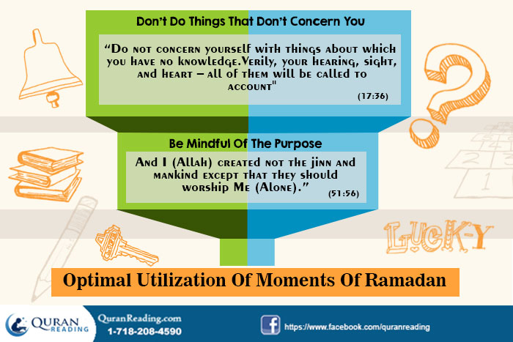
Before moving on to the ways in which the moments of Ramadan can be utilized to the best, it is imperative that one realizes the emphasis put by Islam on the importance of time that is available to a person. Prophet Muhammad (PBUH) said in His hadith:
“Make the most of five things before five others: life before death, health before sickness, free time before becoming busy, youth before old age, and wealth before poverty.” (Sahih Jami)
From this hadith it is clear that free time is of grave importance and when it is available one needs to spend it wisely. Therefore, besides the regular routine, a Muslim needs to make sure that every moment of it is cherished and thus utilized in the best possible manner.
Be Mindful Of The Purpose:
A Muslim can only try to make use of every moment of Ramadan, only when he or she is aware of the importance of the moments. In this regard, it is imperative that a Muslim is mindful of the purpose. Now, this mindfulness needs to be there pertaining to two types of purposes.
The first purpose that a Muslim needs to be mindful about is the purpose of human life. When a person knows what he or she is supposed to do in life, then he or she gets a clear picture of what life is all about and then the same perspective can be applied to the month of Ramadan. In Quran, Allah Almighty says:
“And I (Allah) created not the jinn and mankind except that they should worship Me (Alone).” (51:56)
From the ayah it is imperative that worshiping Allah Almighty is one of the major purpose of the creation of mankind, hence, when a person realizes this purpose, then he or she spends the time in Ramadan in worshiping Allah Almighty as per Islamic code of life. At another place in Quran, Allah Almighty says:
“Did you think that We had created you in play (without any purpose), and that you would not be brought back to Us?” (23:115)
The importance of living a purposeful life is evident from these two verses, which is to worship Allah Almighty and live life in a way that when in the afterlife one is asked about it, then one should be able to answer in good terms.
Secondly, the purpose that one needs to be mindful about is the purpose of Ramadan. In Quran, Allah Almighty has mentioned that the objective of fasting is to help humans practice self-constraint and purify the soul. Thus, when a Muslim is mindful that he or she is in this life for worshipping and praising Allah Almighty and that Ramadan is supposed to help them learn self control and better their soul, then he or she takes advantage of every moment of Ramadan and spends it in an optimal manner.
Take Action:
In addition to those who don’t realize the importance of time during Ramadan, there are others who although realize the importance of the month and its moments, however, there realization is only limited to their words and they don’t put it into action. Thus, whatever resolutions they make of praying in Ramadan, Quran recitation, charity, additional prayers, all are just words and they don’t strive towards materializing those words. For such people, Allah Almighty says in Quran:
“O you who believe! Why do you say that which you do not do? Most hateful it is with Allah that you say that which you do not do.” (61:2-3)
From this ayah it is imperative that those who only say and don’t act upon what they do are people not liked by Allah Almighty. Thus, when it comes to all the planning about Ramadan way before its arrival, the month is the time when all the planning needs to be put into practice and one needs to do all the things which one plans to do during the month.
Don’t Do Things That Don’t Concern You:
Prophet Muhammad (PBUH) said in one of His hadiths:
“From the perfection of a person’s Islam is that he leaves alone that which does not concern him.” (Tirmidhi)
In Ramadan, most of the times it happens that people waste time in idle activities and try to indulge in everything with which they have no concern or relation, thus these diversions lead to wasting of time and ultimately one loses the important moments of Ramadan. Hence, in order to overcome such idle diversions, it is imperative that a person leaves all those matters that do not concern him and stays focused upon what lies at hand – the pearl moments of Ramadan.
Conclusion:
In short, the time in Ramadan is really of essence and for a Muslim it is imperative to spend that time in remembrance of Allah Almighty, living life as per Islamic way, and trying to give as much time to prayers and praise of Allah whenever one has time available after completing the daily chores.
- See more at: http://www.quranreading.com/blog/tips-for-optimal-utilization-of-moments-of-ramadan/#sthash.aqEjJImi.dpuf
***

Planning and Preparation Tips For Ramadan Kareem 2017
Fasting is the act of abstaining from fulfilling one`s physiological needs of eating, drinking and other bodily requirements for a certain period of time. It has been in practice from centuries being the essential religious deed in almost all the religions including Islam, Christianity, Judaism, and Hinduism etc. The objectives behind observing it from previous nations had been diverse but the overall aim has always been to attain the state of sanctity. Regarding this, Allah Almighty says in the Holy Quran:
“O you who have believed, decreed upon you is fasting as it was decreed upon those before you that you may become righteous.” [Quran, 2: 183]

Now talking about the Muslim point of view, fasting is observed in Ramadan, 9th month in Islamic Calendar. It was made obligatory to carry out in the second year of Hijrah (Migration). Roza (fast) is one of the vital constituents of the five Pillars of the Religion of Peace. {Spiritual And Physical Health Of A Muslim
There is no religion in the world that emphasizes that much upon the well being of its followers than Islam. Besides giving moral guidelines to its followers, Islam also gives ways and instructions to help the followers live life in the best manner possible.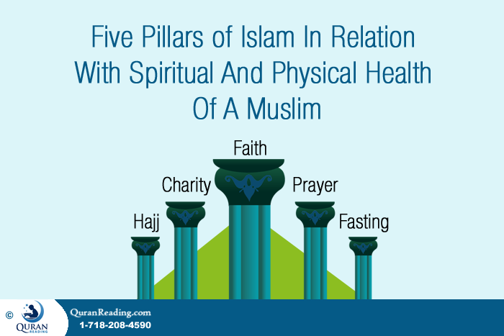
An integral part of the well-being of the followers of a particular religion is their health. Without any doubt, the health of the followers indicates the kind of guidelines they follow. Therefore, Islam does not take this aspect of its followers lightly and tries to help improve the health of its followers in different ways.
The five pillars of Islam if analyzed from the health perspective help increase the spiritual and physical health of its followers. Before explaining how the pillars work in relation with spiritual and physical health, the need is to define the source of health and its deterioration in light of Islam.
In Quran, Allah Almighty says:
“Everything good that happens to you (O mankind) is from God. Everything evil that happens to you is from your own actions.” (4:79)
If analyzed form health perspective, this ayah of Quran, points towards the fact that Allah Almighty has given the best to mankind in the form of all the natural things, whether it’s the constituents of human body or the atmosphere we live in, however, it’s the human tampering with the resources that causes decline in health. The evident example of it can be seen in the form of increasing pollution, the eating of junk and unhealthy foods, adopting an unnatural life style and so on.
The lines below explain how the five pillars of Islam help increase the spiritual and physical health of its followers.
1. Faith:
There cannot be spiritual stability in a person until and unless he expresses his belief in the authority of Allah Almighty and submits to His being the Creator of the Universe and the only Lord. When a follower has such kind of belief, then all the calamities and difficulties that a follower faces appear light as the follower is aware of the fact that Allah Almighty is on his side and He never lets those down who count on Him. Therefore, the reason why a Muslim should never be pessimistic even in the worst conditions is the fact that he has belief in Allah Almighty and His Mercy. Thus, a Muslim always finds the silver lining even in the worst conditions which keeps him spiritually healthy.
2. Prayer:
The second pillar of Islam is prayer. Besides being a religious obligation that definitely elevates the spiritual health, prayer also helps increase the physical health of a Muslim as well. The three attributes associated with prayer help increase the spiritual and physical health of a person. A detail of these attributes is as follows.
Ablution- Performing Wudu (Ablution) is a requisite for performing prayer. A Muslim cannot perform prayer until and unless he has performed ablution. The performing of ablution involves exposing all the apparent body parts like mouth, face, nostrils, feet, hands, and ears to water thus helping them in their cleaning. Therefore, when a Muslim performs ablution five times a day before the prayers, cleanliness is ensured and a Muslim removes the body from all the germs, which accumulate if the body parts are not washed regularly. Hence, ablution before prayers improves hygiene that adds to physical health.
Quran Recitation- For Muslims Quran is the ultimate source of guidance and gives a proper code of conduct for living life. Besides being a beacon of guidance, Quran is also recited during the prayers and this activity helps improve both the physical and spiritual health of a person. This is why Muslims emphasize on Quran education for children, so that when they grow up they are spiritually and physically healthy. In Quran Allah Almighty says:
“O mankind! There has come to you a direction from your Lord and a healing for the (disease) in your hearts- an for those who believe a guidance and mercy!” (10:57)
This ayah clearly states that Quran is the cure for diseases of heart, which can be interpreted both literally and metaphorically. Research is been conducted about the effectiveness of recitation of Quran during the prayer and the effect it has on the heart. As far as the spiritual health of the heart is concerned, Quran recitation during prayer definitely helps elevate the health of spirit.
Physical Exercise- Performing prayer requires making certain kinds of body postures. These body postures if viewed from the perspective of physical exercise work on all the major muscles of the body. Therefore, performing prayer five times a day is a physical activity and keeps the body healthy.
3. Charity:
Islam gives the concept of Zakat (charity), which literally means to purify or cleanse. Although it apparently cleanses the wealth of a person, however, on a deeper level it actually cleanses the soul of a person and decreases the love for worldly wealth and money from the heart of a person, the greed of which is one of the biggest curses.
4. Fasting:
Fasting is the fourth pillar of Islam, and by far the best example of physical health for people who are fond of dieting to lose weight. Besides being a religious obligation, fasting helps a person clean the body from all the impurities that accumulate in it because of eating throughout the day. Moreover, in the month of Ramadan, during fast Muslims refrain from eating or drinking all kinds of things from dusk till dawn, therefore, those who wish to quit smoking or control their overeating, fasting is the best solution. Thus, fasting helps improve the physical well being of a Muslim.
5. Hajj:
The fifth pillar of Islam is Hajj, the activities that comprise hajj are both that improve the physical and spiritual health of a Muslim. The prayers, the Tawaf of Kabah, the running between Saffa and Marwa, the universal gathering all are the factors that elevate the spiritual and physical health of a Muslim.
Conclusion:
In short, Islam is not just prayers and moral obligations; rather Islam is complete code of life and enables a Muslim to enjoy life in the best way possible, whether it’s spiritual or physical.
May Allah Almighty help us all enjoy the life with best of health in both spiritual and physical aspect. Ameen!
- See more at: http://www.quranreading.com/blog/five-pillars-islam-health-muslim/#sthash.wL00VyFg.dpuf}
It has been ordained upon all the Muslims to complete this holy responsibility from dawn to dusk, with a view to refrain from realizing one`s daily needs of food and water, unethical behavior and most importantly to accomplish the spiritual condition of heart and soul.
- See more at: http://www.quranreading.com/blog/ramadan-2015/#sthash.rNTZgESj.dpuf\\
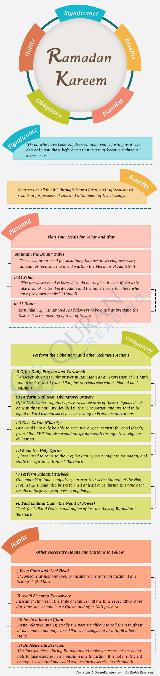
Realizing the Great Significance And Benefits Of Ramadan
The great importance of Ramadan is evident from the fact that the Holy Quran was first revealed upon the Messenger ﷺ of Allah in this month. Every year, Muslims around the globe strive for betterment in their lives through “Soum” (fasting) in the sacred month of Ramadan. They adopt a consecrated routine of morality and uprightness during this period, but it has also been commonly observed that most of its practitioners lose this routine and turn to wickedness after Ramadan, forgetting the true essence of this interval.
Just like employees of any organization are given training and development opportunities for some time, so that they could perform on their jobs more productively, same holds accurate for the divine month of Ramadan, which is the phase of acquiring a complete way of life for a Muslim. So, it is crucial to first understand the basic theme behind this act, which is the transformation and consistency of principled conduct in both thoughts and actions.
A Muslim achieves following things from this month:
- Nearness to Allah SWT through Taqwa (piety and righteousness) resulting in forgiveness of sins and attainment of His blessings
- Strengthening of one`s religious faith by keeping a state of hunger and thirst for whole day
- Consciousness of God`s many blessings which one enjoys at the time of Iftaar (breaking of Fast)
- Realization about the less fortunate people who do not have anything to eat leading to carrying out of charity
- Learning about putting up with unavoidable circumstances of life through patience and perseverance
- Reliance in One Allah is fortified after successful fasting for whole month time after being comforted at the end of every “Soum” (fast) with His countless bounties in the form of food
- The qualities of patience and gratitude adopted during this stage help a person to be patient and resolute during tragedy, and be appreciative to the Almighty and other people for in times of prosperity
- Conquering one`s anger through self control assists in dealing with many harsh situations of life and while coping with other fellow human beings
- Feelings of pride and envy are controlled and moderated with a sense of meekness and modesty towards God and other people
- Increase in tolerance and forgiveness towards others by asking the Exalted One for one`s own clemency of sins
- Development of habit of regulating and scheduling of matters by carrying out prayers and other worships at their set times
- Understanding the difference between one`s needs and wants while fasting and being appreciative of every single blessing of Allah which one tends to ignore in normal circumstances
These are some of the imperative gains that a Muslim tends to benefit from during this auspicious time of the year which add greatly to the overall significance of this sanctified month.
Planning For Ramadan 2015
As, Ramadan Kareem in 2015 is approaching fast, everyone can take advantage from the above described detail base one`s schedule during this greatest period of the Islamic Calendar on it. Ramadan is 2015 has been said to start from around 18th of June and ending nearly on 17th of July. Therefore, one must prepare for it from now in order to spend this blessed month with its due reverence and insinuation.
1) Maintaining The Dining Table
Unfortunately, most of us do not realize the exact meaning of Ramadan and get to eat a lot of food especially during Iftaar (breaking of fast). Throughout the year, those who are obese, they concentrate on their dietary plans to keep fit, but sadly when Ramadan itself offers a great time table for it, they fail to act upon it. Majority of the households keep unnecessary food items on their dining tables which are left spare in the end and nobody has the room in their bellies to eat them all. There is a great need for sustaining balance in this grave matter and necessary amount of foodstuff should be served so as to avoid wasting the blessings of Allah SWT.
i) At Sehar
The instances of Sehar, the time of eating and drinking before officially keeping the fast, are considered to be very revered in their nature. It is a period of getting great bounties of God. Anas ibn Malik (R.A) narrated the Holy Prophet ﷺ to have said:
“Take Suhoor as there is a blessing in it.” (Bukhari)
It means these moments are highly blessed and hold tremendous amount of glad tidings from the Gracious God, so one must also keep on asking for its forgiveness and seek Allah`s pleasure by taking His Name at this time.
Now let us look at some of the essential food items to have during Sehar this time around:
- Drinking a lot of water: Ramadan in 2015 will be held in summer time in most of the regions of the world. So, having 5 to 6 glasses of water during Sehar would fulfill one`s many needs of successful body functioning especially in flow of blood in body organs
- Since days are longer in summer, therefore, one needs to have vigorous rations like egg, milk, fruits, cheese, yogurt, cereals and wheat bread etc. to give one essential quantity of energy throughout the day
- Avoid in-taking sodium rich foodstuff that causes dehydration during day time like canned meat, and soups etc.
One must also not sleep through this time. If one does not have enough time to eat food to fill its need, it can take help from just drinking water as the Messenger ﷺ of God has said:
“The pre-dawn meal is blessed, so do not neglect it even if you only take a sip of water. Verily, Allah and the angels pray for those who have pre-dawn meals.” (Ahmad)
Sehar is a means of getting purity of mind and soul through getting Allah`s blessings. Thus, in Ramadan 2015, every Muslim should avail the opportunity to eat and drink in this hallowed occasion of the late night.
ii) At Iftaar
After a daylong self-restraint from food, water and committing wrongdoings, Iftaar, the starting instance of eating and drinking is an extremely sanctified phase of Ramadan. Rasulullah ﷺ has advised His followers to be quick at breaking the fast as it is the opening of a lot of favors from Allah SWT. Narrated by Sahl bin Sad (R.A):
“The people will remain on the right path as long as they hasten the breaking of the fast.” (Bukhari)
It means that hasting, which is generally not a prescribed action to do in Islam, has been only recommended in availing the great bounties of the Almighty Lord in terms of breaking one`s fast as quickly as possible.
Now let us look at some of the necessary foodstuff one must have during this most promising instance of Ramadan 2015:
- Starting consumption of food with Dates, as it is the Sunnah of the Holy Prophet ﷺ to do so. If it is not available, one is advised to drink water instead. Both of these items provide instant energy and help in regulating the working of body organs
- Saying No to overeating: eating less and in a well planned way. Sudden in-take of a lot of foodstuff at once might lead to causing disturbances in the metabolism of the body
- Eating food rich in proteins and carbohydrates like brown rice, fish, beans, chicken, vegetables or salad etc. in a balanced fashion
- Avoiding ingestion of canned meat and other stuff from stores, rather consume home made provisions to carry on a well managed dietary plan
Therefore, maintaining a sound nutritional arrangement during Iftaar this year will definitely be useful in keeping one`s body fit, and keeping away from carrying extra weight.
2) Performing The Obligatory And Other Religious Actions
“Soum” itself is an essential and must do deed that should be accomplished by every Muslim, but one must not ignore other compulsory acts as they are meant to be carried out at any cost. Unfortunately, most of us do not take care of this serious matter and skip pass our other holy duties by taking fasting as an excuse for it. Accomplishing such actions in Ramadan is even more beneficial than normal days as it is vastly consecrated period of the Islamic Calendar. The necessary spiritual acts to be performed in Ramadan 2015 must include:
i) Offering Daily Prayers and Taraweeh
Salah is second and the most important religious act to do after fulfillment of one`s faith. There is no leniency for leaving any of the five obligatory daily prayers. Apart from that one must also perform Namaz e Taraweeh during this holy month, as Rasulullah ﷺ is reported by Abu Hurairah (R.A) to have said regarding Salat e Taraweeh:
“Whoever observes night prayer in Ramadan as an expression of his faith and to seek reward from Allah, his previous sins will be blotted out.”(Muslim)
Although it is the Sunnah act of the Holy Prophet ﷺ, but as the above mentioned Hadith suggests, offering Taraweeh prayer results in great bounties of God and His Mercy. Therefore, in Ramadan 2015, every Muslim should try to take advantage from this highly revered and blessed Practice of Hazrat Muhammad ﷺ in order to benefit from its blessings.
ii) Performing Nafl (Non Obligatory) Prayers
One must also take advantage from this consecrated time of the year to offer Nafl (supererogatory) prayers as rewards of these religious deeds done in this month are doubled in their proportion and are said to be equal to Fard (compulsory) acts according to Prophetic narrations.
iii) Conducting Zakah (Charity)
As, Ramadan is the best time period to realize basic needs of the poor, therefore, during Ramadan 2015, one should take this opportunity to help out the deprived people by fulfilling the Islamic duty of Zakah. One would not only be able to earn more Ajar (returns for good deeds) from Allah SWT but also would purify its wealth through this religious obligation.
iv) Reading the Holy Quran
Recitation of Furqan e Hameed is a highly informative as well as blessed action to do. It guides mankind in every walk of life. But reading in the month of Ramadan is even more emphasized according to Prophetic traditions:
“Jibreel used to come to the Prophet (PBUH) every night in Ramadan, and study the Quran with Him.” (Bukhari)
Therefore, everyone of us should try to recite the Holy Quran everyday of this coming Ramadan in 2015 to not only fulfill the Sunnah of the Messenger ﷺ of God but also earn many of the bounties of Allah SWT by understanding and glorifying the Heavenly Verses.
Besides reading the Quran, Ramadan is the best time to start learning for those who are naive to reading in Arabic. In this regard, attending online Quran learning and reading classes can help in improving the Quran recitation skills.
v) Carrying Out Salaatul Tasbeeh
One more Nafl (non compulsory) prayer that is the Sunnah of the Holy Prophet ﷺ should also be performed at least once during this time as it results in forgiveness of past wrongdoings.
vi) Finding Lailatul Qadr(the Night of Power)
The Holy Quran was sent down on 27th of Ramadan on the Messenger ﷺ of God. Hazrat Muhammad ﷺ directed all the Muslims to search for Shab e Qadr (the Night of Power) in the last Ashra (Part) of this sacred month. Narrated by Hazrat A`isha (R.A):
“Look for Lailatul Qadr in odd nights of last tens of Ramadan.” (Bukhari)
It was again quoted by Hazrat A`isha (R.A):
“As much Rasulullah PBUH tried (ibadat) in the last Ahra (Ten Days) of Ramadan, He PBUH did not try in any of the Ashra”. (Muslim)
Hazrat Aisha (R.A) asked the Holy Prophet ﷺ, “What should I do when I find it?” The Messenger ﷺ replied, “Recite this:”
“ALLAH HUMMA INNAKA A’FUVUN TOHIB BUL AFVA FA’AFU ANNI” (Tirmidhi)
Translation: “O Allah! You are the Forgiver and You like forgiving so forgive me”
Therefore, one must try it very best to supplicate to Allah SWT in last ten days of Ramadan 2015 so as to find the highly blessed night of Qadr in it.
3) Other Necessary Habits And Customs to Follow
Some of the secondary yet highly imperative acts to take care about during Ramadan 2015 include:
i) Keeping Calm and Cool Head: Most of the Muslims while fasting lose their conscious and start quarreling with each other on pity matters. So, there is a need for making resolution to avoid this act as Rasulullah ﷺ has greatly stressed on staying away from anger. Acting upon this instruction would also result in carrying out of Soum in the rightful manner.
“Fasting is a shield – one who fasts does not use obscenities or act in an ignorant manner. If someone argues with you or insults you, say: ‘I am fasting, I am fasting’.” (Bukhari)
Thus, one should keep this Saying of the Apostle ﷺ of God while interacting with others and evade from annoyance.
ii) Avoiding Sleeping Excessively: Instead of staying in the state of slumber all the time especially during day time, one should learn Quran and offer Nafl prayers besides the obligatory ones to avail this auspicious time of the year in the best way.
iii) Inviting others to Iftaar: One should take this opportunity to invite relatives and especially the poor neighbors to call them to Iftaar at its home to not only earn Allah`s blessings but also fulfill others` rights.
iv) Doing Moderate Exercise: Most of Muslims get obese during Ramadan and make an excuse of not being able to take exercise in gymnasium due to fasting. It is not a sufficient enough reason; rather one could still perform exercise in this month by exerting less strength.
So, to conclude, it is necessary to make a well balanced plan for the upcoming Ramadan in 2015 from right now. One should keep all the above mentioned guidelines and instructions and add more to them by its own choice to benefit from this most promising and sacred month of the Islamic Calendar in the best possible way.
- See more at: http://www.quranreading.com/blog/ramadan-2015/#sthash.rNTZgESj.dpuf
***

Few Common Mistakes to Avoid in Ramadan
Posted in Ramadan By admin On June 10, 2014
Without any doubt, Ramadan is one of the Holiest months in Islamic year. It is the month where Muslims change their regular routine, turn towards prayers seeking of forgiveness, and seek the blessings and mercy of Allah Almighty for the rest of the year.
In the month of Ramadan, the goal of a Muslim is to make the best use of the month and seek as much blessings and mercy as possible and refrain from all such activities that spoil the fast and somehow make a Muslim lose all the reward and blessings, which he or she had earned.
Prophet Muhammad (PBUH) said in His hadith: “When the month of Ramadan starts, the gates of the heaven are opened and the gates of Hell are closed and the devils are chained.” (Bukhari)
From this hadith of Prophet (PBUH), it is clear that in Ramadan there is no Satan, therefore, the element of luring towards evil is missing, thus, the chances of doing and being good increase. Therefore, if there is something that bad occurs from a Muslim, it is his or her personal doing.
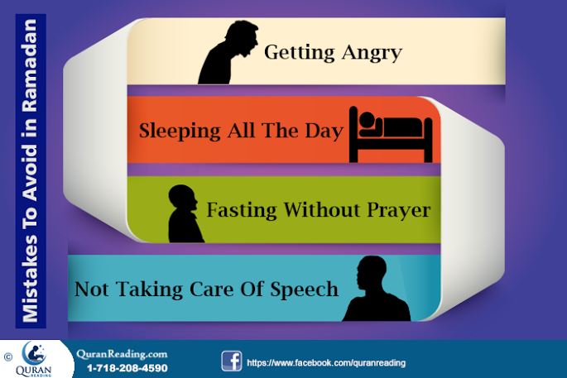
Therefore, it is imperative that during Ramadan a Muslim refrains from all such acts that are not worthy of fasting and are mistakes that should not be committed during the fast.
Avoid Anger:
The first thing that a Muslim needs to avoid during Ramadan is anger. It is the root cause of all the evils and the outcome of it is never good. When angry the judgment of a person gets clouded and he or she is not able to see clearly, and in such unclear situation a person commits mistakes that for which a person has to feel ashamed or repent upon later on. Moreover, one of the essences of fasting in Ramadan is that it teaches a Muslim to be patient and humble, which are the virtues which when present cause the vice of anger to flee. Therefore, it is more than imperative that a Muslim resorts towards patience and tolerance instead of getting angry during Ramadan. This anger leaves to hurting other people emotionally, which definitely is not a good deed and should be avoided during Ramadan. Also, when you feel like getting angry, remember Holy Prophet Muhammad’s (S.A.W) advice of seeking refuge from Allah.
The Prophet S.A.W said:
I know a word which, if only he would say it, this (anger) would leave him. If he said, “A’oothu billaahi min al-shaytaan (I seek refuge with Allah from the Shaitan),”, this [anger] would leave him.’” (Reported by al-Bukhaari, al-Fath, 6/377).
In addition, start concentration upon the Special Deeds of Our Prophet Muhammad S.A.W in Ramadan which would ultimately drive your anger away.
Sleeping All The Day:
Each and every moment of Ramadan is precious and a Muslim must make full use of it by praising and praying to Allah Almighty in the maximum time possible. Although the sleep at night and a little nap in the afternoon is necessary for the health of the body, however, staying awake all night long and sleeping throughout the day is never a good ploy. In order to avoid the hunger and thirst that develops during the day, Muslims try staying awake during the night so that they could sleep through the day. This is wrong and against what fasting teaches us. The thirst and hunger during fast helps us understand what the less fortunate people go through, therefore, if one does not feel all that, then the essence of Ramadan is lost. Hence, it is imperative that a Muslim keeps fast whilst keeping the regular routine intact and continuous.
Fasting Without Prayer:
This usually happens in cases when Muslims stay awake during night and spend all day sleeping. Besides praying in fast, the prayers themselves are mandatory upon a Muslim and fasting or no fast, a Muslim is supposed to offer them regularly. Therefore, a day without prayers in normal circumstances is not complete, let alone the day of Ramadan. In Ramadan a Muslim is supposed to indulge in excessive prayers and seek forgiveness and blessings from Allah Almighty by offering regular prayers, therefore, if one does not do so and only remains hungry and thirsts throughout the day, then perhaps it is not keeping the fast in the way it deserves to be kept. Therefore, a Muslim must make sure that regular fast is accompanied with the mandatory prayers and Taraweeh Salaat at night to keep fast with true essence.
Not Taking Care Of Speech:
Another objective of fasting in Ramadan is to teach a person self control. In a fast, a person is supposed to control his or her desires and urges. Besides these urges and desires, a Muslim is also to control the way he or she is to behave and speak with others. In this regard, one needs to take care of any kind of vulgar speech. Whether its in terms of profane, derogatory or vulgar speech or in the form of backbiting and slandering, a Muslim is to refrain from them all in order to better be able to incorporate the spirit of Islam in his or her personality. Prophet Muhammad (PBUH) says:
“Fasting is a shield, so the one who fasts should avoid obscene speech and ignorant behavior. If someone abuses him or starts to fight with him, he should reply by saying: I am fasting, I am fasting.” (Bukhari)
Therefore, a Muslim to observe fast as a shield and refrain from all such sorts of speech that provoke anger or caused derogation of the other person.
Conclusion:
In a nutshell, the emphasis or focus of a Muslim during Ramadan should be on gathering as much blessings as possible. In addition, one must take care of the things to do and things to avoid in Ramadan. Therefore, it is imperative that one refrains from any such deeds that spoil the blessings gained and is against the essence and spirit of fasting.
- See more at: http://www.quranreading.com/blog/mistakes-in-ramadan/#sthash.lJK9aM9v.dpuf
***

Essential Do’s and Don’ts for Ramadan Fasting
Posted in Ramadan By admin On June 2, 2014
The Holy month of Ramadan is just around the corner. Muslims anxiously await this auspicious month in which they pray and praise Allah Almighty and receive greater blessings and rewards in return. During this whole month, Muslims fast from the beginning of the day from sunrise to till the sunset refraining from any kind of drinking and eating.
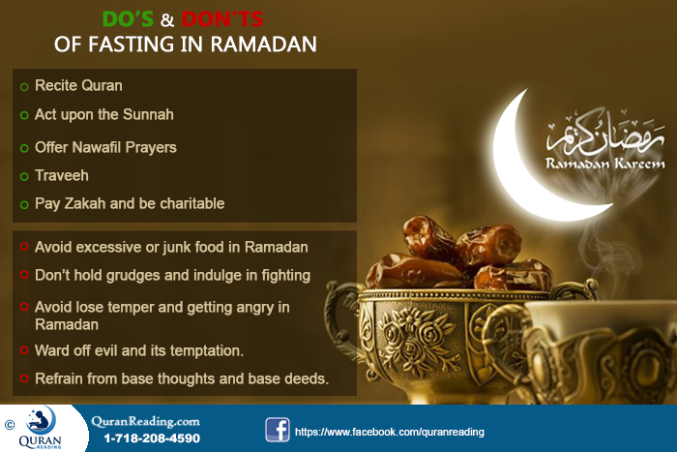
Regarding the month of Ramadan, Prophet Muhammad (PBUH) said in His hadith:
“When the month of Ramadan starts, the gates of the heaven are opened and the gates of Hell are closed and the devils are chained.” (Bukhari)
From this hadith it is clear that Ramadan is the month of asking forgiveness and receiving countless blessings. Moreover, as there is no Satan, therefore, there are minimal temptations in this month. In addition to the simple refraining from eating or drinking, there are other things which Muslims need to avoid and there are other things which they need to do in Ramadan. The lines below give the major do’s and don’ts of Ramadan.
Do’s:
There are a number of things, which a Muslim can do to make use of the blessings of the Holy month of Ramadan. The following lines give the major actions or deeds that Muslims must perform in the month of Ramadan.
- Recite Quran Daily - The first thing that you can do to make sure that you earn maximum blessings and rewards in this Holy month is to recite Quran. With every single word of Quran there is a reward, hence the more you read Quran the more reward you receive. Moreover, pertaining to reading of Quran, you must prefer recitation and understanding its meanings as that is the essence of Quran which can help you become a better Muslim not only in the month of Ramadan only, but for months and years that are to come. In addition, if you are someone who does not know how to read the Quran in Arabic, Ramadan is the month to get started with Quran learning. Daily you can take Quran Tutoring Classes from QuranReading.com to start learning Quran online. In sha Allah, by the end of Ramadan, you will be on the right track to be able to read and recite the Holy Quran with perfect pronunciation.
- Follow the Sunnah – Acting upon the Sunnah of Prophet Muhammad (PBUH) is another deed that brings reward to a Muslim. The month of Ramadan provides a great chance to learn about Sunnah and then practice it in the Holy month, where there is peace and blessing everywhere. Therefore, a Muslim must try learning about Sunnah of Prophet (PBUH) in general and His traditions related to Ramadan in particular and then apply it to daily life throughout the month.
- Nawafil Brings Reward – Although every Muslim regularly observes five times a day prayers during Ramadan, however, as the reward for prayers gets increased in this month, therefore, a Muslim must also indulge in Nawafil prayers whenever he or she finds time. Offering Nawafil brings additional reward and benefits to a Muslim and helps purify his or her heart making them glorify Allah Almighty with a pure and sincere heart.
- Perform Taraveeh – Traveeh is another Sunnah of Holy Prophet Muhammad (PBUH) which is special to the month of Ramadan. A Muslim must ensure that in addition to all the mandatory prayers the Traveeh after the Isha prayer is also observed. Therefore, Traveeh should be observed on regular bases to attain greater blessings and rewards during the whole month.
- Pay Zakah – Although there is no set month for paying Zakah, however, the month of Ramadan is an ideal time when one can pay Zakah and be charitable. As the festival of Eid comes after Ramadan, therefore, paying Zakah helps those who are less fortunate be able to celebrate the festival with somewhat same zest as all the other prosperous people. Therefore, one must try paying the due Zakah in the month of Ramadan. If you want to calculate the amount liable to your possessions, you can take help of our free Zakaat Calculator and instantly do the computing.
Don’ts:
Besides the obvious fact that a Muslim is not allowed to eat or drink anything during the fast and refrain from any sexual activity, there are several other things, which a Muslim must refrain from in order to ensure that fast is observed in the true spirit. The lines below give some major don’ts which a Muslim must observe when keeping a fast during the month of Ramadan:
- Eat Junk Food – Suhur and Aftar are two important elements of Ramadan where former is related with eating before dawn while the latter is concerned with eating on breaking of fast. However, it is observed that Muslims do not take care of what they eat at both these occasions, which makes fasting difficult for them in addition to causing health problems. Therefore, what Muslims need to do is to avoid excessive or junk food eating during the Ramadan to stay healthy.
- Hold Grudges – Fasting gives the lesson of sacrifice and forgiveness; therefore, during the month of Ramadan a Muslim must not hold grudges and indulge in fighting people. Rather, he or she needs to start forgiving people and whatever little mistakes people commit he or she should be tolerant and forgiving towards them.
- Lose Patience – Another thing that fasting in Ramadan teaches is tolerance and patience. These are two character attributes that seriously lack in people these days and even during Ramadan people lose their temper grow impatient and create all kinds of problems for themselves as well as for others. Therefore, getting angry during Ramadan is one thing that a Muslim must try to avoid and increase patience and tolerance.
- Commit Satanic Deed - Ramadan also teaches a Muslim to ward off evil and its temptation. Although the Satan is chained in this month, however, it is the habits of the rest of the months that haunt a Muslim in this month as well. Therefore, a Muslim must try refraining from base thoughts as well as committing vain and base deeds. Instead, a Muslim must do acts of good and kindness so that the fast is kept and observed in the true spirit.
Bottom Line:
In a nutshell, for a Muslim it is imperative to do good deeds and refrain from evil and sinful deeds as well as thoughts so that the true purpose of fasting is achieved. Once a Muslim is able to refrain from the bad and starts doing good, then the practice in Ramadan can be carried on to the rest of the year as well, which is the true purpose of this Holy Month.
- See more at: http://www.quranreading.com/blog/essential-do%e2%80%99s-and-don%e2%80%99ts-for-ramadan-fasting/#sthash.fCvv5Ldy.dpuf
***

How To Strategize Ramadan Schedule
Posted in Ramadan By admin On May 21, 2015
The sacred & most precious month of Ramadan is approaching fast and one must be both physically and mentally prepared for it from this very moment. Some of us mislead ourselves by having silly idea that when Ramadan arrives, we will abruptly modify our timetables and start venerating Allah SWT day and night which is not always the case. The Holy Prophet ﷺ and His righteous companions used to get themselves ready for this auspicious time of the year. Therefore, if we actually desire to make the best out of Ramadan this time around, then we ought to plan for it right now. As our life is uncertain, it makes every Ramadan very much our last one as well. That is why we have to fully utilize it, as the recompense of each noble action in this holy month is many times as compared to deeds committed in normal days. The Messenger of God ﷺ is reported to have said:
“Whoever draws near to Allah during it (Ramadan) with a single characteristic from the characteristics of (voluntary) goodness, he is like whoever performs an obligatory act in other times. And whoever performs an obligatory act during it, he is like whoever performed seventy obligatory acts in other times.” (Sahih Ibn Khuzaymah)
The above mentioned Hadith tells the tremendous amount of rewards received by a believer during these 30 days of blessings. One simple good act is equal to a compulsory action in Islam and necessary religious acts render remuneration equal to 70 times. Such is the irony that we despite being Muslims love to avail every discount offer set at shopping malls, yet we do not realize the great and eternal discounts given to us in the sacred month of Ramadan by the Gracious God.
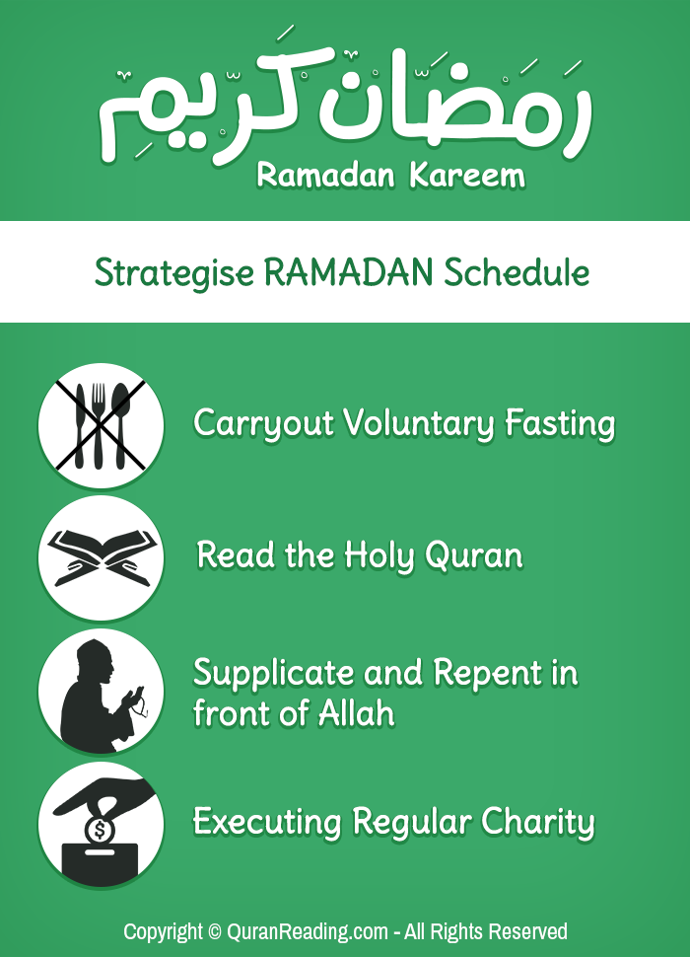
Now the question arises how we can get prepared for a sudden change that occurs in our lives in this time of the Islamic Calendar. We can take help from the following sets of activities in order to strategize our Ramadan Schedule in advance to be better prepared for it:
Carrying Out Voluntary Fasting
The most important task in Ramadan itself is fasting, so there is no other better way to get geared up than performing deliberate fasts. The Apostle ﷺ of Allah SWT used to fast throughout the year and advised Sahaba (R.A) to do the same. Abu Tharr (R.A) narrated:
“O Abu Tharr! If you fast three days of every month, then fast the 13th, the 14th and the 15th [these are called the al-ayaam al-beedh, the white days]“. (Ahmad and Tirmidhi)
Thus, Rasulullah ﷺ has devised for all of us to plan for Ramadan by fasting on these three days of every month. On another occasion, He (PBUH) said:
“Fasting and the Qur’an will intercede for the slave on the Day of Resurrection. Fasting will say: “O My Rabb! I prevented him from food and desires, so accept my intercession for him.’ And the Qur’an will say: “I prevented him from sleep during the night, so accept my intercession for him.’ He (PBUH) said: ‘and they will (be allowed to) intercede.’” (Ahmad)
It means that fasting in normal days will not help us in better preparation for Ramadan but will also lead to our pardoning in the hereafter.
Reading The Holy Quran
The Holy Quran was first revealed in the sacred month of Ramadan which is a great source of enlightenment and guidance for all the disciples of Islam. Apart from getting clearance in different matters of life, its recitation also results in forgiveness on the Day of Judgment as it will intercede for its reader as described in earlier Saying of Hazrat Muhammad ﷺ. The narration of each and every letter of Furqan e Hameed itself renders ten blessings in normal days.
“Whoever reads a letter from the Book of Allaah, he will have a reward, and this reward will be multiplied by ten. I am not saying that ‘Alif, Laam, Meem’ (a combination of letters frequently mentioned in the Holy Quran) is a letter, rather I am saying that ‘Alif’ is a letter, ‘Laam’ is a letter and ‘Meem’ is a letter.” (Tirmidhi)
Therefore, if we want to benefit from increased rewards in Ramadan, then we will have to start reading Holy Quran from now.
Supplicating And Repenting In Front of Allah
Nearly every Muslim prays and regrets its wrongdoings in the holy month of Ramadan, but majority lack sincerity. Therefore, the best way of adopting this attitude in our daily lives is to perform these actions regularly.
“Nothing is more honorable to Allah the Most High than Dua.” (Sahih al-Jami)
Allah SWT says in the Holy Quran:
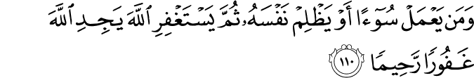
And whoever does a wrong or wrongs himself but then seeks forgiveness of Allah will find Allah Forgiving and Merciful. [Quran, 4: 110]
Hence, by supplicating and repenting to the Most Merciful in normal days will definitely be helpful in attaining the desired level honesty in our actions. It will also result in acceptance of Duas and our forgiveness in Ramadan as deeds are worth more in this month.
Executing Regular Charity
Zakah is the name of helping deprived ones with something that they require. Unfortunately, most of us mistake it for only Ramadan. Although its rewards is many times in it, but one has to conduct it regularly. Rasulullah ﷺ has said:
“He who feeds a fasting person will gain the same reward as he will, without decreasing from the fasting person’s rewards.” (Ahmad)
Therefore, to better recognize the needs of poor people in Ramadan, one has to make a habit of conducting regular charity all through the year.
Applying Prophet`s PBUH Sunnah in Daily Life
Apart from these, we should take on the way of life of the Messenger ﷺ of Allah SWT in our daily routine. We can improve a lot by having moderate diet, controlling our tongue, adopting good manners etc.
“Whoever revives an aspect of my Sunnah that is forgotten after my death, he will have a reward equivalent to that of the people who follow him, without it detracting in the least from their reward.” (Tirmidhi)
There is no doubt that performing and preaching about Sunnah of Hazrat Muhammad ﷺ is a great source of success. This disciplined life in normal days will greatly help in effective execution of necessary tasks in Ramadan.
In short, we should all get ready for upcoming Ramadan from this very moment and assess our lives to make it according to its rightful requirements.
- See more at: http://www.quranreading.com/blog/how-to-strategize-ramadan-schedule/#sthash.DPFm9LPg.dpuf
***

Ramadan Diet Plan and Weight Loss Tips for Muslims
Posted in Ramadan By admin On June 3, 2014
Fasting in the month of Ramadan is mandatory upon every Muslim and Muslims all over the world make special preparations and follow proper guidelines for this Holy month. In addition to the excessive praying and Quran recitation, one other factor that is a change compared to regular life routine is the diet plan.
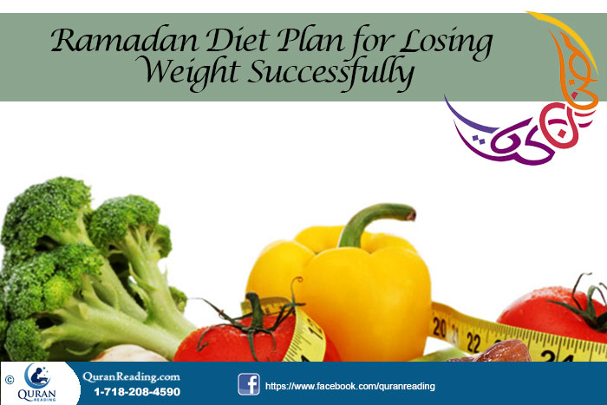
Muslims do not eat from dawn till dusk during the fast in Ramadan, which definitely is a great shift in the regular eating habits of Muslims and which makes the two meals (Suhoor and Aftar) and the time between them more than important in terms of food selection. Eating of right foods at this time can help greatly pertaining to weight loss, as during the rest of the day the body is in a state of fast. Therefore, right eating plan can be a major contributor to increasing the pace of weight loss in Ramadan.
The lines below give some general instructions pertaining to eating in Ramadan and give the kind of foods that one should eat during the meals for effective and greater weight loss.
General Instructions:
In addition to the fact that the foods one consumes during Ramadan has a direct effect on the fast a person keeps, the foods also directly affect the weight loss objective as well. Following are the general eating habits that a person needs to observe during Ramadan to aid in weight loss.
Bring Variety in Foods – The first thing that needs to be done in order to ensure that the fast is easy and that the weight loss keeps on taking place is bringing variety in the foods eaten during Ramadan. Dieting or eating a single food throughout the month is never the solution to excessive weight, rather to keep the weight loss healthy, there is the need of bringing diversity in the kind of foods a person eats. Therefore, instead of emphasizing on a single food or total deprivation of foods, one needs to keep things balanced and incorporate variety of foods in the two meals that a person has during the month of Ramadan. This way the body will be provided appropriate nutrition for the fast, in addition to aiding in weight loss.
Carbohydrates – the duration of varies from region to region, however, it generally longs from eight hours to fourteen hours in different countries of the world, therefore, there is the need of eating sufficient that helps a person go through such long period without suffering from excessive hunger. Carbohydrates being slow digesting foods are a good option in this regard, therefore, they must be made a part of Suhoor where a person can eat them in sufficient quantity and then enjoy a good fast. Moreover, carbs also ensure that the body burns fat during the fast instead of burning the muscles, therefore, they aid in weight loss by making it healthy.
Hydration – Water is an integral component to weight loss. Sufficient water helps boosting the metabolic rate, which in return burns more fats. Therefore, in order to ensure that you get through the fast without dehydration and a metabolic rate that causes more fat burn you need to drink as much water as possible at the time of Suhoor.
Avoid Fats – Usually it’s the spicy foods that are rich in fats because of the way they are cooked. Therefore, if you are on a weight loss program during Ramadan, then you need to strictly avoid the spicy foods throughout the month especially those that are cooked in oil of any kind.
Ramadan Meal Planning:
Usually in the month of Ramadan Muslims rely on two major meals which are at the time of breaking fast called ‘Iftaar’ and the second at the time of closing fast called ‘Suhoor’. However, there are others who include the additional meal in the form of dinner as well. The lines below give the recommended foods that a Muslim on weight loss should consume during these three meals.
Iftar – At the time of Iftar, provided that you are having dinner afterwards, the foods that you need to eat must include two to three dates, a serving of juice of any fruit and a vegetable soup. All these three foods help in replenishing all the energy loss that has occurred because of fasting. The juice provides vitamins and minerals, dates provide protein whereas the soup helps sooth the stress that has occurred because of food deprivation. All these three foods are also an excellent combo for people on weight loss providing them the nutrition that they require to keep the metabolic rate high.
Dinner – Those who prefer having separate dinner instead of eating a full fledged meal in Iftar should select from a variety of foods to make their dinner more assistive to weight loss and replenish energy reserves. In this regard, you need to focus on foods containing proteins and minerals, as both these elements are necessary when it comes to losing weight without losing muscles. Moreover, both these types of foods also give boost to metabolism causing maximum calorie burn. Moreover, drinking milk with light dinner can also help the cause of healthy weight loss.
Suhoor – This predawn meal is perhaps the most important one pertaining to fasting during the month of Ramadan. For this meal to assist in weight loss as well as ensure a less hungry fast, it is imperative that it comprises of foods high in complex carbohydrates. The complex carbs are the slow digesting carbs and take longer time to digest. Therefore, by eating such foods you ensure that during the fast body has energy reserves available using, which it keeps on burning fats. Hence, complex carb foods in addition to fruits are the foods that need to be included in Suhoor meal for a good fast and weight loss.
Bottom Line:
Although the fasting along with a good diet plan are sufficient enough for weight loss in the month of Ramadan, however, if one wishes then he or she can also include a workout routine as well for greater weight loss. The workout session should be either after the Iftar or before the Suhoor meal to attain maximum weight loss benefits.- See more at: http://www.quranreading.com/blog/maintaining-balanced-diet-in-the-month-of-ramadan/#sthash.luLeiN0L.dpuf

