Now that we've gotten good at encouraging anti-Muslim bigots & demagogues, how do we fix it?
By BoGardiner
Thursday Mar 23, 2017 · 4:50 PM CDT
7 Comments (7 New)
3
0
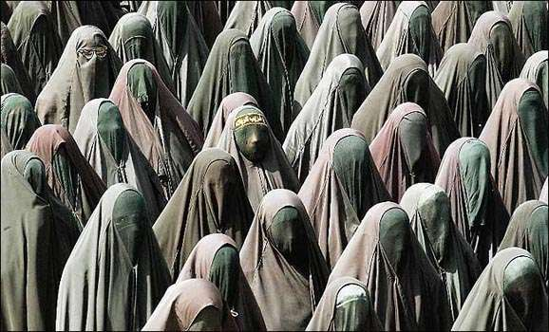
RSS
TAGS
- Bigotry
- Immigration
- Islam
- Refugees
Share this article
So here's a dialogue I've had many times over the last year:
Bigot: Ban Muslims!
Me: Stop! Religious bigotry is immoral.
Bigot: Liberals are fake feminists! They don't give a SHIT about human rights. If it's Muslim oppression, they're just fine with it. Forced veiling, FGM…
Me: Hold up. Muslim oppression is fucking not okay! Islam sucks. Islam-dominated countries suck on human rights. I've written a lot about this, so no need to waste your endless “Horrors of Islam” slogans and memes on me.
Bigot: Huh? I'm confused. Didn't you say you were a lib?
Me: Well, you won't agree with me on this part but: I also think Christianity sucks, and there's still too much extremist Christian human rights abuse. But there's no arguing that globally Christianity has outpaced Islam in reforming its historic barbarities. Hinduism sucks with its residual caste beliefs and misogyny. Many tribal religions also suck, in regions where thousands of women and children are still tortured and burned at the stake as witches.
The fact is, religiously motivated oppression and violence remain a huge global problem, and more education is needed to evolve beyond it. In the meantime, though, statistics show that religiously motivated oppression and violence is dominated now by Islam, so there must be greater pressure for reforms there.
Bigot: Well, you're exaggerating Christianity's problems, but at least you admit the rest, and you're consistent.
Me: So now that we at least have some common ground, can we get back to why religious bigotry sucks? IDEAS don't have rights, but PEOPLE sure as hell do. Let's talk about what that means in real life, and the lives of any given person you've never met who absolutely can not be judged based on their religious beliefs…
Bigot: Now you hold up. Your fellow liberals don't acknowledge any of that. They sounds as if they'd be happy as clams to have sharia in the U.S.
Me: Uh… uh… uh…
There's no single reason why Trump won, but I guarantee this is one of them.
Yes, the “Sharia is coming to America” paranoia is ludicrous and must be reasoned with. But still...
Did you think the everyday conservative wasn't paying attention to our hypocrisy, as we revel in Christian satire while attacking any criticism of Islam as "Islamophobic"?
They were paying very close attention.
Did you think they were buying our excuse "Oh, that's different, criticizing Islam is "punching down" on minorities!" …when Muslims have the highest world population and hold totalitarian powers in many regions?
They didn't buy that for a second and never will.
We want to talk about how to do better within our party? Let's talk about our failure as progressives to fully acknowledge Islamic human rights abuses, how that helped put Trump in office, and how we have to humbly acknowledge we were wrong about that…
…while fighting every bit as hard to protect Muslim immigrants, refugees and citizens from Trump's unconstitutional religious discrimination and incitements to religious hatred, a hatred that consists of unethical, irrational, sweeping indictments of a person's character based solely upon their religious beliefs (or lack thereof).
Please debate this point on its merits, without instead knocking down the straw man of something you heard some celebrity say. If you don't like how Bill Maher or Sam Harris says it, fine, tell us how it can be said. But stop telling us we can't say it at all.
Yes, this is a more nuanced position than either side has been yelling before now. But honestly, it's really not that complicated a position. We could be helping each other develop it as a clear, compassionate message. Those of you who are more pro-religion than me can, I'm sure, find ways to work around my atheism and still get the point across.
But we need to do it, not only to start winning elections again, but because it's the only moral thing for progressives to do. We need to worry less about protecting our personal image of ourselves as liberals to others, and worry more about actual liberal values.

