CAIR Demands Apology for Va. GOP's Anti-Mosque 'Smears' | Threat to Shoot N.C. Muslim | Minn. Muslim Threatened | CAIR Legal Team Seeks Wider Muslim Ban Injunction | CAIR Seeks 'Full Review' After 2nd Deadly Airstrike on Syrian Civilians

- CAIR: Discrimination and Fear are the Norm for Many Muslim Americans
A rash of hateful comments and actions directed at Muslims following the Nov. 8 presidential election has perpetuated that fear, Council on American-Islamic Relations spokeswoman Zainab Chaudry said at a panel announcing the report.
  - Video: CAIR-San Antonio Joins Rally Against Hate
  - Video: CAIR-MN Seeks Criminal Charges for Harassment Targeting Moorhead Muslim Woman Shopper
  - Muslims Inside FBI Describe Culture of Suspicion and Fear: 'It is cancer'
- CAIR-NY Denounces Mayor de Blasio's Surprise Appointment of Intelligence Watchdog
- CAIR Seeks Hate Crime Probe of Threat to Shoot North Carolina Muslim Woman
According to the woman, who is of South Asian heritage and wears Islamic attire (hijab and abaya), a white male in his 40s or 50s driving a pick-up truck pulled into a parking space next to her vehicle as she was nursing her one-month-old child in a Charlotte, N.C., parking lot. The man reportedly stared at the woman for an extended period and then reached in the back seat of the truck to retrieve a rifle, which he then reportedly pointed at the woman.
- CAIR-Minnesota Calls for Hate Crime Probe After Muslim Woman is Followed, Threatened
According to the alleged victim, who was wearing an Islamic head scarf (hijab) and was with her one-year-old child, the two people followed her for 7-8 minutes while she was driving and then blocked her from parking her car. One of those two people, a woman, then reportedly approached the Muslim woman's car and started shouting abuse and obscenities including, "You should f***ing go home, and you should be f***ing deported," and threatened to "rip her face off if she sees her again."
- CAIR Demands Apology for Virginia GOP's Anti-Mosque 'Smears'
While Virginia GOP officials, and recently the FBI, have taken part in public functions at that mosque, the Virginia GOP's website falsely smears it as being "terror-linked" and demands that Attorney General Herring "apologize to the victims of terrorism."
In astatement, CAIR Director of Government Affairs Robert McCaw said:
"The Republican Party of Virginia must immediately apologize for falsely smearing one of Northern Virginia's most civically-engaged and respected houses of worship.
"It's absolutely deplorable that the Virginia GOP would attack Attorney General Mark Herring for visiting the same mosque that many of its own officials attended when seeking to connect with and gain the support of Muslims in Northern Virginia. . .
- CAIR Legal Team Seeks Wider Injunction on Trump's 'Muslim Ban 2.0'
CAIR is seeking an even broader injunction against the executive order than what other judges in Hawaii and Maryland have imposed. At Monday's hearing, CAIR Co-Counsel Gadeir Abbas argued that Section 3 of the order, which impacts how those applying for visas can seek waivers, remains in force despite the rulings in other states.
- CAIR: Many Montana Lawmakers Seem to Be Falling for a Conspiracy Theory About Muslims
"Like other anti-Islam legislation, the Montana bill redundantly protects rights already guaranteed by the U.S. Constitution," said Corey Saylor, the director of the Department to Monitor and Combat Islamophobia at the Council on American-Islamic Relations. "The legislators behind the bill should take a break from wasting taxpayer time and money, admit their goal is anti-Muslim fearmongering, and then take a basic course on how the U.S. Constitution works."
  - North Dakota Lawmakers Mull So-Called Anti-Sharia Law Bill
- CAIR: Who Is Brigitte Gabriel? Trump Welcomes Anti-Muslim Activist to White House
The Council on American-Islamic Relations said Tuesday that ACT for America was "one of the main sources of growing anti-Muslim bigotry in our nation."
  - CAIR: Leader of Group Widely Identified as Anti-Muslim Meets with White House
  - CAIR: Despite Denials, It Sure Looks Like an Anti-Muslim Leader was at the White House
- CAIR Seeks 'Full Review' of Rules of Engagement After Second Deadly U.S. Airstrike on Syrian Civilians
In a statement, CAIR said:
"With two recent attacks by U.S.-led forces in which so many Syrian civilians were killed and injured, it is imperative that our military and political leaders conduct a full review of the rules of engagement in that conflict to ensure that civilians are protected and that our nation's values are maintained. Targeting civilians, even by accident or incompetence, is not only a tragedy for the loved ones of the dead and injured, but also harms America's struggle against terrorism by alienating those we seek to protect."

CAIR-MN Seeks Criminal Charges for Harassment Targeting Muslim Woman

- Video: CAIR-Ohio Legal Director Romin Iqbal Interviewed on Muslim Ban 2.0, Terrorism
- CAIR-MN Seeks Criminal Charges for Harassment Targeting Muslim Woman Shopper
The Minnesota chapter of the Council on American-Islamic Relations (CAIR-MN) is calling on law enforcement authorities to reconsider bringing criminal charges against a man who allegedly harassed a Muslim woman shopper in Moorhead, Minn., because of her Islamic attire (hijab).
According to the alleged victim, Fardoso Mohamed, who was shopping at the Hornbacher's in Moorhead, the man told her, "Hey, you need to remove the hijab." "He was very close to me, and he was yelling very hard, very mad," said Mohamed, who noted that harassment of hijab-wearing women is not unusual in the Fargo-Moorhead area.
Mohamed says she walked away from the man, but he reportedly followed her through the store and confronted her again about her religious attire. Bystanders did not assist Mohamed or intervene on her behalf. But a Hornbacher's employee did confront the alleged perpetrator, and he eventually left. A Moorhead police spokesman said he believed that while the man's behavior was rude, no laws were broken.
"We urge law enforcement authorities to reconsider bringing charges in this case based on Minnesota statutes prohibiting stalking and harassment," said CAIR-MN Executive Director Jaylani Hussein. "We thank the store employee who came to the aid of Ms. Mohamed."
  - Video: FBI Meets with Mosque Targeted by Anti-Islam Letter After CAIR Calls for Hate Crime Probe
- CAIR-MN to Host '1,000 Who CAIR, Call to Action' Event to Challenge Islamophobia, Defend Civil Rights
On Saturday, March 25, the Minnesota chapter of the Council on American-Islamic Relations (CAIR-MN), the largest Muslim civil rights and advocacy organization, will hold an event aimed at challenging Islamophobia and defending civil rights.
WHAT: CAIR-MN Event '1,000 Who CAIR, Call to Action'
WHEN: Saturday, March 25, 4-8 p.m.
WHERE: The O'Shaughnessy Theater on the campus of St. Kate's, 2004 Randolph Ave, St Paul, MN 55105
CONTACT: CAIR-MN Development & Outreach Coordinator, Patti Walsh, 612-206-3360, pwalsh@cair.com
The event will feature noted Muslim scholar Dalia Mogahed, Gold Star father Khizr Khan, Rep. Ilhan Omar, Civil Rights Leader Nekima Levy-Pounds, and other politicians and entertainers such as comedians Jeremy McLellan and Danish Maqbool, to inspire and energize people into action.
- CAIR-SFBA, Community Groups Celebrate the Signing of San Francisco Anti-Registry Ordinance Into Law
A broad coalition of organizations - Asian Americans Advancing Justice - Asian Law Caucus, the San Francisco Bay Area office of the Council on American-Islamic Relations (CAIR-SFBA), Arab Resource & Organizing Center (AROC), Alliance of South Asians Taking Action (ASATA), the National Lawyers Guild -Francisco Bay Area (NLG SF), and the ACLU of Northern California advocated for this law that will create protections against any registry based on religion or country of origin.
- Video: CAIR Condemns Texas Attorney General's 'Cheap Islamophobic Publicity Stunt'
  - CAIR: Texas Attorney General Lied About a School Providing a Muslim-Only Classroom
The Council of American Islamic Relations, the largest Muslim civil advocacy organization in the United States, called Paxton's open letter was an "cheap Islamophobic publicity stunt."

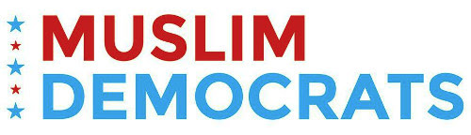
March 21, 2017

Call. It is Making a Difference!
Assalamu Alaikum
Saving a life is like saving the whole humanity (Quran 5:32). 24 million people in America will loose insurance or their lives if Obamacare is destroyed.
Senate Republicans are feeling the pressure. Last week, one Republican senator planned to vote NO on the bill. Today, that number is up to four. Your calls and letters are working, but we cannot let up. If we keep turning the heat up on the GOP, we can defeat the Obamacare repeal.
Please see below an important message from Indivisible. They are doing a great job helping America focus on one issue at a time.
Peace
Muslim Democrats Team

The Affordable Care Act faces a critical repeal votethis Thursday.
This week is one of a handful this year that will decide the fate of the Affordable Care Act (ACA). This THURSDAY, exactly seven years after the ACA became law, the House of Representatives will be voting to repeal it and replace it with TrumpCare—a plan that, if passed, will lead to at least 24 million Americans losing their health care.
Republicans are rushing to pass TrumpCare before the upcoming April recess, ignoring the normal legislative process, because they don’t want to face you, their constituents. They are attempting to ram through a TrumpCare bill that will cut coverage for millions and raise premiums for millions more. Their proposal simultaneously guts Medicaid and gives a $600 billion tax break to the wealthy and corporations. We can’t let them get away with this—millions of lives hang in the balance.
You and your Indivisible group can stop this. The House vote this coming week is the first step towards enactment of this devastating TrumpCare bill. Your Member of Congress (MoC) needs to know that you oppose it. Here’s how:

Key tactics for applying your constituent power this week:
- Show up. Show up at your MoC’s District Office with your group to demand that your MoC vote against TrumpCare. Bring affected individuals to these meetings and use personal stories as much as possible. Your stories are powerful—stories change minds and alter what is politically possible. Your story should answer this question: How will you or your family be affected by TrumpCare?
- Create a public demonstration. Hold a vigil outside your MoC’s office. Invite the media. Their vote in favor of this bill would mean the difference between life or death for thousands each year. You need to demonstrate your resolve. If your member has already committed to vote no, show up and thank them. In a big way.
- Make your calls to your Representative. Start with this script and tell your Representative that a vote to take away health care from 24 million people is a vote you'll be watching. Spread the word on social media using #RejectTrumpCare and tell your friends, neighbors, and colleagues to call their Representatives.
- Get others involved. This vote is too important for people to sit on the sidelines. Time to get someone else involved—empower a friend, family member, neighbor, or colleague. Create social media events, tag a friend on Facebook, or just tell someone else why you get involved.
- Get creative. You’re leading this movement—it’s your constituent power, so use it how you see fit. We’ve seen some local Indivisible groups create scrapbooks of local constituents who would be affected by TrumpCare. Others have brought their children who stand to lose coverage to the MoC’s district office. Your goal is to make clear to your Senators and Representatives—and any local media who will listen—what TrumpCare means for you and your family, friends, and neighbors.
- Plan a Friday district office visit to hold your MoCs accountable. The House vote is expected Thursday. No matter how your MoC votes, you should provide IMMEDIATE feedback (positive or negative) by making a visit to their district office on Friday with your Indivisible group. Your MoCs will have to take more votes in the future on TrumpCare to pass the final bill. They’ll be holding their breath and watching carefully after this vote, hoping that the outrage dies down. By providing immediate feedback today, you’ll change their political calculus tomorrow.

Need more ACA info?
- Wondering how TrumpCare will affect people in your state? Our friends at the Center for American Progress have an interactive map showing TrumpCare’s impact around the country. Check it out here: TrumpCare by the Numbers.
- Want to get wonky? Republicans are trying to push TrumpCare through with a process called “reconciliation” that allows them to pass the bill without the usual 60 votes in the Senate needed to pass legislation. Read up on this tricky bit of congressional procedure with our new explainer: Legislative Process 101—Budget Reconciliation.
- Just want all of the the Indivisible Project’s ACA materials in one place? Absolutely—here’s our resource page: Save the ACA.
You have a chance to stop this legislation by getting involved on your home turf now. If enough members stand up and say NO, Republican leaders will be forced to pull the bill from their weekly schedule—which would be a devastating defeat for Trump. If TrumpCare does pass the House, the fight’s not over. In that scenario, TrumpCare will soon move to the Senate—and then the fight will shift to your Senators.

Join & Support Muslim Democrats
- Join us on Facebook
- Follow us on Twitter
- Sign Up for our Newsletter
- Donate!
- Volunteer
Muslim Democrats
We are a national network of Muslim activists, organizers and community leaders working to enhance the meaningful participation of all American Muslims in the electoral process for political empowerment.
We plan to:
Articulate demands and policy priorities on behalf of the Muslim community to the Democratic party, with the administration, to public officials and to candidates for public office.
- Organize the Muslim electorate through development & maintenance of a database of all Muslim voters, Muslim-led political organizations, Muslim public officials and key political allies.
- Secure appointments for Muslims to boards, commissions, and various public positions.
- Recruit and train Muslim candidates to run for public office and to manage electoral campaigns.
Note: Contributions to Muslim Democrats are not tax deductible for federal income tax purposes. Paid for by Muslim Democrats and not authorized by any candidate or candidate's committee.
You have received this email through your subscription to Muslim Democrats email list. If you would like to remove your email from this list, click here to unsubscribe.
FOR IMMEDIATE RELEASE
CAIR Calls on White House to Cancel Meeting with Anti-Muslim Hate Group Leader
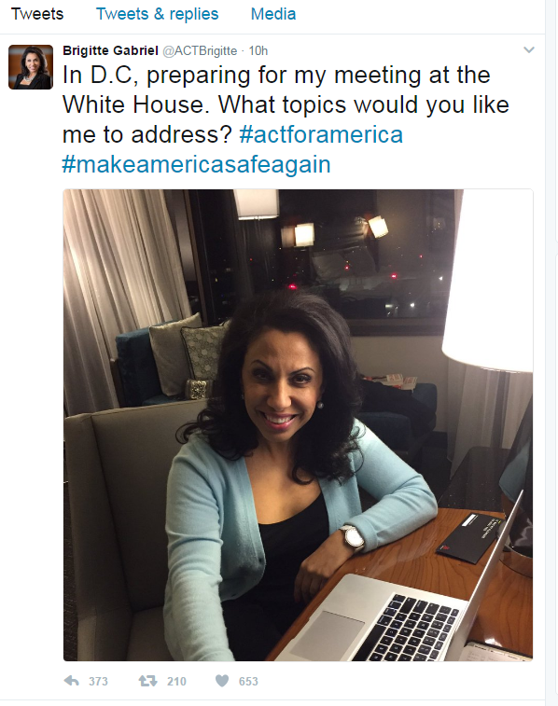
(WASHINGTON, D.C., 3/21/2017) - The Council on American-Islamic Relations (CAIR), the nation's largest Muslim civil rights and advocacy organization, today called on White House officials to cancel a reported meeting with anti-Muslim hate group leader Brigitte Gabriel.
Late yesterday, Gabriel tweeted: "In D.C, preparing for my meeting at the White House."
ACT for America has been designated as a hate group by the Southern Poverty Law Center (SPLC). The SPLC has named "Brigitte Gabriel" as a member of the nation's "Anti-Muslim Inner Circle."
SPLC: Anti-Muslim Inner Circle
"No White House official should be meeting with the leader of a hate group that is one of the main sources of growing anti-Muslim bigotry in our nation," said CAIR National Executive Director Nihad Awad. "This meeting should be canceled immediately and an explanation should be offered as to why it was scheduled in the first place."
Awad noted that such a meeting would only serve to further reinforce concerns about the Trump administration's involvement in the promotion and exploitation of Islamophobia.
CAIR Islamophobia Monitor: Islamophobia and the Trump Team
CAIR: This Map Shows How Many Mosques Have Been Targeted Just This Year (CNN)
ACT for America Backgrounder:
ACT for America is a virulently anti-Muslim hate group headed by Hanah Kahwagi Tudor, who goes by the pseudonym "Brigitte Gabriel." "Gabriel" has stated that an American Muslim "cannot be a loyal citizen" and that Islam is the "real enemy." She once told the Australian Jewish News: "Every practicing Muslim is a radical Muslim." When asked whether Americans should "resist Muslims who want to seek political office in this nation," Tudor said, "Absolutely."
CAIR Islamophobia Monitor: Brigitte Gabriel (ACT for America)
CAIR Islamophobia Monitor: ACT for America
Her hate group's anti-Muslim bigotry was highlighted recently in a Washington Post exposé.
SEE: This group believes Islam threatens America: 'It's a spiritual battle of good and evil.'
A member of ACT for America allegedly attended a recent meeting in North Carolina at which the killing of Muslims was reportedly suggested.
SEE: CAIR Calls on Feds to Probe Call to Violence Against U.S. Muslims at N.C. Meeting of Hate Groups
CAIR is America's largest Muslim civil liberties and advocacy organization. Its mission is to enhance the understanding of Islam, encourage dialogue, protect civil liberties, empower American Muslims, and build coalitions that promote justice and mutual understanding.
La misión de CAIR es mejorar la comprensión del Islam, fomentar el diálogo, proteger las libertades civiles, capacitar a los musulmanes estadounidenses, y construir coaliciones que promuevan la justicia y la comprensión mutua.
- END -
CONTACT: CAIR National Litigation Director Lena Masri, 248-390-9784, lmasri@cair.com; CAIR National Communications Director Ibrahim Hooper, 202-744-7726, ihooper@cair.com

- Hadith of the Day: Religion is Very Easy, Avoid Extremism
The Prophet Muhammad (peace be upon him) said: "Religion is very easy, and whoever overburdens himself in his religion will not be able to continue in that way. So you should not be extremists, but try to be near to perfection and receive the good tidings that you will be rewarded." Sahih Al-Bukhari
- Tennessee Residents, Including a US citizen, Barred Re-Entry From Turkey
Knoxville Mayor Madeline Rogero and staffers from Rep. John J. Duncan's office are attempting to contact a Knoxville family in Istanbul, Turkey, after they claimed their 17-year-old daughter was barred from boarding a flight to Atlanta on Sunday afternoon.
- CAIR Supports NY City Council Security Grant Program to Protect Muslim, Jewish and Other Community Institutions
The New York chapter of the Council on American-Islamic Relations (CAIR-NY) today announced its support for a proposed New York City Council security grant program that would allocate $25 million to protect to help protect Muslim, Jewish and other nonprofit institutions, safeguarding those community centers and cultural institutions at the greatest risk of attack.
- CAIR: State AG Paxton Claims Texas School's Prayer Room Is For Muslims Only (It's Not)
  - Video: CAIR Condemns Texas Attorney General's 'Cheap Islamophobic Publicity Stunt'
- Video: CAIR-Iowa Calls for Hate Crime Probe of Trump Supporter's Anti-Muslim Message Left at Mosque
  - CAIR-Iowa: Anti-Islam Note Leaves Community Shaken
- Video: CAIR-SFBA Joins Interfaith Show of Solidarity for Muslim Community
  - Video: CAIR-FL Rep Wilfredo Ruiz Interviewed About Hate Crimes, Muslim Ban
  - CAIR-San Diego: Immigrant Advocates Rally Against Second Travel Ban, Taxpayer-Funded Border Wall
- CAIR: Religious Head Garb Rule Change Sought by Montgomery County Schools
MEDIA ADVISORY
Hearing March 21 in Virginia on CAIR's Legal Challenge to Trump's 'Muslim Ban 2.0'
(WASHINGTON, D.C., 3/20/2017) - On Tuesday, March 21, a hearing will take place before Judge Anthony Trenga at the US District Court for the Eastern District of Virginia (10 a.m., Courtroom 701) in Alexandria, VA., for arguments on the Council on American-Islamic Relations' (CAIR) legal challenge to President Trump's so-called 'Muslim Ban 2.0" executive order.
In its lawsuit, CAIR seeks a temporary restraining order and/or preliminary injunction to enjoin the entirety of the executive order on behalf of an American citizen - among others - seeking to be reunited with a foreign-born spouse, as well as for students whose ability to visit their families abroad would be imperiled by the executive order.
SEE: Brief in Support of CAIR's Emergency Motion for Temporary Restraining Order and/or Preliminary Injunction
CAIR is also representing more than 20 Muslims who are subject to the stigmatization resulting from the executive order.
Earlier this month, CAIR held a news conference at its Capitol Hill headquarters in Washington, D.C., to respond to the signing of President Trump's new "Muslim Ban 2.0" executive order. In his prepared statement for the news conference, CAIR National Executive Director Nihad Awad said: "This scaled-back order represents a partial victory for Americans fighting for the rights of immigrants in the U.S. and directly responds to several immigration cases and scenarios brought forward in CAIR's anti-ban lawsuit.
SEE: CAIR Calls Trump's Scaled-Back 'Muslim Ban 2.0' a 'Partial Victory,' Will Continue to Challenge Unconstitutional Order
VIDEO: CAIR Muslim Ban 2.0 News Conference
At that news conference, CAIR launched a "Register Me First" (#RegisterMeFirst) website, produced in partnership with a Los Angeles-based design and technology studio Use All Five, to challenge President Trump's Islamophobic policies, including the Muslim ban and a proposed "Muslim registry."
Registermefirst.com will provide an opportunity for anyone who wants to oppose the Muslim ban, any future Muslim registry or other unconstitutional actions by the Trump administration to join the broader movement challenging those unjust policies.
GO TO: Register Me First
Video: Register Me First
The Washington-based civil rights and advocacy organization urges community members to report any bias incidents to police and to CAIR's Civil Rights Department at 202-742-6420 or by filing a report at: http://www.cair.com/civil-rights/report-an-incident/view/form.html
CAIR is America's largest Muslim civil liberties and advocacy organization. Its mission is to enhance the understanding of Islam, encourage dialogue, protect civil liberties, empower American Muslims, and build coalitions that promote justice and mutual understanding.
La misión de CAIR es mejorar la comprensión del Islam, fomentar el diálogo, proteger las libertades civiles, capacitar a los musulmanes estadounidenses, y construir coaliciones que promuevan la justicia y la comprensión mutua.
- END -
CONTACT: CAIR National Litigation Director Lena Masri, 248-390-9784, lmasri@cair.com; CAIR CAIR Co-Counsel Gadeir Abbas, 720-251-0425, gadeir.abbas@gmail.com; CAIR National Communications Director Ibrahim Hooper, 202-744-7726, ihooper@cair.com

CAIR Condemns Texas Attorney General's 'Cheap Islamophobic Publicity Stunt' | The Denationalization of American Muslims
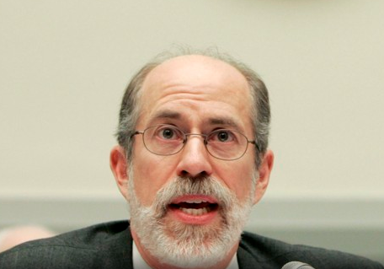
- CAIR: The Denationalization of American Muslims (The Atlantic)
For years, Republican leaders treated Frank Gaffney as a pariah. But his dark warnings about Sharia law taking over America found an audience among grassroots conservatives—and now, in the White House. . .
Reducing Muslim immigration is only one part of the administration's effort.
Stigmatizing Muslims already in the country is the other.
- CAIR-Chicago: 'We Will Have None of It' - Fear, Optimism Among US Muslims
- Video: CAIR Co-Hosts Town Hall on Muslim Ban 2.0 Featuring Talk by Virginia Attorney General
  - CAIR: Virginia Attorney General Promises Residents He Will Fight Trump's Muslim Ban
- Video: Armed Protesters Outside Texas Mosque Met by Anti-Hate Protest
  - Video: CAIR-FL Rep Wilfredo Ruiz Interviewed About Hate Crimes, Muslim Ban
  - Video: CAIR-Alabama Director Responds to Series of Break-Ins at State Mosques
  - Video: CAIR-San Antonio Launches Muslim Voter Registration Drive
  - Video: Khizr and Ghazala Khan Appear at CAIR-Dallas Banquet
FOR IMMEDIATE RELEASE
CAIR Condemns Texas Attorney General's 'Cheap Islamophobic Publicity Stunt'
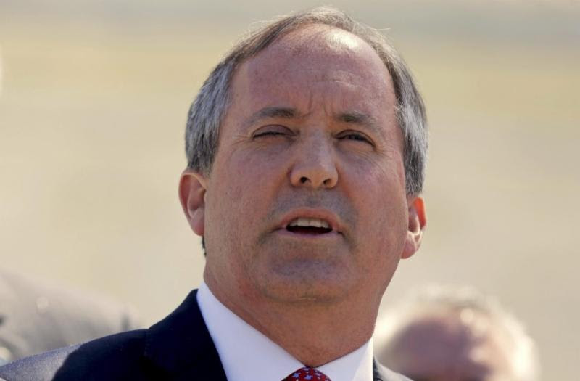
(AUSTIN, TEXAS, 3/19/17) – The Texas office of the Council on American-Islamic Relations (CAIR-Texas) today condemned what it called a "cheap Islamophobic publicity stunt" by that state's Attorney General Ken Paxton, whose office has raised objections to the use of a spare classroom by Muslim middle school students to perform their daily prayers.
Paxton's office sent the Frisco school district superintendent a letter Fridayexpressing "concerns" that the classroom is being used by Muslim students. In a news release, Paxton's office falsely stated: "Recent news reports have indicated that the high school's prayer room is. . .apparently excluding students of other faiths."
According to school district officials: "This 'press release' appears to be a publicity stunt by the OAG to politicize a nonissue. . .Frisco ISD is greatly concerned that this type of inflammatory rhetoric in the current climate may place the District, its students, staff, parents and community in danger of unnecessary disruption." School officials say they had not been contacted by the attorney general's office prior to the criticism of the Muslim students' use of the spare classroom.
In the past, Paxton – who once sued a middle school principal to keep a Bible quote on a door - has criticized what he calls anti-Christian discrimination in state schools.
SEE: The Texas AG sued to keep a Bible quote in school. Now he's troubled by Muslim prayers.
In a statement, CAIR-Texas said:
"It is unfortunate that our state's top law enforcement officer would engage in a cheap Islamophobic publicity stunt that could very well result in increased bullying of Muslim students and the creation of a hostile learning environment. Attorney General Ken Paxton's office appears to have made its ill-informed statements without first contacting school officials. That apparent lack of interest in the facts of this case would seem to confirm suspicions that the 'concerns' about Muslim prayers have less to do with religious neutrality, and more to do with exploiting growing Islamophobia in our state and nationwide.
"It is the duty of any attorney general to protect the constitutional rights of all citizens, regardless of faith."
CAIR's Houston chapter recently called on the administration of the Houston Independent School District (HISD) to meet with representatives of the Muslim community to discuss its social media policy after a teacher sent out virulently anti-Muslim statements on Twitter.
Video: CAIR-Houston Director Tells Anti-Islam Teacher to 'Read His Bible'
A report by CAIR's California chapter, titled "Mislabeled: The Impact of Bullying and Discrimination on California Muslim Students," indicated that that more than half of Muslim students in that state have been subject to at least one form of religion-based bullying.
CAIR-CA Report: More than Half of California Muslim Students Targeted by Faith-Based Bullying
The Washington-based civil rights and advocacy organization is urging Muslim parents and students to report any bias incidents to school officials, to police and to CAIR's Civil Rights Department at 202-742-6420, or by filing a report at: http://www.cair.com/civil-rights/report-an-incident/view/form.html
CAIR is America's largest Muslim civil liberties and advocacy organization. Its mission is to enhance the understanding of Islam, encourage dialogue, protect civil liberties, empower American Muslims, and build coalitions that promote justice and mutual understanding.
La misión de CAIR es mejorar la comprensión del Islam, fomentar el diálogo, proteger las libertades civiles, capacitar a los musulmanes estadounidenses, y construir coaliciones que promuevan la justicia y la comprensión mutua.
- END -
CONTACT: CAIR-San Antonio President Sarwat Husain, 210-378-9528, shusain@cair.com; CAIR-Houston Executive Director Mustafaa Carroll, 832-549-1042, mcarroll@cair.com; CAIR-Houston Communications Coordinator Ruth Nasrullah, rnasrullah@cair.com; CAIR-DFW Executive Director Alia Salem, 817-538-8269, asalem@cair.com; CAIR-Austin, 512-640-9421; CAIR National Communications Director Ibrahim Hooper, 202-744-7726, ihooper@cair.com

Council on American-Islamic Relations
453 New Jersey Ave, S.E., Washington, D.C., 20003
Council on American-Islamic Relations Copyright © 1994. All rights reserved.

- CAIR-Missouri Defend Muslims Civil Rights Fundraising Dinner March 25
- CAIR: 'I'm not going to sit here and let him shoot me,' Muslim Mom Recalls of Terrifying Charlotte Encounter
The woman recounted the terrifying episode in an interview with the Observer on Wednesdayevening, after the nation's largest Muslim civil rights group called on police to investigate the case as a possible hate crime.
"We ask law enforcement authorities to use all resources available to apprehend the alleged perpetrator and to bring all appropriate charges, including that of ethnic intimidation," said Ibrahim Hooper, spokesman for the Council on American-Islamic Relations based in Washington, D.C.
  - Video: CAIR Seeks Hate Crime Probe of Threat to Shoot North Carolina Muslim Woman
  - Video: CAIR-MN Seeks Criminal Charges for Harassment Targeting Muslim Woman Shopper
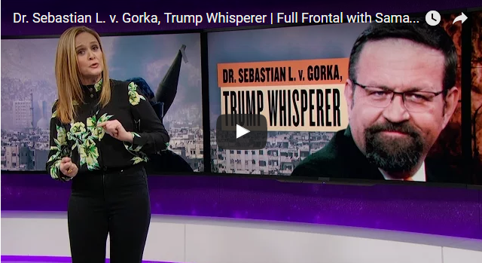
- Video: Samantha Bee Wants You to Get to Know President Trump's Islamophobic Terrorism 'Expert,' Sebastian Gorka
  - CAIR: Even Muslim-American Citizens Have Been Caught in the Net of Trump's Travel Ban
To Muslim advocates like Hassan Shibly, the chief executive director of the Council on American Islamic Relations' (CAIR) Florida chapter, such stories show that, with Trump in power, border agents feel "emboldened" to implement "discriminatory practices."
After Trump's executive orders targeting Muslims were signed, "all the gloves came off," said Shibly.
FOR IMMEDIATE RELEASE
CAIR-NY Condemns White Supremacist's Murder of African-American Man Near Times Square, Islamophobic Attack on Woman in Queens
(NEW YORK, NY, 3/23/17) -- The New York chapter of the Council on American-Islamic Relations (CAIR-NY), a leading Muslim civil rights and advocacy organization, today condemned a white supremacist's allegedly racially-motivated murder of an African-American man near Times Square.
CAIR-NY also condemned another apparently bias-motivated attack earlier this month on a woman in Jamaica, Queens.
In the attack near Times Square, James Harris Jackson stabbed Timothy Caughman multiple times in the chest and back on Tuesday night. Jackson later turned himself in to the NYPD quickly telling them where to find the alleged murder weapon. Jackson reportedly traveled from Baltimore to New York with the intention of killing African-American men, hoping that by committing the crime in New York City, he could secure more media attention.
SEE: Army Vet Accused of Murder Came to NYC to Kill Black Men, Cops Say
In the other incident, which took place March 6 in Jamaica, Queens, an unknown woman punched the victim in the neck after shouting anti-Muslim slurs. The NYPD released surveillance video of the incident to seek the public's help in identifying the alleged attacker.
SEE: Cops Hunt for Half Bald Woman Who Harassed Muslim in Queens
"We must not lose one more New Yorker to bigotry and violence," said CAIR-NY Executive Director Afaf Nasher. "These bias-motivated attacks are an affront to every human being, and we must all work together to ensure the victims receive justice to fullest extent of the law. We continue to see a distressing increase in hate crimes targeting the Muslim community. Far too many hate crime victims continue to suffer in silence. We must make sure that ever attack is reported and that every attacker is apprehended."
"If the person who allegedly murdered Timothy Caughman were Muslim or Arab, it would be called what it is: 'an act of terrorism,'" said CAIR-NY Legal Director Albert Cahn. "Too often we politicize our narratives to highlight some crimes and downplay others. This tragic attack, which targeted the heart of our great city, took the life of one of our fellow New Yorkers."
"Going forward, our city and state must appropriate the resources needed to safeguard all religious and cultural sites against the threat posed by hate crimes," said Cahn.
Earlier this week, CAIR-NY endorsed the New York City Council's proposed security grant program that would allocate $25 million to safeguard Muslim and Jewish Community centers, and other non-profit institutions which have faced increased threats and risk of attacks in recent months.
SEE: CAIR Supports NY City Council Security Grant Program to Protect Muslim, Jewish and Other Community Institutions
Earlier this month, CAIR-NY also condemned the anti-immigrant and racial harassment of a Latino man in Brooklyn, whose attacker subsequently broke his nose.
SEE: CAIR-NY Condemns Desecration of Jewish Cemetery in Rochester, N.Y. and Bias Attack Against Latino Man in Brooklyn, N.Y.
The number of anti-Muslim hate groups in the United States has grown exponentially, almost 300 percent in the past year alone according to the Southern Poverty Law Center.
SEE: Anti-Muslim Groups 2010-2016| SPLC
CAIR's national headquarters in Washington, D.C., has noted an unprecedented spike in hate incidents targeting Muslims and other minority groups since the November 8election.
Video: CAIR-MN Seeks Criminal Charges for Harassment Targeting Muslim Woman Shopper
Muslim community members are asked to report any bias incidents to police and to CAIR-NY at (646) 665-7599, or by filing a report at: http://www.cair-ny.org/incident-report/
CAIR is America's largest Muslim civil liberties and advocacy organization. Its mission is to protect civil liberties, empower American Muslims, and build coalitions that promote justice and mutual understanding.
La misión de CAIR es mejorar la comprensión del Islam, fomentar el diálogo, proteger las libertades civiles, capacitar a los musulmanes estadounidenses, y construir coaliciones que promuevan la justicia y la comprensión mutua.
-END -
CONTACT: CAIR-NY Executive Director Afaf Nasher, 917-669-4006, anasher@cair.com; Legal Director Albert Cahn, 571-766-6273, acahn@cair.com

