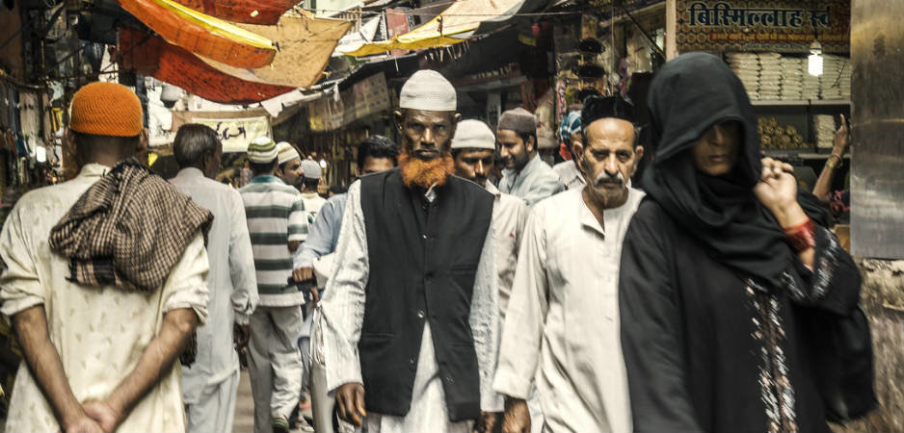
AJMER RAJASTHAN, INDIA © ALUXUM
  - Mar 14, 2017
CENTRAL & SOUTH ASIA | INTERNATIONAL SECURITY | OPINION |

Do Not Mistake a Pious Muslim for a Terrorist
- BY FERNANDE POOL
- MARCH 21, 2017FERNANDE POOL
Fernande Pool is a researcher on Islam and secularism in South Asia. She focuses on Islamic reformism, religious and secular ethics, and related human

How the war on terror is becoming incorporated into mainstream politics.
Well before Donald Trump was elected and Geert Wilders threatened to close all the mosques in the Netherlands, Muslims have been disproportionately affected by reactionary politicians’ lack of commitment to universal human rights. The annual Human Rights Watch World Report draws particular attention to this issue: an introductory essay on terrorism discussed not the human rights abuses committed by violent extremists, but the human rights abuses committed in the name of the war on terror.
Like any war, this war risks disrupting the peaceful lives of innocent citizens. Unlike other wars, this war is becoming incorporated into mainstream politics.
The UN Security Council Resolution 2178 requires governments to take action to prevent or counter violent extremism (CVE). There are, however, no universal legal definitions for terrorism or violent extremism. Resolution 2178 leaves such definitions open to governments. This open-ended nature of the resolution means that Muslims in general could easily end up suffering for the sins of Islamist extremist groups.
This vagueness is particularly worrisome since preventing radicalization through social and “other” activities is an essential element of CVE. “Radical” behavior does not necessarily involve violence or intended violence. Peaceful expression and association, including religious devotion, may fall within the specter of what states consider radicalization and in need of control.
This potential excess of the use of counterterrorism measures and CVE risks targeting innocent people, and Muslims in particular, whereas Muslims, just as much as non-Muslims, are the victims of violent extremism. Crucially, targeting innocent Muslims has an obvious counterproductive effect, making them more vulnerable to the outreach of extremist ideologies.

MARGINALIZATION AND SUSPICION
Marginalization and suspicion of Muslims in the West is relatively recent, starting with the September 11 attacks and the subsequent war on terror, but rapidly intensifying with the current divisive, sometimes overtly anti-Muslim politics spreading across Europe and the United States. In contrast, Muslims in India have faced marginalization and suspicion for decades, if not centuries. The situation in India can thus function as an example for the West, as the effects of the war on terror may replicate the transformations Indian Muslims go through elsewhere.
Embed from Getty Images

As the influential Centre for Strategic and International Studies (CSIS) remarks in a recent report on CVE strategy, various forms of structural conditions (including real and perceived marginalization, experiences of injustice and corruption) can make violent extremist organisations seem appealing. In India, these structural conditions are historically present. In Europe and the US, these conditions are growing due to a wide range of factors—possibly including the very CVE measures that states mobilize to prevent the consequences.
I conducted research in rural West Bengal, between 2011 and 2013, and for shorter periods in 2014 and 2016, in a village I call Joygram. I observed how innocent Muslims could be misidentified as potentially radicalizing. The story I tell here, about Muslims in India, is not directly about the counterproductive effects of CVE, as there were no such measures in place in this rural area when I was there. It is therefore more a cautionary tale on how not to mistake a pious Muslim for a terrorist. However, it is also an example of the potential effects that the marginalization and suspicion of innocent Muslims may have.

SECULARIZING OR RADICALIZING?
Muslims in India have been the subject of marginalization and discrimination at least since its postcolonial foundation. Despite the nation’s proud self-identification as secular and democratic, Muslims who defied partition and remained in India are tacitly considered second-class citizens. Their loyalty to the Indian nation is always questioned. Under current Hindu nationalist Bharatiya Janata Party (BJP) rule, Muslims are openly deemed a “dangerous Other” and a threat to national unity.
This attitude toward Muslims materializes in human rights abuses and actual inequalities. Muslims have less access to governmental resources, including government jobs. They are not only less protected by the police but are also victims of police harassment and violence. They are ghettoized in the cities.
More recently, despite the particularities of Indian Muslim marginalization, the Indian narrative increasingly conflates with a globalized narrative. According to this narrative Muslims are the antithesis to liberal democracy, a disruption of a secular, liberal world order. Terrorist attacks by Islamic extremists groups increasingly legitimize the suspicion of Muslims everywhere. Global terrorism intensifies the already negative attitude toward Muslims in India.
Moreover, the kind of leadership Prime Minister Narendra Modi enacts is gaining global currency. He is an exemplary autocratic leader, purporting to speak in the name of the majority while turning a blind eye toward, if not actively encouraging, human rights abuses against the minority. The election of President Trump and the surge of popularity for Geert Wilders in the Netherlands are just the most recent examples of the populist trend.
As a result, whereas the secular, liberal West seems to increasingly think that Muslims are the greatest threat to peace, for these Muslims that very thought and the measures taken accordingly are a threat to their peace. Many Westerners feel they live under the threat of Islamic terrorism. Muslims everywhere live under the threat of being considered terrorists.

Many Westerners feel they live under the threat of Islamic terrorism. Muslims everywhere live under the threat of being considered terrorists.

This suspicion and concomitant marginalization create a deep sense of disquiet amongst the Muslims I work with. There is anger, and frustration, but foremost a sense of moral failure and responsibility. Paradoxically, perhaps, many of the Muslims in Joygram attempt to gain a sense of peace by converting from the local, non-denominational Islam to the more puritan, reformist Deobandi Islam.
This involves an emphasis on “proper” Sunni Islamic practice (closely following the five pillars of Islam; condemnation of shrine worship); a change in aesthetics (white Muslim dress, Islamic cap and uncut beard and shaven upper lip for men; a salwar kameez instead of sari for women, and in some cases a burka); and changes in everyday habits (as closely as possible following the hadith—the sayings of the Prophet Mohammad).
These visible changes make many non-Muslim Indians suspicious. It looks like reformist Muslims become “more Muslim,” and by implication “less Indian.” The more Muslim they become, the more they (allegedly) reject liberal values and instead (ostensibly) show allegiance to extremist Islamic ideologies.
This is a radical misunderstanding of the project of reformation as explained and practiced by Deobandi Muslims themselves. For them, this conversion to reformist Islam is a holistic ethical transformation: a response to the moral degradation of politics and society (including of Muslims themselves); an attempt to withstand the pervasive corruption implicating every Indian in an immoral economy; an almost desperate attempt to revive virtue in one’s personal, social, economic and political life—as a Muslim, but also as an Indian citizen.
Indeed, Islamic reformism is, from their perspective, the basis for becoming a virtuous, secular Indian citizen, and for claims for equal inclusion in the democratic nation. To them, virtuosity implies living in harmony with others, contributing to the Indian democracy and abiding by national law. So perhaps paradoxically to secular liberal ears, a new, reformed Islam becomes the basis of secularism.
The ethical framework of Muslims in Joygram is not rigidly stuck in time but has gradually incorporated secular liberal values. This ethical framework is called Islam only because India has a long history of reducing holistic moralities to narrow religious and communal modes of identification. Living morally should imply living peacefully, by following Islamic prescripts, locally specific rules of sociality, and the Indian constitution alike. Becoming a reformist Muslim is therefore a public statement showing: I do not engage in any immoral or unlawful activities.
Embed from Getty Images

TERRORIST, NO!
Alas, political and public discourse often positions Islam in contradistinction to secular liberalism. These processes of ethical transformation can therefore be too easily mistaken for processes of radicalisation. This mistake would fit with the conveyer belt theory of radicalization. This theory would presume that reformist Muslims are indeed covering the first steps toward becoming violent extremists. Prominent scholars have widely discredited this theory yet it is still prevalent in certain circles. Other circles, such as the CSIS, follow the evidence that there is no direct link between religious conservatism or reformism and violent extremism.
We cannot easily predict whether these Muslims are on the road to radicalization. Radicalization has more to do with external factors—marginalization, experiences of injustice—than with currently prevalent intentions or sentiments. Suspicion of reformist Muslims is particularly problematic since increased religious devotion may in fact reflect efforts to challenge Islamic extremism. The CSIS, for instance, recognizes that religious fluency can be helpful in challenging extremist ideas and narratives. And, I would add, can help individuals to contribute to secular harmony.
Suspicion of radicalization is a major motivation to join the proselytizing movement the Tablighi Jamaat. The Tablighi Jamaat is an apolitical, non-violent Islamic organization. This was the case for Farid, who joined the Tablighi Jamaat to demonstrate that Muslims are peaceful. Farid fiercely condemns any terrorist attacks committed in the name of Islam; those people are not worthy a Muslim title.
When I introduced Farid to a British friend, Farid immediately pre-empted any suspicion that his Islamic aesthetics may provoke. Imitating shooting an AK-47, and then waving his hand in rejection, he says to my friend, “Terrorist, no! No bombs! We Muslim, shanti (peaceful).” Farid learns and spreads an Islam of peace on the proselytizing tours with the Tablighi Jamaat. Becoming more fluent in this Islam helps him to challenge violence committed in the name of Islam.
Similarly, Deobandi imams preach that is the duty of Indian Muslims to contribute to India’s national identity. An identity captured in the slogan “Unity and Diversity.” Religious devotion includes being welcoming to strangers of whichever community. To pick up a rock on the road to avoid an accident unknowing of who the affected may be. Donning the Islamic garb is a way of demonstrating one’s commitment to this ethical attitude of tolerance and solidarity.
In other words, the turn to reformist Islam is not a rejection of secular liberal values. Instead, it is a response to the failure of secular liberal governance. This failure is painfully visible in the rampantly unequal distribution of resources and rights. It is a response to purposively divisive and corrupt political practice: A politics that fails to secure universal human rights and substantive citizenship. It is a response to the kind of politics that we increasingly see in the US and in Europe.
Joygrami Muslims work hard to become pious Muslims and devoted Indian citizens. Yet fellow Indian citizens suspect them for extremist sentiments. This creates ever more frustration. The ethical transformation that these Muslims engage in further alienates them from the Indian nation state. It makes them ever more suspect of anti-Indian and anti-global secular world order sentiments.
According to some CVE programs in the US and the UK, a perceived sense of being treated unjustly, expressions of hopelessness, futility and connection to group identity (including religion) are criteria suggesting that people are at risk of radicalization.
Most of the Muslims I worked with would easily meet all these three criteria. They feel treated unjustly, because the politicians and police marginalize Muslims on the basis of their religious identity. They feel hopeless because the very measures they take to demonstrate that they are peaceful are counterproductive. Their struggle for inclusion in the Indian nation state instead raises suspicion. They increasingly connect to their religious identity—firstly, because Islam offers them the tools for living ethically and peacefully; secondly, because they feel excluded from claims to the Indian group identity.
Yet their ethical transformation should not in any way be misunderstood as radicalization. It is the misunderstanding of their ethical journey that may incite a very different and otherwise unrelated journey—a journey toward radicalization. Hence a warning: Do not mistake a pious Muslim for a terrorist.
The views expressed in this article are the author’s own and do not necessarily reflect Fair Observer’s editorial policy.
***

POLITICS
03/21/2017 07:52 pm ET

Bias And Fear Are The Norm For Many Muslim Americans, Poll Finds

More than half have experienced religious discrimination in the last year, and Donald Trump isn’t helping.

By Kate Abbey-Lambertz
X
450

Religious discrimination is an ordinary occurrence for the majority of Muslim Americans, and President Donald Trump’s election has spread fear throughout portions of the community, according to a nationwide poll released Tuesday.
The Institute for Social Policy and Understanding think tank surveyed 800 Muslims from Jan. 4 to 23 for a wide-ranging look at the particular struggles they face. The report, “American Muslim Poll 2017: Muslims at the Crossroads,” compared their responses with those of people of other faiths and the U.S. population at large.
Sixty percent of Muslims reported personally experiencing religious discrimination in the past year, compared with 17 percent of the general population. Forty-two percent said their kids had experienced bullying in the previous year.
The new administration loomed large in Muslims’ responses. More than a third said they feared for their own or their family’s safety from hate groups in the wake of the election. A smaller number of Muslims said that since the election they had made preparations to leave the country if needed, changed their appearance to be less obvious as Muslim or signed up for a self-defense class.
A rash of hateful comments and actions directed at Muslims following the Nov. 8 presidential election has perpetuated that fear, Council on American-Islamic Relations spokeswoman Zainab Chaudry said at a panel announcing the report.
“We saw that taper off after the first couple weeks after the election,” Chaudry said, but “the concern, the anxiety and fear, is still very real.”
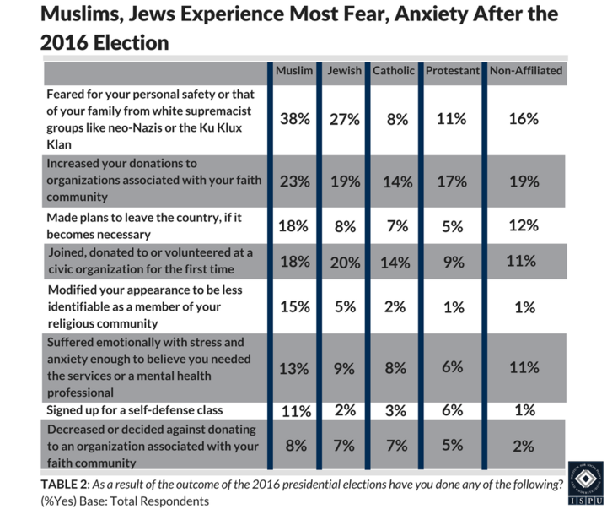
INSTITUTE FOR SOCIAL POLICY AND UNDERSTANDING
Trump’s election has brought Islamophobia into the White House in the forms of the president’s executive orders banning travelers from several Muslim-majority countries and the input of advisers who hold anti-Islamic views. Trump himself has said he thinks “Islam hates us” and repeated the debunked claim that he saw thousands of Muslims Americans celebrating after the Sept. 11, 2001, terrorist attacks.
“There’s been more than 15 years of propaganda, miseducation campaigns, to convince the American public that Islam is inherently evil and violent and that Muslims should be associated with terrorism and fear in their communities,” Charles Haynes, founding director of the Newseum Institute’s Religious Freedom Center, said Tuesday.
“Even in the corridors of power now, this narrative, this propaganda which used to be on the fringe has moved into the center, and it’s now mainstream,” Haynes added.
Only 15 percent of Muslims favored Trump in the election, according to the survey. Just over half supported Democratic presidential nominee Hillary Clinton, and nearly a third didn’t support either candidate.
Muslims are the most racially diverse religious group among those surveyed, according to ISPU, with no one race holding a majority. Half of American Muslims were born in other countries.
ISPU hopes its findings will give the public and policymakers a better understanding of a group often overlooked by pollsters and stereotyped by pundits.
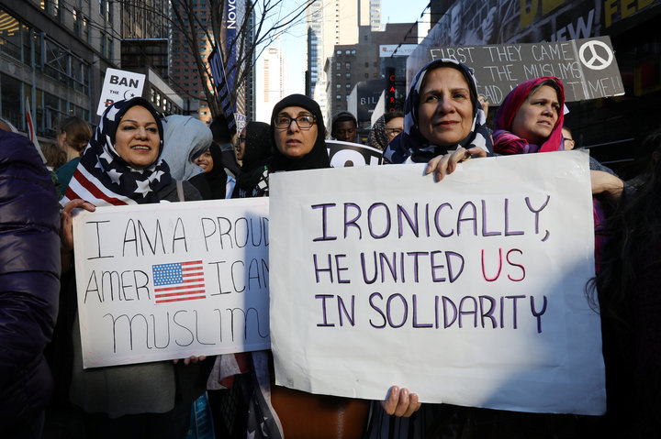
CREDIT: CARLO ALLEGRI/REUTERS
Women wearing U.S. flag hijabs gather at an “I Am Muslim Too” rally in New York City last month.
While the experts discussing the report Tuesday constantly referred to the precarious situation for Muslims under Trump’s administration, they also pointed to some bright spots, including a wave of support from allies and increased community activism. Nearly a fifth of Muslims reported getting involved with civic organizations for the first time after the election.
The political climate and Trump’s executive orders targeting some Muslims have actually brought out the best of the community, Chaudry argued.
“We’re seeing young folks step up to the podium,” she said. “They’re saying that we’re not going to be silent bystanders. We’re not going to allow our religion to be hijacked. We’re going to make sure that we shape our own narrative.”
For the institute’s report, research firm SSRS surveyed 800 Muslims and 340 Jews by cell phone, landline and online panel. Triton Polling conducted a poll of the general public, interviewing 1,250 people by phone to examine the views of Protestants, Catholics and people who weren’t affiliated with a religious group. The responses from the two separate surveys can be accurately compared because each captured a representative sample of its target populations, according to SSRS chief methodologist and executive vice president David Dutwin. The margin of error for the SSRS poll is plus or minus 5.1 percentage points for Muslim respondents and 6.5 percentage points for Jewish respondents, and the Triton poll included a margin of error of plus or minus 2.8 points.
Do you have information you want to share with the Huffington Post? Here’s how.

ALSO ON HUFFPOST
Kate Abbey-Lambertz National Reporter, The Huffington Post
***

POLITICS
03/21/2017 02:48 pm ET | Updated 13 hours ago

Virginia GOP Demands State Attorney General’s Apology For Mosque Visit

Though members of the party have visited mosques before, the GOP now seems to distrust any engagement with Muslims.

By Akbar Shahid Ahmed
X
4.3k
150
WASHINGTON ― The Republican Party of Virginia is attacking the state’s Democratic attorney general, Mark Herring, for visiting one of the U.S.’s largest mosques to talk about President Donald Trump’s Muslim ban.
“On March 17, Mark Herring joined with a Hamas-linked group, the Council on American-Islamic Relations, to host a town hall to oppose the Trump Administration’s efforts to keep Americans safe from terrorism,” reads a petition on the state Republican Party’s website that appears designed to collect emails. “Sign our petition to demand that Mark Herring apologize to the victims of Islamic terrorism.”
The message’s characterization of the Council on American-Islamic Relations, a major Muslim civil society organization, as an affiliate of the Palestinian terror group Hamas echoes a theory that is popular in the right-wing media and Islamophobic circles but has never been proven.
And the party’s description of the mosque where the event was held ― the Dar al-Hijrah Islamic Center in Falls Church, Virginia ― mentions former attendees who have been linked to terror, but makes no reference to the center’s outreach to the FBI, including hosting a top FBI official at the mosque in January. It also doesn’t mention the harassment, including a fake bomb threat and offensive messages, the community there has experienced in recent months.
From the White House on down, Islamophobic rhetoric and actions are on the rise nationally. An FBI report released in November 2016 noted a 67 percent increase in anti-Muslim hate crimes between 2014 and 2015.
In Virginia, an increasingly purple state that twice voted for President Barack Obama and chose Democratic nominee Hillary Clinton over Trump, Republicans have tried to differentiate themselves from an increasingly anti-Muslim national GOP.
Former Rep. Tom Davis (R-Va.) has visited the mosque at the center of the controversy, and in December, the current chair of the state GOP, John Whitbeck, visited a different mosque in Sterling, Virginia.
“The Virginia Republican Party is the party of religious liberty. We don’t support banning Muslims in the United States of America,” Whitbeck said at the time.
Rep. Barbara Comstock (R-Va.), a lawmaker from a swing district Democrats are hoping to pick up in 2018, also attended the Sterling mosque event. She called Trump’s 2015 proposal to ban Muslim entry to the U.S. “not constitutional” and said she believed the president had changed his mind.
Yet the party’s message about Herring suggests that it sees any engagement with Muslims as unacceptable and insulting to those who have experienced Islam-linked terror. “Stop pandering to terrorist sympathizers,” the appeal reads, conveniently ignoring the fact that Muslims in the U.S. and abroad are frequently victims of terror themselves.
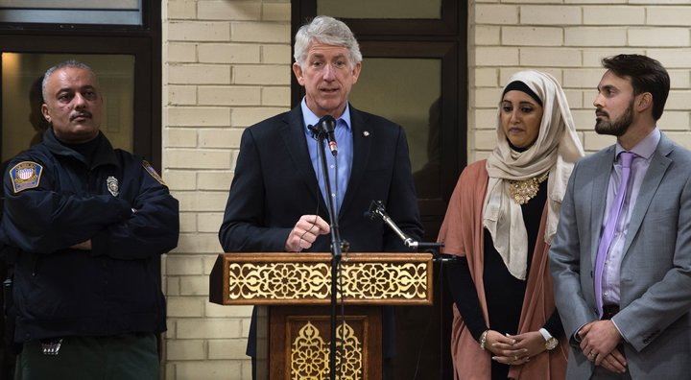
PAUL J. RICHARDS/AFP/GETTY IMAGES
“I’m here to defend and protect the rights and civil liberties of all Virginians, including minority communities, no matter what you look like, what your background is,” Virginia Attorney General Mark Herring told attendees at the Dar al-Hijrah Islamic Center on March 17.
The GOP message reflects the increasingly extreme discourse and political polarization of the Trump era. Muslims’ place in American society is now a major issue of national debate, rather than something that’s largely accepted.
A similar trend has emerged in Europe, with the rise of hyper-nationalist and often anti-Muslim parties. Once-extreme ideas like a Muslim ban or closing all mosques are now part of the political conversation, and politicians trying not to look weak are beginning to adopt more nativist and authoritarian talking points.
“Under the cover of fighting off the ‘populists,’ the political establishment is slowly but steadily hollowing out the liberal democratic system,” Cas Mudde, a University of Georgia professor who studies European politics, argued in a March 20 op-ed.
Robert McCaw, the government affairs director for CAIR and a speaker at the March 17 event, slammed the Virginia GOP’s petition. He said the mosque event offered more than 200 attendees a message of reassurance about their place in the U.S.
“It’s not Herring [who] needs to apologize. It’s the state Republican party for engaging in this smear,” McCaw said. “It endangers Muslims when you have a state party smear an entire faith community in their house of worship. What type of signal is this sending, and on whose ears will it fall?”
Colin Christopher, the deputy director of government affairs for Dar al-Hijrah, contacted HuffPost Tuesday night to say the congregation saw the GOP message as a sign of the party’s shift toward what he called “extremism.”
“Instead of talking about the economic challenges our country faces, the party instead chose to try and criminalize an entire community that was hosting a citizenship application clinic and know-your-rights event with the highest law enforcement official in the State of Virginia,” Christopher said.
The center is used to fear-mongering, he added. “If anyone wants to understand who Dar al-Hijrah is, what we do, they have to go no further than to talk to members of Congress, to local elected officials, to every single rabbi, priest and other religious leader in Fairfax County and Arlington County and they’ll get the story,” Christopher said. “We’re not threatened by this kind of language. It just shows the character of the Republican Party.”
Herring’s team responded Tuesday night as well.
“While Attorney General Herring is actively working to reassure Virginia Muslims and other minority communities that they are safe and welcome, the [Republican Party of Virginia] is sending dangerous messages that only embolden those who want to harm or harass Muslims here in our communities,” communications director Michael Kelly said in an email. “I’ll go ahead and extend an open, standing invitation to anyone from the RPV or any Republican elected official or candidate to join us the next time Attorney General Herring visits a Virginia mosque and they can tell their fellow Virginians to their face how they’re ‘terrorist sympathizers.’”
Herring is one of several state attorneys general challenging Trump’s ban.
“I’m here to defend and protect the rights and civil liberties of all Virginians, including minority communities, no matter what you look like, what your background is,” Herring told attendees at the March 17 event.
John Findlay, the executive director of the Virginia GOP, told HuffPost his party was troubled by the specific mosque Herring spoke at, not by the general idea of political appearances at mosques.
He also condemned CAIR, saying he was certain the civil society organization had links to Hamas. As proof, he emailed a link to a National Review story that cited a decision by the United Arab Emirates to designate CAIR a terror group. (Experts say the UAE action had more to do with suppressing civil society than a true terror threat, but anti-Muslim figures in the U.S. have cheered that government’s repression.) Findlay said he could not imagine the GOP engaging with CAIR.
“We didn’t smear an entire faith community in any way, shape or form,” Findlay said. “We were commenting on Mark Herring’s appearance at this mosque that has been linked to multiple terrorists.”
The visit by Davis, the former Republican lawmaker, was different because he had already left office, Findlay said.
Asked whether he thought it was appropriate for the FBI to attend an event there this past January, he replied, “Oh, man ... when did they?”
Findlay then said the bureau’s decision was different because FBI employees were not politicians. Asked again, he said he did not want to comment on the matter.
This story has been updated to include comment from John Findlay, Herring’s office and Dar al-Hijrah.
Do you have information you want to share with the Huffington Post? Here’s how.
Suggest a correction

Akbar Shahid Ahmed Foreign Affairs Reporter, The Huffington Post

***

UMD students discuss impacts of Islamophobia
By Lisa Kaczke on Mar 21, 2017 at 10:28 p.m.
11
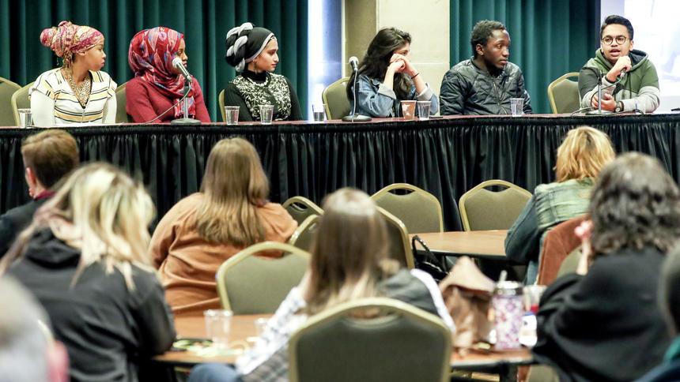Members of a student panel Najma Mohamed (from left), Iman Geleto, Azrin Awal, Nazila Wazirzada, Isaac Bukenya, and Mueez Ahmad participate in the UMD’s Muslim Student Association “Addressing Islamophobia,” event at the Kirby Ballroom in Duluth Tuesday. (Clint Austin / caustin@duluthnews.com)
Azrin Awal was 3 years old when she immigrated to the United States from Bangladesh because her parents wanted their children to have the best opportunities possible. Awal was a 4-year-old Muslim on Sept. 11, 2001.
Trembling at the podium on Tuesday as she remembered the days that followed, she explained the fear that she saw in her parents when the news reported that the terrorists were Muslim.
"I don't think as a child, no moment hurts more than when you see your parents in utter shock and fear because they don't how to protect you and that's what they promised. They promised to protect you. It hurt me so much that I couldn't be there for my parents. I didn't know how to comfort them," she said.
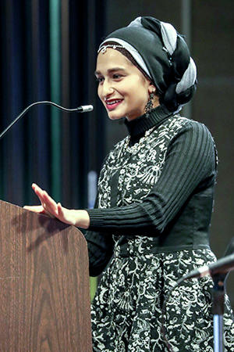
Azrin Awal tells of what it is like to be a Muslim living in the United States.
Separated from her mother and put into a room at an airport, she said she was stripped and patted down as a 4-year-old. She went from being a bubbly, happy kid to a quiet child fearing other people and carrying "so much guilt for my identity." She began exploring other religions, but always came back to Islam.
By the time she enrolled at the University of Minnesota Duluth, she realized she wasn't alone in her struggle about religion and began speaking up about her faith.
Awal was among six Muslim UMD students who spoke to in a packed Kirby Ballroom at UMD for a panel discussion on Islamophobia.
There are 1.6 billion Muslims in the world and, similar to people in other religions, Muslims vary on how religious they are, Awal said. She explained that Islam forbids suicide and killing innocent people, and that Muslims reject suicide bombers. The term "jihad" has been misconstrued and its true meaning is the internal struggle to be a good person, she said.
"Islam means peace. To be Muslim means to submit to peace and one God," she said.
Mueez Ahmad, president of the Muslim Student Association at UMD, said he's become more open to discussing Islam since November's election. Several students said they've seen more support for the Muslim Student Association on campus since President Donald Trump was elected.
The students said they haven't been directly subjected to rhetoric or actions because of their religion since November, but they worry that it could happen to them or their families at some point. However, the hate crimes and Islamophobic sentiments they've heard about since the election makes them uncomfortable and scared, several students said.
"I am an immigrant and a Muslim and it's scary when these negative things are targeting you and your family. I haven't been affected by it personally, but it's scary to think that your father, your mother, your sister could all be targeted at any point, even if they're just at the grocery store and somebody could say something to them," UMD student Nazila Wazirzada said. "It's scary because that could personally happen to my family. Trying to not worry about that so much and focus on the positive is an everyday struggle."
UMD student Iman Geleto said she sees negative comments about Muslims made by UMD students on social media that they wouldn't have the courage to say to her in person. When she goes out in Duluth, people don't make comments, but instead give her "a look," she said.
"There isn't a lot of Muslims here in Duluth as a city, in general, and it's just new to them sometimes. But at the same time, there is some ugly stares and they give you the look like 'who are you,' like you're some kind of alien type of thing," she said.
***

Gorgeous Portraits Capture The Sisterhood Between Muslim American Teenagers

“I now know that there is nothing wrong with me, and that I am just as American as that white boy.”
By Priscilla Frank

KYNA UWAEME
“Being a Muslim girl means so much to me,” a teenager named Aya told photographer Kyna Uwaeme. “In this day and age, many people have misconceptions about Muslims, especially Muslim women. Some people see us as oppressed and closed-minded. However, that is not the case.”
Aya was one of three young women to respond to Uwaeme’s open call inviting Muslim women to participate in a photography project focused on the challenges, joys and misconceptions surrounding Muslim American girls. Aya continued: “Being a Muslim girl in America means that I need to represent my religion properly to get rid of the ignorance that plagues many societies today. It means respect, not submission ― tolerance, love, selflessness and much much more.”
Uwaeme, a Nigerian-American woman who was raised Catholic, had little knowledge of Muslim culture and tradition before this project. However, between hearing news about the violence inflicted by militant Islamist group Boko Haram in her parents’ homeland and the Islamophobia that plagues the U.S., Uwaeme wanted to increase her knowledge of the religion and those who observe it.
KYNA UWAEME
“The whole point was to bridge the gap between the Western understanding of Islam and the African understanding of Islam,” Uwaeme told The Huffington Post.
Although Uwaeme wasn’t planning on working exclusively with teens ― she put a casting call on Instagram and, somewhat unexpectedly, only high-school girls responded ― she was excited by the prospect of working with women who are still growing and discovering themselves.
“Younger girls are more open to working with me,” the photographer said. “They are at a place in their lives where they are becoming who they are. I like to give them confidence and power through my photography, more of a voice. They got to go to school afterwards like, ‘Look at me now.’”
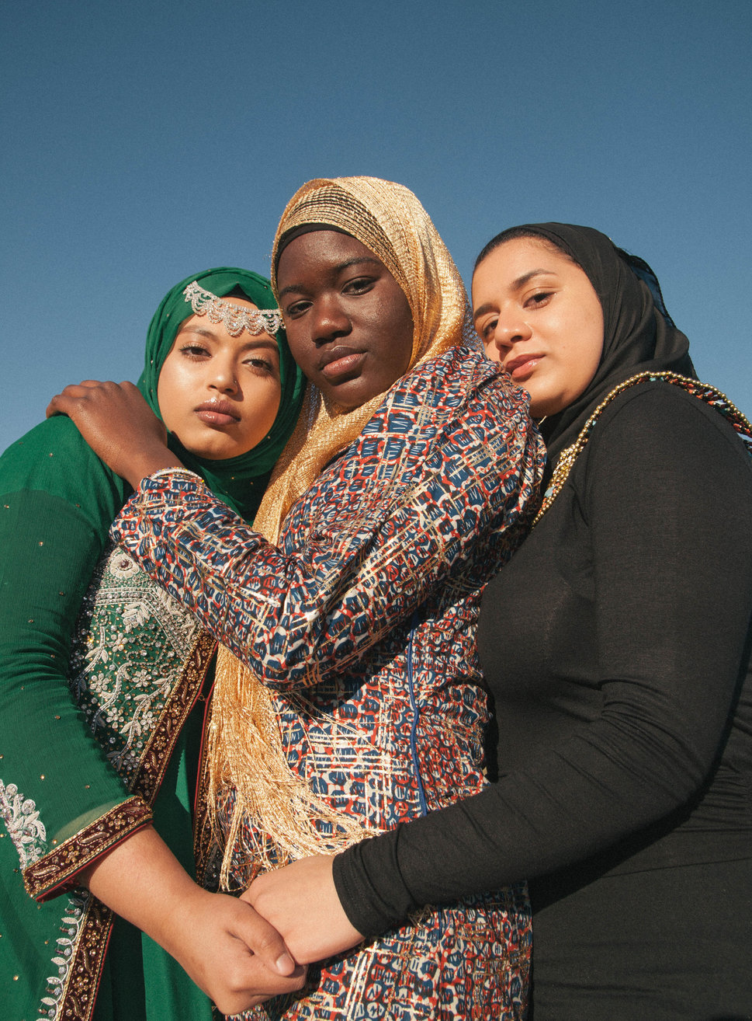
KYNA UWAEME
SUBSCRIBE TO & FOLLOW CULTURE SHIFT
The photographs feature three teens named Alishba, Aissatu and Aya, dressed in earth-toned hijab adorned with sparkles and gold, moving through an empty field against a dusty blue sky. In some images, the women stare confrontationally into the camera, daring the viewer to judge or deride them as they pose with self-possession, power and poise. In others, the girls hold hands, hug and lean on one another, communicating the body language of sisters or old friends.
“Even though they didn’t all know each other they had this sisterly bond,” Uwaeme said. “They all overcame similar struggles and I think that connection shows.”
Alishba, Aissatu and Aya described such struggles to Uwaeme throughout the shoot. Each subject faced more ignorance, discrimination and hatred than any person should have to endure, especially at such a young age. “I have been called a ‘terrorist,’ an ‘immigrant’ ― what’s insulting about that? ― ‘Osama bin Laden’s daughter’ and many other hateful things,” Alishaba recalled. “Staring is almost a daily occurrence and quite frankly I’m used to it.”

KYNA UWAEME
Aissatu’s recollections were just as disturbing. “Two years ago while traveling to Senegal with my family my mum was given a pat down at the airport,” she told Uwaeme. “I will never forget it because my mum began crying because she felt that she was being discriminated against. My mum always gets chosen for pat downs even though they claim it as ‘random.’ There have been times where I’ve sat down next to someone on a bus or train and they immediately sprang up. Once that happened while I was with a friend and she was so shocked that it was such a normal encounter for me.”
Yet despite the prejudice the young women have experienced as a result of their religious identity, to them, Muslim faith is still a source of power and love.
“Being a Muslim girl represents my love of Allah and the prophet Muhammad,” Alishaba told the photographer. “It means that I am not afraid to express what I believe in and it means that I am strong. Islam gives me my strength and hope. So, really, being a Muslim girl means everything to me.”
Additionally, Alishaba is well beyond worrying too much about what others think or say. “I now know that there is nothing wrong with me, and that I am just as American as that white boy,” she said.
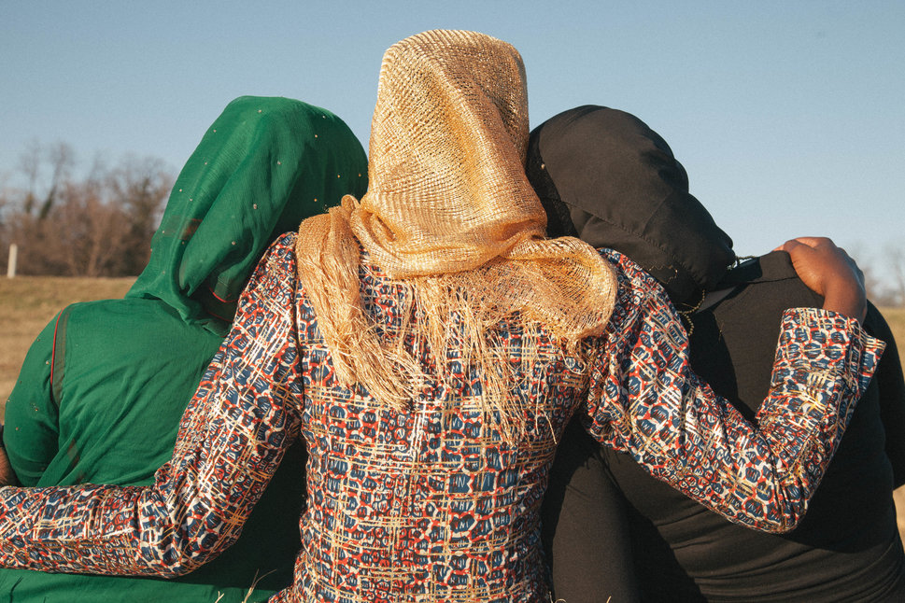
KYNA UWAEME
Through her photos, Uwaeme hopes to spread understanding and compassion in a time when such sentiments are increasingly scarce. “I’m not too much into politics,” she said. “But socially, I just wish for more acceptance within the world. I hope we can accept all people and all groups and just find something in common. We need to realize we are all in this together.”

KYNA UWAEME

ALSO ON HUFFPOST:
X

Priscilla Frank Arts Writer, The Huffington Post
***

Misdiagnosed: Why We Oppose The Refugee Ban
Aniyizhai Annamalai, Director, Yale Adult Refugee Clinic; Assistant professor, Yale School of Medicine

Erik Levinsohn, 4th year MD student, Yale School of Medicine

Shivani Bhatt, 4th year MD-PhD student, Yale School of Medicine

Misdiagnosed: Why We Oppose The Refugee Ban

We feel a responsibility to correct a false and deeply harmful depiction of our patients.
03/21/2017 06:29 pm ET
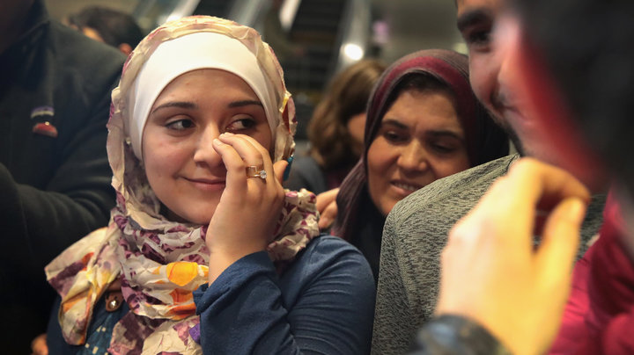
SCOTT OLSON VIA GETTY IMAGES
Syrian refugee Baraa Haj Khalaf wipes away a tear after arriving at O’Hare Airport with her family on a flight from Istanbul, Turkey on February 7, 2017.

“Every night a man approaches me and screams in my left ear,” the man* says with an unchanging expression. “I wake up covered in sweat and can’t fall back asleep.” His nightmares date back ten years to when he was kidnapped from his hometown, shortly after burying his brother who was killed in the war.
The scar on his cheek is a relic of the torture he endured in captivity. Poorly controlled health issues like diabetes forced him to seek help from the UN. He struggled to get medication, and at one point was in a coma for a week. He woke up tethered to a hospital bed by wrist restraints. “They told me I had been shouting and thrashing in my sleep.”
This true story is not an outlier at the Yale Refugee Clinic. It is crucial that physicians, politicians, and laypeople alike hear these narratives because the American debate over President Trump’s refugee bans fundamentally rests on a question of identity: who, exactly, are these refugees?
President Trump has cast refugees in a shadow of suspicion and fear. With each new version of his immigration ban, he continues to denounce the vetting process as unable to weed out terrorists. Although his bans have been overturned in court twice, this issue is not going away anytime soon: President Trump has promised to continue working towards a ban on refugees from Muslim-majority nations. Despite not being able to present evidence in court that refugees from banned countries have ever been involved in terrorism, the Trump administration continues to paint refugees as foreigners who are threats to American security.
As a country, we will determine how, years from today, we will be remembered.
We feel strongly that this is a dangerous misdiagnosis of refugees arriving in America. As health care providers, we gain crucial insight about our patients from their stories. We see their illnesses in a broader social, psychological and political context. As part of our commitment to all our patients, we feel a responsibility to correct a false and deeply harmful depiction of our patients.
So, who are the refugees we see in clinic?
Our patients wait many years in refugee camps after being displaced from their homes. Some have risked their lives doing invaluable work for the American military. As part of their admissions process, they have undergone extensive overseas medical and security screenings. Under the Obama administration, an extremely high threshold was used to identify candidates for resettlement, with less than 1 percent of refugees worldwide meeting standards set by security agencies.
Our patients have already begun the process of integrating into American society within days of getting off the plane. Soon after arrival, most refugees start working in unskilled jobs, despite often having advanced degrees in accounting, engineering, business or medicine. With help from local resettlement agencies, they are taught English through intensive instruction and provided job search support, all designed to make them self-sufficient and financially independent within six months of arrival in the U.S. They become productive members of American society who actually increase average income for their fellow Americans. In short, they represent the “good immigrants” that President Trump has at times acknowledged are worth admitting.
At the Yale Refugee Clinic, we witness our patients adapt to a new life as we help manage the mental and physical conditions that continue to afflict them years after being victims of violence, torture, and persecution. For our refugee, who has lost his home, his family, and his livelihood, working on his English keeps him moving forward. His long hours at the library poring over English books offer him hope for laying the foundations of a new life. He believes in his new country and its people. When asked to choose between treatments for his health conditions, he simply says to us, “I trust you.” Despite years of suffering and betrayal, he has maintained his innate sense of goodness and faith in humanity.
As a country, we will determine how, years from today, we will be remembered. Restricting refugee placement now would mean that innocent people like our refugee will die. It is also in America’s self-interest to repeal the refugee ban: by failing to recognize the humanity of the refugees from the seven banned countries, we provide propaganda for the ISIS claim that America is at war with Islam. This ban risks American security, global health, and our moral standing. When asked by our children and grandchildren how our nation could have forsaken thousands of refugees, what will we say?
* Patient name has been withheld to due to concerns for confidentiality and sensitivity of material
Dr. Annamalai is the director of the Yale Adult Refugee Clinic. Shivani Bhatt and Erik Levinsohn are students at the Yale School of Medicine who have volunteered at the clinic.
Do you have information you want to share with the Huffington Post? Here’s how.

ALSO ON HUFFPOST
X

University can feel like a hostile place to Muslim students
March 20, 2017 6.42am EDT
SLS ISS culture connect, Author provided

Author

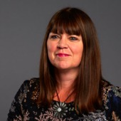
- Jacqueline Stevenson
Professor and Head of Research Sheffield Institute of Education, Sheffield Hallam University

Disclosure statement
Professor Jacqueline Stevenson will be receiving funding from the Social Mobility Commission

Partners
Republish our articles for free, online or in print, under Creative Commons license.
British Muslims are among some of the most disadvantaged people living in the UK, and yet this is not a story many are familiar with. This is because despite the poverty, disadvantage and social immobility Muslims face, headlines that link the faith to crime or terrorism, or to forced marriage or honour killings, are much more common.
But the reality, as reported by the House of Commons Women and Equalities Committee, is that the unemployment rate for Muslims in the UK is more than twice that of the general population – and the disadvantage is even greater for Muslim women.
On top of this, the committee also found that many Muslims face discrimination and Islamophobia, along with stereotyping, pressure from traditional families, and insufficient role models.
And a lack of social mobility – the ability of individuals, families or groups to move up or down the social ladder in society – seems to be a particular issue for British Muslims of Bangladeshi and Pakistani heritage.

Poor access to education
One of the main problems, is that young Muslims face disadvantage when they come to apply to higher education. This has been shown in research by the Nuffield Foundation, which revealed that those of Pakistani heritage are less likely to receive higher education offers compared to white British applicants.
For those Muslims students who do access higher education, the odds can be stacked against them. Students from most ethnic minority backgrounds don’t do as well as their white peers – even when they enter higher education with the same or better qualifications. And although data on religion is not routinely collected by universities it is likely that many Muslims students are underperforming.
It can be hard for young Muslims to access higher education. Shutterstock
Even when Muslim students do manage to get good grades, good jobs are not always on the horizon. A recent report showed that young Asian Muslims face a “broken social mobility promise”, with a lack of jobs outlined as a major issue.
Pakistani and Bangladeshi Muslim women fare particularly badly in this area – which was detailed in the recent Casey Review.
This lack of employment is often made worse by racism, discrimination and the inherent bias faced by those from ethnic minority backgrounds at all stages of their careers. And this includes the move from education to employment.

Hostility on campus
As I reported to the MPs committee, Muslims students’ experiences of higher education are also not always positive. And religion is rarely valued on UK university campuses.
My recent book, Religion and Higher Education in Europe and North America – co-authored with Kristin Aune from Coventry University – explains how universities are often self-consciously secular spaces. This can make those from religious backgrounds feel alienated. And university staff can also feel uncomfortable raising or addressing issues around religion.
Where debates around religion do exist, much of the discourse has drawn on a “moral panic” relating to the growth of fundamentalism and global terrorism. It has focused, in particular, on the threat posed by “Muslim young men”. And in response, ever increasing guidance has been provided to universities on how to tackle violent extremism on campus.
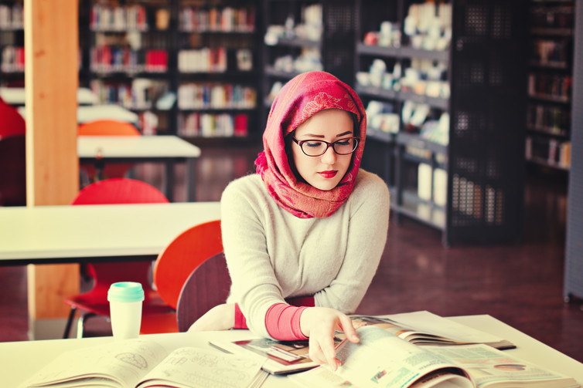Students from most ethnic minority backgrounds don’t do as well as their white peers. Shutterstock
It is unsurprising then that universities can feel like hostile places to Muslim students, which, as my previous research shows, can shape their sense of belonging on campus. Muslim students are of course not the only religious group who find the higher education campus to be, at times, a hostile space. Nor is this a solely British phenomenon.

Implementing change
With this in mind, our book makes a series of recommendations. This includes giving university staff religious literacy training so that they feel equipped and empowered to talk about religion.
Students could also be drawn upon to present different viewpoints on religion. And religious perspectives should be included more often in class discussions. This could help to open these discussions up to both scrutiny and challenge, as well as understanding.
Our call for greater recognition of religious perspectives is not to deny that religion gives rise to conflict – it can and it does. But it is clear that engaging with discussions around religion is a key step to achieving greater equality in the UK.***

