CAIR Community Advisory on Trump's 'Muslim Ban'
| Breaking: Dual Nationals from 7 Muslim Countries Will Be Barred From Entry | CAIR to Monitor Probe of Another Fire at a Texas Mosque
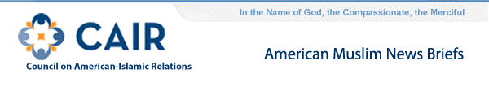
- Breaking: Even Dual Nationals from Muslim Countries Will Be Barred from Entering United States (Wall Street Journal)
Citizens of the seven countries identified by President Donald Trump for a 90-day visa ban who hold dual nationality also will be barred from entering the United States, the U.S. State Department said in a statement Saturday.
In a statement that the State Department is due to release, which was reviewed by The Wall Street Journal, the 90-day visa moratorium extends beyond just citizens of Iraq, Iran, Somalia, Sudan, Syria, Libya and Yemen.
It also applies to people who originally hail from those countries but are traveling on a passport issued by any other nation, the statement notes. That means Iraqis seeking to enter the U.S. on a British passport, for instance, will be barred, according to a U.S. official. British citizens don’t normally require a visa to enter the U.S.
  - CAIR: DHS Says Green Card Holders Will Be Barred from US
"It will bar green card holders," wrote Gillian Christensen, acting DHS spokeswoman, in an email. . .The Council on American-Islamic Relations (CAIR) will file its own lawsuit against the order on Monday, arguing that it violates the US constitution.
- CAIR: Maryland Police Question U.S. Citizen's Immigration Status in 'Walking While Brown' Incident
"People are uncertain - we don't know what to expect. So this is really, I think, a reflection of that uncertainty that people are feeling," says Dr. Zainab Chaudry with the Council on American-Islamic Relations, or CAIR.
- CAIR-MA: The Massachusetts chapter of the Council on American-Islamic Relations is planning a rally Sunday at 1 p.m. on Boston's Copley Square
Activists are protesting President Donald Trump's actions on Muslim immigrants.
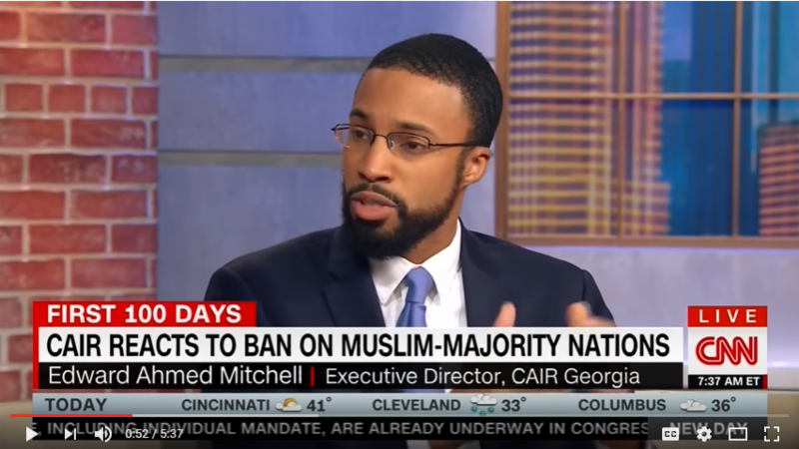
- CAIR: Growing Fallout From Trump's New Immigration Crackdown (AP)
The Council on American-Islamic Relations said it would challenge the constitutionality of the executive order.
"There is no evidence that refugees — the most thoroughly vetted of all people entering our nation — are a threat to national security," Lena F. Masri, the group's national litigation director. "This is an order that is based on bigotry, not reality."
  - Video: CAIR Director Interviewed About 'Muslim Ban' for NBC Nightly News with Lester Holt
  - Video: CAIR-GA Director Interviewed on CNN About Trump's 'Muslim Ban' Executive Order
  - Video: CAIR-SFBA Director Zahra Billoo Interviewed About 'Muslim Ban'
  - Video: CAIR Rep Ibrahim Hooper Interviewed About Trump's 'Muslim Ban'
  - Video: CAIR Rep Interviewed by Al Jazeera About Trump's 'Muslim Ban'
CAIR Community Advisory on Trump's 'Muslim Ban' Executive Order
Dear community members:
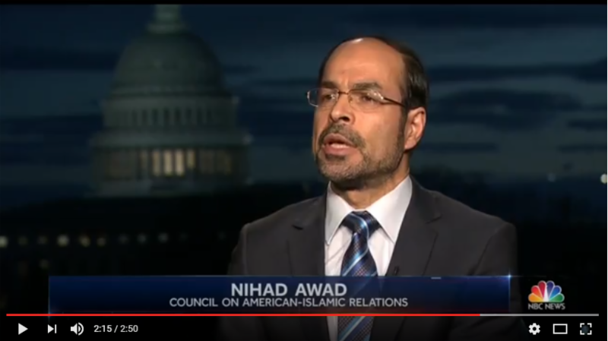
What you need to know right now:
Generally, non-citizens, including green card holders (lawful permanent residents), from Iraq, Iran, Libya, Somalia, Sudan, Syria, and Yemen will be restricted from entering the U.S. for at least 90 days. Non-citizens from these countries who are presently in the U.S. should consult with an immigration attorney prior to any international travel.
However, if you are a green card holder (lawful permanent resident) outside of the U.S., please reach out to an immigration attorney before you travel back to the United States.
The refugee program is being halted immediately, for at least 120 days. This will mean that anyone, anywhere in the process, will not move forward. The effort to resettle Syrian refugees in the U.S. is being halted indefinitely.
What you should do to protect yourself:
If you are non-citizen, even a green card holder (lawful permanent residents), from one of the seven countries named above, and you are inside the U.S., please plan to delay all international travel for at least 90 days.
If you are a non-citizen from one of the seven countries named above, and you are outside of the U.S., you may face issues at the airport. Please keep looking for updates in the coming days to assess your travel options. If you are facing an emergency at the airport or are coming home in the coming days, please contact CAIR's Civil Rights Department at 202-742-6420 or by filing a report at: http://www.cair.com/civil-rights/report-an-incident/view/form.html
You may also contact the nearest CAIR chapter for support. Go to: http://www.cair.com/cair-chapters.html
What you can do to push back against this unconstitutional policy:
Call your elected representatives in Congress at 202.224.3121 to ask them to speak out against anti-Muslim and anti-immigrant bigotry and oppose these executive orders.
Brackground Information:
CAIR: Refugees Detained at U.S. Airports Challenge Trump's Executive Order (Washington Post)
CAIR-AL: Human Rights and Immigrant Rights Advocates, Faith and Community Leaders and Birmingham Mayor to Respond to President's Immigration Executive Orders
CAIR-Missouri Calls Executive Order Unconstitutional
CAIR: Chicago Advocates Condemn Trump's Order on Refugees, Migrants
CAIR: Muslim Woman Attacked at JFK Airport, While FBI Probes Bomb Threat Against Denver Refugee Centre
FOR IMMEDIATE RELEASE
CAIR to Monitor Probe of Another Fire at a Texas Mosque
(AUSTIN, TEXAS, 1/28/17) – The Texas office of the Council on American-Islamic Relations (CAIR-Texas) said today that it will monitor the investigation of a fire that destroyed a mosque in that state.
According to media reports, the Islamic Center of Victoria in Victoria, Texas, was engulfed in flames on Saturday morning. No cause for the blaze has been determined.
SEE: Fire Destroys Mosque; Cause Undetermined (Video)
"Because of growing anti-Muslim bigotry in our nation, and because of the recent spike in hate incidents targeting Islamic institutions and individuals, we urge investigators to keep the possibility of a bias motive for this fire in mind," said CAIR-Houston Executive Director Mustafaa Carroll.
Earlier this month, CAIR-Texas said it would similarly monitor the investigation of a fire at a mosque under construction in Travis County.
SEE: CAIR-Austin to Monitor Probe of Fire at Mosque Under Construction, Work with Community Leaders
A soon-to-be-published CAIR report on Islamophobia in America is expected to show that 2016 was the worst year on record for incidents in which mosques were targets of bias.
SEE: CAIR-Sacramento Urges FBI to Probe Hate Vandalism Targeting Davis Mosque
CAIR is asking American Muslims and Islamic institutions to take extra security precautions and is offering Muslim community leaders free copies of its booklet, "Best Practices for Mosque and Community Safety." The booklet may be requested through CAIR's website: http://www.cair.com/mosque-safety-guide.html
CAIR's national headquarters in Washington, D.C., has noted an unprecedented spike in hate incidents targeting Muslims and other minority groups since the November 8election.
The Washington-based civil rights and advocacy organization urges community members to report any bias incidents to police and to CAIR's Civil Rights Department at 202-742-6420 or by filing a report at: http://www.cair.com/civil-rights/report-an-incident/view/form.html
CAIR is America's largest Muslim civil liberties and advocacy organization. Its mission is to enhance the understanding of Islam, encourage dialogue, protect civil liberties, empower American Muslims, and build coalitions that promote justice and mutual understanding.
La misión de CAIR es mejorar la comprensión del Islam, fomentar el diálogo, proteger las libertades civiles, capacitar a los musulmanes estadounidenses, y construir coaliciones que promuevan la justicia y la comprensión mutua.
- END -
CONTACT: CAIR-San Antonio President Sarwat Husain, 210-378-9528, shusain@cair.com; CAIR-Houston Executive Director Mustafaa Carroll, 832-549-1042, mcarroll@cair.com; CAIR-Houston Communications Coordinator Ruth Nasrullah, rnasrullah@cair.com; CAIR-DFW Executive Director Alia Salem, 817-538-8269, asalem@cair.com; CAIR-Austin, 512-640-9421; CAIR National Communications Director Ibrahim Hooper, 202-744-7726, ihooper@cair.com

- CAIR: With Bias on the Rise, Muslims Turn to Elected Office
Some observers say the political attacks on Islam are helping propel them to office. Robert McCaw, director of government affairs for the Council on American-Islamic Relations, noted that six Muslims were included in the Democratic Party's platform drafting committee last year.
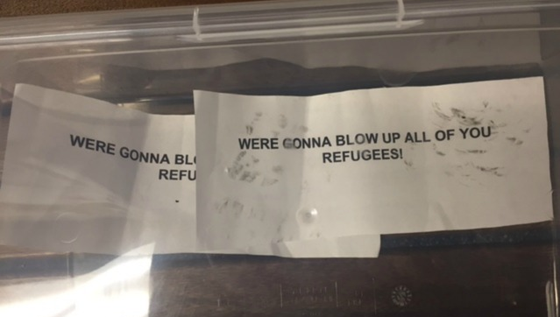
- CAIR Asks Feds to Probe Threat to 'Blow Up' Colorado Refugees
The Council on American-Islamic Relations (CAIR), the nation's largest Muslim civil rights and advocacy organization, today called on the FBI to investigate threats to "blow up" a community center in Colorado that serves refugees.
Police in Aurora, Colo., are investigating threatening notes found at the Mango House community center. The typewritten notes read, "We're gonna blow up all of you refugees."
  - CAIR: Group Asks FBI to Look into Possible Hate Crime at Aurora Refugee Center (Denver Post)
- Video: CAIR-NY Welcomes Arrest in Islamophobic, Pro-Trump Attack at JFK Airport
  - CAIR-NY: Trump 'Will Get Rid of All of You' - Man Allegedly Attacks Muslim Airline Employee (Washington Post)
- Video: CAIR Speaks Out Against Hate Campaign Targeting Ohio Muslim Family
- Video: CAIR Challenges Texas Lawmaker's Islamophobic 'Summit'
  - CAIR: Texas Muslims Voice Concerns After Inflammatory Survey and Forum (NY Times)
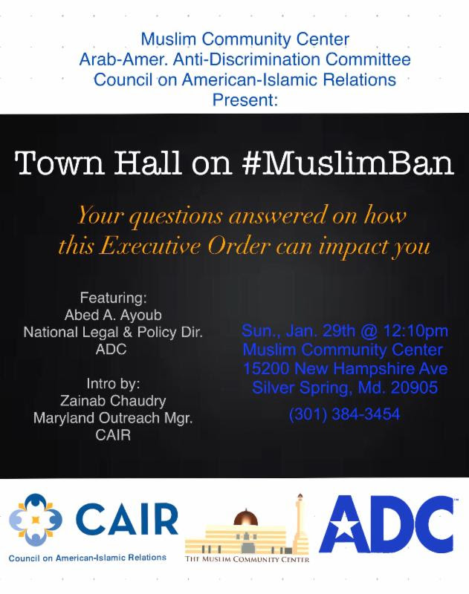
- CAIR to Co-Sponsor Maryland Town Hall Meeting on 'Muslim Ban'
  - CAIR-Pittsburgh Co-Sponsors 'No, Ban, No Wall' Rally on Saturday
- CAIR-Missouri: Local Muslims Decry Refugee/Travel Ban
  - Video: CAIR Rep Corey Saylor Interviewed About Trump's 'Muslim Ban' by Al Jazeera
  - Video: CAIR-Sacramento, Interfaith Leaders Respond to Trump Immigration Orders
  - CAIR-AZ: Americans Rally on Social Media to Push Back on President Trump's Executive Orders
  - Video: CAIR-LA Joins Coalition of Muslims, Latinos Against Trump's Immigration Orders
  - CAIR-Philadelphia: Thousands Protest Trump as Philly Braces for Impact of New Policies
  - CAIR-CT: Demonstrators in New Haven Protest Trump's Enforcement of Immigration Law
  - CAIR-MA: Area Muslims, Others 'Jumpy' at Trump's Executive Order on Immigration
  - CAIR: Maryland Legislators, Faith Leaders, and More Stand with Immigrants and Muslims
- CAIR Joins Ohio Faith Leaders' Call on Senator Portman to Reject Sessions Nomination as Attorney General
MEDIA ADVISORY
CAIR to Announce Constitutional Challenge to Trump's 'Muslim Ban' Executive Order
(WASHINGTON, D.C., 1/27/2017) - On Monday, January 30, the Council on American-Islamic Relations (CAIR) will hold a news conference at its Capitol Hill headquarters in Washington, D.C., to announced the filing of a federal lawsuit on behalf of more than 20 individuals challenging the "Muslim ban" executive order signed today by President Donald Trump.
[MEDIA NOTE: CAIR's news conference will be live-streamed on its Facebook page: https://www.facebook.com/CAIRNational]
WHAT: CAIR to Hold News Conference to Announce Suit Against Trump's 'Muslim Ban' Order
WHEN: Monday, January 30, 1 p.m.
WHERE: CAIR's Capitol Hill Headquarters, 453 New Jersey Avenue, SE Washington, DC 20003
CONTACT: CAIR National Litigation Director Lena Masri, 248-390-9784, lmasri@cair.com; CAIR National Communications Director Ibrahim Hooper, 202-744-7726, ihooper@cair.com
The lawsuit, to be filed in the U.S. District Court – Western District of Virginia, will challenge the constitutionality of the order because its apparent purpose and underlying motive is to ban people of the Islamic faith from Muslim-majority countries from entering the United States.
"There is no evidence that refugees – the most thoroughly vetted of all people entering our nation – are a threat to national security," said CAIR National Litigation Director Lena F. Masri, Esq. "This is an order that is based on bigotry, not reality."
"The courts must do what President Trump will not—ensure that our government refrains from segregating people based on their faith," said Attorney Gadeir Abbas, Esq., who is co-counsel on the lawsuit.
"Our First Amendment is under attack. We, as attorneys, are foot soldiers of the American Constitution and took an oath to protect all from being targeted by the government because of their faith," said Attorney Shereef Akeel, Esq., who is also co-counsel on the lawsuit.
The Washington-based civil rights and advocacy organization urges community members to report any bias incidents to police and to CAIR's Civil Rights Department at 202-742-6420 or by filing a report at: http://www.cair.com/civil-rights/report-an-incident/view/form.html
CAIR is America's largest Muslim civil liberties and advocacy organization. Its mission is to enhance the understanding of Islam, encourage dialogue, protect civil liberties, empower American Muslims, and build coalitions that promote justice and mutual understanding.
La misión de CAIR es mejorar la comprensión del Islam, fomentar el diálogo, proteger las libertades civiles, capacitar a los musulmanes estadounidenses, y construir coaliciones que promuevan la justicia y la comprensión mutua.
- END -
CONTACT: CAIR National Litigation Director Lena Masri, 248-390-9784, lmasri@cair.com; CAIR National Communications Director Ibrahim Hooper, 202-744-7726, ihooper@cair.com

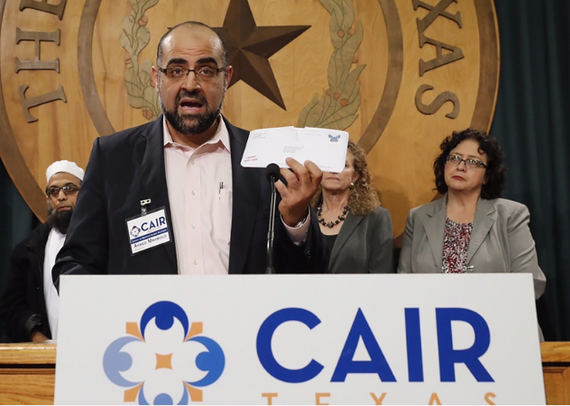
- CAIR-San Antonio: Muslim Leaders Denounce 'Intolerance' as Lawmakers Hold Islamophobic Event
Council on American-Islamic Relations, which puts on the advocacy day, contended that Biedermann's intentions were to derail the upcoming event. On Thursday, Sarwat Hussain, president of the San Antonio chapter of CAIR, reiterated that organizers would move forward with the biennial tradition of bringing hundreds of Muslim Texans to the Capitol to learn about the political process and meet state lawmakers despite Biedermann's poll, which she described as "reminiscent of McCarthyism."
"Get to know us. Be welcoming of us regardless of our faiths, gender, class or anything else," Hussain said. "His intolerance of Texas Muslims is putting this segment of our state into a more vulnerable position. His treatment of Muslims is giving fuel to the fire of Islamophobia that is running rampant in our state."
  - CAIR-Texas: Islamophobic Lawmaker Hosts Summit on 'Radical Islamic Terrorism'
- Frank Gaffney is Behind New Anti-Muslim Interfaith Group
The group, Faith Leaders for America, was apparently started by Gaffney's organization, the Center for Security Policy (CSP), a fact the coalition never acknowledges on its website or press releases.
- Tenn. Muslim B-Ball Coach Says Referee Made Disturbing Comments at Young Team
Partial List of Media Coverage of CAIR's Response to President Trump's 'Muslim Ban' Plan
- CAIR: Muslims, Latinos Unify Over Trump's Immigration, Border Plan
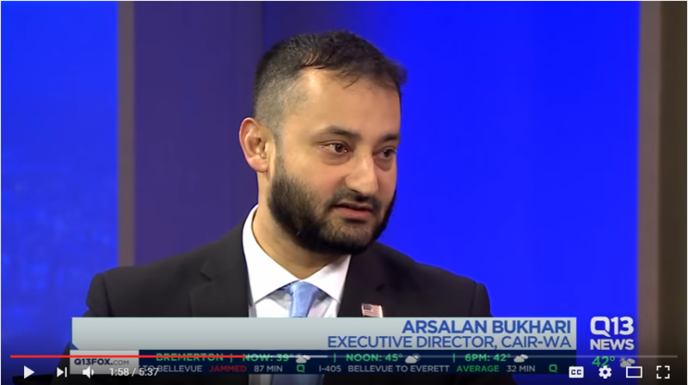
- CAIR-Missouri to Hold News Conference on President Trump's 'Muslim Ban' Executive Orders
- CAIR, CASA de Maryland to Hold 'Together We Rise' Vigil in Support of Immigrants, Muslims and Refugees
- CAIR-GA: Georgia Muslim, Latino Leaders to Hold News Conference With Civil Rights and Refugee Groups In Response to Pres. Trump's Immigration Executive Orders
CAIR: Sacramento Interfaith and Civil Rights Community to Hold Press Conference on Executive Orders
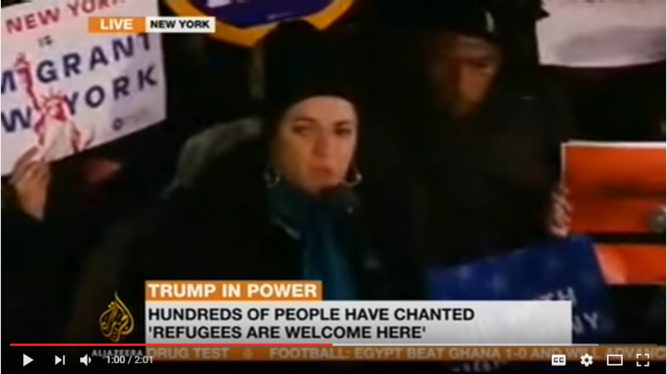
- CAIR-NY: Even Before Trump Acts on Immigration, New Yorkers Protest (NY Times)
The Council on American-Islamic Relations, the country's largest Muslim civil liberties organization, sponsored the protest on Wednesday.
"Muslim-Americans have been attacked over and over again," said Afaf Nasher, executive director of CAIR New York. "But we are resilient and strong, and we will come back with more protests, until we have our civil rights. Because this is what America is supposed to be."
- Video: Al Jazeera Covers CAIR-NY Rally Against Trump's Expected 'Muslim Ban' Executive Orders
- Video: Thousands Join CAIR-NY Rally Against Trump's Expected 'Muslim Ban' Executive Orders
- Video: CAIR Communications Director Ibrahim Hooper Interviewed About Trump's 'Muslim Ban'
- Video: CAIR-SFBA Director Zahra Billoo Reacts to Trump's Planned 'Muslim Ban'
- Video: CAIR-MI Director Dawud Walid Reacts to Trump's Planned 'Muslim Ban'
- Video: CAIR-WA Director Arsalan Bukhari Interviewed About Trump's 'Muslim Ban'
- Video: CAIR Rep Zainab Chaudry on BBC to Discuss Trump's Immigration Orders
- Video: CAIR Dallas Holds News Conference on Trump's 'Muslim Ban' Executive Orders
- CAIR-FL: Miami Civil Rights Groups Plan Rally Against Trump's Muslim Ban at 5 p.m. Today
- CAIR: South Florida Muslim Community Leaders Voice Concern Over Trump's Executive Orders
- CAIR-Philadelphia: With Trump Around the Corner, Philly City Council Claps Back
- Video: CAIR-Cincinnati, Local Islamic, Religious, LGBTQ Groups Condemn Donald Trump's Stance on Refugees, Immigration
- CAIR: Pittsburgh Immigrants, Their Advocates React to Trump's Refugee Plans
- CAIR-San Antonio: Advocates Say Trump's Refugee Ban Demonizes Muslims
- CAIR-MI: Trump Moves to Build Wall, Cut Sanctuary City Funds
- CAIR-Chicago: Trump's ICE Crack Down Will 'Demonize' Immigrants, Chicago Advocates Say
- Video: CAIR Rep Says Banning Muslims from U.S. Sends Negative Message
- CAIR-Cincinnati: Trump's Immigration Orders Compared to World War II Policies
- CAIR-Dallas: Manila Envelopes Contain Message to the Marginalized
Several dozen Muslim, Mexican, LGBT and refugee organizations in North Texas are getting manila envelopes in the mail this week from a P.O. box in Plano.
"You know it's always a nerve-racking thing to open mail at a civil rights organization. You never know what you're going to get," said Alia Salem, Council on American Islamic Relations.
There is a reason her organization keeps its physical location private.
"So we got a couple invitations in the mail and an advertisement for a business. And this is what caught my attention today. This big envelope," said Salem shuffling through Tuesday's mail. Inside is nothing more than a couple sheets of paper.
"To sum it up, it says no agendas, no hate, just a little love from some strangers who say we see you, we support you and we're on our side," she explained.
- CAIR-Texas to Join Interfaith and Community Leaders in Response to Rep. Biedermann's Islamophobic 'Survey'
On Thursday, January 26, the CAIR-TX chapters of the Council on American-Islamic Relations (San Antonio, Austin, Houston and Dallas) will join interfaith and community leaders at a news conference in the State Capitol Building to address Rep. Kyle Biedermann's Islamophobic "survey" sent to mosque leaders and Muslim student associations throughout Texas.
  - Designating the Muslim Brotherhood a "Terrorist Organization" Puts Academic Researchers at Risk (Washington Post)
- CAIR: Michigan Muslims Prepare for Trump Justice Department: "We're bracing for profound change"
  - CAIR-SFBA: Trump Plans Executive Action, SF Holds Steady as Sanctuary City
  - CAIR-FL: The Day After Trump's Inauguration, Thousands March in Downtown Orlando for Central Florida Women's Rally
- Anti-Islam Bill Introduced in Montana Legislature
- Calif. Sikh Man Targeted in US; 'Terrorist' Written on Wall
FOR IMMEDIATE RELEASE
CAIR Issues Statement on Trump's Planned 'Muslim Ban' Executive Orders
(WASHINGTON, D.C., 1/25/17) – The Council on American-Islamic-Relations (CAIR), the nation's largest Muslim civil rights and advocacy organization, today issued a statement in reaction to executive orders expected to be signed by President Donald Trump restricting immigration from a number of Middle Eastern and African countries.
WATCH: Full CAIR News Conference
President Trump is also expected to temporarily bar most refugees from entry to the United States and block visas from being issued to citizens of Iraq, Iran, Libya, Somalia, Sudan and Yemen.
SEE: Trump Executive Order: Muslim countries Are the Target of Upcoming Immigration Ban
Donald Trump is About to Enact a Severe Immigration Crackdown. Here's What You Need to Know.
During a news conference this afternoon at its Capitol Hill headquarters in Washington, D.C., CAIR National Executive Director Nihad Awad said:
[NOTE: Other news conference participants included Jewish Voice for Peace (JVP), the Muslim Public Affairs Council (MPAC) and the National Council of Churches. Nihad Awad's prepared text may be published by media outlets as an editorial.]
"Make no mistake – whatever language is used in President Trump's executive orders on refugees, immigration and visa programs – Muslims are the sole targets of these orders.
"These orders are a disturbing confirmation of Islamophobic and un-American policy proposals made during the presidential election campaign.
"Never before in our country's history have we purposely - as a matter of policy - imposed a ban on immigrants or refugees on the basis of religion, or imposed a religious litmus test on those coming to this nation.
"Ideological and religious questioning imposed on our government agencies by Islamophobes – many of whom are now in policy-making positions - will not make us safer and will instead send a very negative message that Muslims are not welcome in America.
"One of our nation's darkest moments was during World War II when we turned away Jewish refugees seeking our protection. We cannot allow religious bigotry to affect our willingness and ability to welcome those fleeing violence and persecution.
"Refugees coming to America are the most vetted of all those entering our country. They go through multiple levels of screening by multiple national security agencies before they can enter, and before they are even selected as refugees.
"These orders will have an adverse impact on American Muslim families trying to connect with visiting relatives from overseas and parents seeking medical treatment. The orders will tarnish our image in the Muslim world, making us seem uncaring and hard-hearted.
"This ban does not make our country safer. Instead, it serves to stigmatizes Muslim refugees and the entire American Muslim community. It will hand a propaganda tool to our enemies who promote the false narrative of an American war on Islam.
"We have already seen an unprecedented spike in anti-Muslim bigotry in recent months. The negative perceptions and association created by these orders will very likely cause a further increase in hate crimes, discrimination and bigotry against ordinary law-abiding American Muslims.
"The ban on travelers from Muslim-majority and Middle Eastern nations, as well as the construction of a multi-billion-dollar monument to racism on our border with Mexico and the appropriation of sacred Native-American lands, flies in the face of the American values of religious and ethnic inclusion that we all hold dear.
"We must address the issue of terrorism based on evidence and hard data, not based on faith, race or national origin.
"It is encouraging to see that while some national leaders pander to fear and intolerance, many local elected officials and leaders are standing up for their neighbors of all faiths and backgrounds by rejecting Islamophobia and racism.
As we saw more than a million people in this country and around the world marching for justice last Saturday, we will – God willing - see millions more join the movement for human rights and equality.
"We are always strongest as a nation when we stand together in defense of the Constitution and the freedoms it guarantees."
The Washington-based Muslim civil rights group is asking Muslim community members who believe their rights have been violated to contact local police and CAIR's Civil Rights Department at 202-742-6420 or by filing a report at: http://www.cair.com/civil-rights/report-an-incident/view/form.html
CAIR is America's largest Muslim civil liberties and advocacy organization. Its mission is to enhance the understanding of Islam, encourage dialogue, protect civil liberties, empower American Muslims, and build coalitions that promote justice and mutual understanding.
La misión de CAIR es mejorar la comprensión del Islam, fomentar el diálogo, proteger las libertades civiles, capacitar a los musulmanes estadounidenses, y construir coaliciones que promuevan la justicia y la comprensión mutua.
- END -
CONTACT: CAIR Government Affairs Director Robert McCaw, 202-742-6448, rmccaw@cair.com; CAIR National Communications Director Ibrahim Hooper, 202-744-7726, ihooper@cair.com

- CAIR: Activists Poke Trump to Move Faster on Muslim Crackdown (Politico)
Trump has also surrounded himself with aides who have spoken out so harshly against Islamist-inspired extremism that Muslim-American leaders have cast them as "Islamophobes" bigoted against Muslims in general. Those advisers include Michael Flynn, Trump's national security adviser; Stephen Bannon, his chief strategist in the White House; and Mike Pompeo, the new CIA director. . .Now, U.S.-based anti-Islamist activists see the Trump era as a way to gain credibility and followers.
One such organization is ACT for America, which bills itself as a grassroots network dedicated to protecting American culture. The Southern Poverty Law Center has branded ACT for America an anti-Muslim hate group. Flynn, the man tasked with overseeing Trump's National Security Council, has served on ACT for America's board of advisers, and other Trump administration officials are affiliated with the group.
  - CAIR Islamophobia Monitor: ACT for America
  - Islamophobia and the Trump Team
MEDIA ADVISORY
CAIR to Hold News Conference After Trump Signs 'Muslim Ban' Executive Orders
(WASHINGTON, D.C., 1/24/17) – On Wednesday, January 25, the Council on American-Islamic-Relations (CAIR), the nation's largest Muslim civil rights and advocacy organization, will hold a news conference at it Capitol Hill headquarters in Washington, D.C., to offer reaction to executive orders expected to be signed tomorrow by President Donald Trump restricting immigration from Syria and six other Middle Eastern and African countries.
President Trump is also expected to temporarily bar most refugees from entry to the United States. Yet another order will block visas from being issued to citizens of Iraq, Iran, Libya, Somalia, Sudan and Yemen.
The orders will be the actual implementation of what then-candidate Trump said would be a complete ban on Muslims entering the United States.
Reuters: Trump Expected to Sign Executive Orders on Immigration
CAIR: Muslim Groups are Bracing for Trump to Stop Muslim Immigration
CAIR: Activists Poke Trump to Move Faster on Muslim Crackdown (Politico)
"These [executive orders] will not make our nation safer, rather they will make it more fearful and less welcoming," tweeted CAIR National Executive Director Nihad Awad in reaction to initial media reports of the orders.
[MEDIA NOTE: CAIR's news conference will be live-streamed on its Facebook page: https://www.facebook.com/CAIRNational ]
WHAT: CAIR Holds News Conference in Reaction to Executive Orders on Immigration
WHEN: Wednesday, January 25, 1 p.m.
WHERE: CAIR's Capitol Hill Headquarters, 453 New Jersey Avenue, SE Washington, DC 20003
CONTACT: CAIR National Communications Director Ibrahim Hooper, 202-744-7726, ihooper@cair.com
The Washington-based Muslim civil rights group is asking Muslim community members who believe their rights have been violated to contact local police and CAIR's Civil Rights Department at 202-742-6420 or by filing a report at: http://www.cair.com/civil-rights/report-an-incident/view/form.html
CAIR is America's largest Muslim civil liberties and advocacy organization. Its mission is to enhance the understanding of Islam, encourage dialogue, protect civil liberties, empower American Muslims, and build coalitions that promote justice and mutual understanding.
La misión de CAIR es mejorar la comprensión del Islam, fomentar el diálogo, proteger las libertades civiles, capacitar a los musulmanes estadounidenses, y construir coaliciones que promuevan la justicia y la comprensión mutua.
- END -
CONTACT: CAIR Government Affairs Director Robert McCaw, 202-742-6448, rmccaw@cair.com; CAIR National Communications Director Ibrahim Hooper, 202-744-7726, ihooper@cair.com
Thinking Points on Muslim Ban
Assalamu Alaikum.
Silence is not neither an option nor a solution.
Dr. Martin Luther King Jr., Malcolm X, and Muhammad Ali were not known for silence. They were all religious people motivated by the Prophetic ideals of justice, peace, equality and fairness. They all took America forward.
It is important that each Masjid and local Muslim Council in the United States issue a press advisory to their local media that Muslim spokespersons are available for interview. You can prepare yourself using the following talking points. If you do not have a spokesperson, please select one. We prefer a sister to speak up for our community.
If you need media training, sign up here, we can offer a quick webinar-based training. Otherwise, you can join us on February 15th in Michigan, where Sound Vision is organizing a media training workshop.
It is important to invite your interfaith coalition partners and allies to speak up as well.
Each of you in your individual capacity should use social media to speak up.
There are media reports that a major announcement will be made today regarding the Mexican wall, as well as ban on Muslims immigrating to the US from certain countries. In case such orders come into effect, here are some useful talking points and thinking points.

Talking Points
- Once the American factories in Mexico are shut down and moved to the US, Mexicans will be seeking to enter the US to provide cheap labor. Erecting a wall and denying Latinos entry to the US would lead to an economic and a humanitarian crisis.
- America must always side with freedom, liberty, and democracy. This is what these refugees were looking for in their countries, and are now seeking in other countries.
- We must not take America back to the time when Anne Frank was denied a U.S. visa. The Nazis ultimately murdered her.
- Turning refugees away reminds us of the MS St. Louis, a German ocean liner which brought over 900 Jewish refugees fleeing the Holocaust to America in 1939. They were denied entry. Upon returning to Europe, Nazis killed at least a quarter of them.
- All refugees and immigrants entering the U.S. must be equally scrutinized by law enforcement, instead of being selected for vetting based on a religious test.
- While we are pleased that persecuted minorities are welcome, discriminating against Muslims who are equal victims of the cycle of war and terrorism is unAmerican.

Background Information
- The war in Syria began after Syrians were peacefully demonstrating for basic freedoms, fair elections, and democracy. In response, Syrian regime started a campaign of arrests, bombings, and torture, unleashing the largest refugee crisis in the world today.
- See this essay to understand the struggle for democracy in the Muslim world.

Thinking Points
A great new American movement is developing. Let us plan what action we can take month by month. Here are a few ideas and suggestions:
January 21st saw Muslim women marching left, right, and center in the great Women's March on Washington.
- January: It was defined by women's rights, which highlighted the diversity and outspokenness of the movement
- February is Black History Month: Participate and bring forth major focus to anti-racism and reform of criminal justice system. There is a great deal of learning from the civil rights struggle.
- March: Say no to the Muslim registry. Say no to secret evidence. Say no to indefinite detention without a trial. A whole plan is being developed. Please sign up here if you would like to be a part of it.
- April: Climate change marches and Earth Day, as we continue to work in solidarity with the native Americans of Standing Rock.
- May will be Latino and labor rights month, as we stand with the working families for their rights and dignity.
There may be other causes coming up later. But these are solid action items emerging, each providing an opportunity to learn, to work in solidarity with others, and to strengthen the movement that has already began. Intersectionality and diversity defines this new movement.
Each month the movement to liberate America from fear, hate, and anger will be growing.
The plan is to fill up the month of March to bring focus on the challenges Muslims face.
But you don't have to wait for March. Be a part of each coalition, support their actions, while requesting the addition of a line against the Muslim registry. Remember that the registry threat is not just against Muslims entering the U.S., but it is also against American Muslims born and/or raised here.
We will be releasing a list of suggested action items pretty soon for each of these months. Sign up your community leaders, Imams, spokespersons here so that they receive exclusive information and resources.
Sign up your community leaders.
Let us keep seeking help from Sabr and Salat (patience and prayer), as Allah advises us in the Quran (2:153).
God controls the world. We don't. But our actions for His Sake, based on the methods He approves of, will be rewarded in this world and in the world to come. We must put our trust in Allah, but we must act as well. Both are necessary for us to build closeness to Him and to succeed.
Peace,
Abdul Malik Mujahid

