If your rights have been violated contact local police and CAIR's Civil Rights Department at 202-742-6420 or by filing a report at: http://www.cair.com/civil-rights/report-an-incident/view/form.html

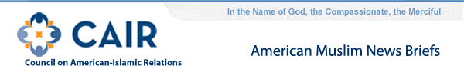
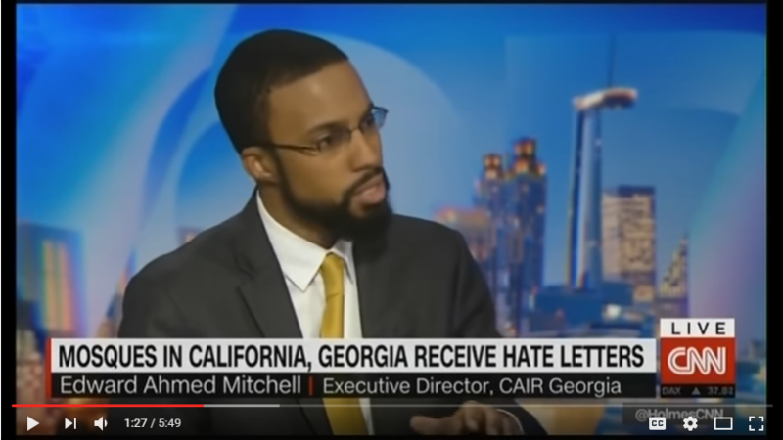
- CAIR-Kansas Welcomes Guilty Pleas for Hate Attack on Somali Men
The Kansas chapter of the Council on American-Islamic Relations (CAIR-Kansas) today welcomed guilty pleas resulting from a June 19, 2015, hate attack on three Somali-Americans in Dodge City. CAIR-Kansas also thanked federal authorities for their successful prosecution of the case.
- Video: CAIR-GA Director Edward Ahmed Mitchell on CNN to Discuss Surge in Anti-Muslim Hate Incidents
  - CAIR-MA Urges Stepped-up Police Protection After Anti-Muslim, Pro-Trump Letter Sent to Rhode Island Mosque
The Massachusetts chapter of the Council on American-Islamic Relations (CAIR-MA) today called for stepped-up police protection of local mosques after an anti-Muslim, hate-filled letter supporting President-elect Donald Trump was sent to Masjid Al-Kareem in Providence, R.I.
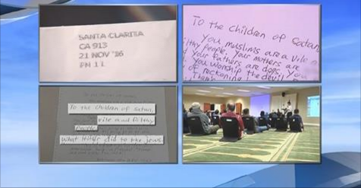
  - CAIR-San Antonio: Hate Crime Statistics Reveal Ongoing Struggle With Bias
  - CAIR-FL: South Florida Mosques Receive Letters Calling for Genocide
  - IN: Letter Sent to Islamic School Threatens To "Cleanse" Muslims Under Trump Presidency
  - Politico: American Muslim Officials Huddle On Ways to Survive Trump
  - CAIR: What Muslim Americans in Chicago Are Doing to Prepare for a Trump Presidency
  - CAIR-LA: This Syrian Mexican American family is Coming to Grips with What a Trump Presidency Will Mean for Them (Video)
  - Donald Trump's Administration Could Be Planning a Witch Hunt Against "Political Islam"
FOR IMMEDIATE RELEASE
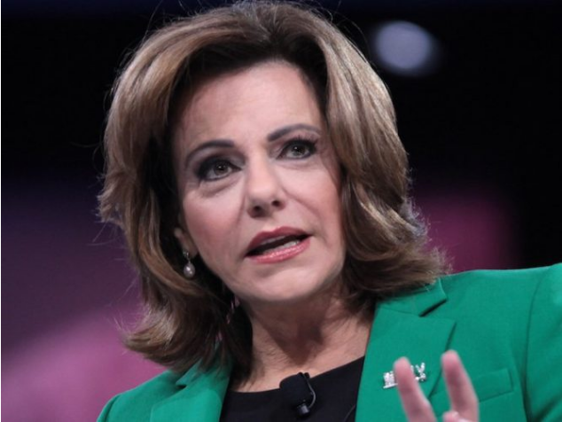
CAIR Alarmed by Addition of More Islamophobes to Trump Transition Team
(WASHINGTON, D.C., 11/30/16) - The Council on American-Islamic Relations (CAIR), the nation's largest Muslim civil rights and advocacy organization, today expressed alarm about the addition of two more individuals with histories of Islamophobic views to President-elect Donald Trump's transition team.
Katharine Gorka has been selected to be part of the DHS "landing team" that will meet with Department of Homeland Security (DHS) officials to manage the transition.
In the past, she has claimed that the DHS trains its agents — falsely, according to Gorka — that Islam is a "religion of peace."
Gorka writes about Islam for the White supremacist website "Breitbart News." In 2014, Gorka wrote that when "Presidents Bush and Obama both publicly declared Islam to be a religion of peace," it "struck a sour chord for many," and that "American and Western leaders have preemptively shut down any debate within Islam by declaring that Islam is the religion of peace."
She is married to Sebastian Gorka, another Breitbart News contributor. Sebastian Gorka, who is also known for his Islamophobic views. He calls religious profiling of Muslims "common sense."
SEE: Anti-Muslim Activist Katharine Gorka Named to Homeland Security Transition Team
President-elect Trump has also named Fox News analyst K.T. McFarland as his deputy national security adviser. McFarland has advocated for war with Iran, supports the use of torture, expressed admiration for Russian strongman Vladimir Putin, and has supported the profiling of Muslims.
Trump Appointee K.T. McFarland: An Anti-Muslim Putin Fan Who Supports Torture
"These most recent appointments again demonstrate a troubling acceptance of anti-Muslim bigotry, conspiracy theories and factually-incorrect policy proposals by the Trump transition team," said CAIR Government Affairs Director Robert McCaw.
CAIR recently expressed concern about a "troubling Islamophobic trend" in President-elect Donald Trump's recent appointments and nominations.
CAIR Islamophobia Monitor: Islamophobia and the Trump Team
The Washington-based civil rights organization cited the nominations and appointments of Alabama Sen. Jeff Sessions for the post of attorney general, Kansas Rep. Mike Pompeo to head the CIA, retired Lt. Gen. Michael Flynn as national security adviser, and "alt-right" extremist Stephen Bannon as Trump's chief strategist and senior counselor.
SEE: CAIR Concerned About 'Troubling Islamophobic Trend' Following Trump's Nomination of Sessions, Pompeo
CAIR also called remarks by incoming White House Chief of Staff Reince Priebus about "problematic" aspects of Islam and his refusal to rule out a "registry" for Muslims as more examples of the Islamophobia exhibited by Trump's transition team.
SEE: CAIR Calls Priebus Remark About 'Problematic' Aspects of Islam, Refusal to Rule Out Muslim Registry More Examples of Trump Transition Team's Islamophobia
The Washington-based Muslim civil rights group is monitoring a troubling spike in anti-Muslim and racist incidents since the November 8 election.
Video: CAIR-GA Director Edward Ahmed Mitchell on CNN to Discuss Surge in Anti-Muslim Hate Incidents
CAIR Islamophobia Monitor: Post-Election Anti-Muslim Bias
Muslim community members who believe their rights have been violated are being asked to contact local police and CAIR's Civil Rights Department at 202-742-6420 or by filing a report at: http://www.cair.com/civil-rights/report-an-incident/view/form.html
CAIR is America's largest Muslim civil liberties and advocacy organization. Its mission is to enhance the understanding of Islam, encourage dialogue, protect civil liberties, empower American Muslims, and build coalitions that promote justice and mutual understanding.
La misión de CAIR es mejorar la comprensión del Islam, fomentar el diálogo, proteger las libertades civiles, capacitar a los musulmanes estadounidenses, y construir coaliciones que promuevan la justicia y la comprensión mutua.
- END -
CONTACT: CAIR Government Affairs Director Robert McCaw, 202-742-6448, rmccaw@cair.com; CAIR National Communications Director Ibrahim Hooper, 202-744-7726, ihooper@cair.com

