stigmatizing American Muslims and imposing arbitrary religious tests will not make our nation more secure and would contradict our democratic values and principles

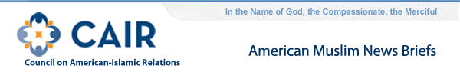
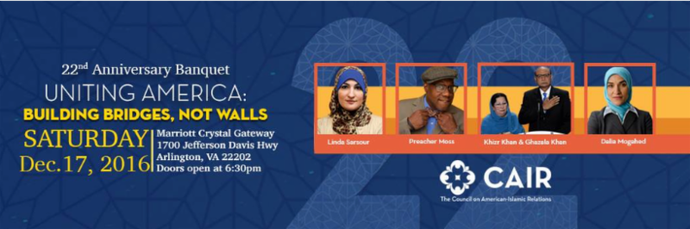
CAIR Banquet Alert:
Did you buy your ticket yet?
CAIR's 22nd Annual Banquet is December 17th at the Crystal Gateway Marriott in Arlington, Va.
Past events have been sold out, and no tickets are sold at the door -- so register TODAY to reserve your place.
Linda Sarsour, executive director of the Arab American Association of New York, has recently been added as a speaker at the banquet.
With the theme "Uniting America: Building Bridges, Not Walls," the evening banquet will also feature Gold Star father and constitutional activist Khizr Khan and Dalia Mogahed, director of research at the Institute for Social Policy and Understanding in Washington, D.C.
Banquet attendees will also be entertained by comedian Preacher Moss and will meet the recipients of CAIR's Community Service Awards.
Registration for the banquet is available at: http://www.cair.com/banquet
Individual tickets cost $65.
Banquet tables for a family, business, mosque, or other group, can be reserved by calling 202-742-6454 or by emailing events@cair.com.
NEWS UPDATES:
- CAIR-CT: Anti-Muslim Letter Arrives at Connecticut Mosque
- CAIR-MI: A Michigan school official posted offensive Facebook memes. Now protesters want him gone. (Washington Post)
- CAIR: Facing Uncertainty, Maryland Muslims to Focus on Education (AP)
- Residents React to Anti-Muslim Poster in Oregon
- AK: Demboski Says at Anchorage Assembly She Has No Reason to Apologize to Muslim Family
FOR IMMEDIATE RELEASE
CAIR Welcomes President Obama's Remarks Against Stigmatizing American Muslims, Imposing Religious Tests
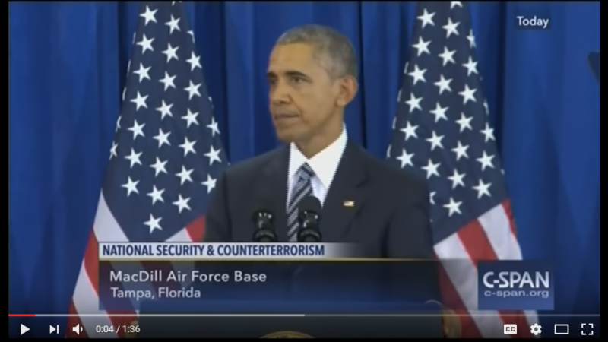
(WASHINGTON, D.C., 12/7/16) - The Council on American-Islamic Relations (CAIR), the nation's largest Muslim civil rights and advocacy organization, today welcomed remarks yesterday by President Obama during his final national security speech at MacDill Air Force Base in Tampa, Fla., warning against stigmatizing "good, patriotic" American Muslims or imposing "religious tests as a price for freedom."
Video: President Obama Warns Against Stigmatizing American Muslims
SEE: White House Transcript on Remarks by the President on the Administration's Approach to Counterterrorism
While the president did not mention President-elect Donald Trump by name, it was widely viewed by many as a message to the next president and a rebuke of Trump's many anti-Muslim policy proposals and his Islamophobic rhetoric.
"President Obama's message to President-elect Donald Trump and his administration was clear – stigmatizing American Muslims and imposing arbitrary religious tests will not make our nation more secure and would contradict our democratic values and principles," said CAIR National Government Affairs Department Director Robert S. McCaw.
The President said in part:
"We are fighting terrorists who claim to fight on behalf of Islam, but they do not speak for over a billion Muslims around the world and they do not speak for American Muslims, including many who wear the uniform of the United States of America's military.
"If we stigmatize good, patriotic Muslims, that just feeds the terrorist narrative. It fuels the same false grievances that they use to motivate people to kill.
"If we act like this is a war between the United States and Islam, we're not just going to lose more Americans to terrorist attacks, but we will also lose sight of the very principles we claim to defend.
So let my final words to you as your commander in chief be a reminder of what it is that you're fighting for. What it is that we are fighting for.
"The United States of America is not a country that imposes religious tests as a price for freedom.
"We are a country that was founded so that people could practice their faiths as they choose. The United States of America is not a place where some citizens have to withstand greater scrutiny, or carry a special I.D. card, or prove that they are not an enemy from within.
"We are a country that has bled and struggled and sacrificed against that kind of discrimination and arbitrary rule here in our own country and around the world."
Yesterday, CAIR National Executive Director Nihad Awad joined more than 300 other American Muslim leaders in issuing a joint letter to President-elect Donald Trump calling on him to reconsider troubling policies proposed during his campaign, as well as recent announcements regarding appointments to his upcoming administration.
SEE: CAIR Director Joins 300+ American Muslim Leaders in Joint Letter to Donald Trump
On Monday, CAIR said president-elect Donald Trump's choice of Islamophobe Ben Carson to be secretary of the Department of Housing and Urban Development (HUD) could negatively impact Muslims served and employed by that federal agency.
SEE: CAIR Questions How Islamophobe Ben Carson Will Treat Muslims Served and Employed by HUD
CAIR recently expressed concern about a "troubling Islamophobic trend" in President-elect Donald Trump's recent appointments and nominations of Alabama Sen. Jeff Sessions for the post of attorney general, Kansas Rep. Mike Pompeo to head the CIA, retired Lt. Gen. Michael Flynn as national security adviser, K.T. McFarland as deputy national security adviser, Katharine Gorka as part of the DHS "landing team," and "alt-right" extremist Stephen Bannon as Trump's chief strategist and senior counselor.
CAIR Islamophobia Monitor: Islamophobia and the Trump Team
CAIR Concerned About ‘Troubling Islamophobic Trend' Following Trump's Nomination of Sessions, Pompeo
CAIR has also called remarks by incoming White House Chief of Staff Reince Priebus about "problematic" aspects of Islam and his refusal to rule out a "registry" for Muslims as more examples of the Islamophobia exhibited by Trump's transition team.
SEE: CAIR Calls Priebus Remark About ‘Problematic' Aspects of Islam, Refusal to Rule Out Muslim Registry More Examples of Trump Transition Team's Islamophobia
CAIR is America's largest Muslim civil liberties and advocacy organization. Its mission is to enhance the understanding of Islam, encourage dialogue, protect civil liberties, empower American Muslims, and build coalitions that promote justice and mutual understanding.
La misión de CAIR es mejorar la comprensión del Islam, fomentar el diálogo, proteger las libertades civiles, capacitar a los musulmanes estadounidenses, y construir coaliciones que promuevan la justicia y la comprensión mutua.
- END -
CONTACT: CAIR Government Affairs Director Robert McCaw, 202-742-6448, rmccaw@cair.com; CAIR National Communications Director Ibrahim Hooper, 202-744-7726, ihooper@cair.com

